Bringing Tax Avoiders to Light: Moral Framing and Shaming in a Public Goods Experiment

**Online Supplementary Material**

1. **Additional Results**

**Table A1:** SHARE OF FULL COMPLIERS

|  |  |
| --- | --- |
| **Disclosure** | |
| **No** | **Yes** |
| **Framing** | **No** | 12.4 (32.99) | 67.64 (46.83) |
| **Tax** | 16.0 (36.71) | 42.44 (49.48) |
| **Loaded** | 24.91 (43.29) | 68.73 (46.40) |

*Notes:* Standard deviations are in parentheses.

**Figure A:** FULL COMPLIANCE ACROSS TREATMENTS OVER TIME

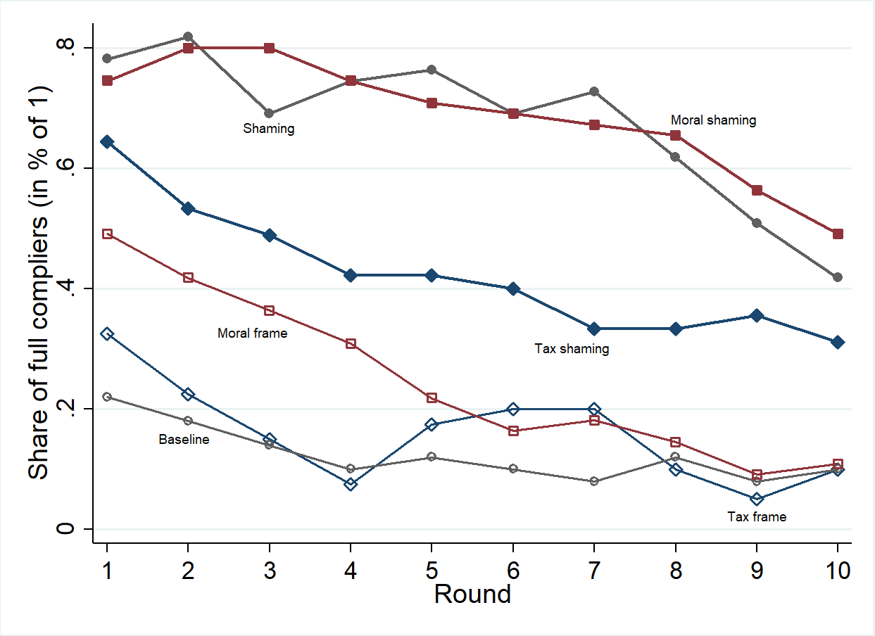

**Table A2:** PROBIT REGRESSIONS FOR FULL COMPLIANCE

|  |  |  |  |  |  |  |
| --- | --- | --- | --- | --- | --- | --- |
|  | (1) | (2) | (3) | (4) | (5) | (6) |
|  | RE | ME | RE | ME | RE | ME |
| Rounds | (1-10) | (1-10) | (1-3) | (1-3) | (8-10) | (8-10) |
|  |  |  |  |  |  |  |
| Tax frame | 0.057 | 0.084 | 0.050 | 0.055 | 0.011 | 0.003 |
|  | (0.070) | (0.073) | (0.073) | (0.071) | (0.085) | (0.103) |
| Moral frame | 0.183** | 0.153* | 0.263*** | 0.241*** | 0.056 | 0.070 |
|  | (0.078) | (0.080) | (0.081) | (0.085) | (0.072) | (0.089) |
| Shaming | 0.514*** | 0.497*** | 0.527*** | 0.523*** | 0.394*** | 0.369*** |
|  | (0.079) | (0.084) | (0.072) | (0.073) | (0.084) | (0.097) |
| Tax shaming | 0.319*** | 0.295*** | 0.353*** | 0.340*** | 0.261** | 0.239** |
|  | (0.095) | (0.096) | (0.076) | (0.075) | (0.105) | (0.112) |
| Moral shaming | 0.525*** | 0.518*** | 0.549*** | 0.541*** | 0.425*** | 0.429*** |
|  | (0.083) | (0.084) | (0.069) | (0.068) | (0.088) | (0.100) |
| Age | 0.009* | 0.003 | 0.010* | 0.006 | 0.010 | 0.003 |
|  | (0.005) | (0.004) | (0.005) | (0.005) | (0.007) | (0.005) |
| Female | -0.073** | -0.002 | -0.048 | -0.006 | -0.046 | 0.026 |
|  | (0.036) | (0.035) | (0.047) | (0.050) | (0.037) | (0.034) |
| Semester | 0.005 | 0.001 | 0.004 | 0.003 | 0.007 | 0.002 |
|  | (0.005) | (0.004) | (0.006) | (0.006) | (0.005) | (0.004) |
| Econ. Major | -0.050 | -0.055 | -0.022 | -0.029 | -0.065 | -0.057 |
|  | (0.048) | (0.039) | (0.053) | (0.054) | (0.063) | (0.050) |
| Bachelor degree | 0.017 | -0.004 | 0.016 | 0.007 | -0.005 | 0.011 |
|  | (0.037) | (0.036) | (0.045) | (0.047) | (0.041) | (0.040) |
| Income | -0.0*** | -0.0* | -0.0** | -0.0* | -0.0** | -0.0*** |
|  | (0) | (0) | (0) | (0) | (0) | (0) |
| Employment | -0.073** | -0.033 | -0.108** | -0.084* | -0.047 | -0.012 |
|  | (0.036) | (0.031) | (0.045) | (0.046) | (0.043) | (0.036) |
| Tax knowledge | -0.019 | -0.051 | -0.017 | -0.025 | -0.036 | -0.064* |
|  | (0.034) | (0.034) | (0.043) | (0.043) | (0.041) | (0.037) |
| Round | -0.029*** | -0.030*** | -0.045*** | -0.046*** | -0.040*** | -0.040*** |
|  | (0.003) | (0.003) | (0.015) | (0.016) | (0.012) | (0.013) |
| Observations | 2 810 | 2 810 | 843 | 843 | 843 | 843 |
| Wald-tests (*p =*) |  |  |  |  |  |  |
| Tax frame = Moral frame | .040 | .326 | .007 | .026 | .545 | .467 |
| Tax shaming = Moral sha. | .047 | .040 | .015 | .014 | .141 | .113 |
| Moral frame = Tax shaming | .134 | .130 | .289 | .258 | .035 | .102 |
| Tax frame = Tax shaming | .002 | .019 | <.001 | .002 | .020 | .043 |

*Notes:* The dependent variable takes a value of 1 if whenever a subject chose to invest 40 ECU (40% of her endowment) to the public investment. Marginal effects are reported. Standard errors, clustered on the group-level, are in parentheses. See Table 2 in the article for the description of the socio-economic covariates. RE: Random effects, ME: Mixed effects. *: *p* < 0.1; **: *p* < 0.05; ***: *p* < 0.01.

1. **On-screen Messages**

**Newspaper commentary**

**Figure B:** NEWSPAPER COMMENTARY



*Note:* As presented to participants on-screen prior to round 1 in the treatments Moral frame and Moral Shaming.

**English translation**

“Tax avoidance is legal, but can it ever be legitimate?”

In the recent past, whistleblowers have uncovered large-scale tax avoidance. It not only involves large multinational corporations but also thousands of individual taxpayers who use shell companies to hide income or assets from national tax authorities. Generally, these tax practices are lawful; no legal consequences are looming.

Primarily, tax avoidance is not a matter of wrongdoing in any legal sense. It is more a matter of morality in an economic system where capital flows have no boundaries, whilst taxation is still chained to nation states. Does a taxpayer behave ethically when he cherishes public funding for universities, infrastructure, or the police but considers the state as an opponent as soon as funding affects his own purse?

Tax avoidance means bypassing the law with legal means. Tax avoiders might not violate tax laws directly – but they do not act in its spirit either. Moreover, tax avoiders undermine the very integrity of the tax system since the adopted tax strategy was neither wanted nor intended by the law-maker.

Every taxpayer with an opportunity to avoid taxes faces the personal choice whether he or she can justify tax avoidance – for himself/herself and for others. This choice, however, should be made with bearing the societal consequences in mind: tax avoidance leads to lesser government revenues and, thus, to fewer public services and a more unjust distribution of the tax burden.

Not everything that is legal is also legitimate.

**Disclosure screen**

**Figure C:** DISCLOSURE SCREEN WITH PICTURES AND PAYMENT INFORMATION

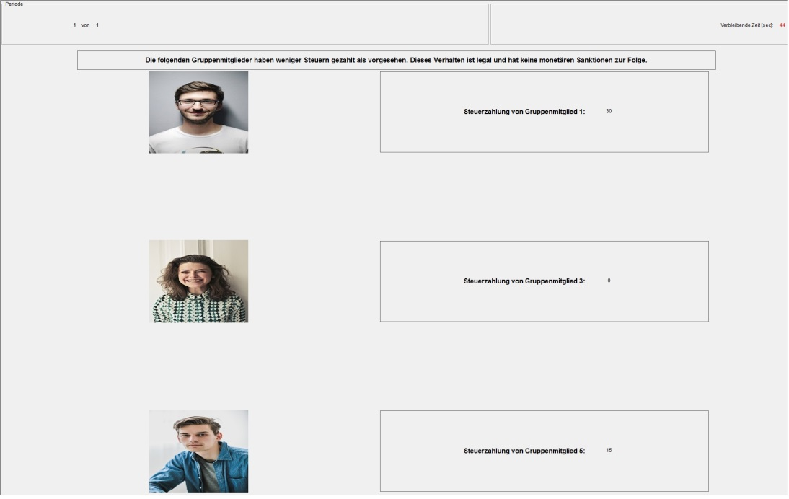

*Notes:* In this sample picture, group members 1, 3, and 5 avoid taxes. Their pictures, together with information about their tax payment, are disclosed to all group members. Group members 2 and 4 did not avoid taxes and thus remain anonymous. The headline reads “The following group members have reduced their personal tax burden. Doing so is legal and not connected with monetary consequences”. In the Shaming and Tax shaming treatments the message read “The following group members contributed less than the maximum possible amount of 40 ECU.” The pictures here do not show actual participants for privacy. The photos used in Figure C were retrieved from the website pexels.com, which provides free stock photos with a CC0 (Creative Commons Zero) license for private and commercial use.

**Differences in on-screen messages**

The wording of the disclosure texts was slightly adjusted between neutral, framed, and morally loaded treatments. With *Shaming*, a message read “On the next page, those group members who contributed less than the maximum possible amount to the public good will be publicly disclosed”. It was modified in the treatment *Moral shaming* to: “On the next page, those group members who paid less taxes than scheduled will be publicly disclosed by their picture and their respective tax payment. Due to the reduction of the individual tax burden, tax revenues decrease to the detriment of the whole group.” In the framed disclosure treatment without the moral appeal (*Tax shaming*) the last sentence was not presented to the participants.

1. **Instructions**

*Notes:* Instructions given to the participants in the experiments were originally in German. Appendix C presents their English translation. Distinct instructions were prepared for each treatment. In the following, the different versions are combined, with variations between treatments being marked by square brackets.

**General Information [common to all treatments]**

Thank you for participating in today's experiment. Upon completion of the experiment you will receive a participation fee of 4 euros. This fee is independent of the experiment's events. In the experiment you have the chance to earn additional money. The amount will depend on your decisions and on the decisions of your fellow players. The total payoff constitutes of your earnings in the experiment plus the participation-fee. Today's experiment consists of a total of 10 rounds.

Please pay attention to the following points:

* Please read the instructions thoroughly. If you do not understand certain aspects, do not hesitate to ask. However, do not ask your question audibly. Instead, please raise your hand.
* Seats are provided with a visual cover. Verbal communication with fellow participants is not permitted. You also must not leave your seat.
* Please turn off your mobile phone or other electronic devices and store them in your bag.
* The pencil on your desk can be used. On the instructions, you may make markings or take notes.
* The program with which the experiment is carried out must not be closed. Please do not open any other programs on the computer.
* Standby times might occur because participants proceed at different speeds.
* At the end of the experiment with a total of 10 rounds, one of the rounds will be randomly selected for your payout (in cash).
* You will receive your total earnings at the end of the experiment. Please return the instructions to the experimenter.

**Proceedings**

In the experiment you will be part of a group consisting of exactly 5 group members. The composition of the group is fixed over the course of the experiment. The 10 rounds are independent.

**Initial endowment and decision [Baseline, Shaming]**

In each of the 10 rounds, you (and each member of your group) have an endowment of 100 ECU (Experimental Currency Unit) at your disposal. Of the 100 ECU, a maximum of 40 ECU can be invested in a profitable public venture. However, you can also decide to invest less or nothing at all. Depending on your decision, at least 60 ECU and maximum 100 ECU go to a private account which does not yield profits. The exchange rate from ECU to euro is 1:10, i.e., 10 ECU equals 1 euro.

**Initial endowment and decision [Tax frame, Moral frame, Tax shaming, Moral shaming]**

In each of the 10 rounds, you (and each member of your group) are endowed with a taxable income of 100 ECU (Experimental Currency Unit). The linear tax rate is 40%, that is, you have to pay 40 ECU taxes. Your tax payment and the taxes of your fellow group members will be invested in a profitable public venture.

However, you have the legal possibility to reduce your individual tax burden: in each round of the experiment, you decide how much tax you pay. This simultaneously determines the rate with which your endowment is taxed. If you do not use the possibility to reduce your tax burden, the tax rate remains at the scheduled 40%. Reducing the tax burden is legal and, thus, not connected to any monetary sanctions. Depending on your decision, at least 60 ECU and maximum 100 ECU go to a private account which does not yield profits. The exchange rate from ECU to euro is 1:10, i.e., 10 ECU equals 1 euro.

**Earnings and payoffs**

[Baseline, Shaming]: Revenues from the public venture depend on the contributions of all group members. The following applies: the more a group member contributes, the higher the returns for each group member.

[Tax frame, Moral frame, Tax shaming, Moral shaming]: Revenues from the public venture depend on the tax payments of all group members. The following applies: the more taxes a group member pays, the higher the returns for each group member.

Payoffs in each round emerge as follows:

Payoff = Stock of private account + revenue from the public venture

Table 1 [here: Figure D] exemplifies some payoffs, conditional on your own contribution and the contributions of the other four group members. Please note:

* [in Baseline, Shaming]: For simplicity, you cannot select an arbitrary contribution between 0 and 40 ECU. You choose from the series of values depicted on your screen.
* [in Tax frame, Moral frame, Tax shaming, Moral shaming]: For simplicity, you cannot select an arbitrary tax payment between 0 and 40 ECU. You choose from the series of tax payments depicted on your screen.
* [in Baseline, Tax frame, Moral frame]: Your decision about your contribution [tax payment, treatments Tax frame, Moral frame] will not be disclosed. The group members will not learn how much you invested into the public venture.
* [in treatments Shaming, Tax shaming, Moral shaming]: Your decision about your contribution [tax payment, Tax shaming, Moral shaming] will be disclosed. The group members will learn how much you invested into the public venture.

**Information at the end of any round**

After each group member has decided about their own contribution [tax payment], your individual contribution [tax payment], the total group contributions [tax revenue] and your personal payoff in the respective round will be displayed to you on your screen.

[Addendum for treatment Shaming:] Additionally, those group members who invested less than 40 ECU to the public venture will be disclosed at the end of each round. In this case, the picture and the contribution of the respective group members will be presented to all group members. Who contributes the full amount will remain anonymous.

[Addendum for treatments Tax shaming, Moral shaming:] Additionally, those group members who paid less than the scheduled 40 ECU taxes will be disclosed at the end of each round. In this case, the picture and the tax payment of the respective group members will be presented to all group members. Who did not reduce the individual tax burden will remain anonymous.

**Figure D:** PAYOFF-TABLE

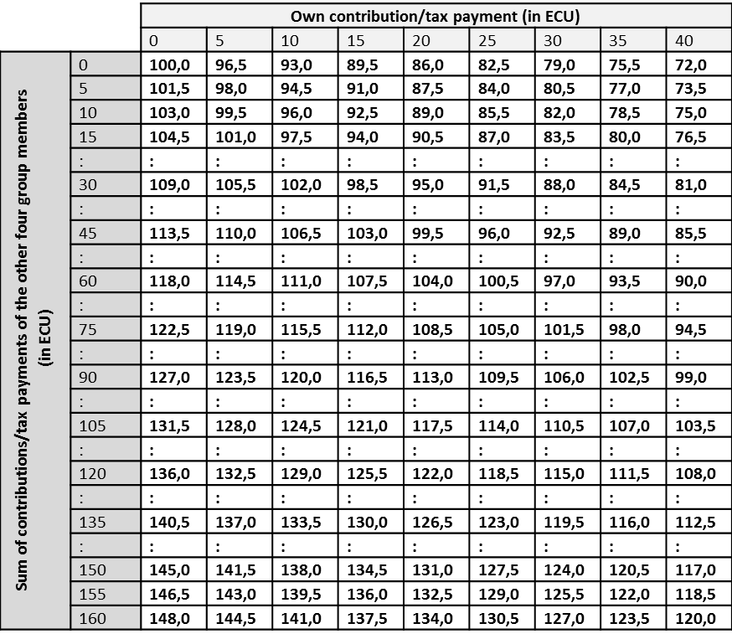

**Final information [common to all treatments]**

After reading these instructions we ask you to answer some questions on your computer. Answering these questions only checks comprehension and is not relevant for payoffs. The experiment will start upon completion of the comprehension test.

After the experiment we ask you to answer a few questions. For this purpose a short questionnaire will start automatically. The questionnaire is not relevant for payoffs either. [Added in treatments Shaming, Tax Shaming, Moral Shaming: The answers will not be disclosed.]

1. **Declaration of consent**

For today’s experiment it is necessary to take your picture and to save it digitally for a short time. Dependent on the events in the experiment it might happen that your photography is presented to you and other participants on screen.

Upon completion of the experiment your photo will be deleted from the camera and the computer. Continued use outside the lab or circulation of your data is foreclosed.

With your signature you consent to the possible use of your photography in today’s experiment.

In case you refuse the possible use of your picture you cannot participate in today’s experiment. Yet you still receive the participation fee of 4 euros.

1. **Comprehension test**

**Question A1:** A group consists of exactly 5 group members (Yes/No).

**Question A2:** The composition of the group changes during the experiment (Yes/No).

**Question A3:** Your decisions remain anonymous (Yes/No (correct in the disclosure treatments)).

**Question A4:** All group members receive the same return from the public good (Yes/No).

**Question B:** What is your income if you invest 20 ECU and the four other group members invest in sum 120 ECU into the public venture?

**Question C:** What is your income if you invest 30 ECU and the four other group members invest in sum 60 ECU into the public venture?