Supplementary Material Experiencing Default Nudges

Study 1
Table S1. Means, standard deviations and correlations for dependent variables in Experiment 1, full sample
Variable | M | SD | 1 | 2 | 3
1. Choice | 4.41 | 2.92
2. Experienced autonomy | 7.71 | 1.32 | .182**  [.068, 291]
3. Choice satisfaction | 7.83 | 1.36 | .159**  [.045, 269] | .567**  [.483, .640]
4. Perceived threat to freedom of choice | 2.33 | 1.94 | -.112  [-.224, .003] | -.543**  [-.619, -.456] | -.209**  [-.317, -.096]
Note: Values in square brackets indicate the 95% confidence interval for each correlation. * indicates p <.05 ** indicates p <.01.

Table S2. Means, standard deviations and correlations for dependent variables in Experiment 1, Opt-out condition.
Variable | M | SD | 1 | 2 | 3
1. Choice | 6.75 | 2.96
2. Experienced autonomy | 7.88 | 1.42 | .231  [-.024, .458]
3. Choice satisfaction | 8.13 | 1.13 | .254*  [.000, .477] | .443**  [.213, .626]
4. Perceived threat to freedom of choice | 2.33 | 2.03 | -.133  [-.374, .125] | -.697**  [-.808, -.538] | -.242  [-.467, .013]
Note: Values in square brackets indicate the 95% confidence interval for each correlation. * indicates p <.05 ** indicates p <.01.

Table S3. Means, standard deviations and correlations for dependent variables in Experiment 1, Opt-in condition.
Variable | M | SD | 1 | 2 | 3
1. Choice | 3.38 | 2.28
2. Experienced autonomy | 7.55 | 1.40 | .179  [-.351, .004]
3. Choice satisfaction | 7.72 | 1.45 | .117  [-.068, .294] | .566**  [.427, .679]
4. Perceived threat to freedom of choice | 2.16 | 1.82 | .006  [-.177, .189] | -.431**  [-.569, -.269] | -.115  [-.292, .070]
Note: Values in square brackets indicate the 95% confidence interval for each correlation. * indicates p <.05 ** indicates p <.01.

Table S4. Means, standard deviations and correlations for dependent variables in Experiment 1, Active choice condition.
Variable | M | SD | 1 | 2 | 3
1. Choice | 4.23 | 2.82
2. Experienced autonomy | 7.78 | 1.17 | .106  [-.079, .284]
3. Choice satisfaction | 7.78 | 1.36 | .073  [-.112, .253] | .643**  [-.739, -.521]
4. Perceived threat to freedom of choice | 2.50 | 2.00 | -.243**  [-.408, -.063] | -.607**  [-.711, -.477] | -.300**  [-.458, -.124]
Note: Values in square brackets indicate the 95% confidence interval for each correlation. * indicates p <.05 ** indicates p <.01.

Individual difference variables
Below are the eight individual difference items included in Experiment 1 and 2. Variable names in parentheses.
“The following questions are about how you see yourself IN GENERAL. (These questions are thus NOT referring to the apartment choices).
Please indicate the extent to which you agree with the following statements:”
- (ind_1) Others usually know what is best for me
- (ind_2) I enjoy making my own decisions
- (loc_1) My life is determined by my own actions
- (loc_2) I am usually able to protect my personal interests
- (loc_3) I can pretty much determine what will happen in my life
- (traitr_1) I become frustrated when I am unable to make free and independent decisions
- (traitr_2) I resist the attempts of others to influence me
- (traitr_3) Advice and recommendations induce me to do just the opposite
Scale: 9-point Likert scale. 1 = do not agree at all, 9 = completely agree.
Additionally, we included two attitude items pertaining to environmentalism and thrift.
- (green) IN GENERAL, how important is it to you to be environmentally friendly in choices that you make?
- (thrift) IN GENERAL, how important is it to you to keep costs down in choices that you make?
Scale: 9-point Likert scale. 1 = not very important, 9 = extremely important.

Items are taken from the desirability of control scale by Burger and Cooper (1979; “ind_1 - ind_2”; Burger and Cooper, 1979), the internal control-subscale from Sapp and Harrod’s (1993) locus of control short scale (“loc_1 - loc_3”), and Hong and Page’s trait reactance scale (1989; “traitr_1” – “traitr_3”).

Burger, J. M., and Cooper, H. M. (1979), ‘The desirability of control’, Motivation and emotion, 3(4): 381-393.
Hong, S. M., and Page, S. (1989), ‘A psychological reactance scale: Development, factor structure and reliability’, Psychological Reports, 64(3): 1323-1326.
Sapp, S. G., and Harrod, W. J. (1993), ‘Reliability and validity of a brief version of Levenson's locus of control scale’, Psychological Reports, 72(2): 539-550.

Table S5. Correlation between dependent variables and individual difference items for Experiment 1.
Variable | Ind_1 | Ind_2 | Loc_1 | Loc_2 | Loc_3 | Traitr_1 | Traitr_2 | Traitr_3 | Green | Thrift
Choice | .003  [-.112, .118] | .088  [-.027, .201] | .091  [-.024, .204] | .079  [-.037, .192] | .068  [-.048, .182] | .090  [-.025, .203] | .035  [-.081, .150] | -.006  [-.121, .109] | .390**  [.288, .483] | -.116*  [-.228, -.001]
Experienced autonomy | -.136*  [-.247, -.021] | .367**  [.263, .463] | .358**  [.253, .454] | .377**  [.274, .472] | .270**  [.169, .374] | .151**  [.036, .262] | .170**  [.056, .280] | -.058  [-.172, .058] | .115*  [.000, .227] | .212**  [.099, .319]
Choice satisfaction | -.109  [-.221, .006] | .340**  [.234, .438] | .224**  [.112, .331] | .274**  [.164, .377] | .164**  [.050, .274] | .113  [-.002, .225] | .105  [-.010, .218] | -.011  [-.126, .104] | .025  [-.090, .140] | .124*  [.009, .236]
Perceived threat to freedom of choice | -.173**  [-.283, -.059] | -.207**  [-.315, -.094] | -.264**  [-.368, -.153] | -.236**  [-.342, -.124] | -.124*  [-.236, -.009] | -.095  [-.208, .020] | -.112  [-.224, .003] | .229**  [.117, .335] | -.045  [-.159, .071] | -.088  [-.201, .027]
Values in square brackets indicate the 95% confidence interval for each correlation. * indicates p <.05 ** indicates p <.01.

Study 2
Table S6. Means, standard deviations and correlations for dependent variables in Experiment 2, full sample
Variable | M | SD | 1 | 2 | 3
1. Choice | 5.32 | 3.03
2. Experienced autonomy | 7.67 | 1.38 | .209**  [.132, .284]
3. Choice satisfaction | 7.73 | 1.40 | .216**  [.139, .291] | .490**  [.427, .548]
4. Perceived threat to freedom of choice | 2.32 | 1.81 | -.081*  [-.081, -.001] | -.475**  [-.534, -.411] | -.256**  [-.329, -.180]
Note: Values in square brackets indicate the 95% confidence interval for each correlation. * indicates p <.05 ** indicates p <.01.

Table S7. Means, standard deviations and correlations for dependent variables in Experiment 2, Opt-out condition.
Variable | M | SD | 1 | 2 | 3
1. Choice | 7.46 | 2.57
2. Experienced autonomy | 7.84 | 1.30 | .174*  [.028, .313]
3. Choice satisfaction | 7.97 | 1.27 | .318**  [.180, .444] | .394**  [.262, .511]
4. Perceived threat to freedom of choice | 2.44 | 1.88 | -.152*  [-.292, -.005] | -.434**  [-.546, -.307] | -.142  [-.283, .005]
Note: Values in square brackets indicate the 95% confidence interval for each correlation. * indicates p <.05 ** indicates p <.01.

Table S8. Means, standard deviations and correlations for dependent variables in Experiment 2, Opt-in condition.
Variable | M | SD | 1 | 2 | 3
1. Choice | 4.14 | 2.65
2. Experienced autonomy | 7.49 | 1.46 | .262**  [.136, .380]
3. Choice satisfaction | 7.57 | 1.39 | .165*  [.035, .290] | .443**  [.331, .543]
4. Perceived threat to freedom of choice | 2.31 | 1.76 | -.106  [-.234, .025] | -.420**  [-.522, -.306] | -.262**  [-.380, -.136]
Note: Values in square brackets indicate the 95% confidence interval for each correlation. * indicates p <.05 ** indicates p <.01.

Table S9. Means, standard deviations and correlations for dependent variables in Experiment 2, Active choice condition.
Variable | M | SD | 1 | 2 | 3
1. Choice | 4.72 | 2.83
2. Experienced autonomy | 7.72 | 1.35 | .121  [-.017, .254]
3. Choice satisfaction | 7.70 | 1.50 | .114  [-.024, .248] | .600**  [.504, .681]
4. Perceived threat to freedom of choice | 2.24 | 1.82 | -.084  [-.219, .054] | -.595**  [-.677, -.498] | -.357**  [-.472, -.231]
Note: Values in square brackets indicate the 95% confidence interval for each correlation. * indicates p <.05 ** indicates p <.01.

Table S10. Correlations between dependent variables and individual difference items in Experiment 2.
Variable | Ind_1 | Ind_2 | Loc_1 | Loc_2 | Loc_3 | Traitr_1 | Traitr_2 | Traitr_3 | Green | Thrift
Choice | .011  [-.069, .091] | .098*  [.018, .176] | .038  [-.042, .117] | .053  [-.027, .132] | -.011  [-.091, .069] | .007  [-.073, .087] | .028  [-.052, .107] | -.017  [-.097, .063] | .497**  [.435, .555] | -.214**  [-.289, -.137]
Experienced autonomy | -.037  [-.116, .043] | .300**  [.226, .371] | .277**  [.202, .349] | .358**  [.282, .426] | .202**  [.124, .277] | .082*  [.002, .161] | .106**  [.027, .184] | -.045  [-.124, .035] | .113**  [.034, .191] | .085*  [.005, .164]
Choice satisfaction | -.016  [-.096, .064] | .267**  [.191, .339] | .200**  [.122, .275] | .223**  [.146, .297] | .201**  [.123, .276] | .064  [-.016, .143] | .078  [-.002, .157] | -.028  [-.107, .052] | .067  [-.013, .146] | .007  [-.073, .087]
Perceived threat to freedom of choice | .028  [-.052, .107] | -.077  [-.156, .003] | -.174**  [-.250, -.096] | -.189**  [-.265, -.111] | -.075  [-.154, .005] | .027  [-.053, .106] | .018  [-.062, .098] | .094*  [.014, .172] | -.041  [-.120, .039] | -.077  [-.156, .003]
Values in square brackets indicate the 95% confidence interval for each correlation. * indicates p <.05 ** indicates p <.01.

ind_1: Others usually know what is best for me
ind_2: I enjoy making my own decisions
loc_1: My life is determined by my own actions
loc_2: I am usually able to protect my personal interests
loc_3: I can pretty much determine what will happen in my life
traitr_1: I become frustrated when I am unable to make free and independent decisions
traitr_2: I resist the attempts of others to influence me
traitr_3: Advice and recommendations induce me to do just the opposite
green: IN GENERAL, how important is it to you to be environmentally friendly in choices that you make?
thrift: IN GENERAL, how important is it to you to keep costs down in choices that you make?

Table S11. 3(choice format) x 2(disclosure) ANOVA for perceived threat to freedom of choice using index including 5th Perceived threat to freedom item (…made me annoyed).
Source | Type III Sum of Squares | df | Mean Square | F | p | Partial Eta Squared
Corrected Model | 2,547ª | 5 | ,509 | ,159 | ,977 | ,001
Intercept | 3247,227 | 1 | 3247,227 | 1013,401 | ,000 | ,628
choice_format | ,805 | 2 | ,403 | ,126 | ,882 | ,000
disclosure | 1,517 | 1 | 1,517 | ,473 | ,492 | ,001
choice_format * disclosure | ,279 | 2 | ,139 | ,043 | ,957 | ,000
Error | 1922,572 | 600 | 3,204
Total | 5201,160 | 606
Corrected Total | 1925,119 | 605
a. R Squared = ,001 (Adjusted R Squared = -,007)

Table S12. 3(choice format) ANOVA for perceived threat to freedom of choice using index including 5th perceived threat to freedom item (…made me annoyed), only disclosed participants passing comprehension check.
Source | Type III Sum of Squares | df | Mean Square | F | Sig. | Partial Eta Squared
Corrected Model | ,251ª | 2 | ,126 | ,036 | ,965 | ,000
Intercept | 1108,107 | 1 | 1108,107 | 318,505 | ,000 | ,625
choice_format | ,251 | 2 | ,126 | ,036 | ,965 | ,000
Error | 664,507 | 191 | 3,479
Total | 1779,320 | 194
Corrected Total | 664,758 | 193
a. R Squared = ,000 (Adjusted R Squared = -,010)

Study 3
Table S13. Means, standard deviations and correlations for dependent variables in Experiment 3.
Variable | M | SD | 1 | 2 | 3 | 4
1. Choice | 0.35 | 0.48
2. Experienced autonomy | 7.91 | 1.26 | .145**  [.089, .200]
3. Choice satisfaction | 7.95 | 1.59 | .244**  [.190, .297] | .628**  [.592, .661]
4. Perceived threat to freedom of choice | 2.68 | 2.04 | -.163**  [-.218, -.107] | -.530**  [-.570, -488] | -.330**  [-.380, -.278]
5. Objection to choice format | 2.57 | 2.23 | -.175**  [-.230, -.119] | -.449**  [-.493, -.402] | -.376**  [-.424, -.326] | .609**  [.572, .644]
Note: Point-biserial correlation was run with all analysis including the dichotomous variable “Choice”. Values in square brackets indicate the 95% confidence interval for each correlation. * indicates p <.05 ** indicates p <.01.

Table S14. Results for hierarchical logistic regression for donation choice
 | Step 1 |  |  |  | Step 2 |  |  |  | Step 3
 | B | SE | Wald | OR | B | SE | Wald | OR | B | SE | Wald | OR
Opt-out† | 0.83 | .153 | 29.271 | 2.29** | 0.83 | .153 | 29.271 | 2.29** | 0.80 | .217 | 13.65 | 2.23**
Active choice† | 0.45 | .156 | 8.41 | 1.57** | 0.46 | .156 | 8.47 | 1.58** | 0.35 | .222 | 2.53 | 1.42
Disclosed‡ |  |  |  |  | 0.17 | .123 | 1.84 | 1.18 | 0.08 | .230 | 0.12 | 1.08
Int1x3 |  |  |  |  |  |  |  |  | 0.05 | .306 | 0.03 | 1.05
Int2x3 |  |  |  |  |  |  |  |  | 0.20 | .313 | 0.41 | 1.22
 | Nagelkerke R² = .034 |  |  |  | Nagelkerke R² = .037  Model change χ2(1) = 1.84, p = .175 |  |  |  | Nagelkerke R² = .037  Model change χ2(2) = .46, p = .794
OR = Odds ratio; CI = confidence interval.
* indicates p <.05 ** indicates p <.01.
†Reference group: opt-in
‡Reference group: undisclosed participants

Table S15. Results for logistic regression for donation choice, disclosed participants passing comprehension check
 | B | SE | Wald | OR
Opt-out† | .311 | .278 | 1.25 | 1.36
Active choice† | .283 | .293 | 0.93 | 1.33
Nagelkerke R² = .006
OR = Odds ratio; CI = confidence interval. * indicates p <.05 ** indicates p <.01. †Compared with opt-in
Figure S1. Frequency distributions for all dependent variables in Experiment 2, only disclosed participants passing the disclosure comprehension check.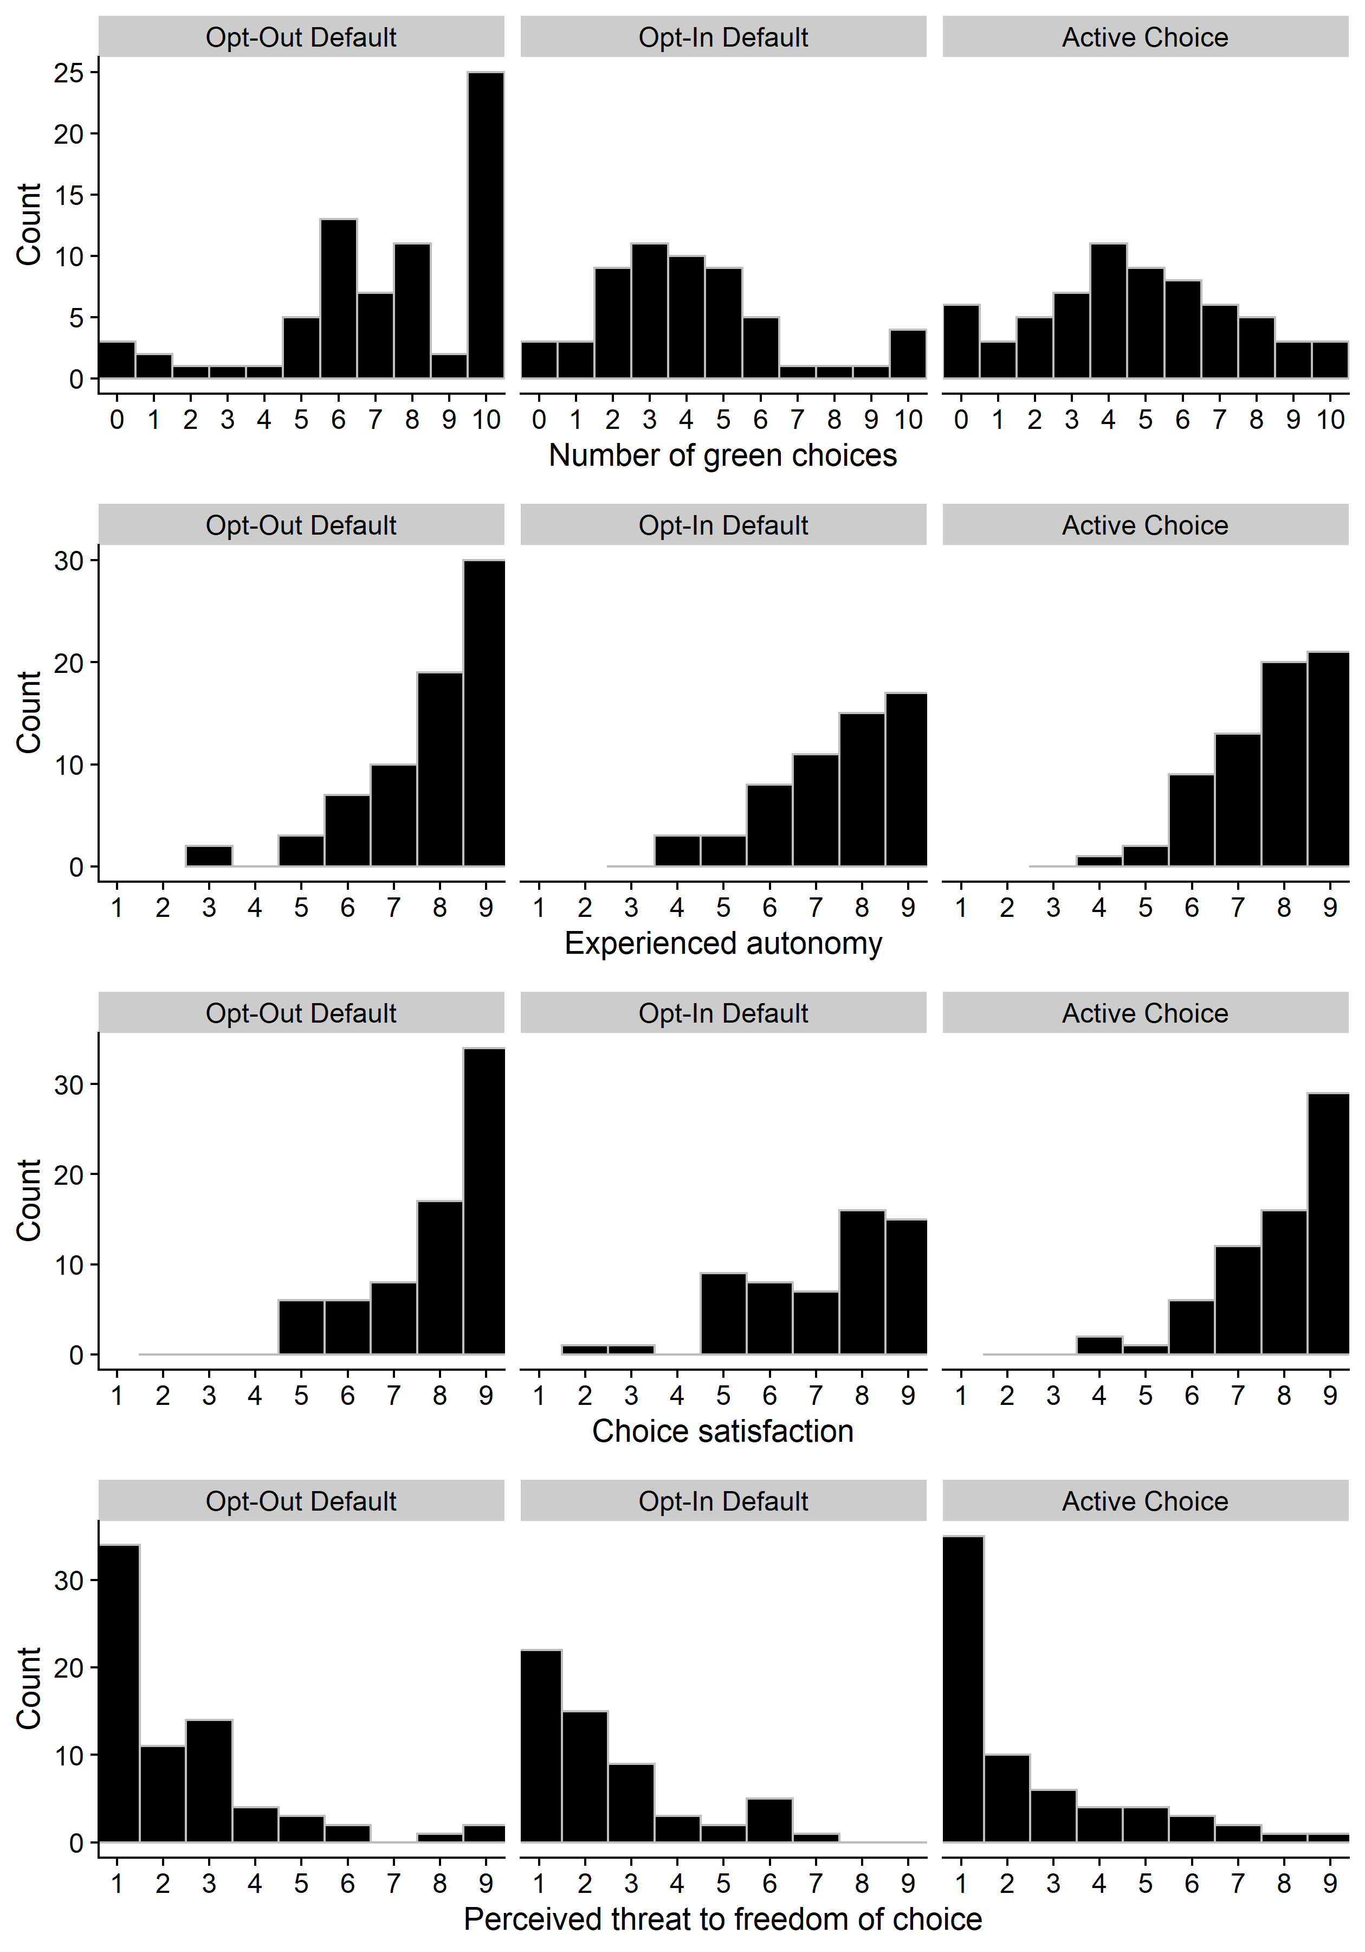
Figure S2. Frequency distributions for all dependent variables in Experiment 2, only undisclosed participants.
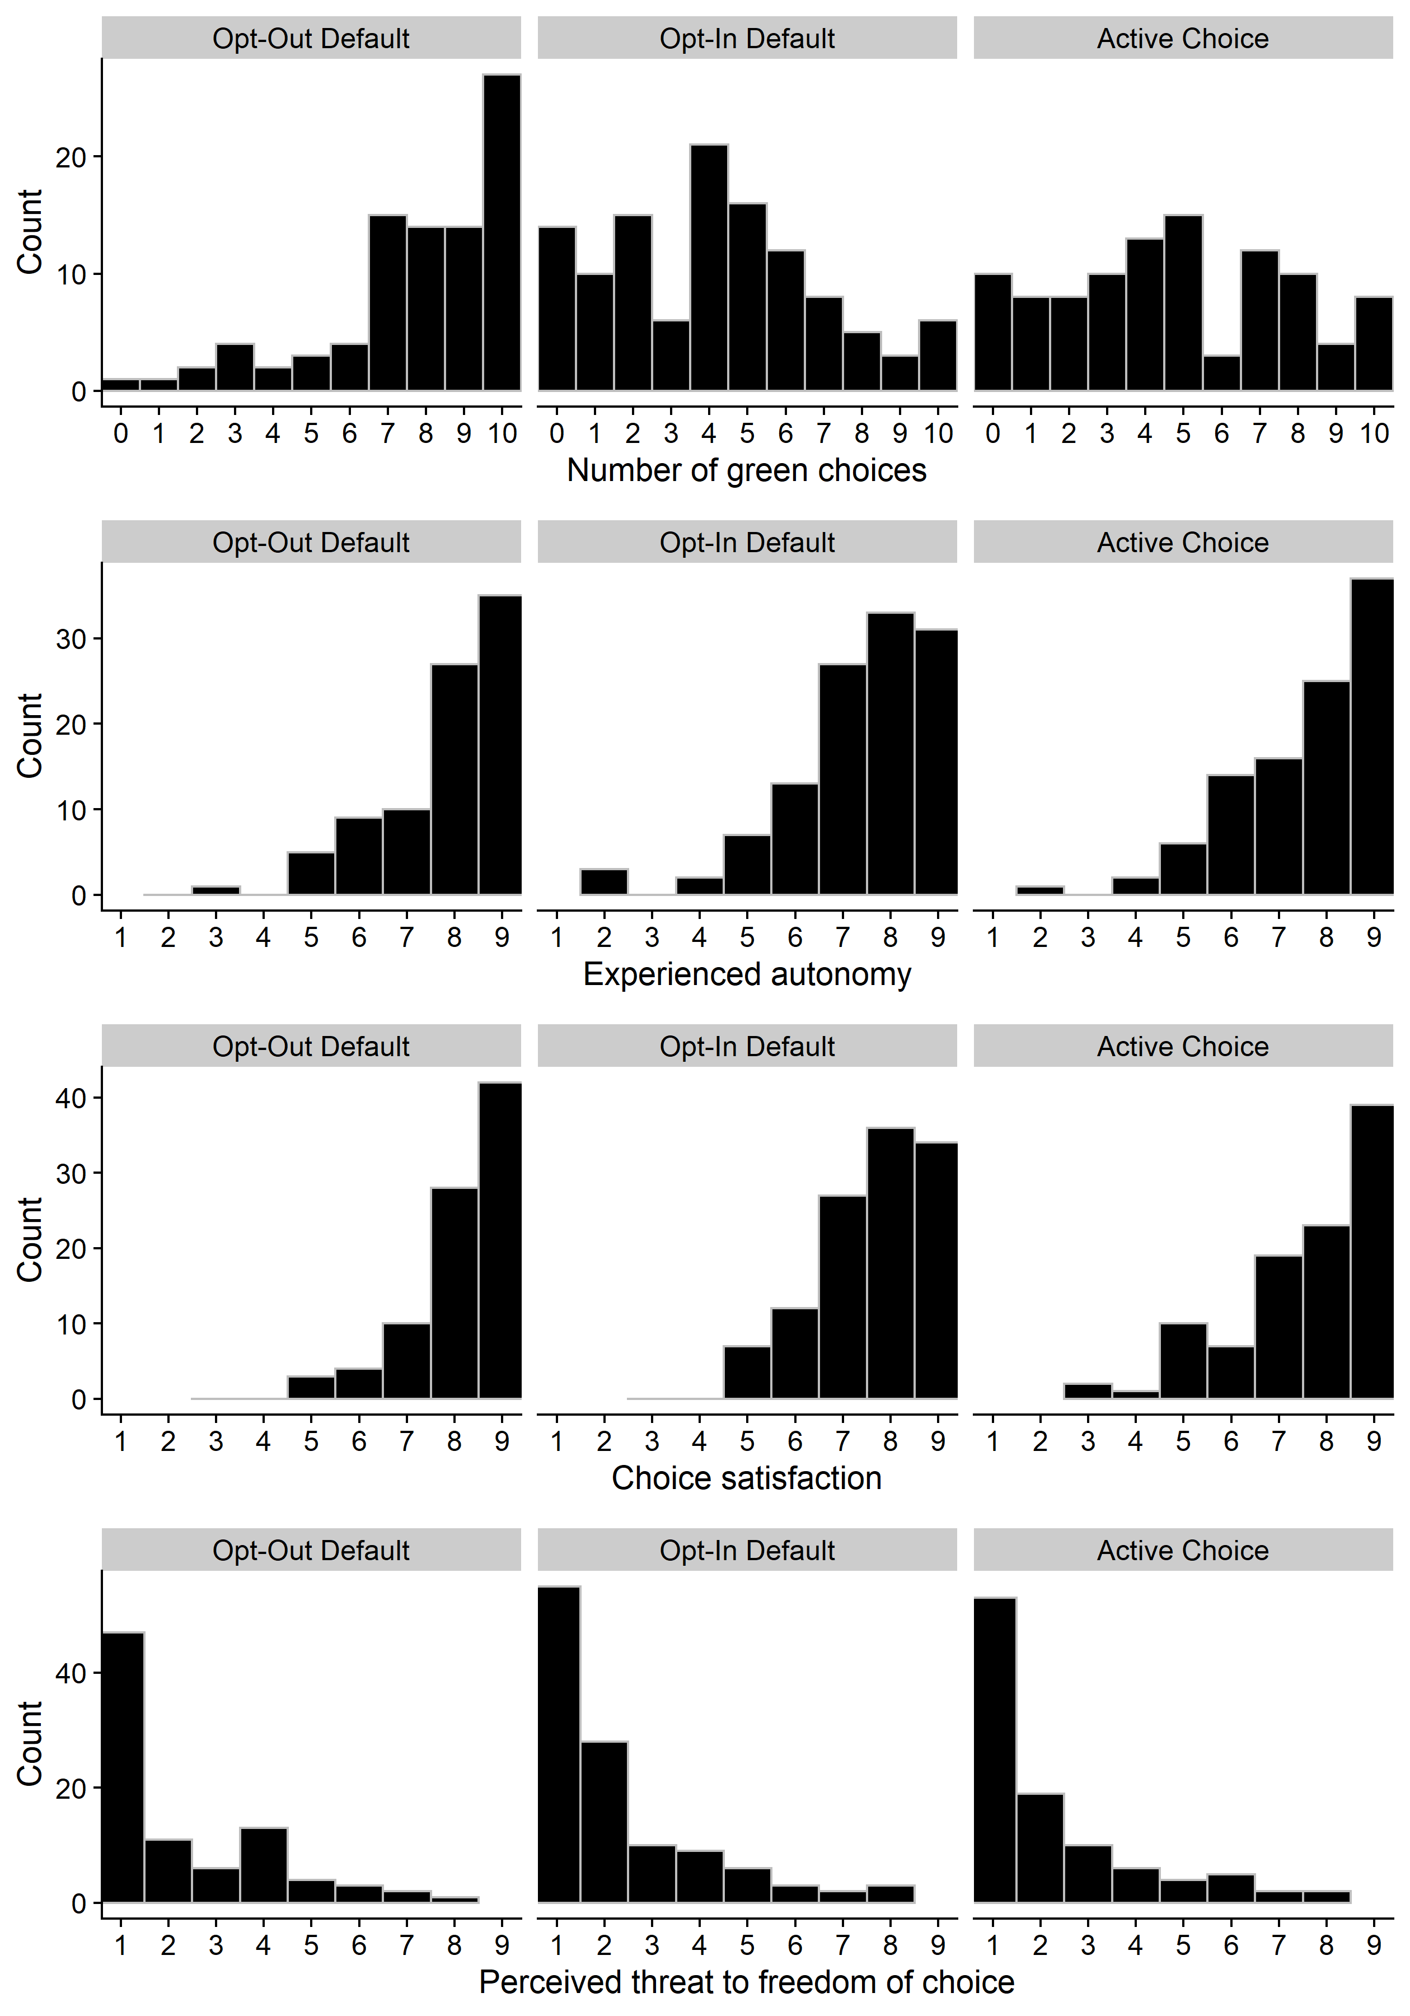
Figure S3. Frequency distributions for all experience and perceptions variables in Experiment 3, only disclosed participants passing the disclosure comprehension check.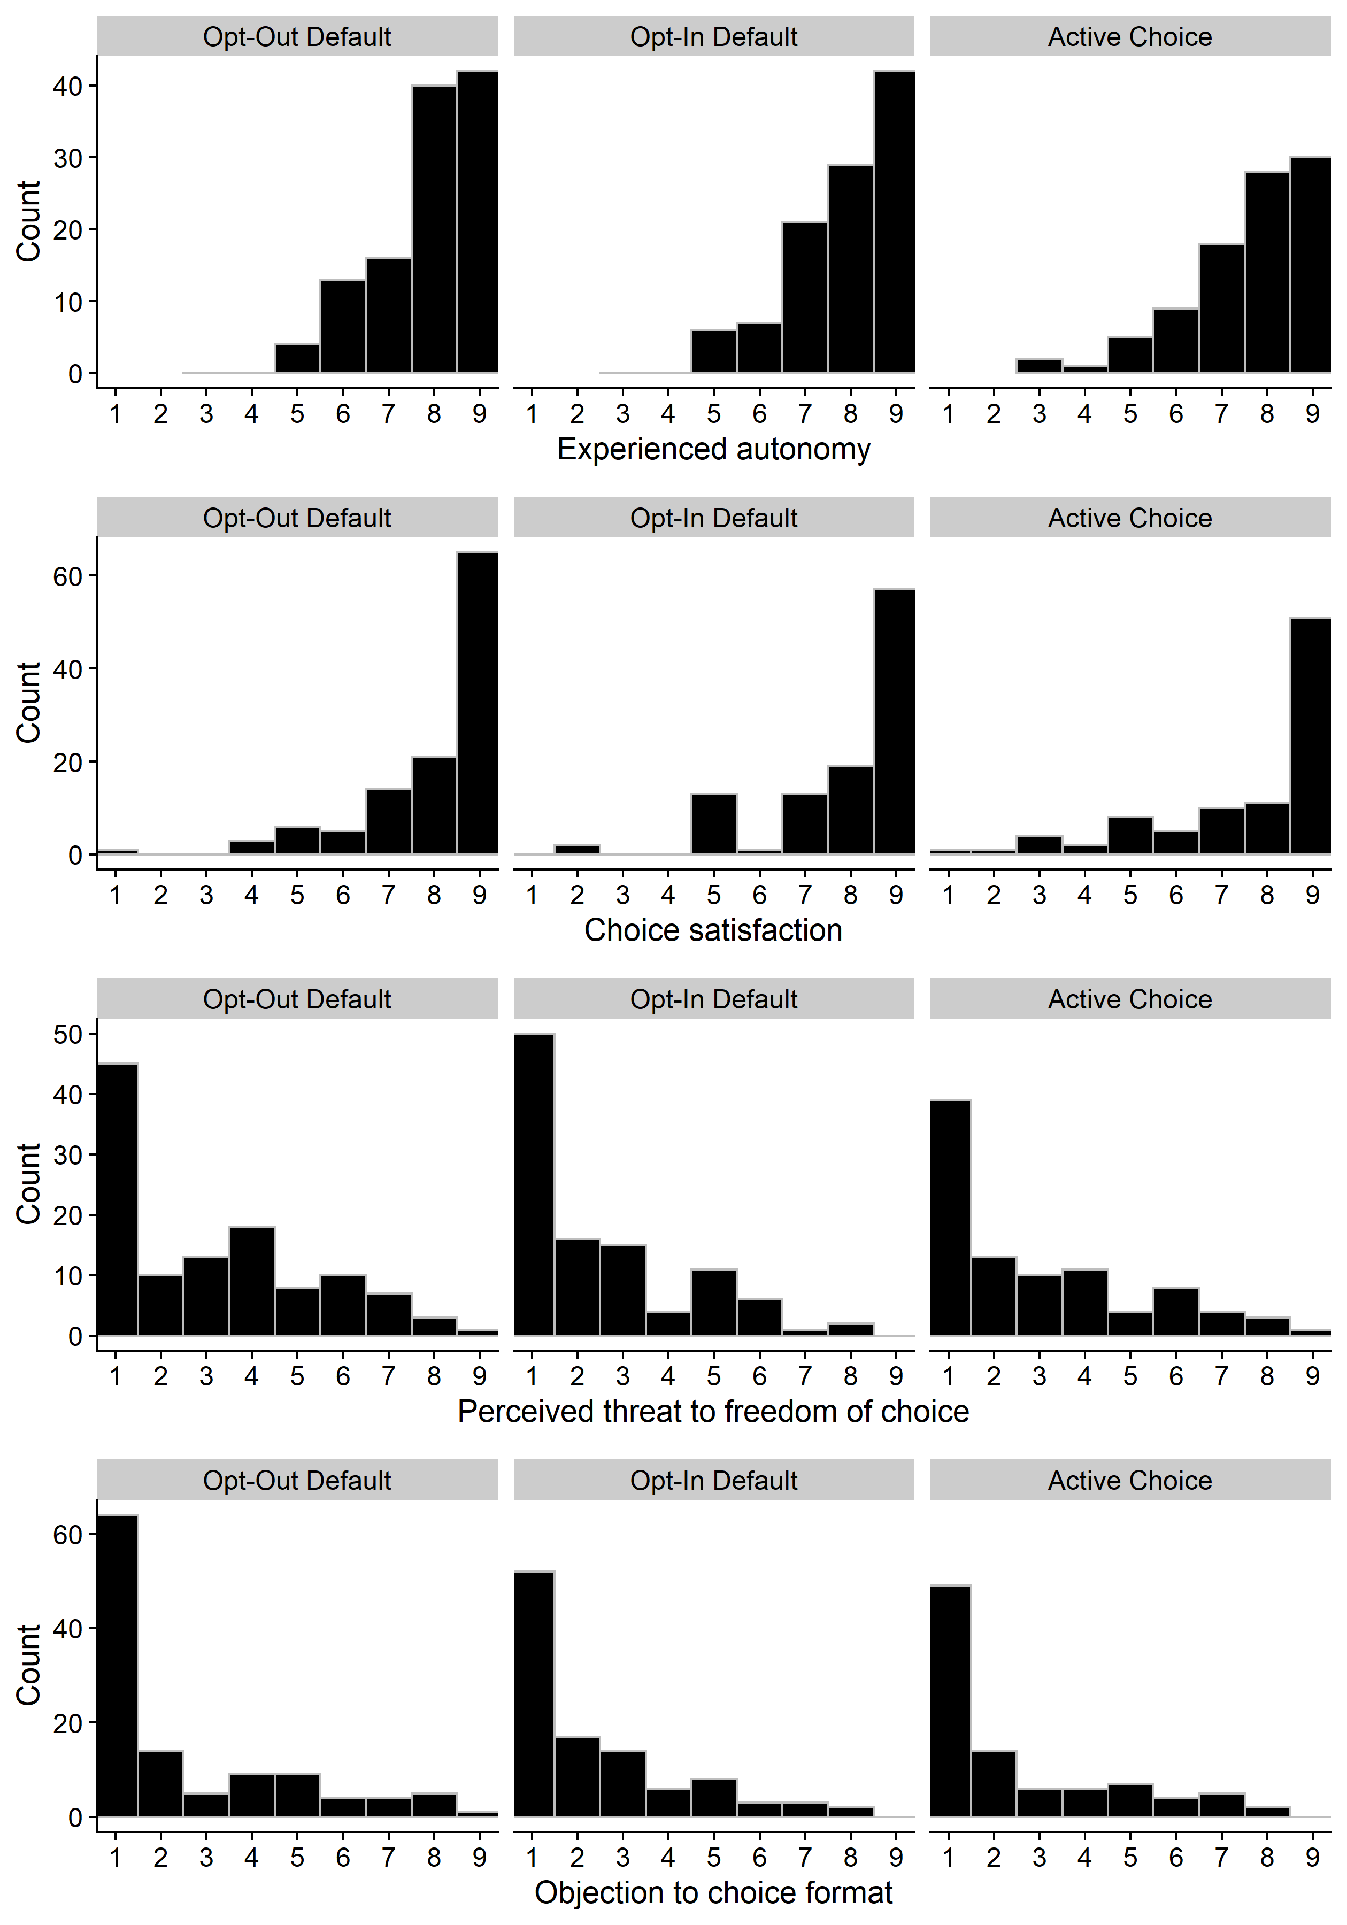
Figure S4. Frequency distributions for all experience and perceptions variables in Experiment 3, only undisclosed participants.
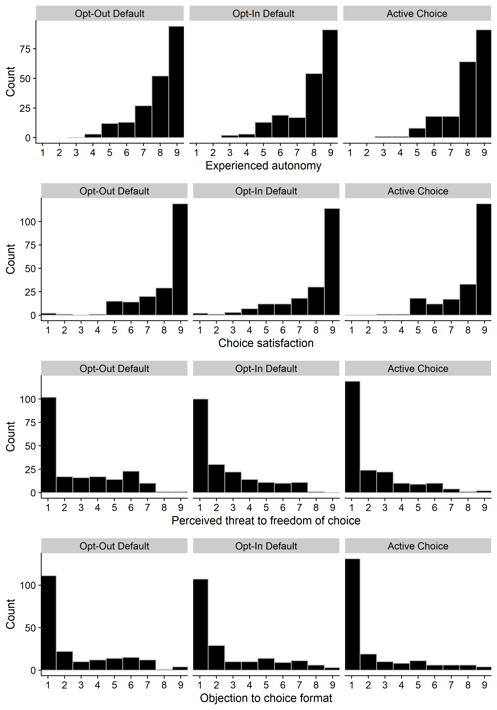
Study 4
Experienced autonomy
Figure S5. Random effects meta-analysis for experienced autonomy. Comparing opt-out default with active choice (left), and opt-out default with opt-in default (right).
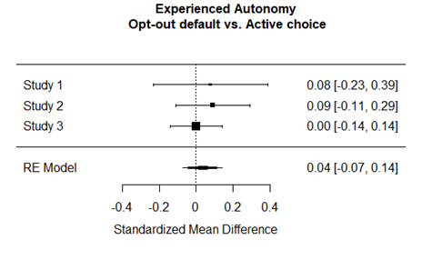 | 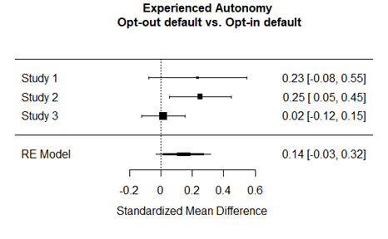

Figure S6. Non-inferiority test for experienced autonomy. Comparing opt-out default with active choice (left), and opt-out default with opt-in default (right).
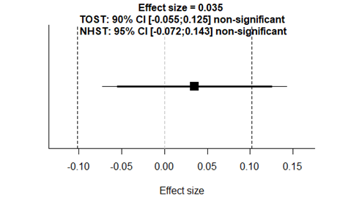 |  | 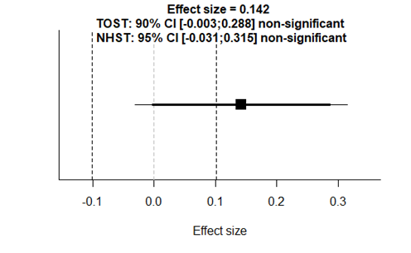

Results Opt-out vs. Opt-in. The non-inferiority test comparing the opt-out default with the opt-in default was significant, Z = 2.75, p = 0.003, given the non-inferiority bound of -0.101. This shows that the autonomy experienced when having been subjected to the opt-out default was not inferior to the autonomy experienced when subjected to the opt-in default. The null hypothesis test was not significant, Z = 1.61, p = 0.108.

Choice-satisfaction
Figure S7. Random effects meta-analyses for choice satisfaction. Comparing opt-out default with active choice (left), and opt-out default with opt-in default (right).

Figure S8. Non-inferiority test for choice-satisfaction. Comparing opt-out default with active choice (left), and opt-out default with opt-in default (right).

Results Opt-out vs. Opt-in. The non-inferiority test comparing the opt-out default with the opt-in default was significant, Z = 3.56, p < 0.001, given the non-inferiority bound of -0.101. This shows that the choice satisfaction experienced when having been subjected to the opt-out default was not inferior to the choice satisfaction experienced when subjected to the opt-in default. The null hypothesis test was significant, Z = 2.37, p = 0.018, showing that the choice satisfaction was significantly higher for participants in opt-out compared to opt-in.

Perceived threat to freedom of choice
Figure S9. Random effects meta-analyses for perceived threat to freedom of choice. Comparing opt-out default with active choice (left), and opt-out default with opt-in default (right).

Figure S10. Inferiority test for perceived threat to freedom of choice. Comparing opt-out default with active choice (left), and opt-out default with opt-in default (right).

Results Opt-out vs. Opt-in. The inferiority test comparing the opt-out default with the opt-in default (right) was not significant, Z = 0.88, p = 0.812, given the inferiority bound of 0.101. This shows that we can not reject that freedom of choice was perceived as only trivially higher by participants in the opt-default condition, compared to participants in the opt-in default condition. The null hypothesis test was significant, Z = 2.74, p = 0.006, which shows that participants in the opt-out condition perceived significantly higher threat to freedom of choice compared to participants in the opt-in condition.

Dependent variables

Choice Study 1 & 2
Scale: 0-10 pro-environmental amenities chosen.
Pro-environmental appliances offered:
- Energy Star furnace and air conditioner ($6 deducted from/added to monthly rent)
- Environmentally friendly radiators ($4 deducted from/added to monthly rent)
- Programmable thermostat ($5 deducted from/added to monthly rent)
- Energy-efficient dishwasher ($5 deducted from/added to monthly rent)
- Insulating windows ($3 deducted from/added to monthly rent)
- Energy-efficient refrigerator and freezer ($7 deducted from/added to monthly rent)
- Energy-efficient washer and dryer ($6 deducted from/added to monthly rent)
- Dimmer switches for indoor lighting ($1 deducted from/added to monthly rent)
- Low-flow toilet ($3 deducted from/added to monthly rent)
- Low-flow faucets and shower heads ($2 deducted from/added to monthly rent)

Choice Study 3
Scale: Dichotomous: keep or donate 20¢ bonus.

Experienced autonomy
- To what extent did you feel in control of your choices of amenities?
- To what extent did you feel your choices of amenities to be thought-through?
- To what extent did you feel that your choices belonged to you?
- To what extent did you feel that your choices reflected your preferences?
- To what extent do you feel that you can "stand for" your choices?
- To what extent do you feel that the choices you ended up making were free from external influence?
Scale: 9-point Likert scale. 1 = not at all, 9 = completely.

Choice-satisfaction
How satisfied are you with your choices of amenities in your new apartment [/your choice of whether or not to donate]?
Scale: 9-point Likert scale. 1 = not satisfied at all, 9 = completely satisfied.

Perceived threat to freedom of choice
"The way in which the choices of amenities [/whether or not to donate] were presented to me...
- ...threatened my freedom to choose what I wanted".
- ...tried to make decisions for me".
- ...tried to manipulate me".
- ...tried to pressure me".
- …made me annoyed". (item only included in Study 2)
Scale: 9-point Likert scale. 1 = do not agree at all, 9 = completely agree.

Objection (Only Study 3)
If at all, to what degree do you object to the way in which the choice options were presented to you?
Scale: 9-point Likert scale. 1 = I do not object at all, 9 = I very strongly object.

Disclosures
The below disclosures were presented to participants within a framed textbox in an attempt to attract participants attention. In Experiment 2 the disclosures were presented in a textbox with white background color and dark blue font. In Experiment 3 the disclosures were presented in a textbox with yellow background color and dark blue font. The below disclosures are presented in the same type face as in the experiments.
Opt-out condition (Experiment 2)
Please note:
When choice options are presented like this (= all green amenitites are included unless you make an active change), it may affect people's choices.
When presented like this, if anything, people may end up with a relatively speakning HIGH number of green amenities.
Opt-in condition (Experiment 2)
Please note:
When choice options are presented like this (= no green amenitites are included unless you make an active change), it may affect people's choices.
When presented like this, if anything, people may end up with a relatively speakning LOW number of green amenities.
Active choice condition (Experiment 2)
Please note:
When choice options are presented like this (= for each amenity you need to actively select Yes or No), it may affect people's choices.
When presented like this, if anything, people may end up with a relatively speakning AVERAGE number of green amenities.
Opt-out condition (Experiment 3)
Please note:
How choice options are presented may affect people’s choices. In the current presentation format one of the options (= to donate the bonus) is pre-selected and will be chosen unless you change it.
Presenting choice options in this way could, relative to other presentation formats, result in a HIGHER likelihood to donate the bonus.
Opt-in condition (Experiment 3)
Please note:
How choice options are presented may affect people’s choices. In the current presentation format one of the options (= to keep the bonus) is pre-selected and will be chosen unless you change it.
Presenting choice options in this way could, relative to other presentation formats, result in a LOWER likelihood to donate the bonus.
Active choice condition (Experiment 3)
Please note:
How choice options are presented may affect people’s choices. In the current presentation format you are required to actively select one of the options for a choice to be made.
Presenting choice options in this way could, relative to other presentation formats, result in a MODERATE likelihood to donate the bonus.

Comprehension and attention checks
Choice format comprehension check (Experiment 1)
[The correct answer for each condition is inside the parentheses next to the choice option]
This question is included here to make sure that all participants were able to understand our survey instructions as intended.
On the page where you made choices of apartment amenities, which alternative below best fits the instruction you received?
- I could check a box next to a specific "green" amenity to INCLUDE it in my apartment (correct for opt-in condition)
- I could check a box next to a specific "green" amenity to NOT INCLUDE it in my apartment (correct for opt-out condition)
- I could check one of two boxes next to a specific "green" amenity to indicate whether I wanted it or not (correct for active choice condition)
Choice format comprehension check (Experiment 2)
[The correct answer for each condition is inside the parentheses next to the choice option]
This question is included here to make sure that all participants were able to understand our survey instructions as intended.
On the page where you made choices of apartment amenities, which alternative below best fits the instruction you received?
- There was only one box next to each amenity in the list, I could check it to ADD the green version of it to my apartment (correct for opt-in condition)
- There was only one box next to each amenity in the list, I could check it to REMOVE the green version of it from my apartment (correct for opt-out condition)
- There were two boxes next to each amenity in the list, I could check one of the two boxes indicate whether I wanted the green version of the amenity or not (correct for active choice condition)
Disclosure comprehension check (Experiment 2)
[This question was only shown to participants receiving a disclosure. The correct answer for each condition is inside the parentheses next to the choice option]
On the same page a text box informed you of the choice presentation format possibly affecting people in a certain direction.
Did it inform you that the presentation format could influence in the direction of a low, average, or high amount of green amenities chosen?
- Low amount of green amenities chosen (correct for opt-in condition)
- Average amount of green amenities chosen (correct for active choice condition)
- High amount of green amenities chosen (correct for opt-out condition)
Disclosure comprehension check (Experiment 3)
[This question was only shown to participants receiving a disclosure]
PLEASE ANSWER THIS QUESTION CAREFULLY
What did the colored text box convey information about?
Please select the option that best describes that information:
- Goteborg University's online survey policy
- The likelihood of mTurkers to donate to charity
- How options are presented may affect people's choices (correct answer)
- Further information about the charity organization

Attention check (Experiment 1)
My answers to these questions are attentive (Then please only tick the alternative second from the left!)
Scale: 9-point Likert scale. Second point was the correct answer for the attention check.
Attention check (Experiment 1 & 2)
How many of the 10 environmentally friendly amenities did you choose to include in your apartment? (If you are not certain, make a best estimate.)
Scale: 0-10 amenities.
Attention check (Experiment 3)
To ensure that our instructions on the previous page were clear to everyone:
Did you choose to keep or donate your 20¢ bonus?
- I chose to DONATE my 20¢ bonus to hurricane relief
- I chose to KEEP my 20¢ bonus

