APPENDIX S1: Attrition

Variables | Attrition=0 | Attrition=1 | Difference | p-value
Use latrine | 0.758 | 0.693 | 0.065 | 0.264
 | (0.027) | (0.056) | (0.058)
Social norms (SN+SE) | -0.057 | 0.217 | -0.274 | 0.133
 | (0.081) | (0.139) | (0.165)
SN: Pro-latrine use | -0.067 | 0.229 | -0.296 | 0.158
 | (0.081) | (0.140) | (0.165)
SE: Pro-latrine use | 0.026 | -0.064 | 0.090 | 0.666
 | (0.084) | (0.125) | (0.166)
HH Income / Month | 10291 | 15223 | -4932 | 0.090
 | (939) | (2878) | (2323)
Age | 41.2 | 46.2 | -5.0 | 0.000
 | (1.4) | (2.2) | (2.8)
Education (Highest level) | 4.712 | 4.875 | -0.163 | 0.187
 | (0.161) | (0.334) | (0.344)
Male | 58.3% | 93.8% | -35.4% | 0.000
 | (0.040) | (0.035) | (0.074)
Household size | 7.9 | 8.2 | -0.3 | 0.005
 | (0.358) | (0.520) | (0.814)
N | 156 | 48 | 204

Standard errors in brackets

APPENDIX S2: Theory of Change

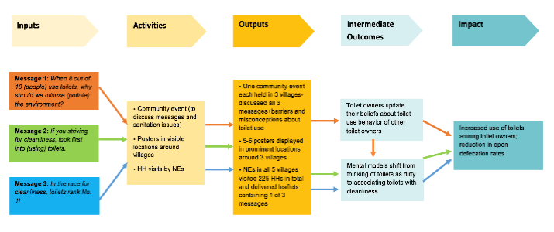

Appendix S3. Full Results (Difference in Means)

VARIABLE | Group | n | Baseline | Endline | T-test for difference of means
 |  |  |  |  | Difference | t | df | p-value
Latrine use | Control | 16 | 0.80  (0.07) | 0.81  (0.08) | 0.02  (0.08) | 0.1939 | 15 | 0.8489
 | NE | 53 | 0.79  (0.04) | 0.88  (0.04) | 0.08***  (0.03) | 3.1574 | 52 | 0.0026
 | Mass comm. | 87 | 0.73  (0.04) | 0.81  (0.03) | 0.08***  (0.03) | 3.0506 | 86 | 0.0030
SE: Latrine use | Control | 16 | 0.45  (0.07) | 0.39  (0.06) | 0.06  (0.06) | 1 | 15 | 0.3332
 | NE | 53 | 0.42  (0.03) | 0.43  (0.03) | 0.02  (0.03) | 0.5737 | 52 | 0.5687
 | Mass comm. | 87 | 0.35  (0.03) | 0.45  (0.03) | 0.11***  (0.03) | 3.3406 | 86 | 0.0012
PB: Pro-latrine | Control | 16 | 0.67  (0.06) | 0.78  (0.06) | 0.11*  (0.06) | 2.0676 | 15 | 0.0564
 | NE | 53 | 0.69  (0.03) | 0.90  (0.03) | 0.22***  (0.03) | 6.5860 | 52 | 0.0000
 | Mass comm. | 87 | 0.58  (0.03) | 0.74  (0.03) | 0.16***  (0.03) | 5.2510 | 86 | 0.0000
SN: Pro-latrine | Control | 15 | 0.67  (0.07) | 0.79  (0.06) | 0.12  (0.05) | 2.5463 | 14 | 0.0233
 | NE | 52 | 0.62  (0.04) | 0.79  (0.03) | 0.18***  (0.04) | 4.4327 | 51 | 0.0000
 | Mass comm. | 86 | 0.50  (0.03) | 0.69  (0.03) | 0.18***  (0.03) | 5.7268 | 85 | 0.0000
PB: OD is bad | Control | 16 | 0.98  (0.02) | 1  (0.00) | 0.02  (0.02) | 1 | 15 | 0.3332
 | NE | 53 | 0.90  (0.03) | 0.99  (0.01) | 0.09**  (0.03) | 3.4548 | 52 | 0.0011
 | Mass comm. | 87 | 0.75  (0.04) | 0.96  (0.02) | 0.20***  (0.04) | 5.5308 | 86 | 0.0000
SN: OD is bad | Control | 15 | 0.92  (0.05) | 1  (0.00) | 0.08  (0.05) | 1.6846 | 14 | 0.1142
 | NE | 52 | 0.84  (0.04) | 0.98  (0.01) | 0.14***  (0.04) | 3.4378 | 51 | 0.0012
 | Mass comm. | 86 | 0.71  (0.04) | 0.91  (0.02) | 0.21***  (0.04) | 5.3270 | 85 | 0.0000
PB: No exceptions | Control | 16 | 0.48  (0.09) | 0.65  (0.10) | 0.17*  (0.09) | 1.8489 | 15 | 0.0843
 | NE | 53 | 0.55  (0.05) | 0.85  (0.04) | 0.29***  (0.05) | 6.4883 | 52 | 0.0000
 | Mass comm. | 87 | 0.47  (0.04) | 0.61  (0.04) | 0.14***  (0.04) | 3.2631 | 86 | 0.0016
SN: No exceptions | Control | 15 | 0.52  (0.10) | 0.67  (0.10) | 0.15*  (0.07) | 2.0602 | 14 | 0.0585
 | NE | 50 | 0.48  (0.06) | 0.68  (0.05) | 0.20***  (0.05) | 3.8781 | 49 | 0.0003
 | Mass comm. | 86 | 0.38  (0.04) | 0.55  (0.04) | 0.17***  (0.05) | 3.6746 | 85 | 0.0004
PB: Latrine not impure | Control | 16 | 0.50  (0.13) | 0.65  (0.12) | 0.16  (0.13) | 1.2322 | 15 | 0.2369
 | NE | 53 | 0.63  (0.07) | 0.86  (0.05) | 0.23***  (0.08) | 2.9919 | 52 | 0.0042
 | Mass comm. | 86 | 0.55  (0.05) | 0.72  (0.05) | 0.16***  (0.06) | 2.6925 | 85 | 0.0085
SN: Latrine not impure | Control | 15 | 0.57  (0.13) | 0.73  (0.12) | 0.17  (0.11) | 1.4349 | 14 | 0.1733
 | NE | 49 | 0.52  (0.07) | 0.62  (0.07) | 0.09  (0.08) | 1.2196 | 48 | 0.2286
 | Mass comm. | 85 | 0.55  (0.05) | 0.72  (0.04) | 0.18***  (0.06) | 2.8511 | 84 | 0.0055

Appendix S4. Informational materials presented to villages

