Appendix A: hypothetical insurance scenarios
The hypothetical scenarios presented to respondents in each of the four Treatment and Control groups are presented below. After being presented with one of the scenarios below, respondents are each asked the following three questions:
- Consider an annual insurance policy with a coverage amount of $75,000. What do you believe is the monthly cost for such a policy?
- Would you be interested in purchasing an annual flood insurance policy for your Coastalville home?
- As a Coastalville homeowner, what is the highest amount you would be willing to pay per month to purchase an annual insurance policy with a coverage amount of $75,000?
Control condition
Respondents in the Control condition are presented with the following hypothetical scenario:
We will now ask you to consider a hypothetical scenario and then indicate your interest in different insurance policies that cover damages due to coastal flooding. Imagine the following scenario:
Coastal Area: You currently own a standalone home in Coastalville, which is located in a floodplain in the coastal USA. The total value of your home is estimated to be $300,000. There is a 1% chance, in any given year, that you will experience flooding resulting in approximately $75,000 worth of damages.
An annual insurance policy that will cover the cost of damages associated with severe flooding is available in exchange for a monthly payment. An insurance policy’s ‘coverage amount’ indicates the maximum monetary amount you can be reimbursed under the policy.
Treatment 1
Before being presented with the hypothetical scenario, respondents in Treatment 1 are provided with the following information:
We will now ask you to consider a hypothetical scenario and then indicate your interest in different insurance policies that cover damages due to coastal flooding. Before we do so, we would like to provide you with some information on the principles of probability that may prove useful as you think through the questions in this section.
It is often helpful to think about the probability of an event occurring as the frequency with which that event will occur in the long run. For example, the probability of landing on ‘heads’ when tossing a fair coin is 50%, or 1/2. We can interpret this probability as implying that in a large number of tosses – say, 100 tosses – the frequency with which ‘heads’ actually occurs will be approximately 1/2: for each toss resulting in ‘heads’, we expect a toss to result in ‘tails’. Thus, flipping our fair coin 100 times, we expect the coin to land on ‘heads’ approximately 50 times and ‘tails’ approximately 50 times.
This interpretation of probability applies not only to coin flips, but also to a wide array of problems that individuals face on a regular basis. An easy rule for converting probabilities to expected long-run frequencies is to convert the probability from a percentage or fraction to a frequency by multiplying the given probability by 100. This allows you to estimate the expected number of times an event will occur over 100 iterations. For example, if the probability of your friend not returning the umbrella that you lend him/her is 1%, or 1/100, each time that you do so, then you would expect that if you lend him/her the umbrella 100 times, he/she will not return the umbrella on 1 of those occasions.
Respondents in Treatment 1 are then presented with the following hypothetical scenario:
Imagine the following scenario:
Coastal Area: You currently own a standalone home in Coastalville, which is located in a floodplain in the coastal USA. The total value of your home is estimated to be $300,000. There is a 1% (or 1 in 100) chance, in any given year, that you will experience flooding resulting in approximately $75,000 worth of damages. This implies that across 100 different floodplains in the coastal USA with the same 1% probability of experiencing this type of severe flood, we expect that 1 of those floodplains would experience this type of severe flood in a given year. Similarly, this implies that over the course of 100 years, we expect Coastalville to experience 1 severe flood of this type.
An annual insurance policy that will cover the cost of damages associated with severe flooding is available in exchange for a monthly payment. An insurance policy’s ‘coverage amount’ indicates the maximum monetary amount you can be reimbursed under the policy.
Treatment 2a
Respondents in Treatment 2a are presented with the following hypothetical scenario:
We will now ask you to consider a hypothetical scenario and then indicate your interest in different insurance policies that cover damages due to coastal flooding. Imagine the following scenario:
Coastal Area: You currently own a standalone home in Coastalville, which is located in a floodplain in the coastal USA. The total value of your home is estimated to be $300,000. There is a 1% chance, in any given year, that you will experience flooding resulting in approximately $75,000 worth of damages. While the probability of experiencing a severe flood of this type over the course of a year is relatively low, over the course of 30 years of home ownership, the probability of experiencing a severe flood of this type is approximately 26%.
An annual insurance policy that will cover the cost of damages associated with severe flooding is available in exchange for a monthly payment. An insurance policy’s ‘coverage amount’ indicates the maximum monetary amount you can be reimbursed under the policy.
Treatment 2b
Before being presented with the hypothetical scenario, respondents in Treatment 2b are provided with the following information:
We will now ask you to consider a hypothetical scenario and then indicate your interest in different insurance policies that cover damages due to coastal flooding. Before we do so, we would like to provide you with some information about coastal flooding that may prove useful as you think through the questions in this section.
In the USA, more than 8.6 million Americans live in areas susceptible to coastal flooding, with more than $1 trillion of property and structures located within just a few feet of current sea level. Moreover, the problem of coastal flooding is expected to worsen as the sea level rises and major storm events intensify due to climate change. By 2050, experts predict that a majority of US coastal areas are likely to be threatened by 30 or more days of flooding each year. Higher sea levels and more intense storms will contribute to more damaging flooding events like Hurricanes Harvey and Irma, which made landfall in Texas and Florida, respectively, during the 2017 hurricane season. In total, the 2017 hurricane season was the costliest on record, with total damages of at least $282 billion.
The above information is also accompanied by the following photographs:
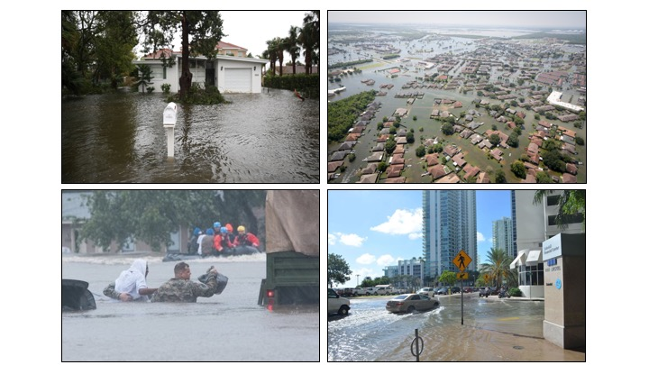
Respondents in Treatment 2b are then presented with the same hypothetical scenario as that shown to respondents in Treatment 2a.

Appendix B: motivation elicitation
Following the WTP elicitation, respondents were then asked to consider the hypothetical scenario (varying by treatment status; see Appendix A) and indicate their level of agreement or disagreement with the following statements:
- [Situational] If I lived in Coastalville, then I would worry about the possibility of experiencing flooding.
- [Situational] If I lived in Coastalville, then I would make sure that I am prepared for possible flooding.
- [Global] A safe environment is important to me; I prefer to avoid risky situations and I prefer to protect myself from natural hazards.
- [Global] Financial security is important to me.

Appendix C: estimation method
Respondents are asked to report their maximum WTP for an annual flood insurance policy in a hypothetical scenario on a continuous sliding scale from $0/month to $125/month. The resulting positive, continuous measure of respondents’ WTP is therefore censored from below and above by 0 and 125, respectively. Thus, $WTP_{i}$ given by equation (7) is treated as an unobserved latent variable. Instead, draws of censored data $(WTP_{i}^{*},X_{i},D_{i},C_{I},P_{i},T_{i})$ are observered. $WTP_{i}^{*}$ is characterized by:
$\begin{matrix}WTP_{i}^{*}=\left\{\begin{matrix}0 & \text{ if }WTP_{i}≤0 \\ WTP_{i} & \text{ if }0<WTP_{i}<125 \\ 125 & \text{ if }WTP_{i}≥125\end{matrix}\right.\end{matrix}$ (9)
Thus, for $WTP_{i}∈(0,125)$, the observed $WTP_{i}^{*}$ is given by equation (7). Note that, in the survey instrument employed herein, there is no heterogeneity in $D_{i}$ and $P_{i}$, so these are not included in the estimation of equation (7) since they are captured by the inclusion of a constant term. Given the structure of equation (9), the two-limit Tobit model is employed. Define:
$\begin{matrix}Z_{i}=\left[\begin{matrix}1 & X_{i} & C_{i} & T_{i}\end{matrix}\right] & & β={\left[\begin{matrix}β_{0} & β_{1} & {\tilde{β}}_{3} & γ\end{matrix}\right]}^{T}\end{matrix}$ (10)
It can be shown that:
$\text{Pr}\{WTP_{i}^{*}=0|Z_{i}\}=Φ\left(\frac{-Z_{i}β}{σ_{ϵ}}\right)$ (11)
$\text{Pr}\{WTP_{i}^{*}∈(0,125)|Z_{i}\}=Φ\left(\frac{Z_{i}β}{σ_{ϵ}}\right)$ (12)
$\text{Pr}\{WTP_{i}^{*}=125|Z_{i}\}=Φ\left(\frac{-(125-Z_{i}β)}{σ_{ϵ}}\right)$ (13)
where $Φ(⋅)$ is the standard normal cumulative density function. It follows that the log-likelihood for a random draw $i$ is:
$\begin{matrix}\text{log}f\left(WTP_{i}^{*} | Z_{i};β\right) & =1\{WTP_{i}^{*}=0\}\text{log}\left[Φ\left(\frac{-Z_{i}β}{σ_{ϵ}}\right)\right] \\ & + 1\{WTP_{i}^{*}=125\}\text{log}\left[Φ\left(\frac{-\left(125-Z_{i}β\right)}{σ_{ϵ}}\right)\right] \\ & + 1\{WTP_{i}^{*}∈\left(0,125\right)\text{\}}\text{log}\left[\frac{1}{σ_{ϵ}}ϕ\left(\frac{WTP_{i}^{*}-Z_{i}β}{σ_{ϵ}}\right)\right]\end{matrix}$ (14)
where $ϕ(⋅)$ is the standard normal probability density function. The two-limit Tobit model maximizes the log-likelihood function for the sample:
$\begin{matrix}\hat{β}=\text{arg}\underset{β}{\text{max}}\frac{1}{N}\sum_{i=1}^{N}{\text{log}}f(WTP_{i}^{*}|Z_{i};β)\end{matrix}$ (15)
It follows that:
$\begin{matrix}E[WTP_{i}^{*}|Z_{i},WTP_{i}^{*}∈(0,125)]=Z_{i}β+σ\left[\frac{ϕ\left(\frac{-Z_{i}β}{σ_{ϵ}}-ϕ\left(\frac{-Z_{i}β}{σ_{ϵ}}\right)\right)}{Φ\left(\frac{125-Z_{i}β}{σ_{ϵ}}-Φ\left(\frac{-Z_{i}β}{σ_{ϵ}}\right)\right)}\right]\end{matrix}$ (16)
and the unconditional expectation of $WTP_{i}^{*}$ is given by:
$\begin{matrix}E[WTP_{i}^{*}|Z_{i}] & =\text{Pr}\{WTP_{i}^{*}∈(0,125)\}E[WTP_{i}^{*}|Z_{i},WTP_{i}^{*}∈(0,125)] \\ & +125×Φ\left(\frac{-(125-Z_{i}β)}{σ_{ϵ}}\right)\end{matrix}$ (17)
The partial effect of covariate $Z^{j}$ simplifies to:
$\begin{matrix}\frac{∂E[WTP^{*}|Z]}{∂Z^{j}}=\left[Φ\left(\frac{125-Zβ}{σ_{ϵ}}-Φ\left(\frac{-Zβ}{σ_{ϵ}}\right)\right)\right]β_{j}\end{matrix}$ (18)
The average partial effects are therefore given as:
$\begin{matrix}APE(Z^{j})=\left(\frac{1}{N}\sum_{i=1}^{N}{\left[Φ\left(\frac{125-Z\hat{β}}{{\hat{σ}}_{ϵ}}-Φ\left(\frac{-Z\hat{β}}{{\hat{σ}}_{ϵ}}\right)\right)\right]}\right){\hat{β}}_{j}\end{matrix}$ (19)
for the continuous regressor $Z^{j}$. The results of the two-limit Tobit model characterized by equation (9) are reported in Table 6.

Appendix D: distribution of WTP by treatment group
The figure below shows the distribution of WTP by treatment/control status (group means shown as vertical dashed lines). Though there is heterogeneity across groups, there is clear left and right censoring at $0/month and $125/month, respectively.
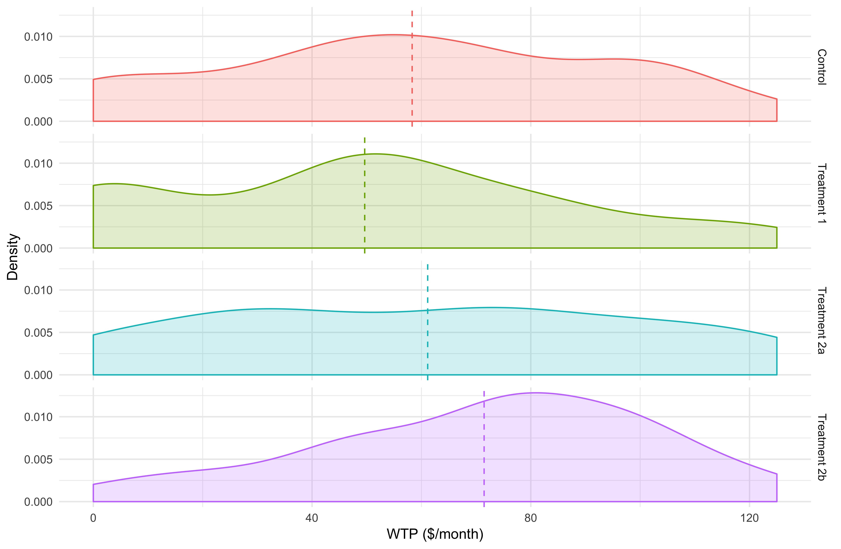

This assumption allows for WTP values that are less than $0/month and greater than $125/month, which, given the data observed, is reasonable. Of course, it is possible that there are valid WTP responses elicited that equal $0 or $125 precisely. However, in the sample used herein, no respondents who indicated interest in purchasing the insurance product indicated a WTP equal to $0.
The Tobit model was first developed by Tobin (1958). Amemiya (1984) provides a useful classification of different forms of the Tobit model. The two-limit Tobit model is a natural extension of the Type I Tobit model to the case of left and right censoring. For a helpful reference on the two-limit Tobit model, see Wooldridge (2010). A sample selection model, such as Heckman’s two-stage estimator, is deemed inappropriate in this setting as: (1) the assumption of negative WTP values and WTP values greater than 125 is reasonable; and (2) those same factors affecting the decision to enter the insurance market explain WTP elicited via the survey and these factors operate in the same direction (Amemiya, 1984). Assuming that agents employ a decision rule for market entrance that states that they will enter the insurance market (i.e., indicate interest in the hypothetical insurance product) if and only if their WTP for insurance is non-negative, then using the Tobit model instead of a sample selection model is reasonable. This decision rule is viewed as reasonable in the current setting.

