**Online Appendices**

**Appendix A: Postcard Intervention in Study I**

**Baseline Treatment**



**Fine treatment**



**Lottery Treatment**



**Lottery Regret Treatment**



**Reminder Treatment**



**Intention Treatment**



**Appendix B: Details of assignment to treatment**

Table B1 presents a breakdown, by university and place of residence, of the subjects assigned to each treatment. As stated in Section 2.3, we randomised assignment to treatment at the building level. For the University of Oxford, all students living in a single college were assigned to the same treatment.

For Oxford Brookes University, all students living in a single hall of residence were assigned to the same treatment, with the exception of two very large halls, Cheney and Clive Booth, which were split into several units of assignment. Cheney and Clive Booth are naturally split into discrete residence blocks, so we subdivided them on this basis, ensuring maximum geographical distance between the subjects in these halls assigned to different treatments. For the purposes of clustering in our regression analysis, each subdivision that we split Cheney and Clive Booth into is treated as one unit of residence.

Beyond balancing assignment at the university level, the randomisation was also subject to the following constraints. Each treatment had to feature a mixture of large and small residence units; we ensured this by splitting the residence units into pools based on size, and assigned one unit from each pool to each treatment. Each treatment also had to feature a mixture of ancient and modern University of Oxford colleges, to the extent that the average college age in all treatments had to be within 200 years. Finally, the total number of subjects assigned to the largest treatment had to be no more than 15% greater than the number assigned to the smallest. We repeated the randomisation until it produced an assignment which met all the above criteria.

We ran regressions to test whether individual characteristics were correlated with treatment assignment. These are reported in Table B2. Model (1) is a logistic regression where the dependent variable is a dummy variable indicating whether an individual attends Oxford Brookes University or Oxford University, while Model (2) is a logistic regression with the dependent variable a dummy variable indicating whether an individual lives in a modern hall/college (i.e. less than 100 years old), and Model (3) is an OLS regression with the dependent variable the size of the residence unit the individual lives in. These variables were regressed against treatment assignment dummies, with Baseline the omitted category. In each regression some of the treatment dummies are significant, indicating that although we applied a randomisation technique particular types of people are significantly more likely to be assigned to some treatments than others. For this reason, it is important that our analysis of treatment effects includes control variables capturing university, hall/college age and residence unit size.

Mailing errors resulted in some subjects not being assigned to the intended treatments (in italics in Table B1). 16 students in Lincoln College were assigned to the Fine treatment, while the other 132 were assigned to the Baseline treatment. As a robustness check, we re-ran our analysis excluding Lincoln from our dataset. All of our results are robust to this exclusion.

**Table B1: Breakdown of treatment assignment by university and college/hall**

|  |  |  |  |  |  |  |  |  |  |
| --- | --- | --- | --- | --- | --- | --- | --- | --- | --- |
| College/hall | Number assigned | Percentage of total assigned to treatment | College/hall | Number assigned | Percentage of total assigned to treatment | College/hall | Number assigned | Percentage of total assigned to treatment | |
| **Baseline** | | | **Lottery** | | | **Intention** | | |
| **University of Oxford**  Keble  Magdalen  St Hugh’s  Lincoln  Corpus Christi  Harris Manchester  All Souls | **889**  206  201  200  132  120  26  4 | **74.52**  17.27  16.85  16.76  11.06  10.06  2.18  0.34 | **University of Oxford**  Worcester  Hertford  Trinity  Oriel  Mansfield  Linacre | **940**  311  236  154  140  74  25 | **75.20**  24.88  18.88  12.32  11.20  5.92  2.00 | **University of Oxford**  Christ Church  New College  Wadham  Castle Mill  Exeter  Brasenose  St. Cross/Brasenose  St. Cross | **947**  199  195  182  160  80  74  29  28 | **75.04**  15.77  15.45  14.42  12.68  6.34  5.86  2.30  2.22 | |
| **Oxford Brookes**  Clive Booth  Paul Kent | **304**  153  151 | **25.48**  12.82  12.66 | **Oxford Brookes**  Clive Booth  Cheney | **310**  162  128 | **24.80**  14.56  10.24 | **Oxford Brookes**  Crescent  Cheney | **315**  212  103 | **24.96**  16.80  8.16 | |
| **Total** | **1193** | **100.00** | **Total** | **1250** | **100.00** | **Total** | **1262** | **100.00** | |
| **Fine** | | | **Lottery Regret** | | | **Reminder** | | |
| **University of Oxford**  St. Catherine’s  Jesus  Pembroke  University College  St. Peter’s  Green Templeton  *Lincoln*  Kellogg  140 Walton Street | **1026**  254  188  188  147  146  71  *16*  11  5 | **75.61**  18.72  13.85  13.85  10.83  10.76  5.23  *1.18*  0.81  0.37 | **University of Oxford**  St. Edmund  Merton  The Queen’s  St. Hilda’s  Nuffield  Wycliffe | **1044**  398  253  209  156  14  14 | **79.27**  30.22  19.21  15.87  11.85  1.06  1.06 | **University of Oxford**  St. Anne’s  Balliol  St. John’s  Somerville  Lady Margaret Hall  Wolfson  *Kellogg* | **979**  216  192  167  164  162  72  *6* | **75.31**  16.62  14.77  12.85  12.62  12.46  5.54  *0.46* |
| **Oxford Brookes**  Clive Booth  Warneford | **331**  187  144 | **24.39**  13.78  10.61 | **Oxford Brookes**  Clive Booth  Cheney | **273**  168  105 | **20.73**  12.76  7.97 | **Oxford Brookes**  Clive Booth  Cheney | **321**  182  139 | **24.69**  14.00  10.69 |
| **Total** | **1357** | **100.00** | **Total** | **1317** | **100.00** | **Total** | **1300** | **100.00** |

**Table B2: Treatment Balance Regressions**

|  |  |  |  |
| --- | --- | --- | --- |
|  | (1) | (2) | (3) |
|  | Brookes  (Logit) | Modern  (Logit) | Hall-size  (OLS) |
|  |  |  |  |
| Fine | 0.931 | 4.492*** | -31.431*** |
|  | (0.083) | (0.374) | (9.752) |
| Lottery | 0.935 | 1.081 | 0.892 |
|  | (0.085) | (0.096) | (9.917) |
| Lottery Regret | 0.752*** | 0.806** | 169.424*** |
|  | (0.069) | (0.074) | (9.809) |
|  |  |  |  |
| Intention | 0.993 | 2.087*** | -44.545*** |
|  | (0.089) | (0.177) | (9.931) |
|  |  |  |  |
| Reminder | 0.925 | 1.247** | -82.802*** |
|  | (0.083) | (0.108) | (9.817) |
|  |  |  |  |
| N | 8397 | 8397 | 8397 |

Notes: Models (1) and (2) report odds ratios from logistic regressions; Model (3) reports coefficients from an OLS regression. An odds ratio greater than 1 implies a positive effect, whereas a ratio smaller than 1 implies a negative effect. In Model (1) the dependent variable is a dummy variable taking the value of 1 if an individual is a student at Oxford Brookes University, and 0 otherwise; in Model (2) it is a dummy variable taking the value of 1 if an individual is resident in a hall/college which is less than 100 years old, and 0 otherwise; in Model (3) it is the size of the residence unit in which an individual lives. The regressions include all students who were assigned to the Baseline, Fine, Lottery and Lottery Regret treatments. Standard errors are reported in parentheses. Significance levels: *** p<0.01, ** p<0.05, * p<0.1

**Appendix C: Duration analysis**

To test the robustness of the results in Table 1 of the main text, for the post-intervention period we use the Cox proportional hazard approach to model the duration until an individual registers. Estimated hazard ratios are reported in Table C1. In line with the results from the logistic regression, we find a positive and significant effect of the Fine dummy: the hazard ratio of 1.655 indicates that the probability of registering on a given date (conditional on not having registered before) is 65.5% larger than in Baseline. The corresponding hazard ratios for the Lottery treatments are negative but not significant. The hazard ratios for the two non-monetary treatments are very close to one and not significant, confirming that they had no additional effect on registration rates relative to our baseline treatment.

**Table C1: Duration analysis**

|  |  |
| --- | --- |
| Dependent variable | Duration to registration after Intervention (Mar 9 – Apr 20) |
|  |
|  |  |
| Fine | 1.655*** |
|  | (0.306) |
| Lottery | 0.737 |
|  | (0.214) |
| Lottery Regret | 0.832 |
|  | (0.205) |
|  |  |
| Intention | 1.008 |
|  | (0.189) |
|  |  |
| Reminder | 1.026 |
|  | (0.180) |
| Controls | Yes |
| *N* | 7679 |

*Notes*: The table reports hazard ratios from a Cox proportional hazard model. A ratio greater (smaller) than 1 implies a positive (negative) effect. Robust standard errors, clustered on residence, in parentheses. Significance levels: *** p<0.01, ** p<0.05, * p<0.1

**Appendix D: Screenshots of Study II**

**Screen 1:**

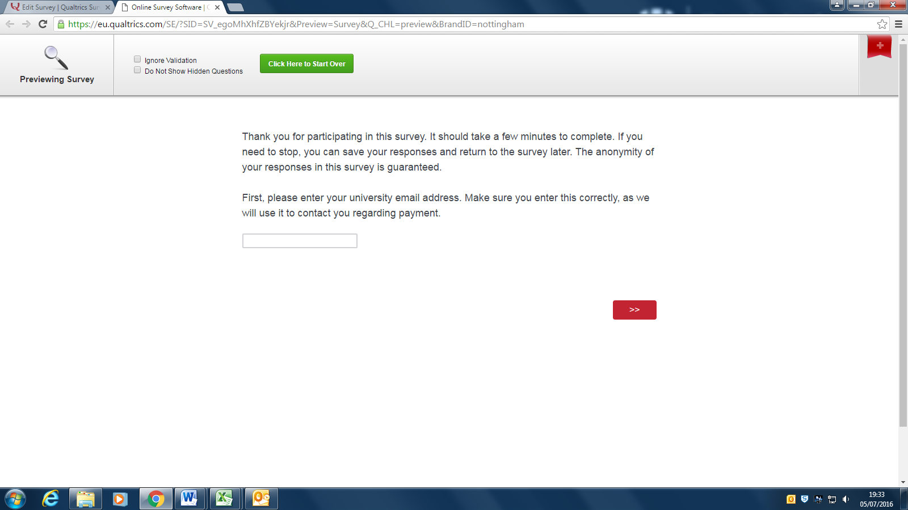

**Screen 2:**

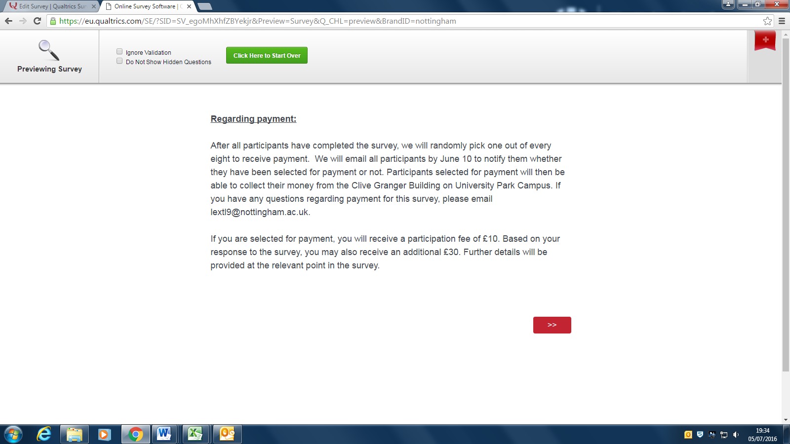

**Screen 3:**

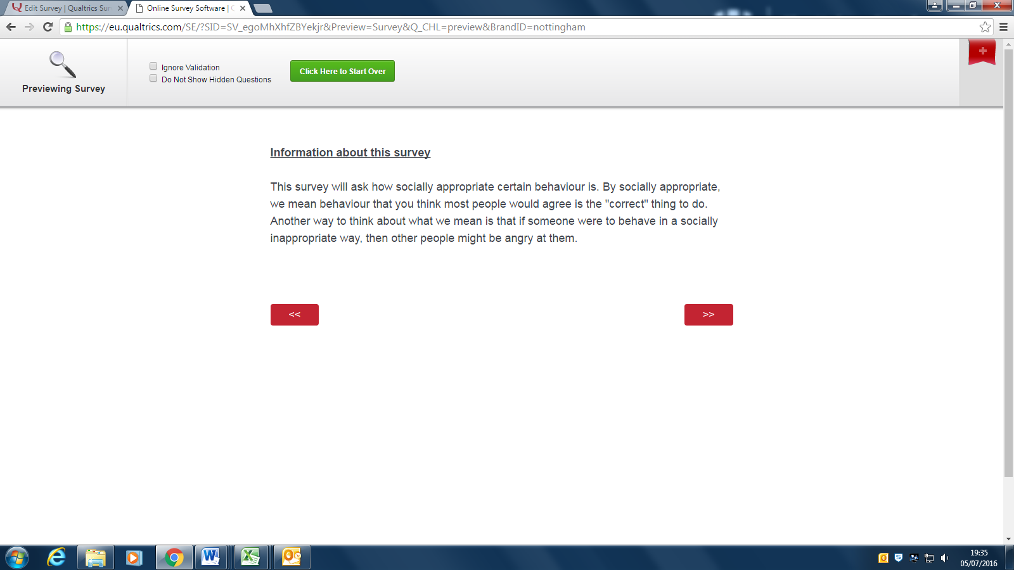

**Screen 4:**

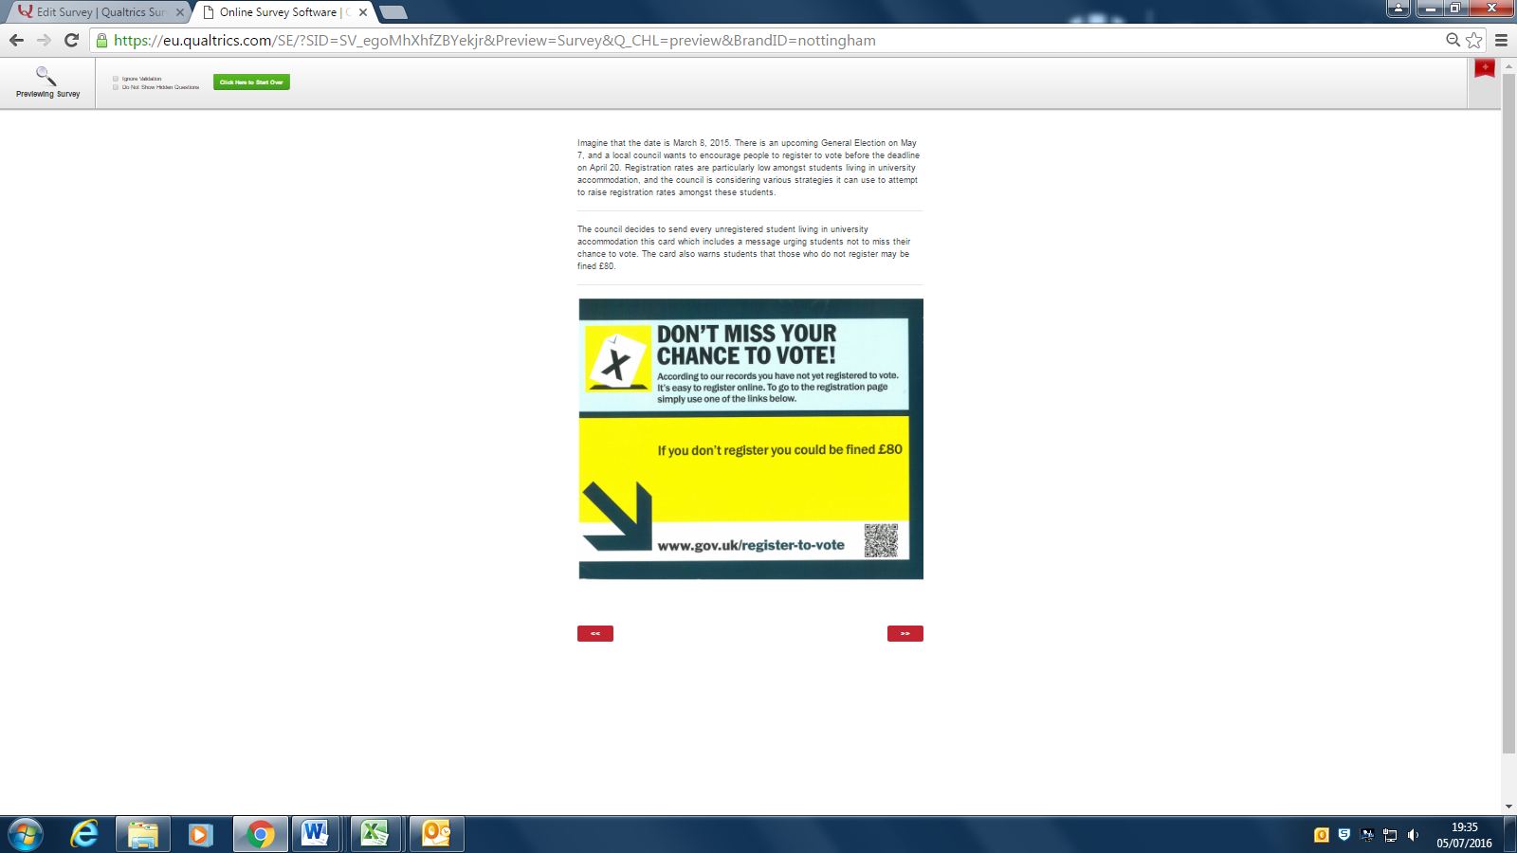

**Screen 5:**

