Figure S1
Timeline of Experimental Procedure from January 2015 to May 2016
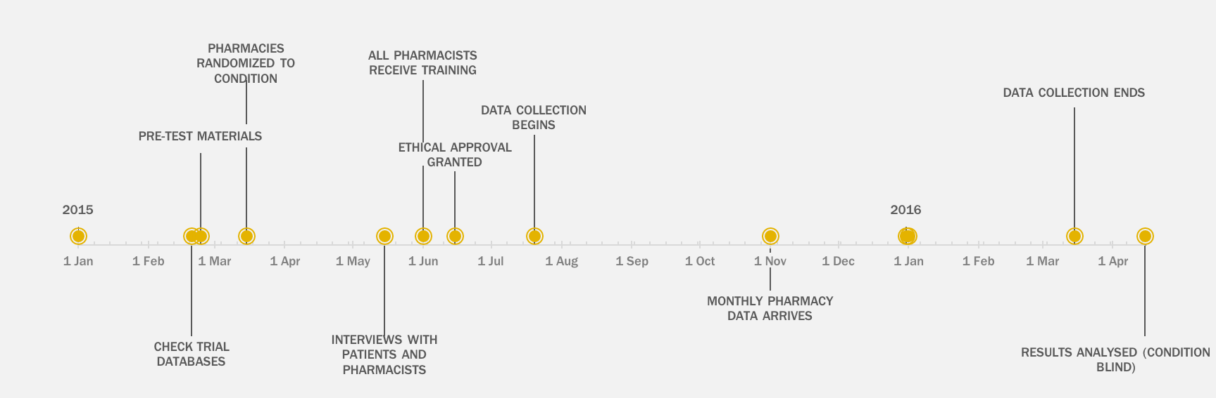

Table S1
Logistic Regression Predicting Individual Medication Adherence Scale Items
 | Model 1: Forget |  |  |  | Model 2: Careless |  |  |  | Model 3: Feel Better |  |  |  | Model 4: Feel Worse
 | OR | CI_{95%} |  | z | OR | CI_{95%} |  | z | OR | CI_{95%} |  | z | OR | CI_{95%} |  | z
Intercept | 6.79 | 4.90 | 9.42 | 11.47*** | 15.12 | 10.29 | 22.21 | 13.84*** | 7.89 | 5.17 | 12.04 | 9.58*** | 10.28 | 6.92 | 15.26 | 11.54***
Personal Health Costs | 1.60 | 1.12 | 2.29 | 2.56* | 1.78 | 1.21 | 2.62 | 2.93*** | 2.10 | 1.47 | 3.01 | 4.04*** | 2.11 | 1.38 | 3.21 | 3.47***
Age | 1.01 | 1.00 | 1.01 | 2.00† | 1.01 | 1.00 | 1.01 | 2.15* | 1.00 | 1.00 | 1.01 | 1.12 | 1.01 | 1.00 | 1.02 | 3.46***
Male | 1.01 | 0.88 | 1.16 | 0.15 | 0.99 | 0.82 | 1.20 | -0.08 | 1.03 | 0.89 | 1.18 | 0.34 | 1.09 | 0.93 | 1.28 | 1.04
Deprivation | 1.00 | 0.93 | 1.07 | -0.10 | 0.94 | 0.87 | 1.01 | -1.80† | 0.98 | 0.90 | 1.06 | -0.62 | 0.99 | 0.92 | 1.07 | -0.22
Asthma | 0.88 | 0.72 | 1.06 | -1.37 | 0.86 | 0.68 | 1.09 | -1.25 | 0.95 | 0.79 | 1.14 | -0.56 | 0.44 | 0.34 | 0.58 | -6.01***
Anti-platelet | 1.01 | 0.75 | 1.37 | 0.08 | 0.93 | 0.57 | 1.52 | -0.28 | 1.14 | 0.79 | 1.64 | 0.69 | 1.02 | 0.67 | 1.54 | 0.09
Type-2 Diabetes | 1.16 | 0.96 | 1.41 | 1.50 | 1.25 | 0.93 | 1.67 | 1.50 | 0.97 | 0.79 | 1.20 | -0.26 | 1.16 | 0.88 | 1.53 | 1.05
Note. † p = .1, * p = .05, ** p = .01, *** p = .001. Standard errors are clustered at the pharmacy level. The reference group for the personal health costs condition is an indicator variable comprising the mean for all three comparison groups. The reference group for illness type is hypertension, the largest group.

