Online Appendix A. Facebook Ads for July 2016 Experiment

Control: Generic Message “Start preparing for retirement today”
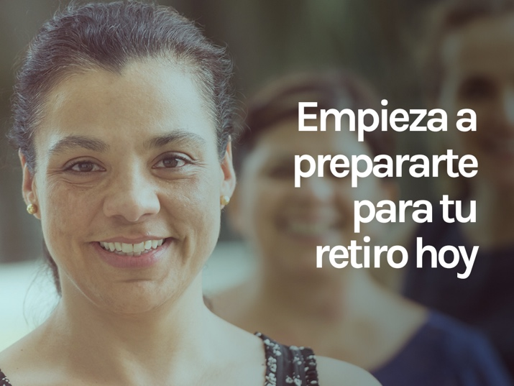

Treatment 1: “Many Hispanic women like you have a plan for retirement”

Treatment 2: “Having a plan for retirement protects me and my family”
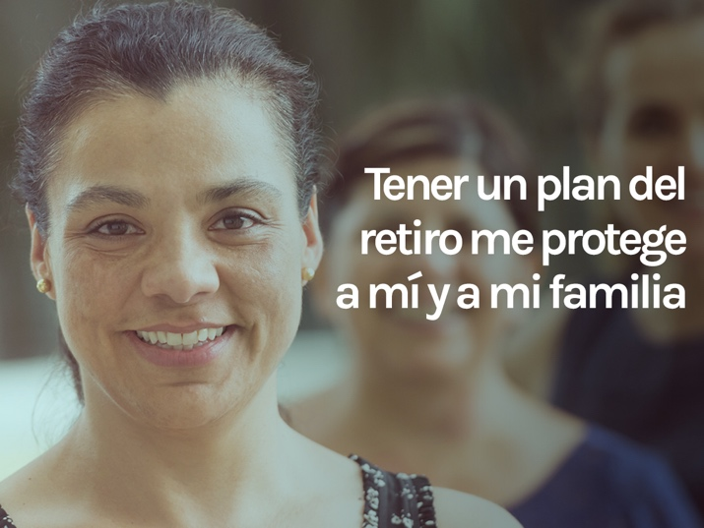

Online Appendix B. Facebook Ads for April 2018 Experiment

Control: Generic Message “Start preparing for retirement today”

Treatment 1: “Many Hispanic women like you have a plan for retirement”

Treatment 2: “Having a plan for retirement protects you and your family”
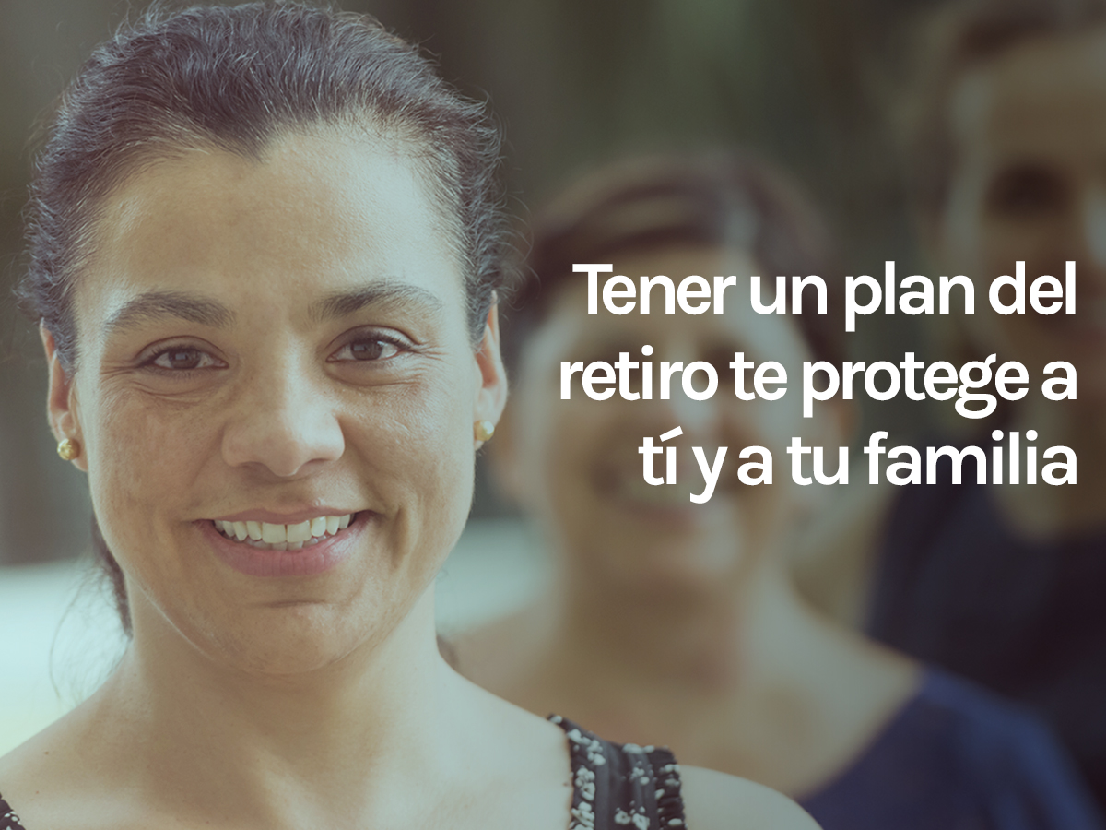

Online Appendix C. Screenshots of Study Website yoplaneomiretiro.com July 21-21, 2016
Website link (development site): http://yoplaneomiretiro.com/dev/

Website main page screen shot

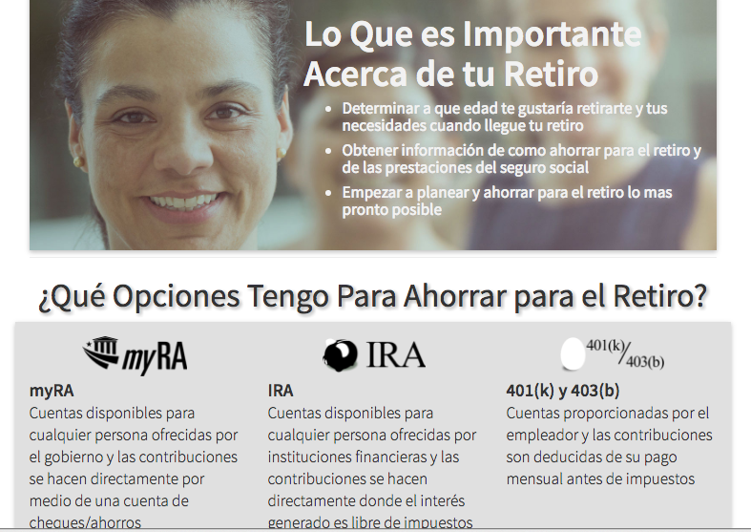
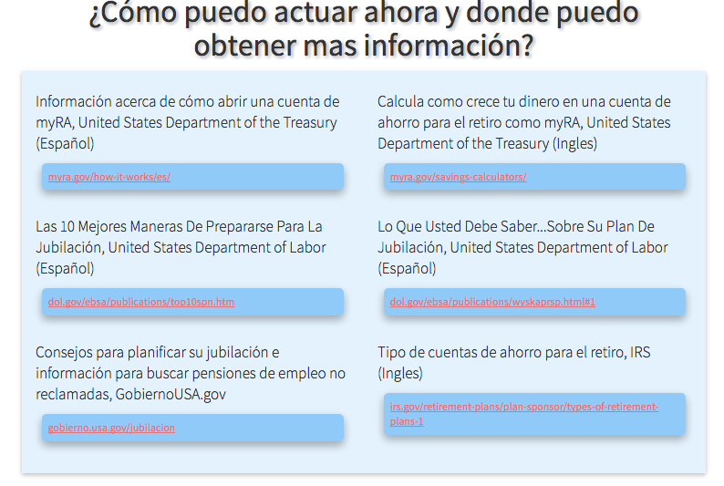
Website privacy statement page: http://yoplaneomiretiro.com/privacy-es.html

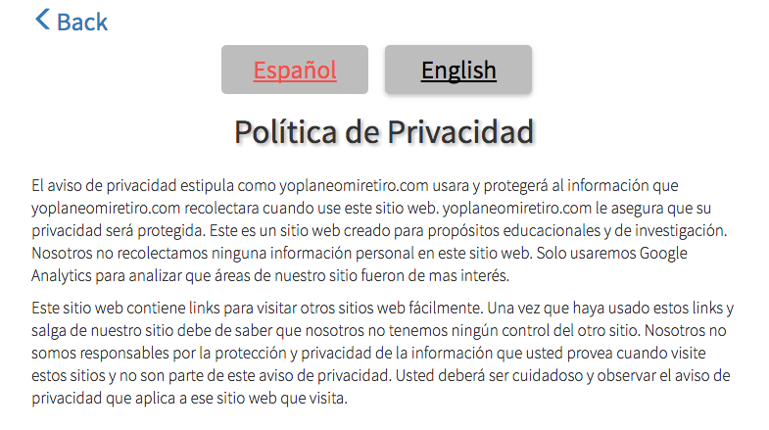

ENGLISH
This privacy policy sets out how yoplaneomiretiro.com uses and protects any information that yoplaneomiretiro.com collects when you use this website. Yoplaneomiretiro.com is committed to ensuring that your privacy is protected. This is a website created for educational and research purposes. We are not collecting any personal information in this website. We are only using Google Analytics to find out what areas of our website were more attractive.

Our website may contain links to enable you to visit other websites of interest easily. However, once you have used these links to leave our site, you should note that we do not have any control over that other website. Therefore, we cannot be responsible for the protection and privacy of any information, which you provide whilst visiting such sites and such sites are not governed by this privacy statement. You should exercise caution and look at the privacy statement applicable to the website in question.

Website Information (about) page: http://yoplaneomiretiro.com/about-es.html

ENGLISH

The website yoplaneomiretiro.com has been created for educational and research purposes by Luisa Blanco, Ph.D., MBA, Associate Professor of Economics at Pepperdine University.

The objective of this study for which this website was created is to better understand how we can promote retirement planning and saving among Hispanic women. For this study we created three different ads in Facebook and assigned them randomly to Hispanic women. We want to find out which ad was more effective getting Hispanic women interested on retirement planning and saving.

We will not collect any personal information from those who visit this website. We do not foresee any important risk from participating in this study. The potential benefits from participating is that those who visit the website might learn some information about retirement planning and saving.

If you have any questions or concerns about this study, please do not hesitate to contact Dr. Luisa Blanco via email lblanco@pepperdine.edu. If you have questions about your rights as a research participant, please contact the Graduate & Professional School Institutional Review Board at Pepperdine University, via email at gpsirb@pepperdine.edu.

Thank you for visiting our website - Luisa Blanco

Online Appendix D. Screenshots of Study Website yoplaneomiretiro.com April 22-25, 2018
Website link (development site): http://yoplaneomiretiro.com/dev/

Website main page screen shot

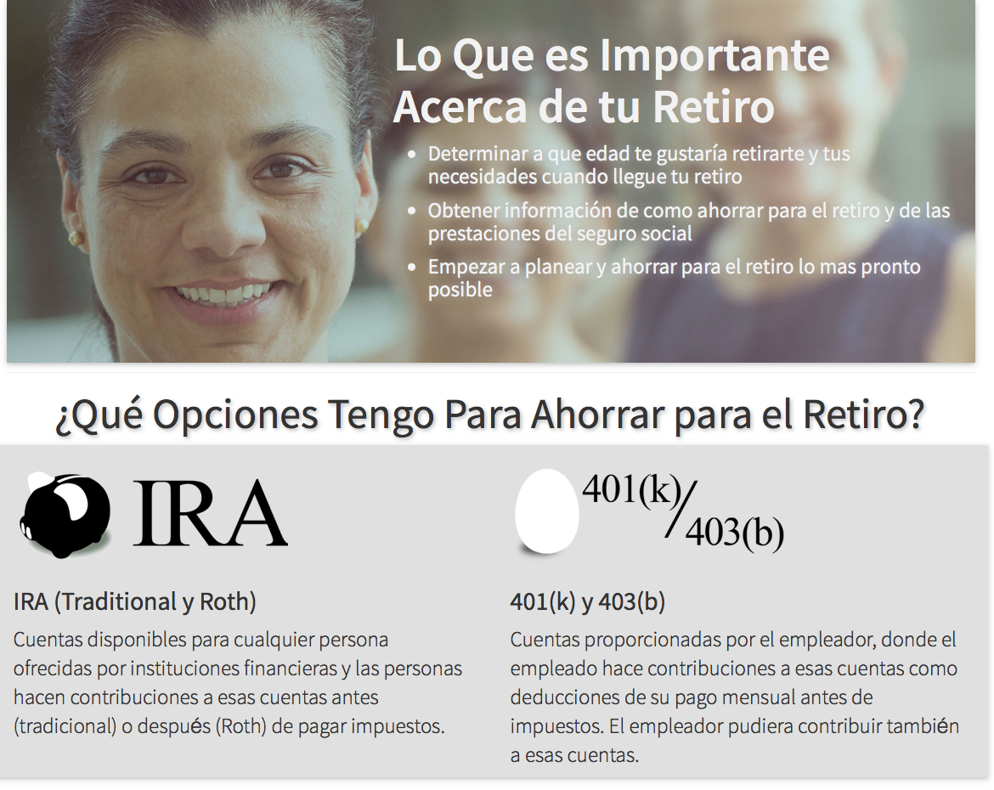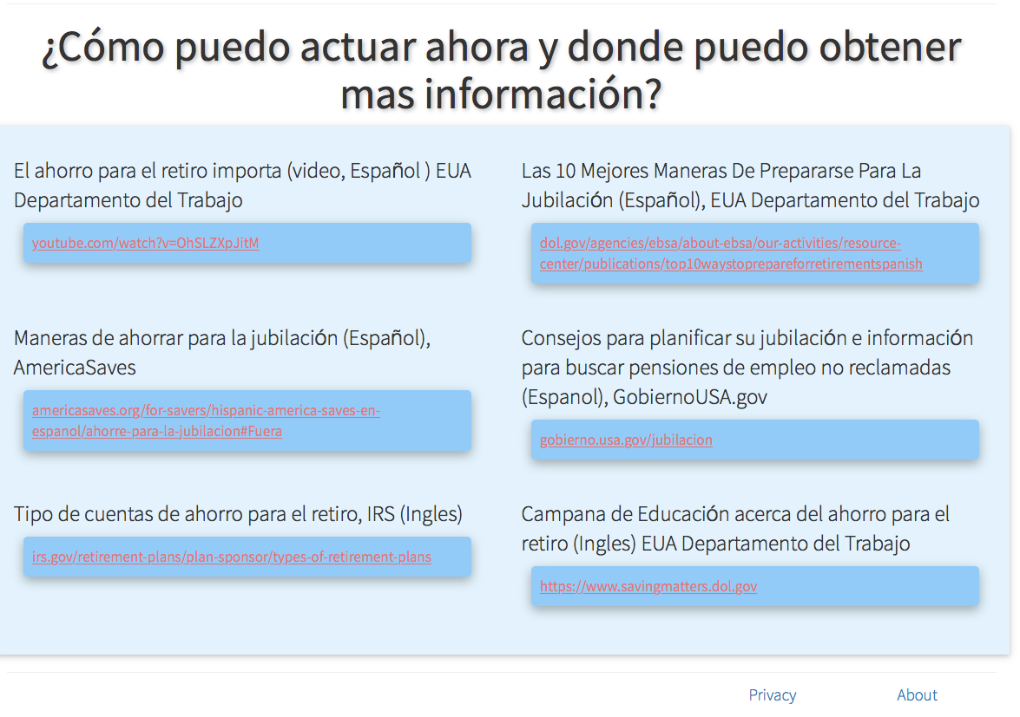
Website privacy statement page: http://yoplaneomiretiro.com/privacy-es.html

ENGLISH
This privacy policy sets out how yoplaneomiretiro.com uses and protects any information that yoplaneomiretiro.com collects when you use this website. Yoplaneomiretiro.com is committed to ensuring that your privacy is protected. This is a website created for educational and research purposes. We are not collecting any personal information in this website. We are only using Google Analytics to find out what areas of our website were more attractive.

Our website may contain links to enable you to visit other websites of interest easily. However, once you have used these links to leave our site, you should note that we do not have any control over that other website. Therefore, we cannot be responsible for the protection and privacy of any information, which you provide whilst visiting such sites and such sites are not governed by this privacy statement. You should exercise caution and look at the privacy statement applicable to the website in question.

Website Information (about) page: http://yoplaneomiretiro.com/about-es.html

ENGLISH

The website yoplaneomiretiro.com has been created for educational and research purposes by Luisa Blanco, Ph.D., MBA, Associate Professor of Economics at Pepperdine University.

The objective of this study for which this website was created is to better understand how we can promote retirement planning and saving among Hispanic women. For this study we created three different ads in Facebook and assigned them randomly to Hispanic women. We want to find out which ad was more effective getting Hispanic women interested on retirement planning and saving.

We will not collect any personal information from those who visit this website. We do not foresee any important risk from participating in this study. The potential benefits from participating is that those who visit the website might learn some information about retirement planning and saving.

If you have any questions or concerns about this study, please do not hesitate to contact Dr. Luisa Blanco via email lblanco@pepperdine.edu. If you have questions about your rights as a research participant, please contact the Graduate & Professional School Institutional Review Board at Pepperdine University, via email at gpsirb@pepperdine.edu.

Thank you for visiting our website - Luisa Blanco

