Appendix A: Described framing

Carbon fee

Recent studies have examined how people react to being asked to pay a fee when they emit carbon dioxide, because the carbon dioxide emitted when they fly across the country contributes to climate change, which in turn imposes costs on the country and other people. The goal of such a fee is to make activities, such as flying across country on an airplane, carbon neutral – meaning that there is no net contribution to global warming, and the price of the activity reflects the true cost to society. Specifically, researchers found that when the fee is called a “carbon offset”, approximately 65% of potential buyers are willing to pay it. However, when the fee is called a “carbon tax”, as few as 20% of potential buyers are willing to pay it.

Suppose that an airline company [the government] is deciding how to describe these fees on its website when people are buying plane tickets. The company realizes that people will be more likely to pay the fee when it is described as a “carbon offset” instead of a “carbon tax”.

Small plates

Research has discovered that people eat more food when it is served to them on larger plates. For example, consider the dishes of ice cream below:

While the actual amount of ice cream is the same in both bowls, many people would perceive the bowl on the left to have more ice cream simply because of the smaller bowl size. Since food served on smaller plates and bowls seems like more food, people eating from these smaller plates will feel full faster and stop eating sooner.

Imagine that you have paid to eat lunch at a buffet restaurant [a government-run cafeteria]. The buffet [the cafeteria] has recently switched from larger plates and bowls to smaller ones in an attempt to make people eat less. [Imagine that you have gone over to a friend’s house for dinner. Your friend recently switched from larger plates and bowls to smaller ones in an attempt to encourage everyone to eat less.

Organ donation

Recent studies on organ donation rates have found that the default setting for who is an organ donor (i.e., whether one is or is not a donor when no active decision is made) can have a very large effect on how many people agree to donate their organs after death. Being an organ donor means consenting to having your organs and tissue made available for transplantation upon death to other people with serious medical needs. In general, countries have one of two defaults for organ donation decisions. In a country with an "opt in" system, such as the United States and the UK, individuals must make an active decision to make their organs available for donation. For example, in California, you need to sign up for the Organ Donor Registry through either an online form or at the DMV. Other countries use a system called "opt out" or “presumed consent”. Under this system, individuals must take an action to not be registered for automatic donation. They are organ donors, unless they make an active decision not to be organ donors, i.e., unless they sign a registry that states they do not want to become an organ donor. The use of "opt in" versus "opt out" has significant effects on donor rates, as can be seen in the following chart. Countries with opt-in have donation rates around 20%, while those with opt-out often have donation rates around 98%.

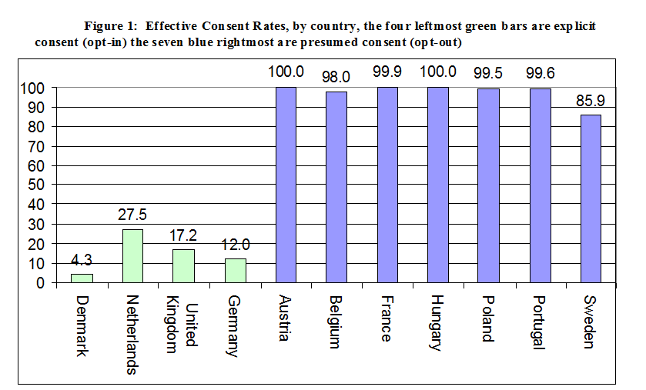

Suppose that a health insurance company [a government-sponsored organ donation network] is suggesting a change to the current rules of organ donor registration, switching from an ‘opt in’ system to an ‘opt out’ system. This change will encourage people to participate in the organ donor program more.

Beef framing

Researches on decision making have shown that people respond differently to different representations of the same information. Specifically, people react differently to a particular choice depending on whether it is presented as a positive message or as a negative message. For example, when people were asked to evaluate a hypothetical purchase of ground beef, they tend to be more favorable toward the beef labeled ‘75% lean’ than the meat labeled '25% fat'.

Suppose that a local grocery store [the US Department of Agriculture] in your town is changing all ground beef labels to ‘__% lean’. The store realizes that people will be more likely to buy beef when it is described as ‘__% lean’ instead of ‘__% fat’.

Appendix B: Experienced framing (Study 2 only)

Asian disease

Imagine that a small city in the U.S. is preparing for the outbreak of an unusual disease, which is expected to kill 600 people. Two program options to combat the disease have been proposed. On the next page, we will present you with the exact scientific estimate of the consequences of each of the two program options and ask you to choose one program for the city. Given the information below, which of the two program options would you be most in favor of?

Save frame

If Program option A is adopted | If Program option B is adopted
200 people will be saved. | There is a 1/3 chance that 600 people will be saved, and a 2/3 chance that no people will be saved.

Death frame

If Program option C is adopted | If Program option D is adopted
400 people will die. | There is a 1/3 chance that nobody will die, and a 2/3 chance that 600 people will die.

Beef framing

Imagine that you are going grocery shopping to buy beef for your dinner. Suppose you are contemplating buying a package of fresh ground beef described as 75% lean [25% fat] at a grocery store. How would you expect the meat to rate on each the following aspects on a 7-point scale?

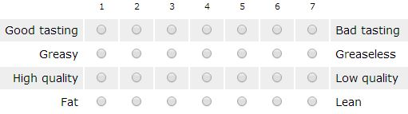

Cancer treatment
Suppose you have been diagnosed with lung cancer and you are given the choice of two alternative therapies - radiation and surgery. Both radiation therapy and surgery for lung cancer have some therapeutic effects and some undesired side effects, but you can assume that most patients treated with either surgery or radiation therapy generally feel about the same at the end of the treatment. The table below describes the probability of death immediately after the treatment, one year after the treatment, and five years after the treatment. Given the information about treatment outcomes, which treatment would you choose?

Mortality frame
Surgery A | Radiation therapy A
Of 100 people having surgery A, 10 will die during treatment, 32 will have died by one year and 66 will have died by five years. | Of 100 people having radiation therapy A, none will die during treatment, 23 will die by one year and 78 will die by five years.

Survival frame
Surgery B | Radiation therapy B
Of 100 people having surgery B, 90 will survive during treatment, 68 will live more than one year and 34 will live more than five years. | Of 100 people having radiation therapy B, 100 will survive during treatment, 77 will live more than one year, and 22 will live more than five years.

Carbon fee

As you may know, carbon dioxide (CO2) emissions are produced by many human activities, such as driving, flying, or using electricity. According to the Intergovernmental Panel on Climate Change (IPCC), an international panel of credible scientists who study the issue, these carbon emissions contribute to global warming. The carbon you produce can be balanced out through measures such as funding alternative energy sources (which reduces reliance on polluting energy sources such as coal), or carbon sequestration (which traps greenhouse gases so they do not enter the atmosphere). The goal of a carbon fee is therefore to fund these activities and ensure that the cost of an activity reflects its true cost to society. Policymakers are considering a mandatory program which would raise the cost of certain products and services but make these activities carbon neutral through reputable measures such as those described above. We will ask you to choose between two products, both of which cause some carbon emissions, but only one of which includes payment for compensating those emissions. Note that all prices and costs in the following questions are actual, real world prices and costs.

Suppose you are purchasing a round trip flight from New York City to Los Angeles, and you are debating between two tickets, that are otherwise equivalent. Which of the following two tickets do you prefer?

Tax frame

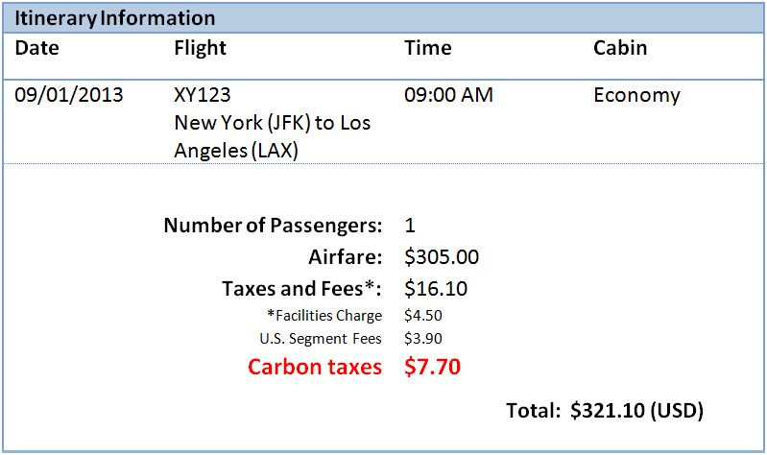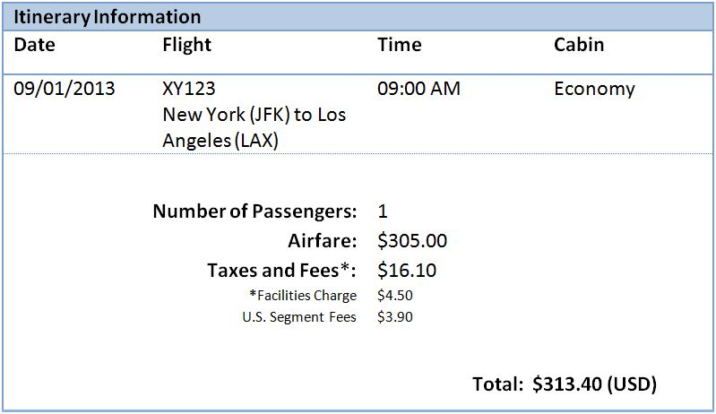

Offset frame

