*Supporting Information for*

Building better dual-ion batteries

Kostiantyn V. Kravchyk,1,2* and Maksym V. Kovalenko,1,2*

1 Laboratory for Thin Films and Photovoltaics, Empa – Swiss Federal Laboratories for Materials Science and Technology, Überlandstrasse 129, CH-8600 Dübendorf, Switzerland

2 Laboratory of Inorganic Chemistry, Department of Chemistry and Applied Biosciences, ETH Zürich, Vladimir-Prelog-Weg 1, CH-8093 Zürich, Switzerland

Corresponding Authors

*E-mails: [kravchyk@inorg.chem.ethz.ch](mailto:kravchyk@inorg.chem.ethz.ch), [mvkovalenko@ethz.ch](mailto:mvkovalenko@ethz.ch)

Gravimetric (mAh g−1) (S1)

Volumetric (mAh mL-1) (S2)

mAh mol−1 (Faraday constant), $M_{d}$ and $M_{c}$ are molarities (mol L−1) of the electrolyte in discharged ($M_{d}$) and charged ($M_{c}$) state of the battery, $ρ$ is the density of the electrolyte in g mL-1 and is the charge of the electroactive species in the electrolyte ( $x$ = 1 for systems comprising monovalent ions).

Gravimetric (mAh g−1) (S3)

Volumetric (mAh g−1) (S4)

is the molar mass of AlCl3 in g mol-1, is the molar mass of Cl- source (for example 1-ethyl-3-methylimidazolium chloride, 1-butyl-3-methylimidazolium chloride orHCl in the simplest case) in g mol-1, is the AlCl3:XCl molar ratio and $ρ$ is density of the chloroaluminate-based anolyte in g mL-1.

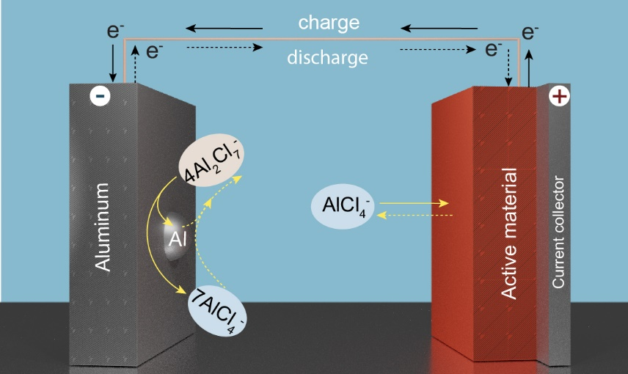

**Figure S1.** Schematic of the charging and discharging processes of Al DIB.