Supporting Information

Sustainable Design of Fully Recyclable All Solid-State Batteries
Darren H. S. Tan,^{a,†} Panpan Xu,^{a,†} Hedi Yang,ª Min-cheol Kim,ª Han Nguyen,ª Erik A. Wu,ª Jean-Marie Doux,ª Abhik Banerjee,ª Ying. Shirley Meng,^{a,b} and Zheng Chen,^{a,b,c*}
ª Department of NanoEngineering, University of California San Diego, La Jolla, CA 92093
^{b} Sustainable Power & Energy Center (SPEC), University of California San Diego, La Jolla, CA 92093
^{c} Program of Chemical Engineering, University of California San Diego, La Jolla, CA 92093
*Correspondence to: zhengchen@eng.ucsd.edu;

This PDF file includes:

Supplementary text
Table S1
Figs. S1 to S5

- METHODS & MODELS
Materials preparation. Commercial Li₆PS₅Cl was obtained from NEI Corporation. XRD and Raman was conducted on the commercial sample to ensure phase purity before use. The Li₆PS₅Cl-LiCoO₂ electrode composite was prepared by hand mixing LiCoO₂ (MTI Corporation) and Li₆PS₅Cl in a 70:30 weight ratio in an agate mortar and pestle for 5 minutes. Commercial lithium metal foil (FMC) was used as the counter electrode; the surface of the foil was first polished and pressed between stainless steel plates to reduce its thickness to 50-100 µm before use. Approximately 2wt% of LiNbO₃ protective coating was applied onto the LiCoO₂ particles via the sol-gel method before use.
Materials Characterization. XRD was conducted using Cu Kα radiation (λ=1.54178 Å) over a 2θ range of 5-70° with a step size of 0.01°. The ICSD database was used to identify the peaks of Li₆PS₅Cl. A Perkin Elmer Raman Station 400F Spectrometer was used to collect Raman spectra intensity values from 134 to 1500 cm⁻¹. As sulfide-based materials are sensitive to air and moisture, decomposing to form toxic gases such as H₂S, all synthesis and characterization steps were done within an Argon-filled glovebox (MBraun MB 200B, H₂O < 0.5 ppm, O₂ < 5.0 ppm).
Electrochemical Characterization. EIS was performed with a Solartron 1260 impedance analyzer for the pristine and recycled SSE. In an EIS setup, 70 mg of Li₆PS₅Cl was cold pressed between two titanium current collectors. An applied AC potential of 30 mV over a frequency range from 1 MHz to 0.1 Hz was used for the EIS measurement. The measurements were conducted at room temperature. For cell cycling, the solid electrolyte powders were first pressed at 370 MPa between the titanium plungers enclosed in a polyetheretherketone (PEEK) intermediate holder to form a separator pellet. Next 10 mg of electrode composite powders (70wt% LiCoO₂) was placed on one side of the pellet and once again pressed at 370 MPa. Finally, the lithium metal foil is placed on the opposite side of the pellet and pressed lightly to adhere the foil to the entire cell. The entire cell was then placed in an aluminum jig for mechanical support, a load cell used on one end of the cell to maintain the pressure at 5 MPa throughout the cycling process. Cells were electronically connected via the titanium plungers as the current collectors and cycled using the Neware Battery cycler and analyzed with the BTS9000 software. All cells were cycled under galvanostatic conditions between 2.5-4.2V at 0.1C rate at room temperature with no rest between each cycle.
Recycling Methods. After cell cycling, the cell was removed from its aluminum jig and the entire cell pellet was immersed in anhydrous ethanol to dissolve the solid electrolyte, with the undissolved cathode remaining as the solutes. After dissolution, the entire suspension was phase separated using centrifugal methods sealed under inert conditions. After separation, the solution was decanted and the dissolved Li₆PS₅Cl was recovered using a rotavapor under 80˚C and vacuum conditions. The recovered solid electrolyte powder was then annealed at 450°C under vacuum to regain its ionic conductivity. The ethanol used for the dissolution was recovered via distillation from the rotavapor. For the cathode hydrothermal regeneration, recovered cathodes after decanting were first washed with distilled water and sonicated to remove the CEI before being loaded into a 100 mL Teflon-lined autoclave filled with 80 mL of 4 M lithium hydroxide (LiOH) solution and heated at 220°C for 4 hours. The treated LiCoO₂ powders were washed thoroughly with deionized water before heat treatment under flowing oxygen in a tube furnace to remove impurities. This procedure was designed to simulate scalable conditions where the full ASSB removed from its external pouch packaging can be directly processed for recycling without additional separation into its sub-components.

EverBatt Model. The impacts of battery recycling were modelled by the EverBatt model. The output parameters of energy consumption and environmental emissions were extracted for comparison. Evaluation of recycling energy consumption and emissions for cathode and electrolytes were conducted. The anode is excluded from the modelling considerations. Cathode: Three recycling technologies: direct, hydrometallurgical, and pyrometallurgical cathode recycling are considered in the EverBatt model. Electrolyte: Two recycling technologies, solid electrolyte and liquid electrolyte recycling, are considered in the EverBatt model. Both cases consider direct cathode recycling in order to retain the electrolytes for recycling. Direct cathode recycling is modelled for the electrolyte recycling cases as there would be no remaining electrolyte to be recycled if hydro/pyro processes were used.

Hydrometallurgy (cathode). Hydrometallurgical methods for cathode recycling without electrolyte considerations are modelled in Figure 5. Discharged and disassembled spent batteries are shredded, undergo a low temperature calcination process to burn off the binder and any other organics. Next, several physical separation processes are conducted to separate out aluminum, copper, steel, and metal scraps and plastics. A leaching process is used followed by solvent extraction and precipitation to produce compounds (such as lithium carbonate) for new cathode material production.
Pyrometallurgy (cathode). Pyrometallurgical methods for the cathode recycling without electrolyte considerations are modelled in Figure 6. spent batteries are sent to a smelter, where the electrolyte and plastics in the batteries are burned off to supply heat. Binder/carbon and aluminum in the batteries act as reductants for the metals and are oxidized. Copper and iron in the batteries end up in the matte, and the rest of the materials, including oxidized aluminum, end up in the slag. The Cu/Fe matte is then further processed by acid leaching followed by solvent extraction and precipitation to produce compounds that can be used to produce new cathode materials.
Direct Recycling (cathode). Direct methods for the cathode recycling without electrolyte considerations are modelled in Figure 7. Discharged and disassembled batteries undergo a series of similar up-stream procedures to hydrometallurgical recycling process before acid leaching. After shredding and physical separation processes, the harvested cathode material is then re-lithiated to produce the recycled cathode powder.

Direct Recycling (full LIB). Direct recycling of a full cell with liquid electrolyte considerations is modelled in Figure 8. discharged and disassembled batteries are perforated and then undergo supercritical CO₂ extraction to recycle the electrolyte solvents and lithium salts. The rest of the battery is then shredded and a series of physical separation processes is performed to recover plastics, metals, the anode material, and cathode material, respectively. The recovered cathode material is then re-lithiated to produce the recycled cathode powder.

Direct Recycling (full ASSB). Direct recycling of a full cell with solid electrolyte is modelled in Figure 9. Discharged and disassembled batteries are directly processed with an alcohol solvent and undergo filtration or gravitational separation to separate the solution and precipitates. The solution is vacuum dried under heat to recover the solid electrolyte before thermal annealing to directly regenerate it. The recovered cathode material (precipitates) are then re-lithiated to produce the recycled cathode powder. While anhydrous alcohol is assumed in this model, it is possible that moisture impurities are present in industrial processing that result in minor H₂S gas formation during the cell dissolution step. To avoid release of acid gases, all fumes will first pass through an alkali NaOH treatment step to neutralize gasses before being vented.

Table S1. Energy requirements to recycle 1 kg of spent batteries through different recycling technologies. Only the consumption from recycling (without upstream processes) are included.
In MJ | Only Cathode without Electrolyte |  |  | Full Cell with Electrolyte
 | Pyro-metallurgy | Hydro-metallurgy | Direct Recycling | Liquid Electrolyte | Solid Electrolyte
Diesel | 0.6 | 0.6 | 0.6 | 0.6 | 0.6
Natural gas | ~ | 2.5 | ~ | ~ | ~
Electricity | 4.68 | 0.125 | 0.29 | 2.73 | 1.54

From Table S1, it is seen that energy consumption from only the recycling processes is relatively low compared to the total energy required (Figure 2) when the upstream processes are included. Thus, it is vital to consider the cumulative impact on energy consumption as well as greenhouse gas emissions throughout the battery’s entire life cycle.

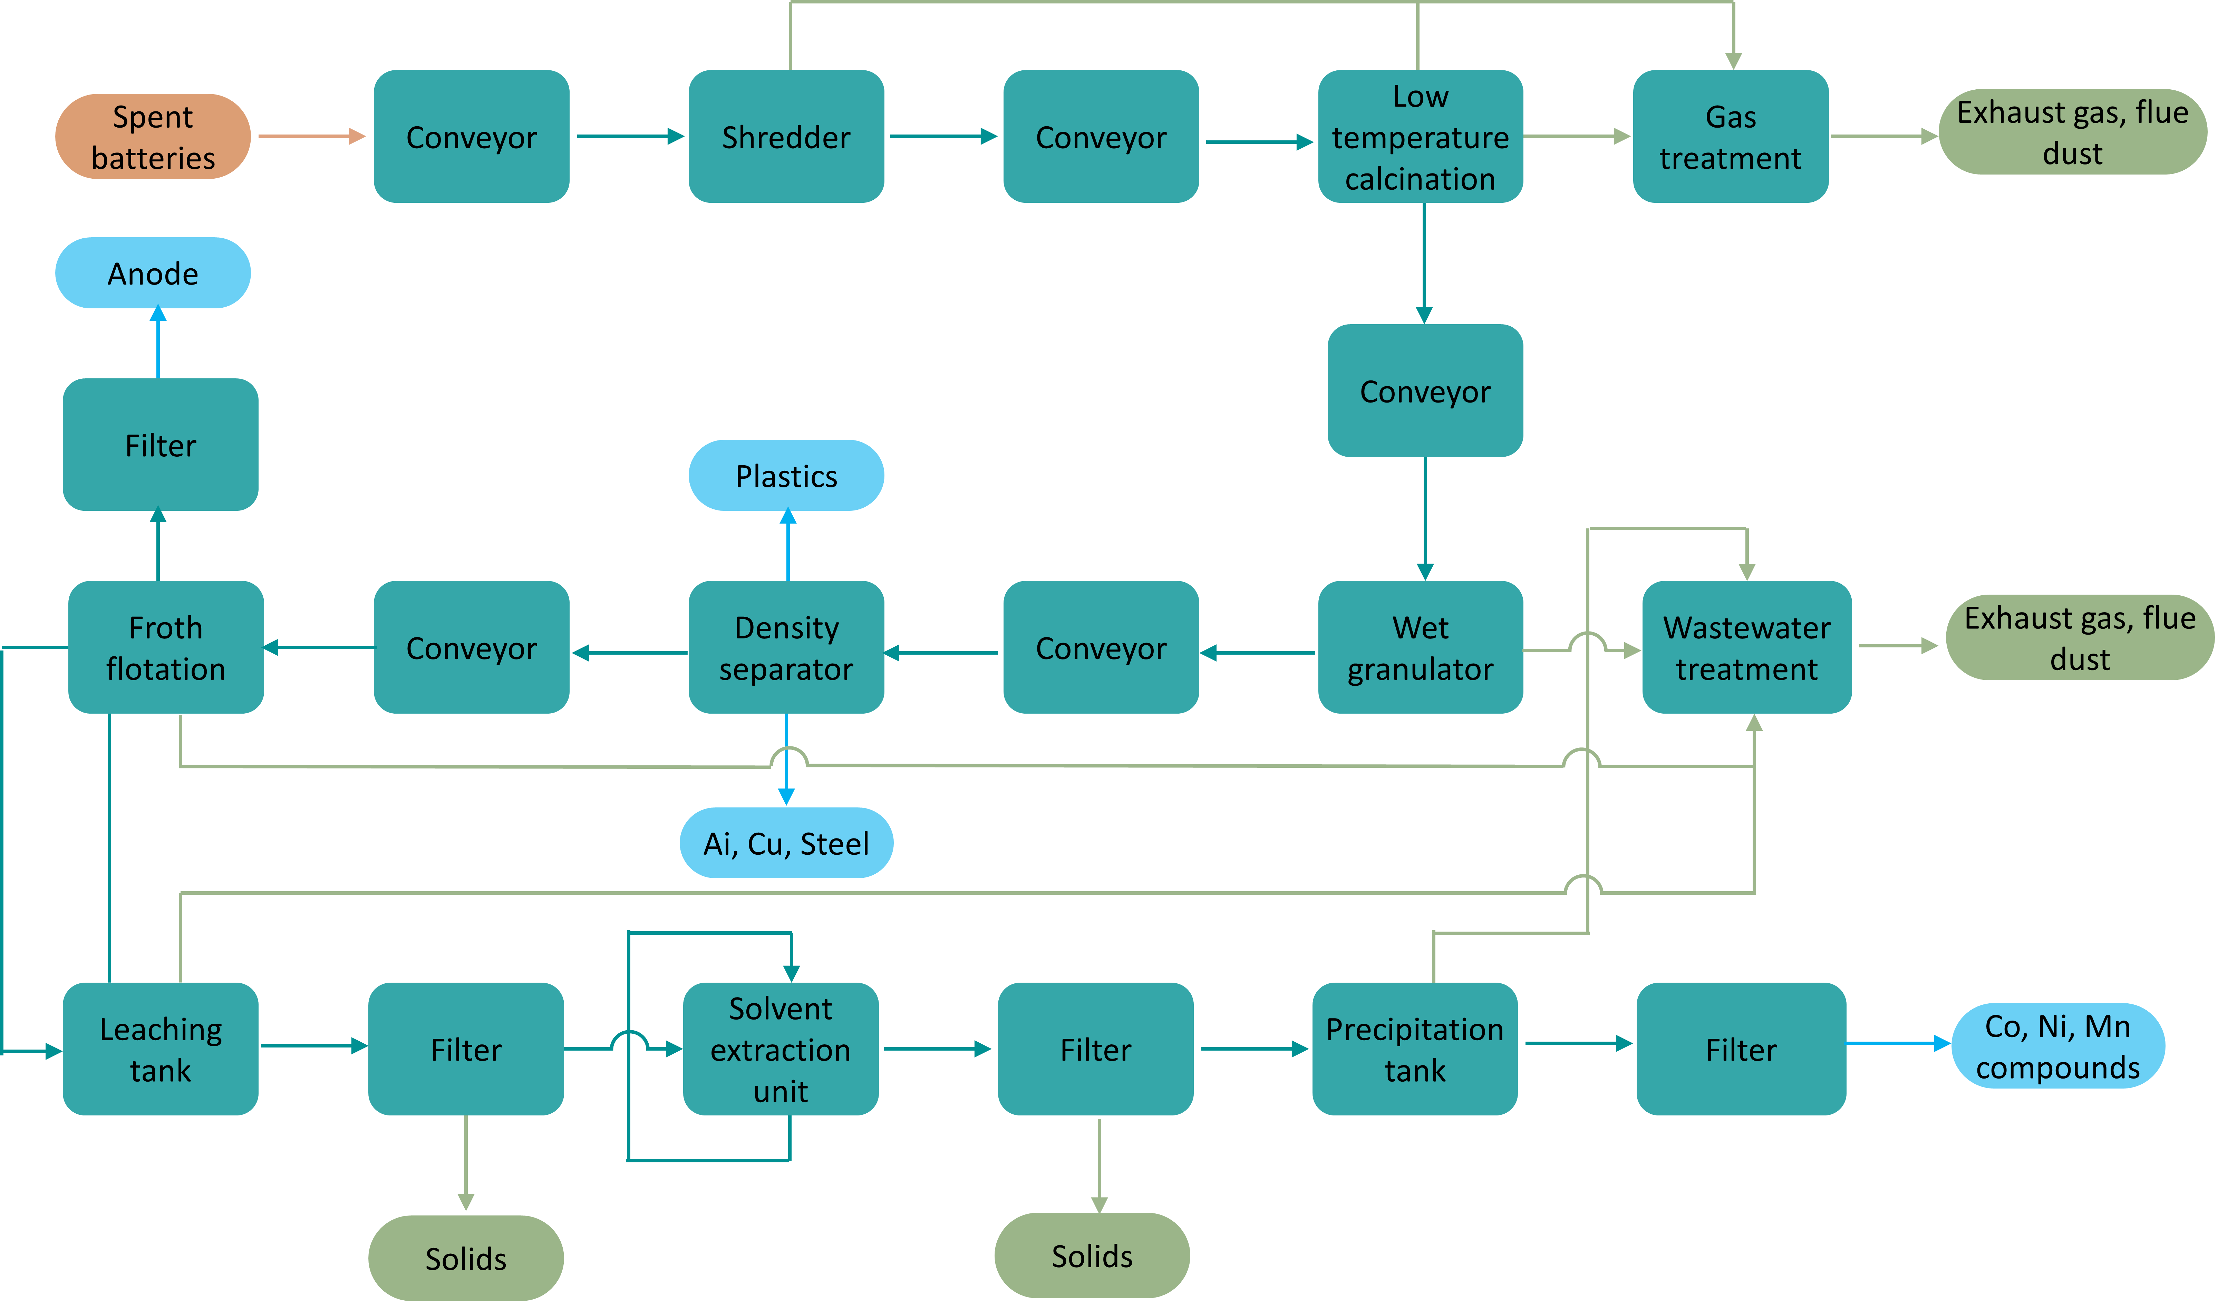

Figure S1. Process flow for a hydrometallurgical recycling model for cathode recycling (without electrolyte recycling considerations).

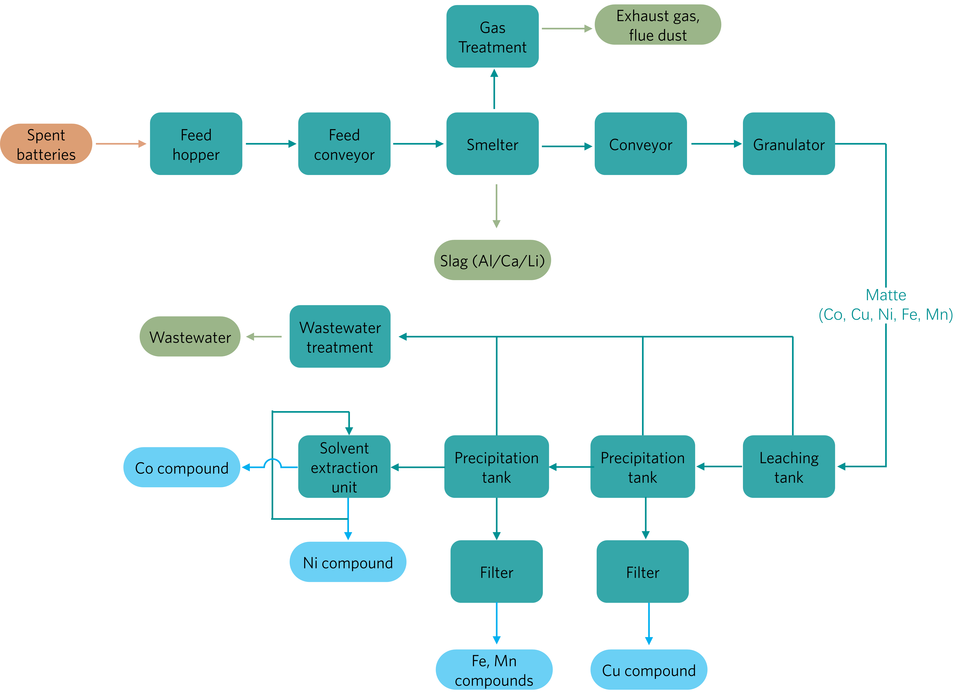
Figure S2. Process flow for a pyrometallurgical recycling model for the cathode (without electrolyte recycling considerations).

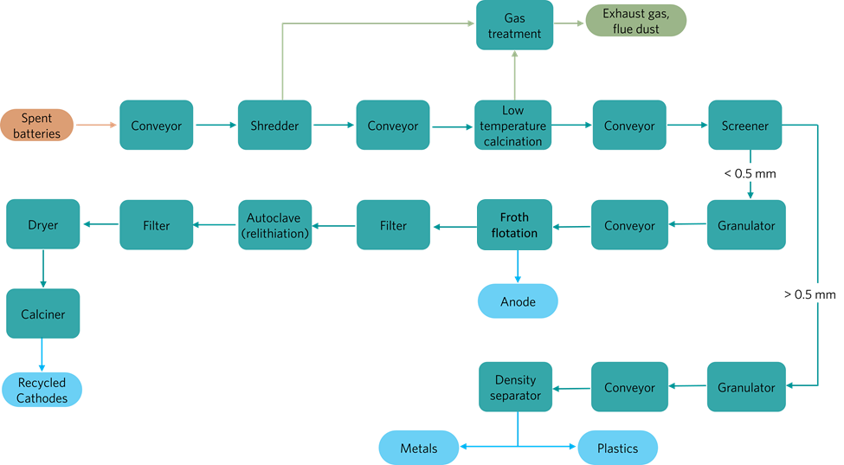

Figure S3. Process flow for direct recycling of the cathode (without electrolyte considerations).

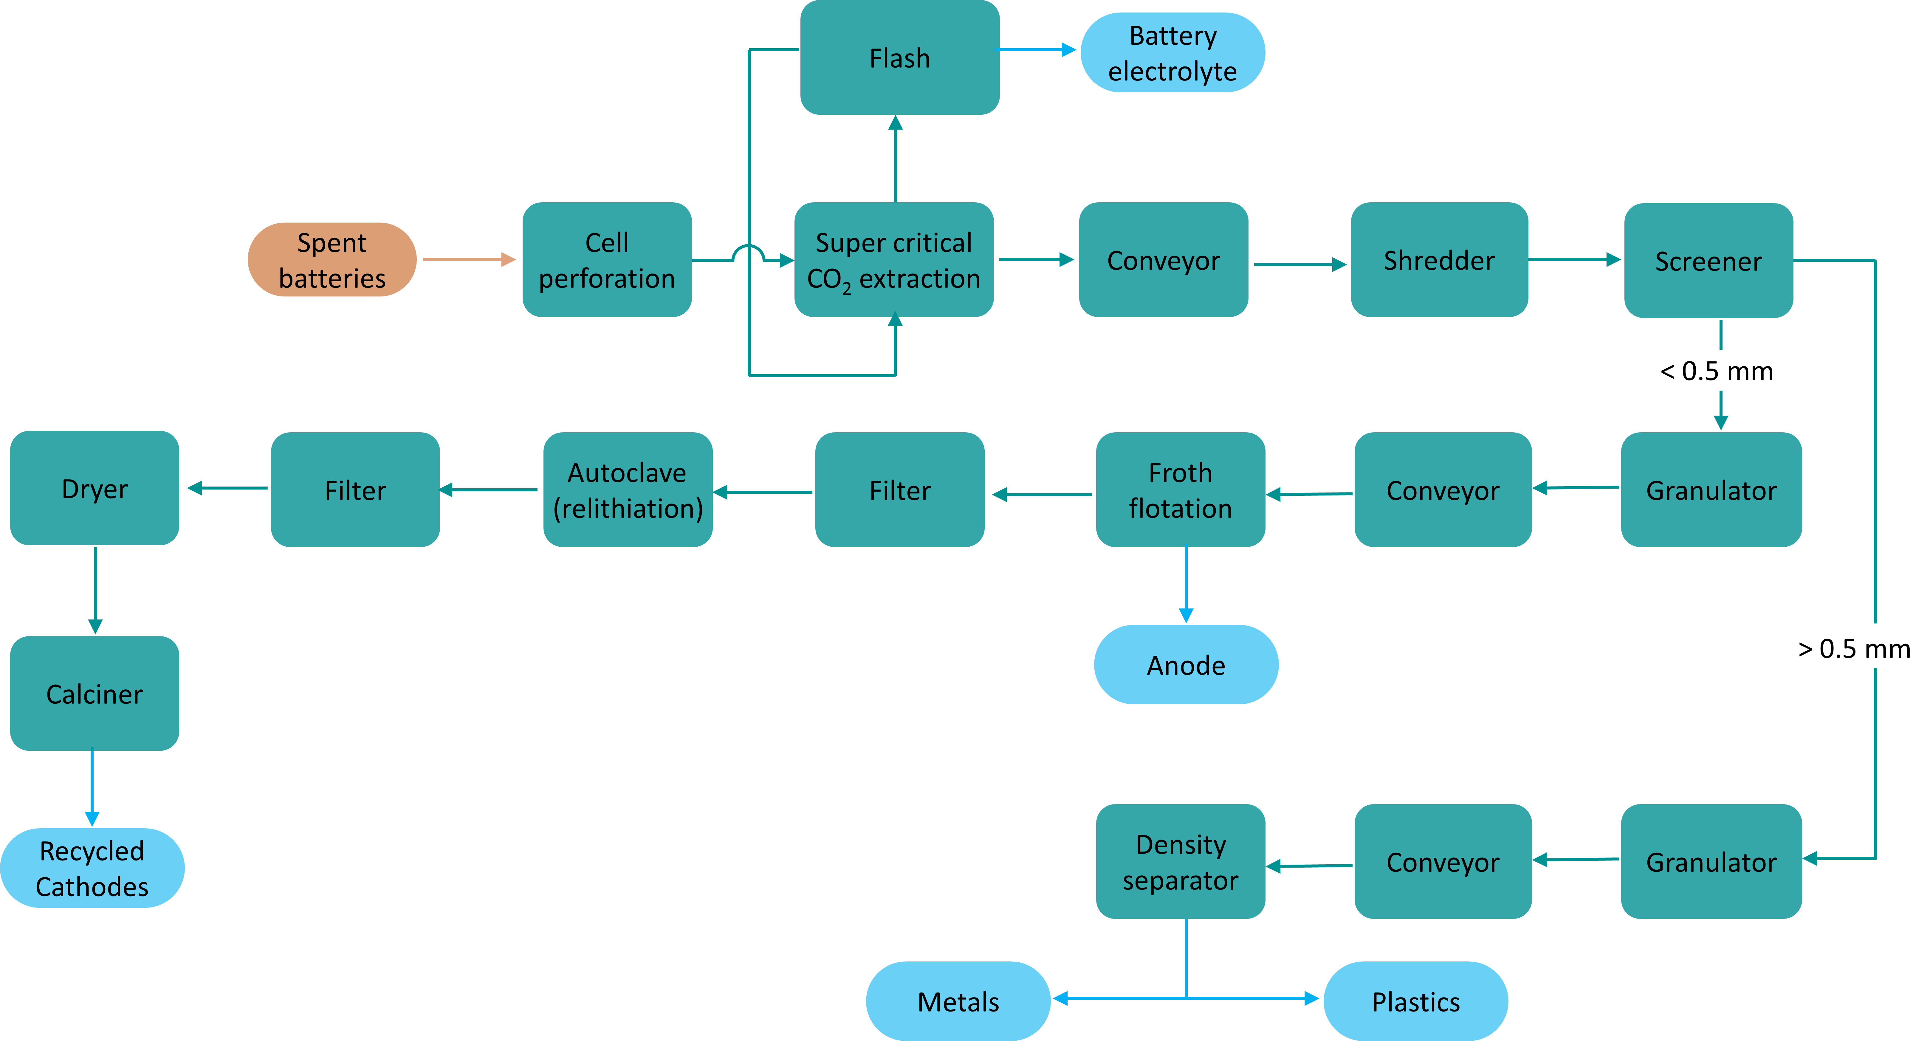

Figure S4. Process flow for the direct recycling of a full cell with liquid electrolyte recycling considerations.

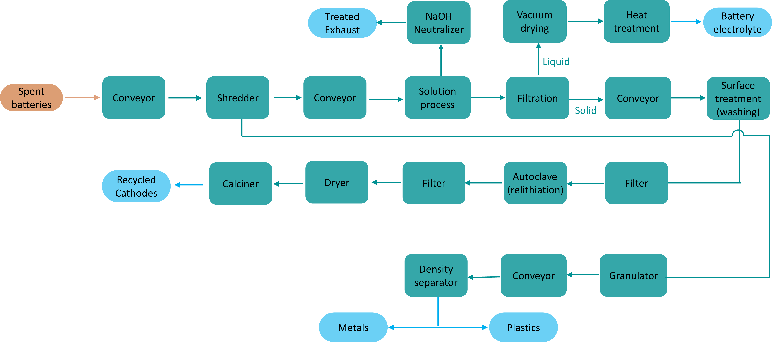

Figure S5. Process flow for direct recycling of a full cell with solid electrolyte recycling considerations.

