Supplemental Materials

For supplemental material accompanying this article, visit www.journals.cambridge.org/[AdvancesinArchaeologicalPractice].”

Supplemental Figure Captions

Supplemental Figure 1. Comparison of whole rock pXRF results and XRF results on powdered samples. Rb, Sr, and Y provided results with high r² values and were statistically significant. Full list of Rb, Sr, and Y values are list in Supplemental Table 2 (from Tibbits 2016:55).

Supplemental Figure 2. The results of the Monte Carlo Simulation as shown by a bivariate chart. The average for n=5 is shown in red as a diamond. The average obtained by 5 random data points over 1000 simulations for Rb, Sr, and Y is always within one standard deviation of the average for 50 data points run through 1000 simulations (from Tibbits 2016:194).

Supplemental Figure 3. Calibration curves for all analyzed geochemical standard materials. Several elements were accurately and precisely analyzed without the need for a curve. The blue line represents all analyses taken from 2013 until the end of the 2015 season. The orange line represents the newest data obtained from the pXRF after routine maintenance and a software upgrade. Note that several of the r² values were strengthened by the update. Al₂O₃, SiO², MnO, TiO₂, and Th were consistently beyond the range of expected variation for most geologic reference materials (from Tibbits 2016:195).

Supplemental Figure 1.

Supplemental Figure 2.

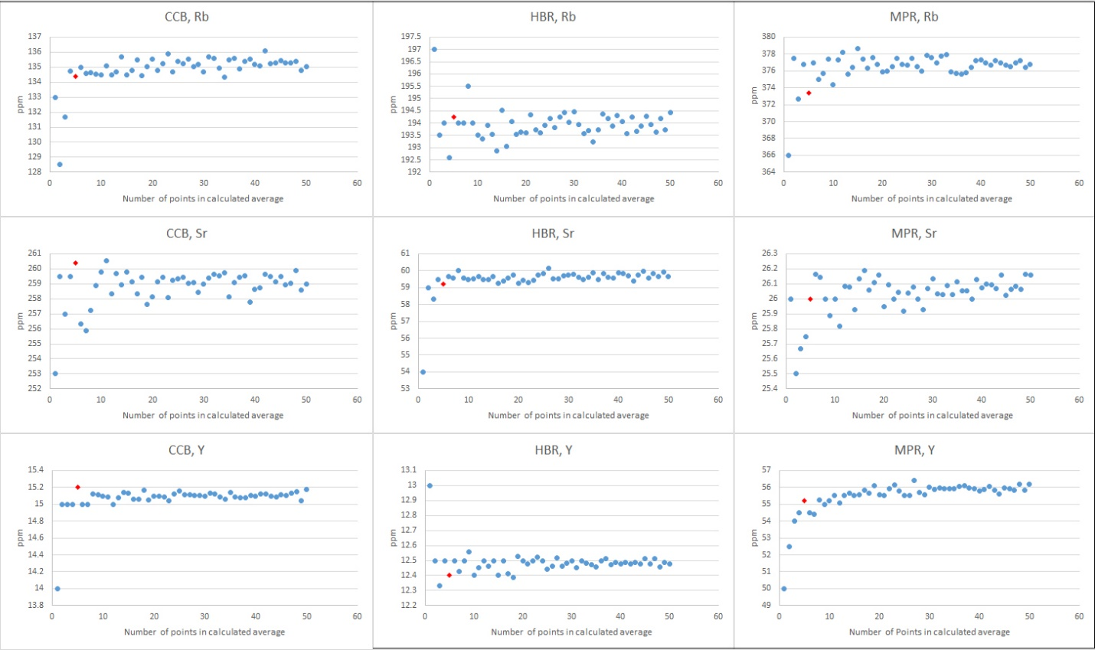

Supplemental Figure 3.

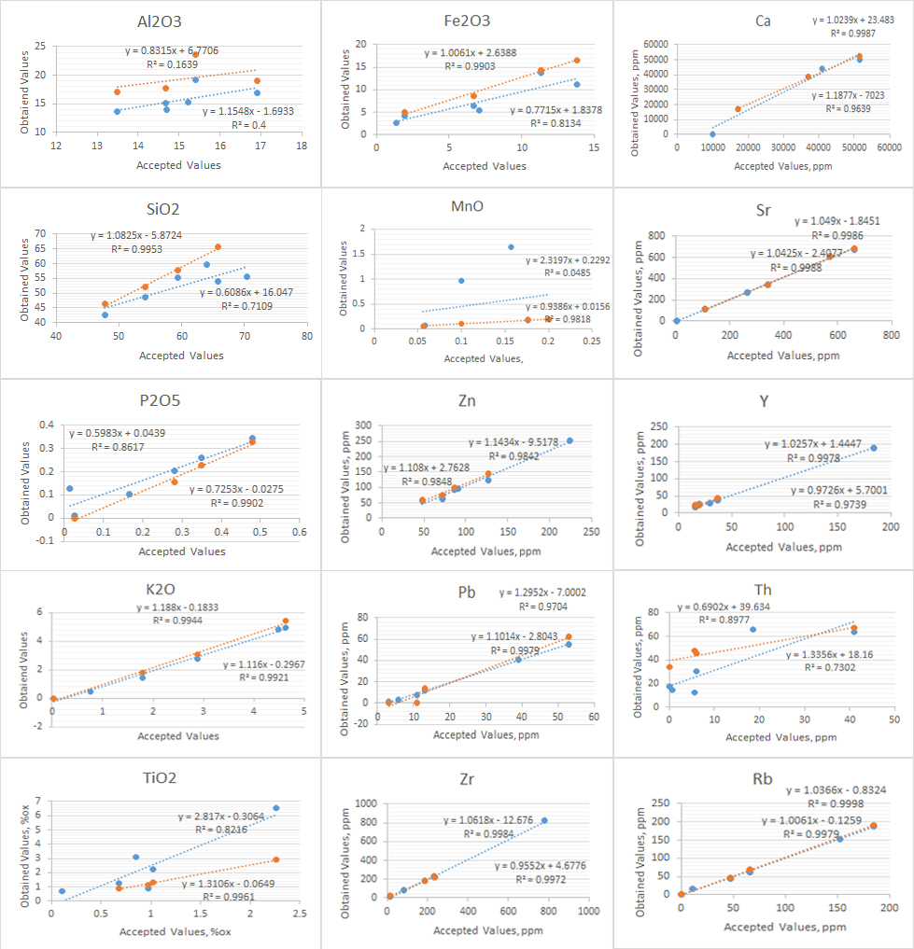

Supplemental Tables

Supplemental Table 1. Sites and References for Table 1.
Region | Most common source for finished materials | Sites (Projects) | References
Northern Belize | Presumed* local sedimentary rock (e.g., limestone), semi-local granite and non-local basalt less common, mostly metates | Altun Ha | Abramiuk and Meurer (2006)
 |  | Aventura | Sidrys and Andresen (1976)
 |  | Caye Coco | Delu (2007:69). Note: majority GST semi-local with significant local manos and significant non-local metates
 |  | Cerros | Garber (1989). Note: majority GST semi-local metamorphic quartzite and limestone
 |  | Chac Balam | Garber (1995), Guderjan (1995)
 |  | K’axob | McAnany and Ebersole (2004:325)
 |  | Laguna de On | Delu (2007:26)
 |  | Lamanai (Lamanai Archaeology Project) | Abramiuk and Meurer (2006), Graham (2015, 2016), Simmons (2004, 2006). Note: limestone, basalt, and granite all present in significant proportions
 |  | La Milpa and Dos Hombres | Tibbits (2016:84)
 |  | Nohmul | Abramiuk and Meurer (2006)
 |  | San Estevan | Levi (1993). Note: basalt and granite also make up a significant portion of this assemblage
 |  | San Juan | Garber (1995:116), Guderjan (1995)
 |  | Santa Rita Corozal | Duffy (2011), Jaeger et al. (1988)
Upper Belize Valley | Local granite, some non-local basalt, and local/semi-local limestone, sandstone, andesite | Baking Pot, Cahal Pech, Lower Dover, Barton Ramie, Xunantunich (Belize Valley Archaeological Reconnaissance Project) | see e.g., Helmke and Awe (2006, 2008), Hoggarth and Awe (2009, 2010, 2011, 2014, 2015, 2016), Hoggarth et al. (2012, 2013), Ebert et al. (2017, 2018, 2019, 2020), Peniche May (2016), older samples also summarized in Abramiuk and Meurer (2006)
 |  | Blackman Eddy (Blackman Eddy Archaeological Project) | Garber et al. (1992, 1993, 1995, 2002)
 |  | Pacbitun (Pacbitun Regional Archaeology Project) | Skaggs et al. (2020), Ward (2013)
Middle Belize Valley | Semi-local granite | Hats Kaab, Hum Chaak, Ik’nal, Kaax Tsaabil, Ma’xan (Belize River East Archaeology Project) | Brouwer Burg et al. (2016), Harrison-Buck (ed.) 2013, Tibbits (2015a, 2016)
Maya Mountains | Local granite, limestone, quartzite, and non-local basalt common | Caracol (Caracol Archaeological Project) | Chase and Chase (2005:Figure 54B, 2006:Figure 34B, 2008:Figure 26, 2012:23, 2015:22-23, 2016:163, 2017:Figure 32I), Chase et al. (2019:Figures 31, 75, 76, 82)
Sibun Valley | Non-local basalt, then semi-local granite | Augustine Obispo, Samuel Oshon, Cedar Bank, Hershey, Queso Blanco, Actun Chanona, Arch Cave (Xibun Archaeological Research Project) | Thibodeau (2004:243, Table 17.1)
Southern Belize | Non-local basalt, local granite, other local volcanics | Lubaantun | Abramiuk and Meurer (2006:347). Note: non-local, vesicular basalt
 |  | Alabama (Stann Creek Regional Archaeology Project) | Peuramaki-Brown (2016). Note: local Cockscomb Basin granite
 |  | Ek Xux, Muklebal Tzul, Quebrada de Oro | Abramiuk and Meurer (2006). Note: local Bladen group volcanics

*Sedimentary tool stone from northern Belize has not been tested, so is presumed to be local.

Supplemental Table 2. Observed Average Modal Abundances of Mountain Pine, Hummingbird, and Cockscomb Granites (from Tibbits 2016:48).

Pluton | Major Minerals | Accessory Minerals | Additional Minerals
MPR | Quartz: 25%  Plagioclase: 30%  K-Spar: 35% | Biotite, chlorite, muscovite, apatite, Fe-Ti oxides (approx. total 10%) | ---
HBR | Quartz: 30%  Plagioclase: 25%  K-Spar: 30% | Muscovite > biotite, chlorite, apatite, Fe-Ti oxides (approx. total 15%) | ---
CCB | Quartz: 25%  Plagioclase: 30%  K-Spar: 30% | Biotite > muscovite, chlorite, margarite, Fe-Ti oxides (approx. total 15%) | Bateson and Hall (1977) report monazite and rutile

Supplemental Table 3. Comparison of Values Obtained on Known Granite Geologic Reference Materials AC-E and GS-N (from Tibbits 2016:52).

 | Rb/Sr | Sr/Y | Al₂O₃ | K₂O | MnO | P₂O₅ | SiO₂ | TiO₂ | Zn | Y | Sr | Rb | Zr
AC-E* | 54.29 | 0.015 | 14.70 | 4.49 | 0.06 | 0.01 | 70.35 | 0.11 | 224 | 184 | 2.8 | 152 | 780
AC-E,  n = 31 | 130.5 | 0.006 | 14.05 | 4.82 | 0.07 | 0.16 | 55.59 | 0.68 | 252 | 190 | 1.5 | 151 | 822
Standard deviation | -- | -- | 0.38 | 0.17 | 0.003 | 0.017 | 24.3 | 1.28 | 9.0 | 1.28 | 1.5 | 2.12 | 10.3
GS-N* | 0.32 | 35.6 | 14.90 | 4.63 | 0.06 | 0.28 | 65.80 | 0.68 | 48 | 16 | 570 | 185 | 235
GS-N, n = 44 | 0.31 | 32.9 | 15.1 | 4.94 | 0.05 | 0.21 | 54.05 | 1.2 | 55 | 18 | 607 | 188 | 219
Standard deviation over time | -- | -- | 1.53 | 0.25 | 0.005 | 0.04 | 21.4 | 1.37 | 8.7 | 1.8 | 9.4 | 4.6 | 6.6
GS-N  standard deviation repeated run | -- | -- | 0.25 | 0.04 | 0.00 | 0.01 | 0.7 | 0.03 | 4.8 | 1.5 | 6.4 | 2.8 | 5.0
AGV-2  standard deviation repeated run | -- | -- | 0.22 | 0.02 | 0.00 | 0.01 | 0.38 | 0.03 | 4.6 | 1.5 | 5.3 | 2.0 | 3.2

* = values obtained from results published on GeoReM. The other value is the average of multiple runs over time. Major elements are shown in percent oxide. Minor and trace elements are shown in ppm. Experimental data shown are from a year of analyses. The standard deviation for running these analyses on GS-N on repeat 25 times consecutively are included to demonstrate the consistency within a run. Results shown here are representative of the results for all geologic reference materials measured during this project (complete list in Tibbits 2016:Appendix B).
Supplemental Table 4. Comparison of pXRF and lLab-Based XRF Techniques Showing Rb, Sr, and Y Results (from Tibbits 2016:56).

Sample | Analysis | Rb, ppm | Sr, ppm | Y, ppm | Sr/Y | Rb/Sr
CS 5-28-5 | Whole Rock, pXRF | 151 | 201 | 17 | 0.7 | 11.9
 | Powdered Sample, pXRF | 154 | 227 | 22 | 0.7 | 10.3
 | Powdered Sample, XRF | 152 | 230 | 24 | 0.7 | 9.5
CS Aug Cr | Whole Rock, pXRF | 139 | 196 | 41 | 0.7 | 4.8
 | Powdered Sample, pXRF | 168 | 184 | 29 | 0.9 | 6.3
 | Powdered Sample, XRF | 179 | 197 | 46 | 0.9 | 4.2
HB-HRQ | Whole Rock, pXRF | 276 | 46 | 10 | 6.0 | 4.6
 | Powdered Sample, pXRF | 273 | 48 | 10 | 5.7 | 4.8
 | Powdered Sample, XRF | 299 | 54 | 14 | 5.5 | 4.0
HB-MC | Whole Rock, pXRF | 296 | 74 | 16 | 4.0 | 4.5
 | Powdered Sample, pXRF | 339 | 76 | 22 | 4.5 | 3.4
 | Powdered Sample, XRF | 324 | 79 | 26 | 4.1 | 3.0
HB-Teak | Whole Rock, pXRF | 212 | 106 | 17 | 2.0 | 6.4
 | Powdered Sample, pXRF* | 173 | 119 | 20 | 1.4 | 5.9
 | Powdered Sample, XRF* | 234 | 104 | 24 | 2.2 | 4.3
HB-Teak-D | Whole Rock, pXRF | 57 | 210 | 20 | 0.3 | 10.4
 | Powdered Sample, pXRF | 87 | 225 | 24 | 0.4 | 9.4
 | Powdered Sample, XRF | 88 | 233 | 28 | 0.4 | 8.4
MPR 6-4-2 | Whole Rock, pXRF | 297 | 28 | 61 | 10.6 | 0.5
 | Powdered Sample, pXRF | 355 | 47 | 79 | 7.5 | 0.6
 | Powdered Sample, XRF | 341 | 34 | 64 | 9.9 | 0.5
MPR BP | Whole Rock, pXRF | 252 | 18 | 19 | 14 | 0.9
 | Powdered Sample, pXRF | 362 | 29 | 42 | 12.5 | 0.7
 | Powdered Sample, XRF | 371 | 31 | 51 | 12 | 0.6
MPR-BRF | Whole Rock, pXRF | 312 | 37 | 38 | 8.4 | 1.0
 | Powdered Sample, pXRF | 327 | 38 | 38 | 8.6 | 1.0
 | Powdered Sample, XRF | 340 | 45 | 47 | 7.8 | 0.9
RC-1 | Whole Rock, pXRF | 284 | 45 | 53 | 6.3 | 0.9
 | Powdered Sample, pXRF | 313 | 61 | 45 | 5.1 | 1.4
 | Powdered Sample, XRF | 331 | 67 | 52 | 5.0 | 1.3
RC-3 | Whole Rock, pXRF | 135 | 148 | 35 | 0.9 | 4.3
 | Powdered Sample, pXRF | 122 | 134 | 35 | 0.9 | 3.8
 | Powdered Sample, XRF | 140 | 154 | 40 | 0.9 | 3.8
SR-1 | Whole Rock, pXRF | 117 | 140 | 22 | 0.8 | 6.4
 | Powdered Sample, pXRF | 140 | 148 | 29 | 1.0 | 5.1
 | Powdered Sample, XRF | 150 | 158 | 37 | 1.0 | 4.2
SR-2 | Whole Rock, pXRF | 115 | 183 | 28 | 0.6 | 6.5
 | Powdered Sample, pXRF | 130 | 175 | 38 | 0.7 | 4.6
 | Powdered Sample, XRF | 128 | 185 | 49 | 0.7 | 3.7
WP-13 | Whole Rock, pXRF | 380 | 24 | 37 | 15.6 | 0.7
 | Powdered Sample, pXRF | 416 | 28 | 66 | 14.9 | 0.4
 | Powdered Sample, XRF | 419 | 34 | 72 | 12.2 | 0.4
* = only instances in which Spearman’s rho and the Pearson correlation value were not statistically significant at the 0.01 level for a two-tailed analysis.

Supplemental References Cited
Abramiuk, Marc A., and William P. Meurer
2006 A Preliminary Geoarchaeological Investigation of Ground Stone Tools in and around the Maya Mountains, Toledo District, Belize. Latin American Antiquity 17(3):335–354. DOI:10.2307/25063056.

Brouwer Burg, Marieka, Astrid Runggaldier, and Eleanor Harrison-Buck
2016 The Afterlife of Earthen-Core Buildings: A Taphonomic Study of Threatened and Effaced Architecture in Central Belize. Journal of Field Archaeology 41(1):1–20.

Chase, Arlen F., and Diane Z. Chase (editors)
2005 Searching for Caracol’s Last Urbanites: Continued Investigation of Small Structures in and near Caracol’s Epicenter: 2005 Field Report of the Caracol Archaeological Project. University of Central Florida. Report submitted to the Belize Institute of Archaeology. Copies available at https://caracol.org/wp-content/uploads/2016/05/Season-Report-2005.pdf, Accessed April 5, 2021.

2006 Trying to Understand the End: Continued Investigation of Small Structures in and near Caracol’s Epicenter: 2006 Field Report of the Caracol Archaeological Project. University of Central Florida. Report submitted to the Belize Institute of Archaeology. Copies available at https://caracol.org/wp-content/uploads/2016/05/Season-Report-2006.pdf, Accessed April 5, 2021.

2008 Household Composition and Ritual Patterning: Continued Investigation of Residential Groups near Caracol’s Epicenter: 2008 Field Report of the Caracol Archaeological Project. University of Central Florida. Report submitted to the Belize Institute of Archaeology. Copies available at https://caracol.org/wp-content/uploads/2016/05/Season-Report-2008.pdf, Accessed April 5, 2021.

2012 Interpreting Ancient Maya Society Through Neighborhoods: Investigation of Adjacent Residential Complexes near Caracol’s Epicenter: Caracol Archaeological Project Investigations for 2012. University of Central Florida. Report submitted to the Belize Institute of Archaeology. Copies available at https://caracol.org/wp-content/uploads/2016/05/Season-Report-2012.pdf, Accessed April 5, 2021.

2015 Investigating Early Long-Distance Interaction in Caracol’s Epicenter: Caracol Archaeological Project Investigations for 2015. University of Central Florida. Report submitted to the Belize Institute of Archaeology. Copies available at https://caracol.org/wp-content/uploads/2015/12/2015.pdf, Accessed April 5, 2021.

2016 Investigating Early Long-Distance Interaction in Caracol’s Epicenter: Caracol Archaeological Project Investigations for 2016. University of Nevada, Las Vegas. Report submitted to the Belize Institute of Archaeology. Copies available at https://caracol.org/wp-content/uploads/2016/12/2016.pdf, Accessed April 5, 2021.

2017 Interpreting Ancient Maya Society Through Residential Groups: Investigating Early Long-Distance Interaction in Caracol’s Epicenter: Caracol Archaeological Project Investigations for 2017. University of Nevada, Las Vegas. Report submitted to the Belize Institute of Archaeology. Copies available at https://caracol.org/wp-content/uploads/2017/12/2017.pdf, Accessed April 5, 2021.

Chase, Arlen F., Diane Z. Chase, and Adrian S. Z. Chase (editors)
2019 Markets and the Socio-Economic Integration of Caracol, Belize: Investigating Residential Groups and Public Architecture in the Vicinities of the Monterey Residential Group and the Puchituk Terminus: Caracol Archaeological Project Investigations for 2019. Pomona College, Claremont Graduate College, and Arizona State University. Report submitted to the Belize Institute of Archaeology. Copies available at https://caracol.org/wp-content/uploads/2020/11/2019.pdf, Accessed April 5, 2021.

Delu, Antonia M.
2007 The Ground Stone Tools of Caye Coco, Belize. Occasional Paper No. 12. Institute for Mesoamerican Studies. The University at Albany – State University of New York, Albany.

Duffy, Lisa G.
2011 Maize and Stone A Functional Analysis Of The Manos And Metates Of Santa Rita Corozal, Belize. Master’s thesis, Department of Anthropology, University of Central Florida, Orlando.

Ebert, Claire E., Chrissina C. Burke, Jaime J. Awe, and Julie A. Hoggarth (editors)
2017 The Belize Valley Archaeological Reconnaissance Project: A Report of the 2016 Field Season, Vol. 22. Baylor University and Northern Arizona University. Report submitted to the Belize Institute of Archaeology. Copies available at https://f718f5f6-ff16-4649-955b-b63b954ed46c.filesusr.com/ugd/ad402d_d059f25714014ac68d69514988af17f0.pdf, Accessed April 1, 2021.

Ebert, Claire E., Julie A. Hoggarth, and Jaime J. Awe (editors)
2018 The Belize Valley Archaeological Reconnaissance Project: A Report of the 2017 Field Season, Vol. 23. Baylor University and Northern Arizona University. Report submitted to the Belize Institute of Archaeology. Copies available at https://f718f5f6-ff16-4649-955b-b63b954ed46c.filesusr.com/ugd/f1e973_b4f6440894604b449cb2533f123a94a7.pdf, Accessed April 1, 2021.

Ebert, Claire E., John P. Walden, Julie A. Hoggarth, and Jaime J. Awe (editors)
2019 The Belize Valley Archaeological Reconnaissance Project: A Report of the 2018 Field Season, Vol. 24. Northern Arizona University and Baylor University. Report submitted to the Belize Institute of Archaeology. Copies available at https://f718f5f6-ff16-4649-955b-b63b954ed46c.filesusr.com/ugd/f1e973_551a7c60cd4c415abb9fe34e56c5c981.pdf, Accessed April 1, 2021.

2020 The Belize Valley Archaeological Reconnaissance Project: A Report of the 2019 Field Season, Vol. 25. Northern Arizona University and Baylor University. Report submitted to the Belize Institute of Archaeology. Copies available at https://f718f5f6-ff16-4649-955b-b63b954ed46c.filesusr.com/ugd/f1e973_047f7920e63e45a487df07bacb2807b1.pdf, Accessed April 1, 2021.

Garber, James F.
1989 The Ground Stone Industry. In Archaeology at Cerros Belize, Central America, edited by David A. Freidel, pp. 15–36. Southern Methodist University Press, Dallas.

1995 The Artifacts. In Maya Maritime Trade, Settlement, and Population on Ambergris Caye, Belize, edited by Thomas H. Guderjan and James F. Garber, pp. 113–138. Labyrinthos Press, Culver City.

Garber, James F., W. David Driver, Lauren A. Sullivan, and Sean Goldsmith (editors)
1992 The Blackman Eddy Archaeological Project: Results of the 1991 Field Season. Report submitted to the Department of Archaeology, Belmopan, Belize.

Garber, James F., W. David Driver, and Lauren A. Sullivan (editors)
1993 The Blackman Eddy Archaeological Project: Results of the 1992 Field Season. Report submitted to the Department of Archaeology, Belmopan, Belize.

Garber, James F., F. Kent Reilly, and David M. Glassman (editors)
1995 The Blackman Eddy Archaeological Project: Results of the 1994 Field Season. Report submitted to the Department of Archaeology, Belmopan, Belize.

Garber, James F., M Kathryn Brown, and Christopher J. Hartman
2002 The Early/Middle Formative Kanocha Phase (1200-850 B.C.) at Blackman Eddy, Belize. Report submitted to the Foundation for the Advancement of Mesoamerican Studies, Inc. (FAMSI). Copies available at http://www.famsi.org/reports/00090/index.html, Accessed February 19, 2021.

Graham, Elizabeth (editor)
2015 Report on the 2015 Investigations at Lamanai, with update on Marco Gonzalez. University College London. Report submitted to the Belize Institute of Archaeology. Copies available at https://lamanai.org.uk/uploads/3/4/5/0/34505207/2015_report_final_egraham.pdf, Accessed April 1, 2021.

2016 Report on the 2016 Investigations at Lamanai. University College London. Report submitted to the Belize Institute of Archaeology. Copies available at https://lamanai.org.uk/uploads/3/4/5/0/34505207/2016_report_final_egraham_5April18.pdf, Accessed April 1, 2021.

Guderjan, Thomas H.
1995 Settlement Patterns and Survey Data. In Maya Maritime Trade, Settlement, and Population on Ambergris Caye, Belize, edited by Thomas H. Guderjan and James F. Garber, pp. 9–30. Labyrinthos Press, Culver City.

Harrison-Buck, Eleanor (editor)
2013 Archaeology in the Middle Belize Valley: A Report of the 2012 Belize River East Archaeology Project. Occasional Paper No. 6. University of New Hampshire, Durham, NH. Report submitted to the Belize Institute of Archaeology. Copies available at https://brea-project.org/wp-content/uploads/2020/11/BREA2012_Report.pdf, Accessed April 1, 2021.

Helmke, Christophe G.B., and Awe, Jaime J. (editors)
2006 The Belize Valley Archaeological Reconnaissance Project: A Report of the 2005 Field Season. Report submitted to the Belize Institute of Archaeology. Copies available at https://f718f5f6-ff16-4649-955b-b63b954ed46c.filesusr.com/ugd/ad402d_df287e42c4aa443e8a7086779d0a6be2.pdf, Accessed April 1, 2021.

2008 The Belize Valley Archaeological Reconnaissance Project: A Report of the 2007 Field Season. Report submitted to the Belize Institute of Archaeology. Copies available at https://f718f5f6-ff16-4649-955b-b63b954ed46c.filesusr.com/ugd/ad402d_8b8ac79f28c94a2a81a45da3b9e7b346.pdf, Accessed April 1, 2021.

Hoggarth, Julie A., and Jaime J. Awe (editors)
2009 The Belize Valley Archaeological Reconnaissance Project: A Report of the 2008 Field Season, Vol. 14. Report submitted to the Belize Institute of Archaeology. Copies available at https://f718f5f6-ff16-4649-955b-b63b954ed46c.filesusr.com/ugd/ad402d_89240c09743645c6a5726409cbb5bc37.pdf, Accessed April 1, 2021.

2010 The Belize Valley Archaeological Reconnaissance Project: A Report of the 2009 Field Season, Vol. 15. Report submitted to the Belize Institute of Archaeology. Copies available at https://f718f5f6-ff16-4649-955b-b63b954ed46c.filesusr.com/ugd/ad402d_2e80f1d5bf724ca9b05b41007fe09a20.pdf, Accessed April 1, 2021.

2011 The Belize Valley Archaeological Reconnaissance Project: A Report of the 2010 Field Season, Vol. 16. Report submitted to the Belize Institute of Archaeology. Copies available at https://f718f5f6-ff16-4649-955b-b63b954ed46c.filesusr.com/ugd/ad402d_7623de161c3e4ef290db60f2678806f7.pdf, Accessed April 1, 2021.

2014 The Belize Valley Archaeological Reconnaissance Project: A Report of the 2013 Field Season, Vol. 19. Report submitted to the Belize Institute of Archaeology. Copies available at https://f718f5f6-ff16-4649-955b-b63b954ed46c.filesusr.com/ugd/ad402d_49af3995a8f4465fb5eff9ced7953364.pdf, Accessed April 1, 2021.

2015 The Belize Valley Archaeological Reconnaissance Project A Report of the 2014 Field Season, Vol. 20. Report submitted to the Belize Institute of Archaeology. Copies available at https://f718f5f6-ff16-4649-955b-b63b954ed46c.filesusr.com/ugd/ad402d_0f73b68b8bfb4146b92cfa1fee523ff7.pdf, Accessed April 1, 2021.

2016 The Belize Valley Archaeological Reconnaissance Project A Report of the 2015 Field Season, Vol. 21. Baylor University. Report submitted to the Belize Institute of Archaeology. Copies available at https://f718f5f6-ff16-4649-955b-b63b954ed46c.filesusr.com/ugd/ad402d_796c134eb4d7457f818402cc3a4b36cd.pdf, Accessed April 1, 2021.

Hoggarth, Julie A., Rafael A. Guerra, and Jaime J. Awe (editors)
2012 The Belize Valley Archaeological Reconnaissance Project: A Report of the 2011 Field Season, Vol. 17. Report submitted to the Belize Institute of Archaeology. Copies available at https://f718f5f6-ff16-4649-955b-b63b954ed46c.filesusr.com/ugd/ad402d_228aa44f0c7844aa9f228d9608f02c0f.pdf, Accessed April 1, 2021.

Hoggarth, Julie A., Reiko Ishihara-Brito, and Jaime J. Awe (editors)
2013 The Belize Valley Archaeological Reconnaissance Project: A Report of the 2012 Field Season, Vol. 18. Report submitted to the Belize Institute of Archaeology. Copies available at https://f718f5f6-ff16-4649-955b-b63b954ed46c.filesusr.com/ugd/ad402d_e32f5126626a482583e0f6b93acc3912.pdf, Accessed April 1, 2021.

Jaeger, Susan E., Diane Z. Chase, and Arlen F. Chase
1988 The Manos and Metates of Santa Rita Corozal, Appendix II. In A Postclassic Perspective: Excavations at the Maya Site of Santa Rita Corozal, Belize, edited by Diane Z. Chase and Arlen F. Chase, pp. 99-110. Pre-Columbian Art Research Institute, Monograph 4, San Francisco.

Levi, Laura J.
1993 Prehispanic Residence and Community at San Estevan, Belize. PhD dissertation, Department of Anthropology, University of Arizona, Tucson.

McAnany, Patricia A., and Justin P. Ebersole
2004 Ground and Polished Stone Tools. In K’axob: ritual, work, and family in an ancient Maya village, edited by Patricia A. McAnany, pp. 314–330. Costen Institute of Archaeology, University of California, Los Angeles.

Peniche May, Nancy
2016 Building Power: Political Dynamics in Cahal Pech, Belize during the Middle Preclassic. PhD dissertation, Department of Anthropology, University of California, San Diego.

Peuramaki-Brown, Meaghan
2016 Settlement and Resource Development at Alabama, Belize: Past, Present, and Future Investigations. Research Reports in Belizean Archaeology 13:239–250.

Sidrys, Raymond, and John Andresen
1976 Metate Import in Northern Belize. Maya Lithic Studies: Papers from the 1976 Belize Field Symposium. Center for Archaeological Research, University of Texas, San Antonio.

Simmons, Scott E. (editor)
2004 Preliminary Report of the 2004 Field Season at Lamanai, Belize: The Maya Archaeometallurgy Project and Lamanai Archaeological Project Field School. UNCW Anthropological Papers No. 2. University of North Carolina at Wilmington. Report submitted to the Belize Institute of Archaeology. Copies available at https://lamanai.org.uk/uploads/3/4/5/0/34505207/2004_map_field_season_report_-_lamanai__belize-libre.pdf, Accessed April 1, 2021.

2006 Preliminary Report of the 2006 Field Season at Lamanai, Belize: The Maya Archaeometallurgy Project. UNCW Anthropological Papers No. 7. University of North Carolina at Wilmington. Report submitted to the Belize Institute of Archaeology. Copies available at https://lamanai.org.uk/uploads/3/4/5/0/34505207/2006_field_season_report-libre.pdf, Accessed April 1, 2021.

Skaggs, Sheldon, George J. Micheletti, Michael Lawrence, Nicaela Cartagena, and Terry G. Powis
2020 Identification of an Ancient Maya Groundstone Production Site in the Periphery of Pacbitun, Belize. In An Archaeological Reconstruction of Ancient Maya Life at Pacbitun, Belize, edited by Terry G. Powis, Sheldon Skaggs, and George J. Micheletti, pp. 159–173. BAR International Series 2970.

Thibodeau, A. M.
2004 Groundstone Tools from Ritual and Residential Contexts. The Sibun Valley from Late Classic through Colonial Times: Investigations of the 2003 Season of the Xibun Archaeological Project, edited by Patricia A. McAnany. Boston University, Boston.

Tibbits, Tawny L. B.
2015a Provenance Analysis of Ground Stone Tools from the Middle Belize Valley. In Investigations of the Belize River East Archaeology Project: A Report of the 2014 and 2015 Field Seasons Volume 2, edited by E. Harrison-Buck, pp. 48-57. Occasional Paper No. 7, Vol. 1-2. University of New Hampshire, Durham, NH. Report submitted to the Belize Institute of Archaeology. Copies available at https://brea-project.org/wp-content/uploads/2020/11/BREA_2014-15_reportV2_Reduced_Size.pdf, Accessed March 15, 2021.

2016 Geochemical sourcing of granite ground stone tools from Belize. PhD dissertation, Department of Earth and Environmental Sciences, University of Iowa, Iowa City.

Ward, Drew T.
2013 Investigations of a Ground Stone Tool Workshop at Pacbitun, Belize. Master’s thesis, Department of Anthropology, Georgia State University, Atlanta.

