Appendix 1: Weighing tradeoffs when there is more than one non-status-quo policy under consideration.
Suppose there are two alternatives to the status quo under consideration, and both are deemed to be preferable to the status quo, taking welfare and some dimension(s) of equity into consideration. In order to choose between the two, the correct analysis is not to compare them in terms of the metrics we have computed relative to the status quo. (For example, not to compare the welfare value per unit of distributional impact of one policy, relative to the status quo, to the same metric for the other policy, relative to the status quo.) The correct analysis is to think in terms of opportunity cost. If we have two policies, A and B, in choosing policy A we are giving up the “opportunity” presented by policy B. In other words, having concluded that both policies are preferable to the status quo, what matters is what is gained or lost when we move from policy A to policy B. For example, the fact that policy A looks better than policy B in terms of the welfare value per dollar of increased poverty impact relative to the status quo, does not mean that, after taking the status quo off the table, the incremental increase in welfare generated by choosing policy A over policy B will warrant the incremental increase in poverty caused by choosing A over B.
The first step is to compute the absolute value of the difference between the welfare impact under policy A and the welfare impact under policy B. In other words, the incremental gain or loss of welfare. Next, for any given univariate metric of some dimension of equity, compute the absolute value of the difference between the metric under policy A and the metric under policy B. In other words, the incremental gain or loss on that dimension of equity. Finally, compute the ratio of the incremental welfare change and the incremental equity change, which can be thought of as the dollar value, in terms of incremental welfare impact, of each unit of incremental equity impact. As with the comparison of one policy to the status quo, when there are multiple dimensions of these metrics might point in different directions, requiring the kind of multi-goal analysis discussed earlier.
We do not include the breakeven weight in the comparison of two policies because, in certain not-uncommon situations, the breakeven weight can be less than one, or even negative. For example, when benefits are to the poor and costs are to the wealthy, and one policy is superior to the other in terms of net benefit, there is no weight greater than one that can be placed on the benefits to the poor under both policies that will make the second policy breakeven with the first. A breakeven weight of less than one is intuitively meaningless. The only approach that can overcome this mathematical conundrum is to treat the policy with lower net benefits as, in some sense, the default, and compute the weight on the benefits to the poor under only the policy with higher net benefits that would cause the two policies to breakeven. This would be conceptually the same as treating the policy with lower net benefit as the “status quo.” It is hard to imagine what justification might be provided for selecting one policy over the other as the default in the comparison between the two. Why would we give normative privilege to the policy with higher utility-weighted net benefit? Furthermore, if this approach is taken, then in the case where costs are to the poor and benefits to the wealthy, it is necessary to treat the policy with higher net benefits as the default, the reverse of the first case. Even if we felt justified in treating one policy as the default, it is hard to imagine justifying choosing a different default depending on who receives the costs and benefits.
If there are only two alternatives other than the status quo, the decision-making process is quite simple. First, compare each policy to the status quo, with respect to welfare and equity, using the metrics in the body of the paper, and rule out any policy that is deemed to be inferior to the status quo. If both alternatives survive this comparison, choose between them using the comparative metrics above. If there are more than two alternatives other than the status quo, the process may require iteration.
In the first round:
- Compare each alternative to the status quo.
- Eliminate any alternative that is deemed inferior to the status quo. If any remain, eliminate the status quo.
- If more than one alternative remains, set the alternative with the highest net benefit as the default.
In the second round, do exactly the same steps, substituting the default for the status quo, as follows:
- Compare each policy to the default.
- Eliminate any alternative that is deemed inferior to the default. If any remain, eliminate the default.
- If more than one alternative remains, set a new default and continue.
An additional step could be added between rounds, which would be to eliminate any policy that is dominated by any other policy on welfare, equity, and poverty. This would reduce the number of policies that would need to be compared to the default in the following round.

Appendix 2: analysis of policies with more than two groups.
As noted in the body of the paper, when there are more than two groups involved in some distributional dimension of equity (such as poor, wealthy, and median income, or Black, white and Hispanic), it is not possible to compute the metrics we suggest, because those require a univariate measure of each dimension of equity, typically the difference between the two groups in some quantifiable impact (welfare, hourly wage, per-capita number of toxic waste sites). When there are three groups, the distribution of a given impact across groups cannot be captured by a single number.
Here we develop an approach to using breakeven equity weights that can be applied to policies that have differential impacts on more than two groups. Conceptually, this can be done for any number of groups, but it is only practicable for three groups, for reasons of exposition and graphical display. We will consider policies that have impacts on the poor, the wealthy, and those of median income. For any given policy, the impacts on each group are tallied, and utility weights applied. Then, what we call a “locus” of breakeven weights is computed and graphed. The locus answers the question, “for any given equity weight on the costs or benefits of the poor, what is the equity weight on the costs or benefits of the median necessary for the policy to breakeven in terms of net benefits (in other words, the breakeven equity weight on the median). For example, if a policy generates costs for the poor and the median, and benefits for the wealthy, we might ask, if we place a weight of 2 on the cost to the poor, what would the breakeven weight on the median be? Note that the locus also answers the question, “for any given weight on the median, what is the breakeven weight on the poor.” That is why we call it a locus of breakeven weights. Each point on the locus is a pair of weights such that the policy would breakeven.

Figure 1. Breakeven locus for a policy with costs to poor and median.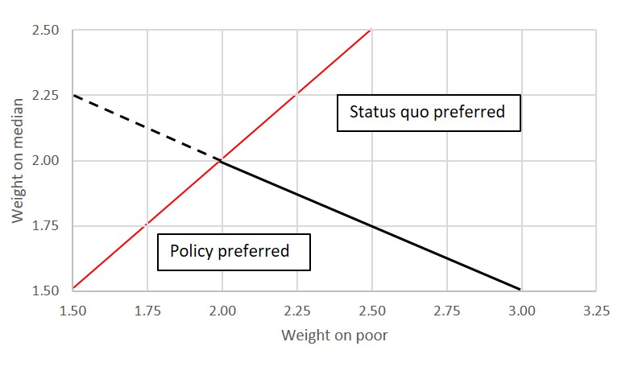
Figure 1 shows the breakeven locus for a policy which, after utility-weighting, generates costs of 5 to the poor and 10 to the median, and benefits to the wealthy of 30, generating a net benefit in terms of welfare efficiency of 15. It shows, for example, that if we equity weighted the costs to the poor, relative to the wealthy, by 2.5, we would need to apply an equity weight of 1.75 to the costs of the median for the policy to breakeven. If we raise the weight on the poor while holding the weight on the median constant or raise the weight on the median while holding the weight on the poor constant, the net benefit of the policy will become negative, and the status quo will be preferred. If we lower either of the weights, holding the other constant, the policy will be preferred. This information allows decision makers to consider whether the importance they place on the welfare of the poor and the median, relative to the wealthy, is sufficient to outweigh the aggregate welfare benefit of the policy. If a policy maker concludes that they consider the welfare of the poor to be worth at least 150% more than the welfare of the wealthy, and the welfare of the median to be worth at least 75% more than the welfare of the wealthy, they should stick with the status quo.
Note that the portion of the locus above the 45-degree line is dashed. In this region, the weight on the median is greater than the weight on the poor, which would violate intuition about the relative concern society should have for the two groups.
In figure 2, we consider a policy that has costs to the poor and benefits to both median and wealthy. In particular, suppose that after utility weights, the cost to the poor is 35, the benefit to the median is 15, and the benefit to the wealthy is 40. Without equity-weighting, the net benefit is 20. The locus of breakeven equity weights is upward sloping in this case, reflecting the fact that as the costs to the poor are inflated, the total net benefit falls, requiring the benefits to the median to be inflated in order to bring net benefits back up. Now the policy is preferred above the locus. For example, if the equity weight we place on the poor is 1.75 and the weight we place on the median is 1.5 (a point above the locus), the net benefit of the policy becomes positive. Starting with the same weight on the poor, if we instead place a weight on the median of only 1.25, which is just below the locus, the net benefit becomes negative.
Figure 2. Breakeven locus for a policy with costs to poor and benefits to median.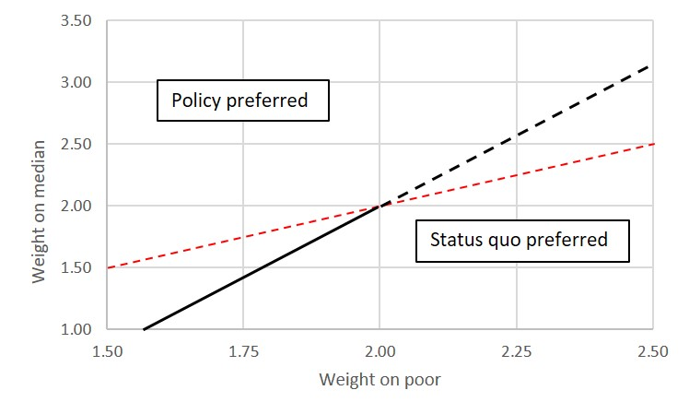

Again, we believe that the information contained in these graphs is intuitively meaningful and could be of use to decision makers. However, for a time constrained decision maker without a certain degree of familiarity with graphic presentation of numbers, the interpretation figures might be prohibitively complex.

We will get the same results whether we think in terms of moving from A to B, or in terms of moving from B to A.

