Appendix. Google Doc for Turkers

This document contains slightly longer directions to those found in this Amazon Mechanical Turk HIT. There are 7 graphs to categorize and review.

- Please select whether the graph appears to be made with data or is a diagram or illustration of a theory or concept. For example, this is a conceptual diagram. The author is plotting and labeling the lines, but they don’t appear to be directly tied to any data—there are no numbers and no numbers labeling the axes.

Figure A1. Conceptual Diagram
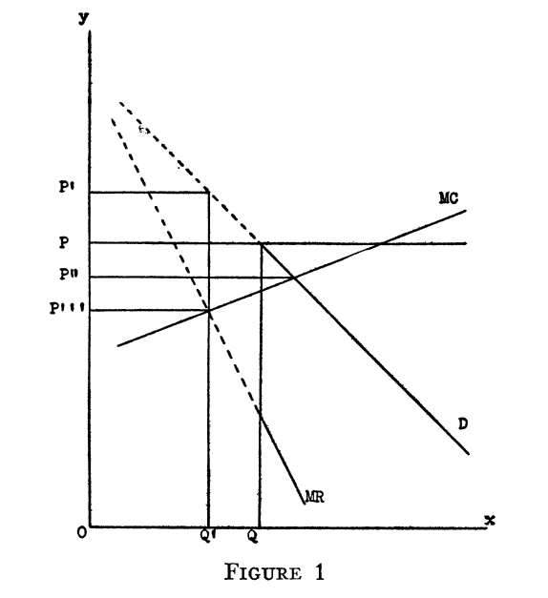

By comparison, this is a standard line chart that is clearly plotting data. There is a legend in the upper-right, years along the x-axis, and percentage labels along the y-axis.

Figure A2. Graph made with data
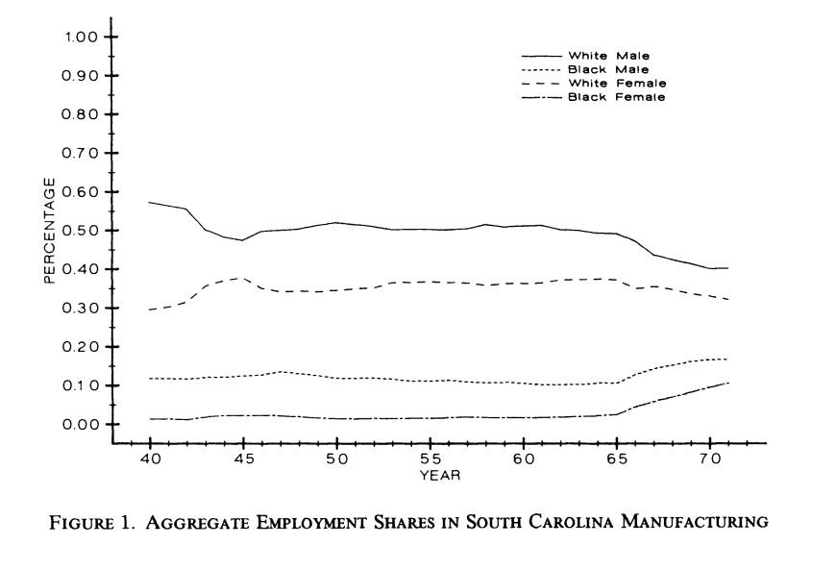

- Select the type of graph you see. If the option is not available, please type it in the box. Here are some examples.

Figure A3. Area Chart
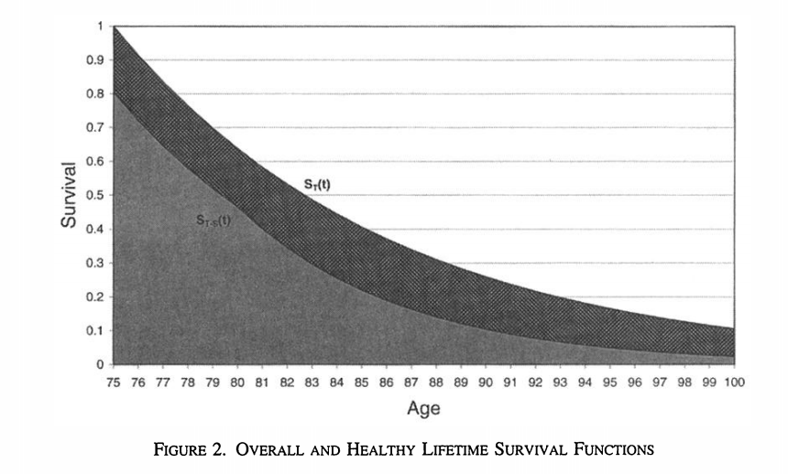

Figure A4. Bar/Column Chart
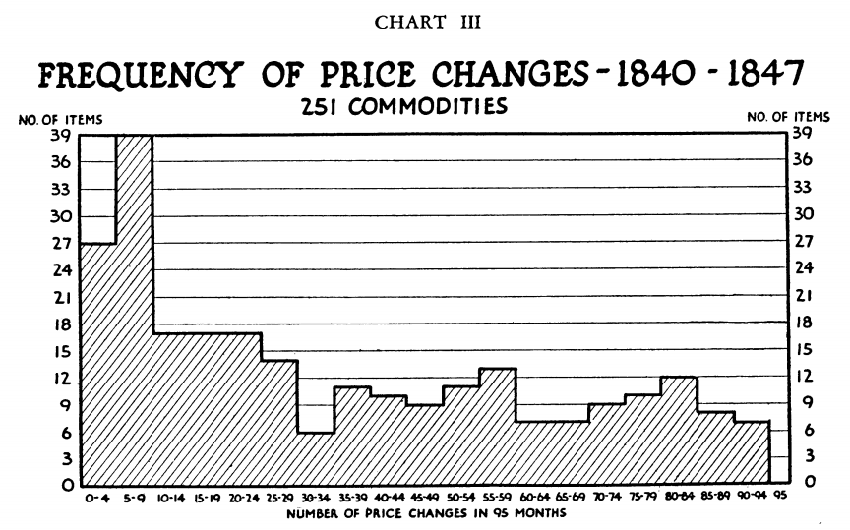

Figure A5. Histogram
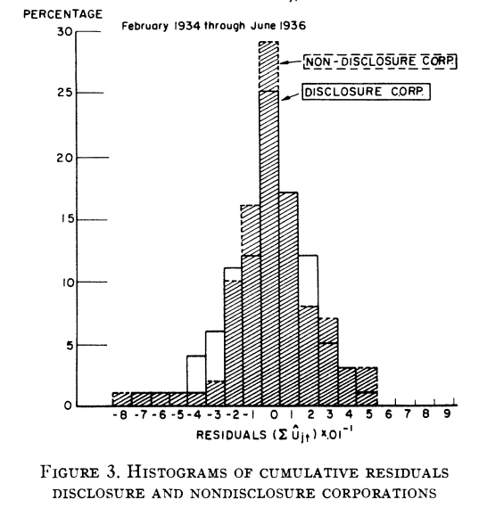
Figure A6. Line Chart
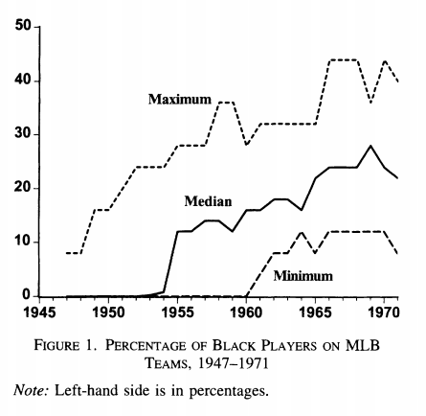

Figure A7. Map
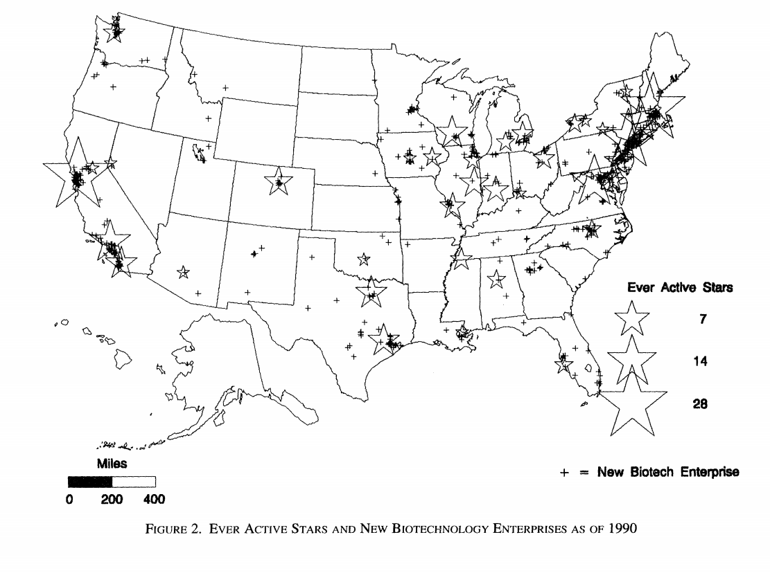
Figure A8. Pie Chart
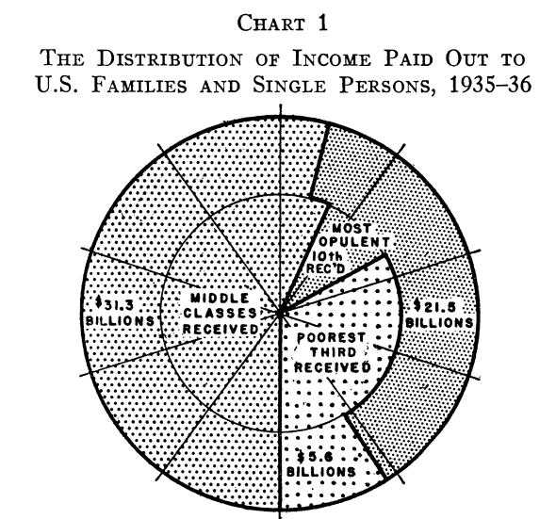

Figure A9. Scatterplot
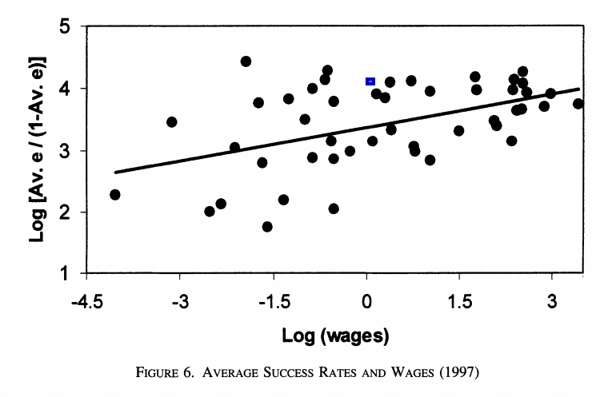
Figure A10. Table
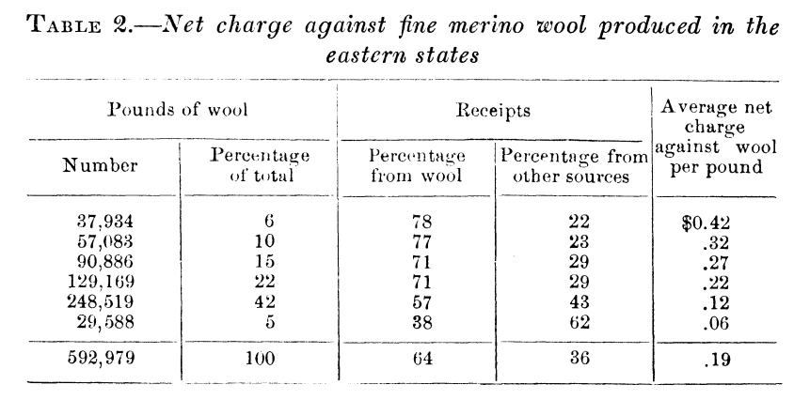

Figure A11. Other (Timeline)
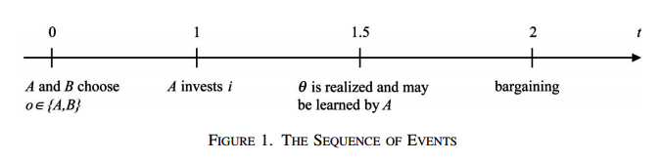

Figure A12. Other (3D Contour Plot)
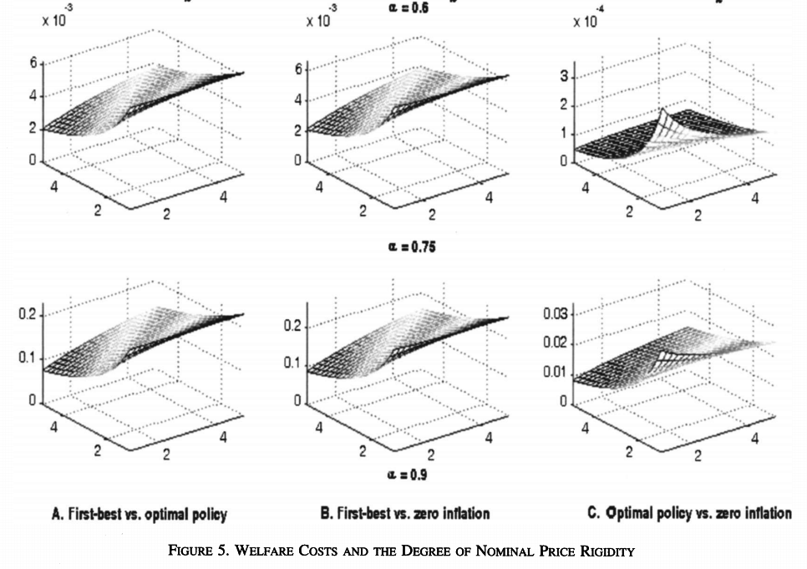

Figure A13. Other (Venn Diagram)
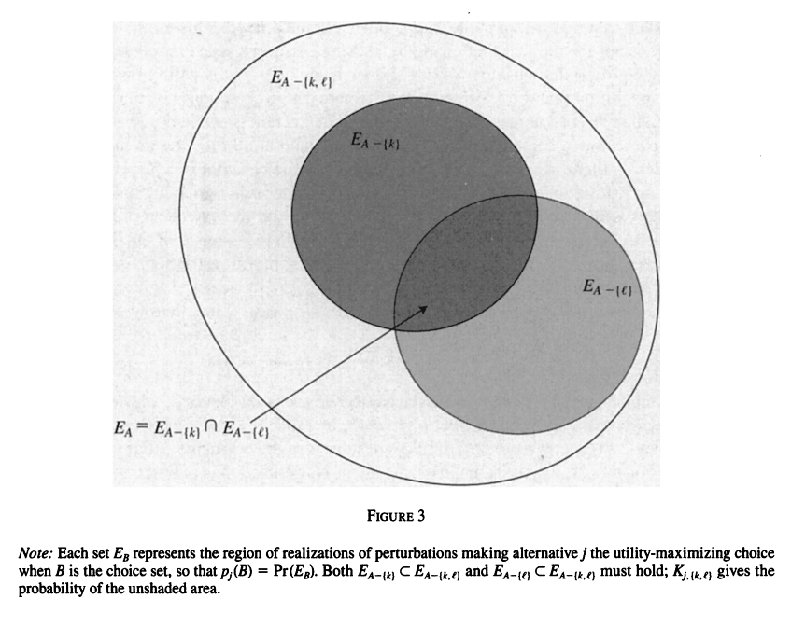

- Please rate the graph (1=bad, 5=great) based on your ability to review and understand the graph. This is inherently a subjective question, so make your best judgment based on your perception of the visual.

