Supplementary material
Table 3: Sample, by country and historical year
Country | Historical year
 | 2006 | 2007 | 2008 | 2009 | 2010 | 2011 | 2012 | 2013
AT | 161 | 156 | 159 | 180 | 173 | 135 | 142 | 166
BE | 209 | 176 | 219 | 242 | 172 | 193 | 222 | 213
BG | 100 | 145 | 163 | 143 | 142 | 138 | 114 | 128
CY | 65 | 59 | 47 | 97 | 66 | 98 | 65 | 109
CZ | 245 | 174 | 245 | 226 | 207 | 140 | 145 | 160
DK | 49 | 24 | 42 | 33 | 48 | 41 | 51 | 45
EE | 84 | 72 | 78 | 89 | 119 | 125 | 98 | 103
EL |  | 155 | 177 | 127 | 160 | 194 | 440 | 387
ES | 219 | 229 | 229 | 245 | 283 | 256 | 250 | 321
FI | 73 | 69 | 69 | 157 | 130 | 95 | 36 | 52
FR | 171 | 165 | 208 | 206 | 179 | 179 | 146 | 200
HR |  |  |  |  | 377 | 232 |  | 232
HU | 384 | 287 | 414 | 397 | 611 | 288 | 259 | 245
IE |  | 156 | 207 |  |  | 279 | 193 | 208
IS | 9 | 6 | 5 | 21 | 20 | 18 | 13 | 11
IT | 510 | 496 | 439 | 409 | 508 | 440 | 403 | 427
LT | 88 | 79 | 91 | 133 | 107 | 113 | 61 | 58
LU | 22 | 10 | 96 | 131 | 115 | 128 | 83 | 82
LV | 98 | 106 | 117 | 191 | 185 | 118 | 140 | 117
MT |  | 127 | 152 | 143 | 157 | 126 | 123
NL | 155 | 170 | 108 | 119 | 179 | 119 | 107 | 142
NO |  |  | 17 | 20 | 21 | 46 | 28 | 42
PL | 412 | 368 | 334 | 391 | 365 | 374 | 321 | 358
PT |  | 50 | 30 | 30 | 25 | 6 | 2 | 4
RO |  | 184 | 287 | 260 | 255 | 178 | 160 | 162
RS | 54 | 42 | 37 | 42 | 37 | 28 | 34 | 23
SE | 110 | 127 | 96 | 113 | 122 | 140 | 128 | 126
SI | 73 | 55 | 68 | 138 | 115 | 5 | 50 | 49
SK |  | 184 | 195 | 184 | 211 | 199 | 357 | 262
UK | 161 | 156 | 159 | 180 | 173 | 135 | 142 | 166
Note: Source EU-SILC (Eurostat), own calculation. The historical year 2014 is not shown. It does however figure in the data, because the change of the dependent variable after 2013 requires the information on the household’s status in 2014.

Figure 2: Mean change of the (quasi-)jobless households’ work intensity over one year, by country, in percentage points
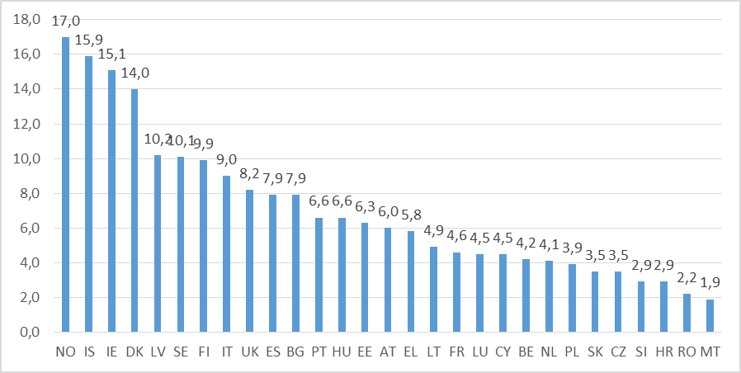
Note: Source EU-SILC (Eurostat), own calculation.

Table 4: Variables used in the regression models
Category | Variable | Scale | Source
dependent variable | change in work intensity, measured in p.p. | metric | EU-SILC*
fixed effects
independent variables: social benefits measured at household level | non-adjusted, measured as PPS | metric | EU-SILC*
 | non-adjusted, measured as % of poverty threshold** | metric | EU-SILC*
 | ENI-adjusted, measured as PPS | metric | EU-SILC*
 | ENI-adjusted, measured as % of poverty threshold** | metric | EU-SILC*
micro-level controls: household situation and composition | equivalised income before transfers as % of poverty threshold | metric | EU-SILC*
 | work intensity, part-time adjusted | metric | EU-SILC*
 | # of working-aged members below 30 | metric | EU-SILC*
 | # of working-aged members above 55 | metric | EU-SILC*
 | # of members with low education | metric | EU-SILC*
 | # of members with low education | metric | EU-SILC*
 | # of members with limited activity due to health | metric | EU-SILC*
 | partner household | dummy | EU-SILC*
 | # of children aged 0–2 | metric | EU-SILC*
 | # of children aged 3–6 | metric | EU-SILC*
 | # of children aged 7–17 | metric | EU-SILC*
macro-level controls | Gini coefficient | metric | Eurostat
 | change of unemployment rate as % of population | metric | Eurostat*
historical time | year | dummy | EU-SILC*
random effects
geographical unit | country | dummy | EU-SILC*
*Own calculations. **Sensitivity analysis.

Table 5: Regression output on work intensity changes, with both main and alternative independent variables
Category | Variable | Non-adjusted amounts |  | ENI-adjusted amounts
dependent variable: change in work intensity |  | PPS | PTH¹ | PPS | PTH¹
Social benefits | non-adjusted, measured as PPS | -0.000***
 | non-adjusted, measured as % of poverty threshold |  | -0.000***
 | ENI-adjusted, measured as PPS |  |  | -0.000***
 | ENI-adjusted, measured as % of poverty threshold |  |  |  | -0.001***
household situation | EDHI¹ as % of poverty threshold | 0.004*** | 0.004*** | 0.005*** | 0.005***
 | work intensity, part-time adjusted | 0.167*** | 0.167*** | 0.175*** | 0.175***
household composition | # of working-aged members below 30 | 0.001*** | 0.001*** | 0.001*** | 0.001***
 | # of working-aged members above 55 | -0.001*** | -0.001*** | -0.001*** | -0.001***
 | # of members with low education | -0.013*** | -0.013*** | -0.013*** | -0.013***
 | # of members with high education | 0.030*** | 0.030*** | 0.030*** | 0.030***
 | # of members with limited activity due to health | -0.052*** | -0.053*** | -0.054*** | -0.055***
 | partner household | -0.009*** | -0.009*** | -0.009*** | -0.009***
 | # of children aged 0–2 | 0.009* | 0.010* | 0.009 | 0.009*
 | # of children aged 3–6 | 0.009* | 0.009* | 0.009* | 0.009*
 | # of children aged 7–17 | 0.001 | 0.001 | 0.001 | 0.001
Historical time | Historical year (base 2006)
 | 2007 | -0.018*** | -0.019*** | -0.018*** | -0.018***
 | 2008 | -0.026*** | -0.026*** | -0.026*** | -0.026***
 | 2009 | -0.019*** | -0.020*** | -0.019*** | -0.020***
 | 2010 | -0.020*** | -0.021*** | -0.021*** | -0.021***
 | 2011 | -0.003 | -0.004 | -0.003 | -0.004
 | 2012 | -0.030*** | -0.031*** | -0.031*** | -0.032***
 | 2013 | -0.031*** | -0.032*** | -0.031*** | -0.032***
macro-level controls | change of unemployment rate as % of population | -0.006*** | -0.006*** | -0.006*** | -0.006***
 | Gini coefficient | -0.004*** | -0.004*** | -0.004*** | -0.004***
 | Intercept | 0.272*** | 0.265*** | 0.263*** | 0.259***
Level 2 estimates | Random intercept variance | -3.322*** | -3.380*** | -3.365*** | -3.397***
 | Within-group error variance | -1.681*** | -1.681*** | -1.680*** | -1.680***
 | N | 34081 | 34081 | 34081 | 34081
Note: Source EU-SILC (Eurostat), own calculation. Legend: * p<.05; ** p<.01; *** p<.001. ¹Equivalised social benefits received by households deflated not by purchasing power parity, but by the level of the poverty threshold in the respective country and year.

Table 6: Reduction of the change of work intensity following a hypothetical 100% increase of social benefits, by initial (pre-transfer) poverty gap, for both main and alternative independent variables, in p.p.
Social benefits | Whole sample | Subsamples by size of poverty gap
 |  | > than 50% of threshold | 50% – 1% of threshold | no poverty gap
non-adjusted benefits, measured as PPS | -0.8*** | -2.4*** | not sig. | not sig.
non-adjusted benefits, measured as % of poverty threshold | -0.8*** | -2.7*** | not sig. | -0.1*
ENI-adjusted benefits, measured as PPS | -0.6*** | -2.3*** | not sig. | not sig.
ENI-adjusted benefits, measured as % of poverty threshold | -0.5*** | -2.6*** | not sig. | -0.1*
N | 34,081 | 14,390 | 6,108 | 13,581
Note: Source EU-SILC (Eurostat), own calculation. Average partial effects. Legend: * p<.05; ** p<.01; *** p<.001

Table 7: Reduction of the change of work intensity following a hypothetical 100% increase of social benefits, by features of working-age household members, in p.p.
Working-age household members |  | non-adjusted benefits, measured as PPS | ENI-adjusted benefits, measured as PPS | N
Age | all < 30 | -2.9** | -2.4** | 1,464
 | all 30–55 | -2.4*** | -1.9*** | 9,552
 | all > 55 | not sig. | not sig. | 16,760
Education | all low | -0.6*** | -0.4*** | 11,395
 | no low | -0.9*** | -0.6*** | 17,942
 | all high | -0.9*** | -0.6*** | 4,244
 | no high | -0.7*** | -0.4*** | 27,410
Limitations  due to health | none | -0.7*** | -0.5*** | 17,102
 | some | -0.6*** | -0.4*** | 16,979
Note: Source EU-SILC (Eurostat), own calculation. Average partial effects. Legend: * p<.05; ** p<.01; *** p<.001

