Supplementary Material

Stable Near-Infrared Photoluminescence from Silicon Quantum Dot–Bovine Serum Albumin Composites
Asuka Inoue†, Hiroshi Sugimoto†, Yozo Sugimoto†, Kensuke Akamatsu‡, Marie Hubalek Kalbacova§, Chiaki Ogino|| and Minoru Fujii†*
†Department of Electrical and Electronic Engineering, Graduate School of Engineering, Kobe University, Rokkodai, Nada, Kobe, Japan
‡Department of Nanobiochemistry, Frontiers of Innovative Research in Science and Technology (FIRST), Konan University, Minatojimaminami, Chuo-ku, Kobe, Japan
§Biomedical Center, Faculty of Medicine in Pilsen, Charles University in Prague, Pilsen, Czech Republic.
||Department of Chemical Science and Engineering, Graduate School of Engineering, Kobe University, Rokkodai, Nada, Kobe, Japan

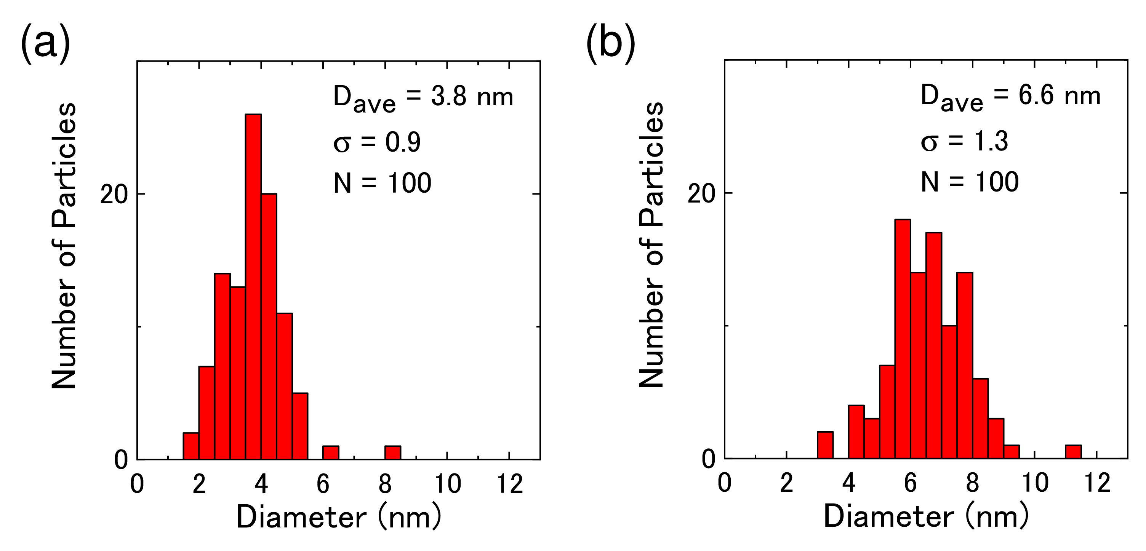Figure S1. Size distribution of Si QDs obtained from TEM images. The growth temperatures of Si QDs are (a) 1100 C ̊ and (b) 1200 C ̊, respectively.

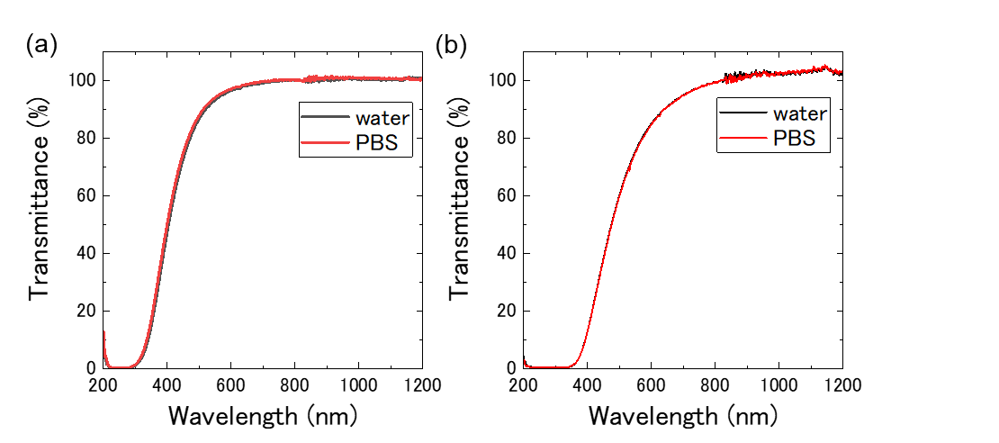
Figure S2. Optical transmittance spectra of Si QDs in water (black) and in PBS (red). The diameters of Si QDs are (a) 4 nm and (b) 7 nm.

