Supplementary Material
Rugged Nanoparticle Tracers for Mass Tracking in Explosive Events
Lance Hubbard,†* Ryan Sumner,†* Martin Liezers,† Trevor Cell,† Clara Reed,† Caleb Allen,† Brittney Berry,† Hugh Curah,† Erin Fuller,† Erin Kinney,† Nathaniel Smith,† Michael Foxe,† and April Carman†

†Pacific Northwest National Laboratory, 902 Battelle Boulevard, Richland, WA 99354, USA
ᶵ Pacific Northwest National Laboratory, 902 Battelle Boulevard, Richland, WA 99354, USA
*Corresponding Authors, correspondence to lance.hubbard.pnnl.gov: ryan.sumner@pnnl.gov
1. HORIBA Scientific: Photoluminescence spectra of samples shown in Figures S1 and S2 were measured on HORIBA NanoLog 3. All slit widths and blazes were held constant for measurements at λ_{ex}=325 nm and λ_{ex}=405 nm light, with the integration of 1 nm*s⁻¹ and 3 nm*s⁻¹, respectively. All cuvette samples were compared at similar particle concentrations (~0.8 mg/mL). All cuvette samples were vortexed at 3200 rpm for 30 s prior to measurement.
2. Scanning electron images (SEM) were taken on a Helios focused ion beam (FIB) SEM. The bias was set to 10 kV and the working distance varied between 6 and 8 mm. Scanning transmission electron microscope (STEM) images and transmission electron microscope (TEM) images were taken on a Titan 80-300™ scanning/transmission electron microscope. All electron images were analyzed with ImageJ 1.50i.
3. Photoluminescence spectra of pre- and post-exploding wire data were collected with an Ocean Optics HDX-UV-Vis fiber optic spectrometer, a 6-ft fiber 1 mm diameter optical patch cord NA24, and fused silica collimating lens. Integrations times of 100 ms were used in all cases with 2000 averaged iterations with a boxcar averaging of 10. Sample distance from the collimating lens was maintained at 1 cm for all cases. Illumination at 325 nm was performed with a MighTex 325 nm fiber coupled LED from Mightex Inc., and 405 nm illumination from readily available 405 nm LEDs. All illumination distances were maintained at 1 cm, and the irradiance for all LEDs was maintained at 220 µW, as measured at the end of the fiber.
4. The exploding bridge wire (EBW) generator employed for this work can be broken into four main components: the high-voltage charging unit, the energy storage capacitors, a triggered spark gap, and the assembly that holds the exploding wire. One end of the wire is connected to ground and the other to one side of the spark gap electrodes. In operation the target wire is fitted into the sample holder and the capacitors are charged to the required voltage, which typically takes 30-60 s. To prevent premature firing, the spark gap acts as an open switch, isolating the target wire from the charged capacitors. To discharge the stored energy rapidly through the wire on a microsecond timescale, a low-current high-voltage spark is used to breakdown the air in the spark gap. This effectively connects the charged capacitors to the target wire, which is then very rapidly heated and explosively vaporizes by the stored energy. The energy storage capacitors comprise four 30 µF capacitors with a voltage rating of 4500 volts mounted in parallel (Model: ZD452EW030S21A, Aerovox, New Bedford, MA, USA). When charged to 4000 volts, this would provide up to 960 joules of stored energy, which is small compared to some systems that have been built with mega joule energy capacities. However, the system is still more than adequate to vaporize a 0.1 mm diameter tungsten wire, even at reduced charging voltages.
Supplemental Figures:
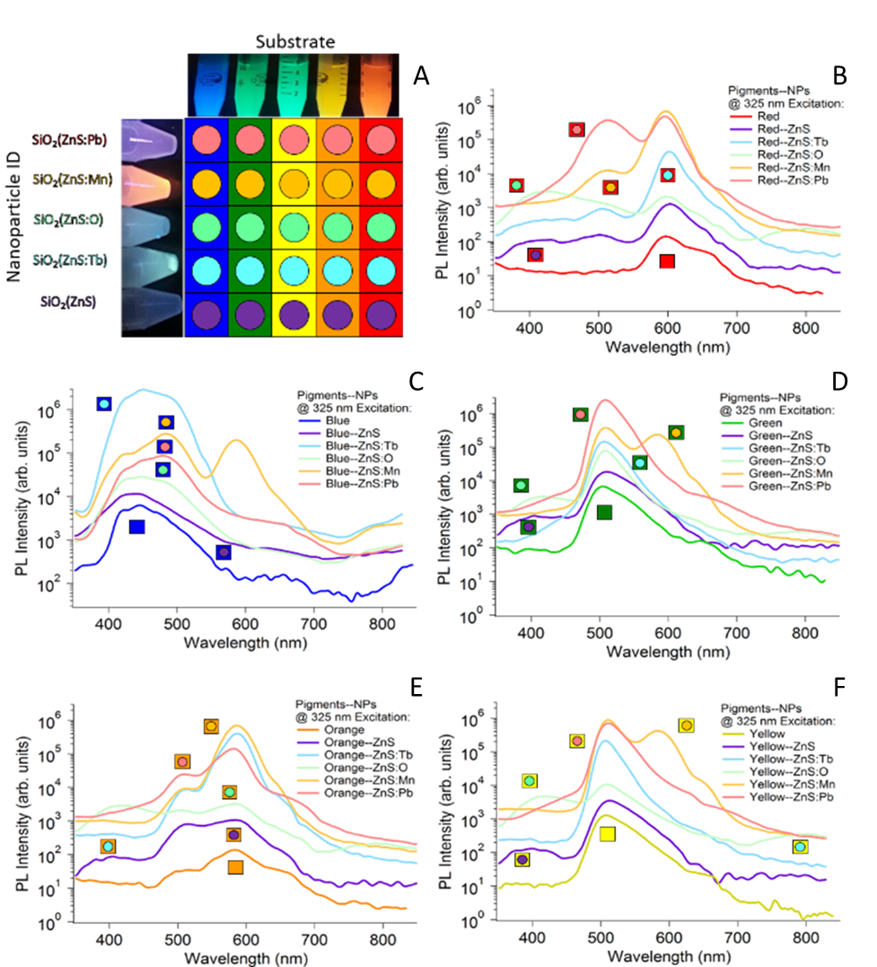
Figure S1. A comparison of the substrates bound with different quantum dots. A) A general overview of the 25 tracers with the main luminescent color of the substrates as squares and the QDs as circles. B) Intensity versus wavelength graph of the five substrate-nanoparticle complexes based on red substrate. C) intensity versus wavelength graph of the five substrate-nanoparticle complexes based on blue substrate, D) intensity versus wavelength graph of the five substrate-nanoparticle complexes based on green substrate, E) intensity versus wavelength graph of the five substrate-nanoparticle complexes based on orange substrate, F) intensity versus wavelength graph of the five substrate-nanoparticle complexes based on yellow substrate.

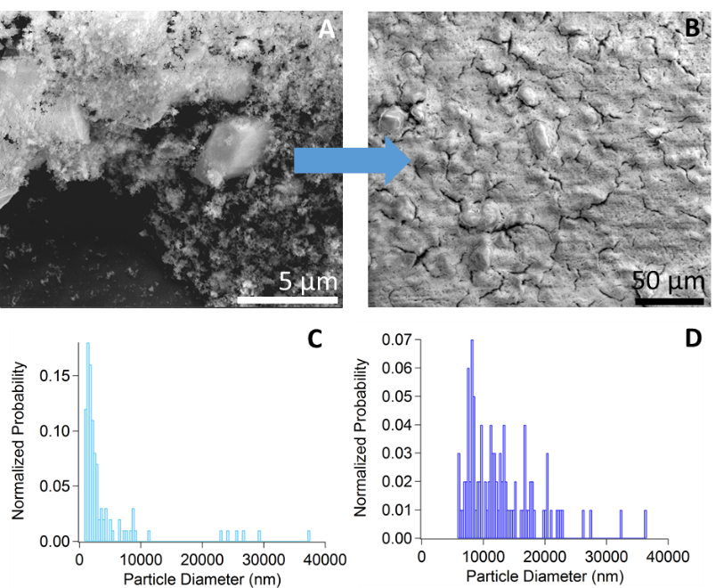
Figure S2. A) SEM image of the bound nanoparticles to the substrate, B) SEM image of the substrate nanoparticle complex encased in a silica gel, C) normalized size distribution of the bound nanoparticles to the substrate, D) normalized size distribution of the substrate nanoparticle complex encased in a silica gel.
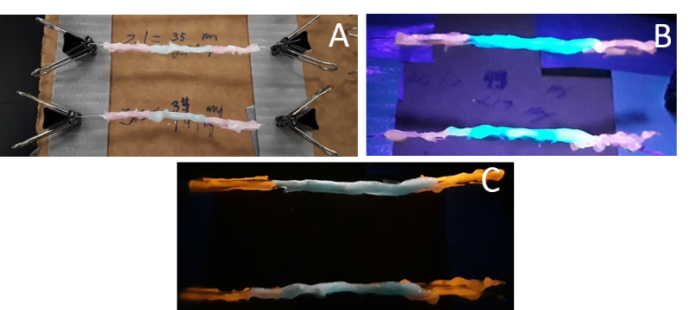

Figure S3. Representative wires coated with tracers used for this work: A) wires under ambient light, B) wires under illuminated light (λ_{ex}=405 nm), C) wires under illuminated light (λ_{ex}=325 nm).
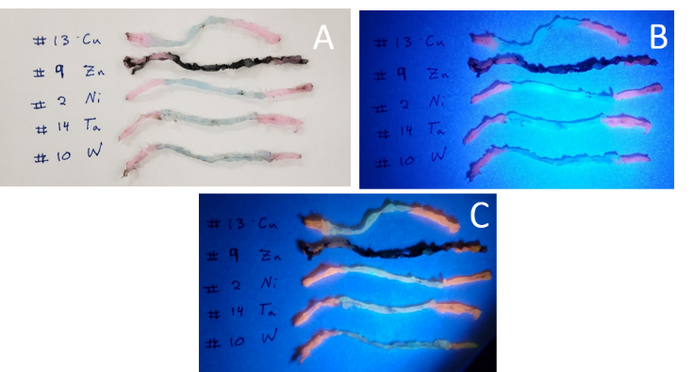
Figure S4. Representative wires coated with tracers used for this work after explosive wire test: A) wires under ambient light, B) wires under illuminated light (λ_{ex}=405 nm), C) wires under illuminated light (λ_{ex}=325 nm).
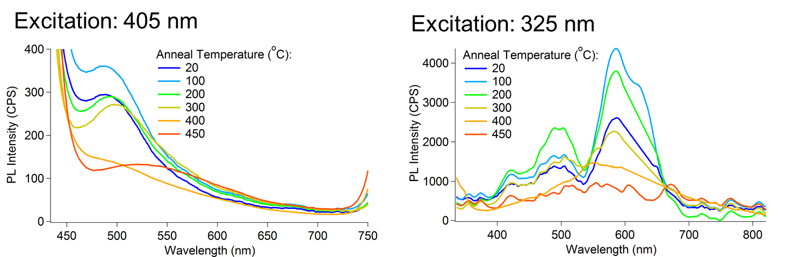
Figure S5. Static furnace testing of the tracer substrate (left) and particles (right). The particles were deposited on a steel plate and placed into a forced air, preheated furnace for 20 min. The samples were allowed to cool to RT and their photoluminescence was measured.

Table S1. Optically Active Tracer Mass by Layer Added to the Particles
Layer: | PL  (ug) | 95% Error  (± ug) | UV Imaging  (ug) | 95% Error  (± ug) | Average Active Fraction (%) | 95% Error  (%)
Control (water) | 54 | 61 | 0 | 0 | 0.5 | 1.2
NPs | 1343 | 101 | 1587 | 428 | 29.3 | 8.6
Silica@NPs | 2837 | 213 | 2593 | 322 | 54.3 | 6.4
Silica Gel@Silica@NPs | 4618 | 346 | 4631 | 289 | 92.5 | 6.9

Table S1, shows that the fraction of quantum dots remaining optically active after the explosion increases with the addition of each subsequent layer. The final fraction of surviving particles was 92.5±6.9%, which is a large improvement over previous work. Lastly, the survivability of the linked particle and substrate system was evaluated to show the durability of the dual tracer system to the environments of chemical high-explosives.
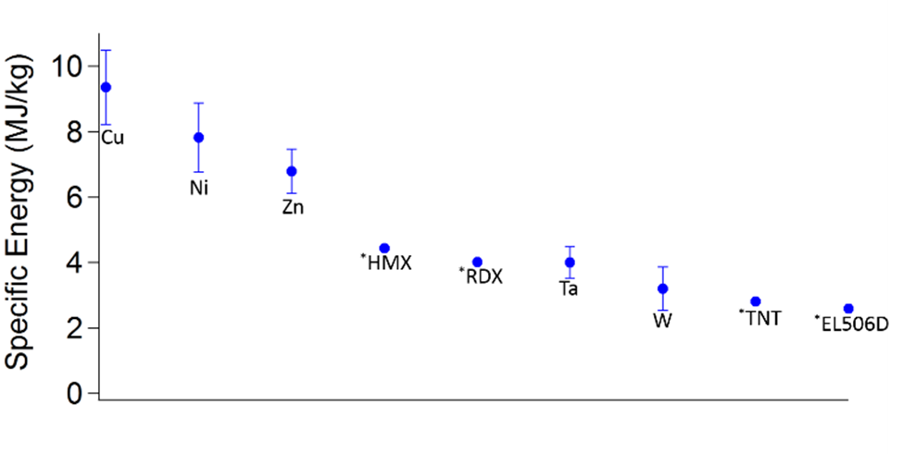
Figure S6. Specific energy of different compositional wires in the explosive wire setup compared to common chemical explosives. The specific energies of select chemical explosives are taken from Reference 14 ( the data points are marked with an * prior to the label).
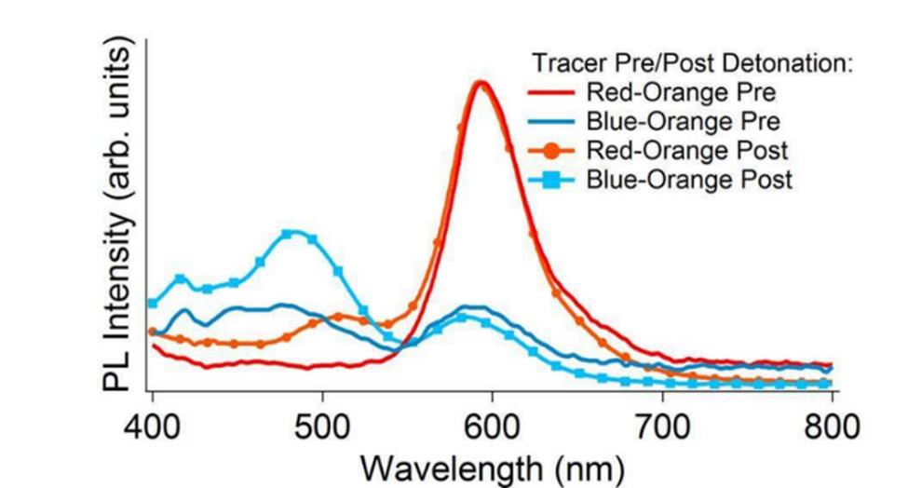
Figure S7. Photoluminescent spectra of red and blue tracer post- and pre-detonation of copper wire, excitation wavelength = 325 nm

