Supporting Information

§S1. Supplemental Figures for Referenced Models and Modelling

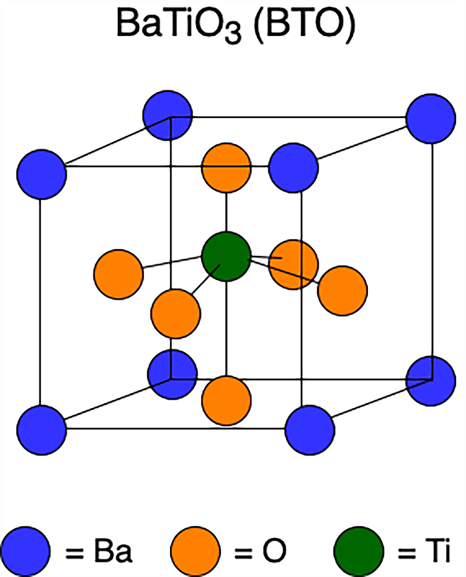
Figure S1. A unit cell of a BTO crystal, showing the perovskite structure and displaced titanium that results from room temperature polarization.

Figure S2. The finite element model of the composite specimen
In Fig. S2, N_{a} = 1 and n = 7, corresponding to F_{a} = 0.6699, with the single agglomerate centered as a 7x7 array of particles in the cube. The 169 dispersed particles are randomly distributed throughout this agglomerate.
Figure S3. SEM image of 400 nm BTO as received from Sakai Chemical.

§S2. Additional Data Concerning Nanocomposite Dielectric Constant

BTO Nanoparticle Diameter | 50 nm | 100 nm | 200 nm | 300 nm | 400 nm | 500 nm
ε_{c} | 7.40±0.17 | 7.30±0.19 | 7.29±0.15 | 7.20±0.10 | 7.14±0.17 | 7.03±0.14
Table S1. ε_{c} for fabricated nanocomposites containing BTO nanoparticles with different diameters and a volume loading set at δ_{v} = 0.05.

BTO Nanoparticle Diameter | 50 nm | 100 nm | 200 nm | 300 nm | 400 nm | 500 nm
ε_{p}  Maxwell-Garnett | 2,913±311 | 3,138±439 | 3,131±335 | 3,324±245 | 3,650±786 | 4,040±664
ε_{p}  Bruggeman | 3,679 ± 388 | 3,967±564 | 3,954±428 | 4,200±316 | 4,655 ± 1,000 | 5,500±853
ε_{p} Jayasundere-Smith | 1,337±17.3 | 1,276±18.6 | 1,240±15.1 | 1,230±9.68 | 1,170±17.4 | 1,143±13.58
Table S2. Maxwell-Garnett, Bruggeman, and Jayasundere-Smith EMAs (δ_{v} = 0.05) experimental results with a sample size of 6 nanocomposites for each particle diameter.

tBuPA loading (corresponding BTO Size) | 2.249 g (50 nm) | 0.225 g (500 nm)
ε_{m}  _{(LDPE + tBuPA)} | 6.29±0.69 | 5.58±0.32
Table S3. Dielectric constants of LDPE consisting of different amounts of tBuPA.

§S3. Surfactant Calculations

The amount of surfactant (tert-Butylphosphonic acid, or tBuPA) required for each batch of specimens is inversely proportional to the diameter of BTO nanoparticles used to fabricate the nanocomposite. These calculations assume that the nanoparticles are completely spherical. Previous research verified that this spherical assumption is reasonable by comparing nanoparticle surface area values derived from the equations outlined below (for a certain mass of BTO used) to estimates of the surface area of the nanoparticles provided by Sakai Chemical Industry (as determined by the Brunauer-Emmett-Teller method).^{[1]} Fig. S3 demonstrates the approximate sphericity of the nanoparticles through scanning electron microscopy (SEM).
The amount of surfactant needed is calculated by equation (S1) below:
 | $m_{tBuPA}={mol}_{tBuPA}⋅{MW}_{tBuPA}$ | (S1)

The mass of surfactant required (m_{tBuPA}) is given by multiplying the moles of surfactant (mol_{tBuPA}) by the molecular weight of surfactant (MW_{tBuPA} = 138.1 g/mol), and mol_{tBuPA} is given by equation (S2):
 | $${mol}_{tBuPA}=\frac{{SA}_{total}}{SA/mol tBuPA}$$ | (S2)

The surface area per mol of tBuPA (SA/mol tBuPA) was found to be 3.029 x 10⁴ m²/mol based on thermogravimetric analysis (TGA) performed by Sandia National Laboratories.^{[1]} The total surface area of the nanoparticle sample (SA_{total}) is the product of the total number of BTO nanoparticles (in a given mass m_{BTO}) and the surface area of a nanoparticle (SA_{nanoparticle}), as in equation (S3):
 | $${SA}_{total}=\# of BTO nanoparticles⋅{SA}_{nanoparticle}$$ | (S3)
Considering the spherical assumption, the formula for the surface area of a sphere is used to calculate the surface area of a nanoparticle (SA_{nanoparticle} = 4𝜋r²), where r is the radius of the nanoparticle stock being used. The number of BTO nanoparticles is calculated with equation (S4):
 | $$\# of BTO nanoparticles = \frac{m_{BTO}}{{m_{BTO}}/{nanoparticle}}$$ | (S4)
The mass of BTO per nanoparticle (m_{BTO}/nanoparticle) is given by the product of the volume of a nanoparticle ($V_{nanoparticle}=\frac{4}{3}πr^{3}$) and the density of BTO (𝜌_{BTO} = 6.02 g/cm³).
As stated in the manuscript, tBuPA is polar which results in the variation of medium dielectric constant values. The effect of the surfactant on ε_{m} was studied both experimentally and computationally through the use of FEA. Experimental results of the effect of the surfactant on ε_{m} were taken for samples of 50 nm and 500 nm particle size. With the use of quadratic interpolation, the effect of tBuPA on ε_{m} for different nanoparticle sizes was approximated. The steps involved to conduct this mathematical technique are summarized below.
Polynomial interpolation is a common numerical method utilized for approximation by finding a function that describes the behavior given an interval of data. Given that the values ε_{m} of samples with tBuPA were experimentally measured only for the smallest and largest nanoparticle size, quadratic interpolation was applied. This method estimates the behavior of ε_{m} for samples in between these two nanoparticle sizes by solving a system of equations. Setting the quadratic interpolation equation as in equation (S5):
 | $$ε_{m}\left(x\right)=c_{2}x^{2}+c_{1}x+c_{0}$$ | (S5)
A system of three equations can be applied with three unknowns where x₁ and x₂ define the two experimentally extracted points, as shown in equations (S6):
 | $$ε_{m}\left(x_{1}\right)=c_{2}x_{1}^{2}+c_{1}x_{1}+c_{0}$$  $$ε_{m}\left(x_{2}\right)=c_{2}x_{2}^{2}+c_{1}x_{2}+c_{0}$$  $$δ(ε_{m}\left(x_{1})\right)={2c}_{2}x_{1}+c_{1}$$ | (S6)
After solving the system of equations, establishing a minimizer of the function δ(ε_{m}(x)), the estimated values of the medium dielectric constant for nanocomposites fabricated with nanoparticle sizes between 50 nm and 500 nm can be calculated.

§S4: Complete Nanocomposite Manufacturing Procedure

i. Mixing for 5 vol% loaded BTO nanocomposites in LDPE

In the first step of the mixing stage, agglomerated BTO is ball milled with zirconia grinding balls (0.5 mm diameter, Retsch 32.368.0003) and surfactant for four hours at 150 rpm. The ball mill (Retsch PM100) disperses agglomerated nanoparticles, which enables BTO to be evenly dispersed within the LDPE matrix.^{[2]} BTO nanoparticles were functionalized with tBuPA, obtained from Sigma-Aldrich, to prevent nanoparticle re-agglomeration after ball milling. The calculations for the amount of tBuPA in each batch are presented in section S1 of this document. Once the surfactant required is calculated, tBuPA, BTO nanoparticles, and zirconia grinding balls are placed into a ball milling jar. The ball mill, a Retsch PM100, runs for four hours at 150 rpm. After ball milling is complete, the grinding jar is removed, and the contents are transferred into a Finum steel mesh filter to separate the deagglomerated BTO from the grinding balls.

Figure S4. Finum Steel Mesh Filter

A stirring tool is used to agitate the mixture and force the BTO through the sides of the filter. The BTO is filtered directly into a planetary mixing container of known weight and then a corresponding amount of powderized polymer is added into the mixture to achieve the desired percent volume loading. Before transferring the BTO and polymer mix into a Pyrex container for melting, the elements are mixed rigorously in a cyclical rotating motion for approximately five minutes. In order for the LDPE-BTO mixture to be injection molded, it must be converted into a pelletized form. The reasoning behind this is twofold. Firstly, the powderized BTO is not inserted directly into the injection molder to reduce the safety risks involved with aerosolized nanoparticles. Secondly, powdered polymer does not work as well in the injection molder as the powder can easily get trapped in the walls of the barrel, which will then impact the functionality of the machinery. Additionally, powder stuck in the barrel increases the risk of contamination between samples of different sized BTO nanoparticles.
The first step in pellet formation is to melt the mixed BTO and polymer. To do this, the mixture of LDPE and BTO is transferred into a Pyrex container. This container is placed inside of a vacuum oven for 15 minutes at -101 kPa to ensure that any air trapped inside the mixture is expelled. The oven is then turned on and set to 215°C. After 2 hours, the Pyrex container is removed from the oven. The resulting BTO-LDPE sheet is placed in a fume hood to cool until the mixture has completely solidified and the Pyrex is cool enough to touch.
In order to form pellets, a pair of clean PVC cutters (cleaned with ethanol and water) is used to cut the sheet into squares of approximately 1 cm². Once the sheet of LDPE and BTO nanoparticles has been converted to a pelletized form, these pellets are ready to be injection molded into nanocomposite disks.

ii. Density Measurements and Sputtering

Density measurements are completed via the Archimedes method by measuring the mass of each sample and taking a volumetric measurement by submerging the sample in water. To prepare nanocomposites for capacitance measurements a sputter-coater is used to sputter gold electrical contacts on each side. The sputter coater (Quorum Technologies Q150T) is set to deliver 20 mA of current for 3,240 seconds per side of the nanocomposite disk. A 3D printed specimen holder is used to ensure that the edges of the disk are not sputtered. 8.45 mm along the edge of the disk should not be sputtered because the top and bottom surfaces of the disk should have two distinct electrical contacts for capacitance measurements. Once both sides of the nanocomposite have been sputtered with a gold coating, the parallel plate capacitor model can be applied to measure capacitance.

iii. Modifying the Procedure for 30 vol% Loading: Xylenes Solvation

The following fabrication procedure has been effective for fabricating nanocomposites with a volume percent loading of up to 30%. This process can also be used to fabricate samples with volume loadings up to 50% or possibly higher. This step takes place between i and ii, after the BTO has been ball milled and filtered, but before the baking step (Fig. S5). Instead of directly mixing LDPE and BTO, the polymer is first dissolved in a solution of xylenes, which sits on a hot plate at 100˚C in a fume hood. A magnetic stir rod is placed in the solution to ensure that it remains homogeneous. Once the LDPE dissolves, the BTO is added into the beaker to reach the desired volume percent loading. To produce the 30 vol% sample, 8.3 g of LDPE was dissolved in 138 mL of xylenes (in keeping with the 16.67:1 xylenes:LDPE ratio prescribed by Wong, et al.^{[3]}). Adding 22.842 g of 500 nm nanoparticles achieved 30 vol% BTO loading. The stir rod is left stirring the mixture until it is viscous enough that the rod is unable to move. At this point, the stir rod is removed from the mixture and the heat is turned off. The mixture is left in the fume hood overnight to allow for further evaporation of the xylenes, and then it is transferred from the beaker to a Pyrex container which is placed in the vacuum oven at a pressure of -101 kPa under vacuum at 215 ˚C for two hours. The vacuum oven melts the mixture to produce a uniform sheet, and further evaporates any remaining xylenes. The sheet is cooled and cut as described for the 5 vol% procedure. It is advisable for future work to investigate the impact of stirring or sonication during the melting process to aid in degassing the mixture.

Figure S5. The modified mixing stage component of the manufacturing process.

iv. Injection Molding

Injection molding is a manufacturing process in which molten material is injected into a prefabricated mold. It can be performed with a variety of materials such as glass, elastomers, and thermoplastics. The material is heated to a temperature above its melting temperature or glass-transition temperature (depending on the material) in the machine’s barrel, at which point it is subjected to high pressure by pneumatically depressing a ram inside the barrel, forcing the molten material through the nozzle and into a prefabricated mold. The high pressure at which the material is injected prevents voids and inconsistencies from forming in the final sample, with a uniform distribution of material across the mold. The device used for this investigation is the Morgan Industries Plastic Injection Molding Machine 4 Oz. G-100T.

Figure S6. A CAD model of the injection mold generated in SolidWorks.

Using an injection molder in the nanocomposite fabrication process is advantageous because it facilitates rapid production at scale. A dedicated mold was machined for nanocomposite fabrication (Fig S6) and the injection molding process was fine-tuned for rapid sample fabrication. The mold is clamped tightly against the nozzle to prevent leakage. The temperature of the heating elements, injection pressure, and mold clamping pressure are all adjustable. The injection material melts in the barrel after about 10 minutes, and the actual injection of polymer into the mold takes approximately five seconds. After that, the mold is cooled on a heat sink to allow the sample to completely solidify. Once the nanocomposite is removed, the mold is ready to be used again. Furthermore, injection molding is advantageous in terms of scalability. If the final sample dimensions must be changed, simply manufacturing a new mold with the desired shape and size will solve the issue.

v. Production of Injection Mold

Specimens are created by injecting polymers into a mold. Molds are machined from aluminum, which balances structural integrity and heat dispersal for the injection molding process. Since the mold must be put under significant pressure to ensure that the molded material is not lost and effectively fills the mold, the mold must be sufficiently strong to undergo repetitive stress on the order of 5 or more tons of clamping force. Using Multipurpose 6061 Aluminum obtained from McMaster-Carr, the mold would be expected to last for approximately 500 injection cycles at an average clamping force of 5 tons^{[4]}. Considering the dimensions of the mold (Fig S6), an 8” x 8”, 1.5” thick aluminum sheet (part no. 8812T236) is sufficient to manufacture two molds.

vi. Mold Design considerations

Venting

The polymer is injected into the mold at a minimum pressure of 60 psi. There is air trapped in the mold which could resist this stream of polymer, and it must be cleared. In order to allow air to exit the mold, a small vent must be cut from the mold cavity to the mold seam. Typical mold designs use channels with a depth and width of 0.5 mm and 6.35 mm, respectively.

Gate
The entrance to the mold through which the polymer flows is called the gate. In order to restrict the polymer flow so that it maintains enough pressure and flow velocity to fill the entire mold, the gate is often kept quite small and shallow. Typically, the gate is on the order of 2.032 mm in diameter, and 3.175 mm in depth.^{[4]} The gate is also situated at the bottom of the sprue, the channel that connects the injection molder nozzle through to the mold.

Sprue
The sprue channels polymer through the gate from the injection molder nozzle. One primary concern with the sprue is its draft and alignment. The sprue is not a cylindrical channel, but instead progressively decreases in radius in order to throttle the injected polymer. The polymer must be throttled so that it maintains a relatively even flow profile while passing through the gate, without creating voids due to turbulent flow. The alignment of the sprue with the injection molder nozzle is also of primary concern, as misalignment can cause turbulent flow and disrupt the injection process. In this case, the sprue was designed with a 3^{O} draft (Fig S7).

Size determination
An analysis of the geometric configuration of nanocomposite specimens in previous years yielded some insight into the optimal geometry of the disc. The group utilized previous calculations conducted by a previous team under the guidance of Peter Saeta, Professor of Physics at Harvey Mudd College.^{[1]} The geometric configuration of the nanocomposite mold was set to 30 mm in diameter by 1 mm in depth, as below in Fig S7.

Figure S7. Custom injection mold CAD drawings manufactured out of 6061 aluminum.

§S5: Alternate Effective Medium Approximations (EMAs)

Three EMAs were used in a previous BTO nanocomposite study by Kaufman et al to approximate the dielectric constants of BTO nanoparticles. The Jayasundere Smith EMA is described in the main text. The other two discussed by Kaufman et al are outlined below.
The Maxwell-Garnett EMA^{[5]} is a model of the system that assumes that all the BTO nanoparticles with a volume loading fraction (δ_{v}) are evenly dispersed in a polymer matrix and do not interact with each other. This approximation is given by equation (S7).
 | $$\frac{ε_{c}-ε_{m}}{ε_{c}+2ε_{m}}=δ_{v}(\frac{ε_{c}-ε_{m}}{ε_{p}+2ε_{m}})$$ | (S7)
The Bruggeman EMA,^{[6]} which is shown in equation (S8), does not assume that the particles are spatially separated and evenly dispersed in the polymer matrix. However, previous studies have shown that it does not work well when ε_{p} is significantly larger than ε_{c}.^{[7,8]}
 | $\frac{ε_{p}-ε_{c}}{ε_{c}-ε_{m}}=\left(1-δ_{v}\right){\left(\frac{ε_{c}}{ε_{m}}\right)}^{1/3}$ | (S8)
The experimental results for ε_{p} extracted using these two EMAs are presented in Table S2 and plotted in Fig. S8 below.
(a)(b)
Figure S8. (a) Maxwell-Garnett EMA ε_{p} for nanocomposites containing BTO nanoparticles of increasing diameter.
(b) Bruggeman EMA ε_{p} for nanocomposites containing BTO nanoparticles of increasing diameter.

§S6: Supplemental Data and Analysis for FEA Modeling of Nanocomposites

To test the dependence of ε_{c} on F_{a}, a sweep was conducted from F_{a} = 0 (no agglomeration) to F_{a} = 1 (complete agglomeration) on a simulated nanocomposite loaded with BTO 500 nm in diameter. N_{p} and N_{a} were held constant at 512 and 1, respectively, while n was swept from 1 to 8 in increments of 1. As shown in Fig. S10, Fa ranges of 0.6699 to 1 correspond to an ε_{c} of 7.03±0.14, which matches experimentally measured values from nanocomposites containing 5 vol% BTO nanoparticles with a diameter of 500 nm (Table S1). Fig. S10 also demonstrates the linear relationship between F_{a} and ε_{c}.
Figure S9. ε_{c} (ε_{p} = 1500) vs ε_{m}, at a BTO diameter of 500 nm (δ_{v} = 0.05, F_{a} = 0.6699).

FEA was used to analyze the impact of medium dielectric constant (ε_{m}) on composite dielectric constant (ε_{c}) at 5 vol% BTO loading. The purpose of these simulations was to determine a relationship between these two parameters and allow for future research to compare experimental ε_{m} results to the values reported in the main body of the manuscript (Table II). This comparison, along with physical examination of the fabricated specimens, will allow for discussion as to how the xylenes affect the medium dielectric constant. A sweep was conducted over values of the medium dielectric constant, in which ε_{m} varied from 2 to 7 in increments of 0.5, with ε_{p} = 1500, F_{a} = 0.6699, and a particle diameter of 500 nm. Fig S9 demonstrates a linear relationship between ε_{m} and ε_{c}.
Figure S10. Simulated ε_{c} values (ε_{p} = 1500 and ε_{m} = 5.58) versus F_{a} at a BTO diameter of 500 nm (δ_{v} = 0.05)

§S7: Consideration for Higher Volume Loading and Future Work

Unfortunately, the circumstances prevented the production of more than a single sample before the laboratory became inaccessible due to the COVID-19 pandemic. The 30 vol% specimen was fabricated using the modified procedure for higher volume percent loading mentioned in this document, but investigations have not yet been made into whether any xylenes remained in the fabricated nanocomposite, as well as the effects of xylenes on the nanocomposite dielectric constant. Future work will necessitate research into any potential impact of this additional fabrication step on experimental results, beginning with the production of specimens made with just LDPE and surfactant (no nanoparticles) as a control.

§S8. The Impact of Ball Milling on BTO Particle Size

SEM imaging done by previous teams shows evidence that the ball milling procedure does not significantly impact particle size. Fig. S11 shows SEM imaging of BTO nanoparticles as received, and after 90 minutes of ball milling at 150 RPM (which was the speed used in the ball milling procedure). A 400 nm reference for particle size is given in each of the images, showing that the relative particle size of the BTO is not impacted by the ball milling procedure. This allows for the FEA model to serve as a relatively accurate prediction of composite and particle behavior at higher volume loading percentages for each nanoparticle diameter examined.
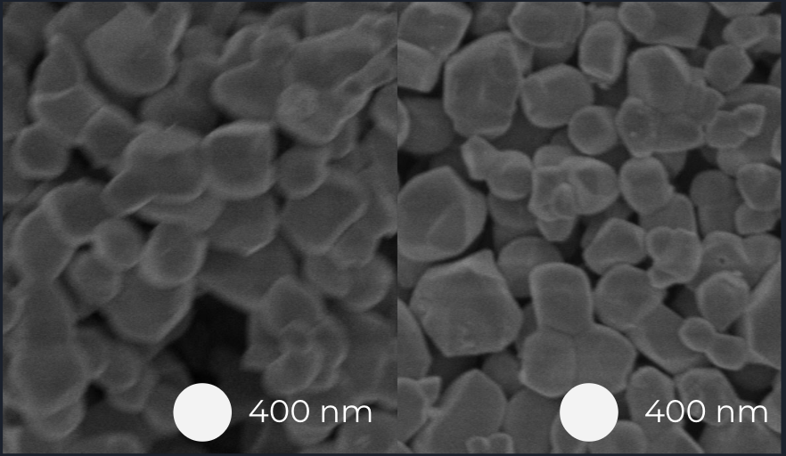
Figure S11. SEM Images of BTO nanoparticles i.) As received, ii.) After 90 minutes of ball milling at 150 RPM (as seen from left to right).

§S9. Table of Variables used in Equations and Models

Symbol | Variable
ε_{c} | dielectric constant of the nanocomposite
ε_{m} | Dielectric constant of the medium
ε_{p} | Dielectric constant of the particle
ε₀ | Vacuum permittivity (8.854x10⁻¹² F/m)
C | Capacitance of the nanocomposite
d | Average thickness of each nanocomposite
A | Area of deposited gold film on composite
F_{a} | Factor of agglomeration in nanocomposite specimen
N_{a} | Number of agglomerates in nanocomposite specimen
N_{p} | Total number of particles in nanocomposite specimen
n | Number of particles per agglomerate
δ_{v} | Volume loading fraction
Table S4. Variable symbols and definitions

References
1. A. Khan, B. Lehman, D. Andrew, C. Downing. E. Antholis, and M. Ventrakaman: “Measuring the Permittivity of Ferroelectric Nanoparticles in an Epoxy Composite.” Harvey Mudd College Clinic Midyear Technical Memorandum, Dec. 2018.
2. M. E. Mackay, A. Tuteja, P. M. Duxbury, C. J. Hawker, B. Van Horn, Z. Guan, G. Chen, and R. Krishnan: General strategies for nanoparticle dispersion. Science 311, 1740–1743 (2006).
3. W. Syie Luing, N. Norzita, and A. T. Tuan Abdullah: Study on Dissolution of Low Density Polyethylene (LDPE). Applied Mechanics and Materials 695, 170–173 (2014).
4. Morgan Press G-100T Instruction Manual, Ver. 1.1. Morgan Industries INC., Long Beach, U.S.A, 2016.
5. J. C. Maxwell Garnett: Colours in metal glasses, in metallic films, and in metallic solutions. II. Philosophical Transactions of the Royal Society of London B: Biological Sciences 205, 237–288 (1906).
6. D. A. G. Bruggeman: Berechnung verschiedener physikalischer konstanten von heterogenen substanzen. I. Dielektrizitatskonstanten und leitfahigkeiten der mischkorper aus isotropen substanzen.” ¨ Annalen der Physik 5, 636–664 (1935).
7. J. L. Kaufman, S. H. Tan, L. Kirklann, A. Shah, R. G. Gambee, C. Gage, L. MacIntosh, A. Dato, P. N. Saeta, R. C. Haskell, and T. C. Monson: Permittivity effects of particle agglomeration in ferroelectric ceramic-epoxy composites using finite element modelling. AIP Advances 8 (2018).
8. T. C. Choy: Effective medium theory: principles and applications (Oxford University Press, Oxford, England, 2015).

