Supporting Information

3D Printed Porous Tissue Engineering Scaffolds with the Self-folding Ability and Controlled Release of Growth Factor

Jiahui Lai, Junzhi Li, Min Wang *

Department of Mechanical Engineering
The University of Hong Kong
Pokfulam Road, Hong Kong

__________________________________________________________________________
* Corresponding Author:
Professor Min Wang, at the University of Hong Kong, Hong Kong
Email: memwang@hku.hk Tel: +852 3917 7903 Fax: +852 2858 5415

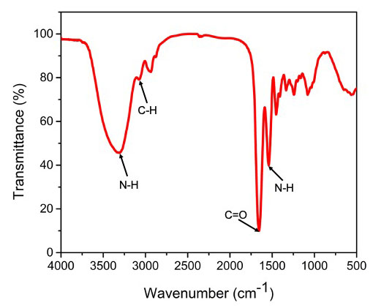
Figure S1. FTIR spectrum of synthesized gelatin methacrylate (GelMA). As shown in this FTIR spectrum, there are characteristic peaks at about 1654 cm⁻¹ and 1541 cm⁻¹ arising from the vibration of C=O bond and N-H bond, respectively. Besides, there are also peaks at about 3307 cm⁻¹ and 3077 cm⁻¹, separately, that are related to vibrations of N-H bond and C-H bond. These results confirm the successful synthesis of GelMA.

