Supplementary Material

Electrochemical detection of natural organic matter (humic acid) and splitting of H₂O₂ on a micro-pore 3D catalytic polysulfone-copper oxide nanocomposite surface

Olayemi J. Fakayode^{a*}and Thabo T.I. Nkambuleª

ª Nanotechnology and Water Sustainability Research Unit (NanoWS), College of Science, Engineering and Technology (CSET), University of South Africa (UNISA), Florida Campus, 60 Christian de wet street, P.O. Box 2820, Roodepoort, Florida, South Africa. *Email: fakayaj@unisa.ac.za / olayemifakayode@gmail.com

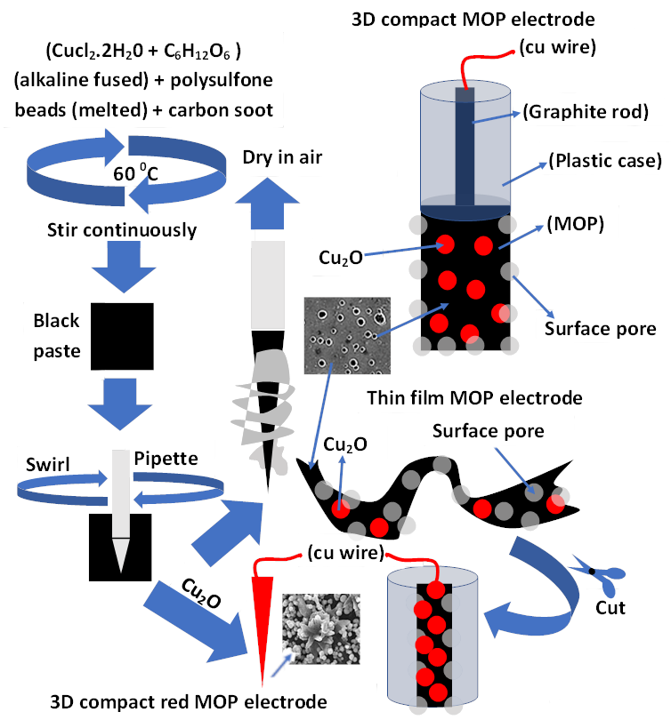
Fig. S1. Fabrication of Cu₂O(Cl)-polysulfone-carbon soot metalloplastic electrodes.

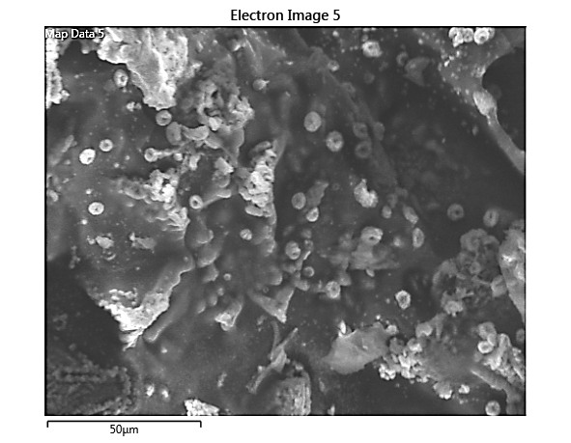
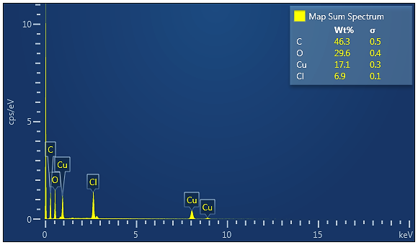
(i)
(a)
(b)

Figure S2. Characterization of the copper clusters in alkaline glucose matrix before composite formation with polysulfone and carbon soot. (a) SEM image; (b) EDS image.

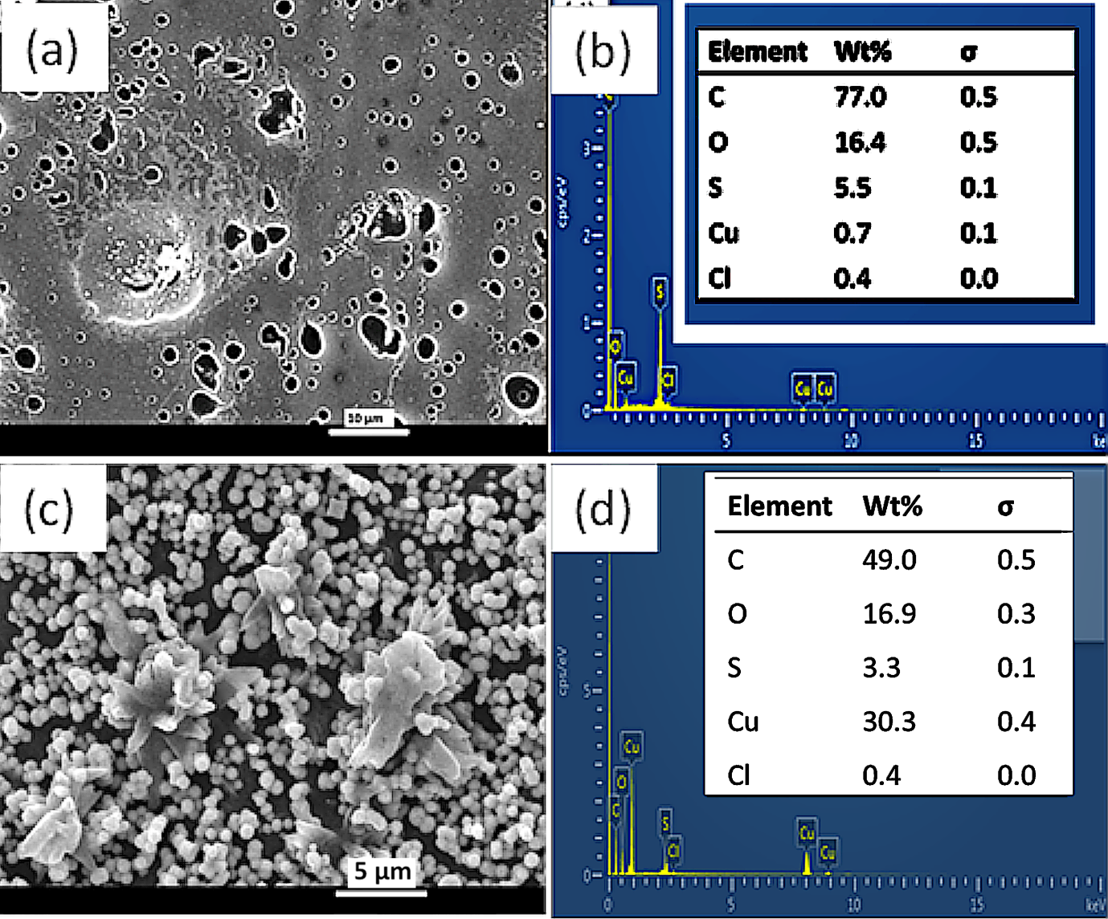

Figure S3. Comparative SEM and corresponding EDX images of the black and red MOP materials. (a-b) Black MOP material; (c-d) Red MOP material.

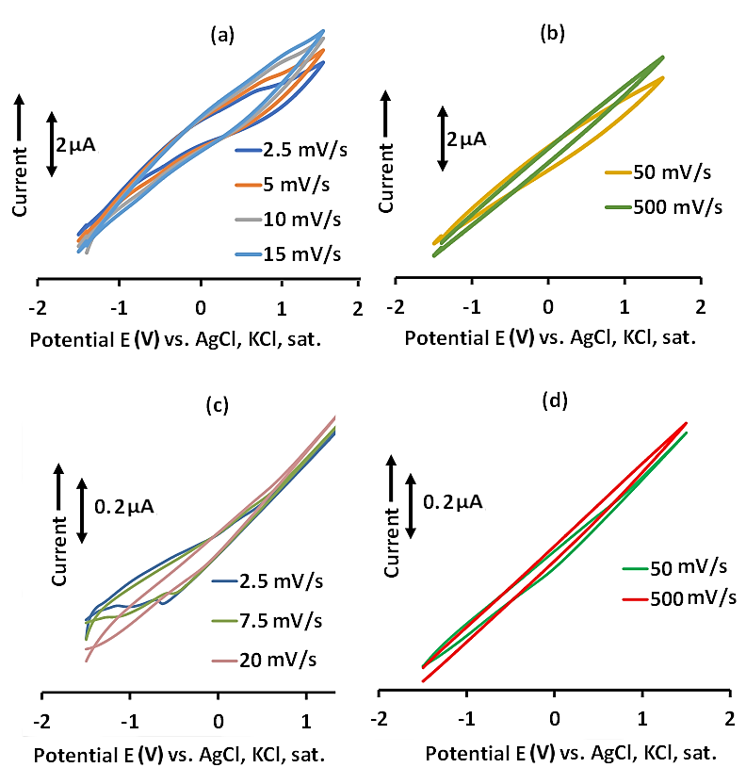

Figure S4. Variation of current vs. potential at different scan rates. (a-b) compact MOP electrode; (c-d) Thin-film MOP electrode.

Table S1. Comparison of the sensing behaviour of the MOP composite with some literature works
Method | LOD (mg/L) | Range (mg/L) | R² | Reference
FIA-Diode Array  Detection | 9.18 | 0-2000 | 0.9988 | [1]
Chemiluminescence | 1 x10⁻² | 0.03-10 | 0.9920 | [2]
Fluorescence | 4 x 10⁻¹ | 0 – 8 | 0.9972 | [3]
UV-Vis Spectrophotometry | 1.58 x 10⁻² | 0.0 - 0.41 | 0.9971 | [4]
UV-Vis Spectrophotometry | 4.6 × 10⁻⁵ | 0–0.00047 | 0.9979 | [5]
MOP -Compactª | 1.584 x 10⁻⁶ | 1.90-8.0 x 10^{-4b} | 1.0000 | This work
MOP –Thin-filmª | 1.04 x 10⁻¹³ | 17-153^{c} | 1.0000 | This work
ªMOP = Metalloplastic;^{b}@ +0.35 V;^{c}@ -1.0 V.

References
[1] I. Tarhan, H. Kara: A chemometric study : Automated flow injection analysis method for the quantitative determination of humic acid in Ilgın lignite. Arab. J. Chem. 9, 713–720 (2016). https://doi.org/10.1016/j.arabjc.2014.09.002.
[2] X. Cheng, L. Zhao, X. Wang, J. Lin: Sensitive Monitoring of Humic Acid in Various Aquatic Environments with Acidic Cerium Chemiluminescence Detection. Anal. Sci. 23, 1189–1193 (2007). https://doi.org/https://doi.org/10.2116/analsci.23.1189.
[3] C. Ma, M. Chen, H. Liu, K. Wu, H. He, K. Wang: A rapid method for the detection of humic acid based on the poly(thymine)-templated copper nanoparticles. Chinese Chem. Lett. 29, 136–138 (2018). https://doi.org/https://doi.org/10.1016/j.cclet.2017.09.012.
[4] O.J. Fakayode, A.S. Adekunle, T.T.I. Nkambule: Detection of low-level humic acid in water using room temperature- synthesized copper ( I ) oxide colloids. MRS Commun. 9, 1317–1322 (2019). https://doi.org/10.1557/mrc.2019.128.
[5] O.J. Fakayode, S. Williams, A.S. Saheed, T.T.I. Nkambule: Detection of humic acid in water using flat-sheet and folded-rod viscous alkaline glucose syrups. Analyst 145, 2682–2691 (2020). https://doi.org/10.1039/c9an02083g.

