Supplementary Material:

Investigation of Thermal Transport Properties in Pillared-Graphene Structure Using Non-Equilibrium Molecular Dynamics Simulations
Khaled Almahmoud,¹ Thiruvillamalai Mahadevan,² Nastaran Barhemmati-Rajab,¹ Jincheng Du,² Huseyin Bostanci,³ and Weihuan Zhao¹, *
¹ Mechanical and Energy Engineering Department, University of North Texas, Denton, TX 76207
² Materials Science and Engineering Department, University of North Texas, Denton, TX 76207
³ Engineering Technology Department, University of North Texas, Denton, TX 76207
* Corresponding author: Tel: +1 940-369-5929; Fax: +1 940-369-8675; Email: weihuan.zhao@unt.edu

S1. Molecular Dynamics Simulations:
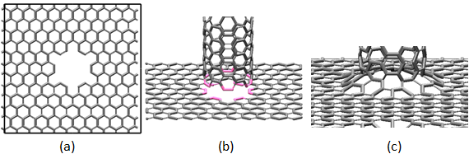
Figure S1: The process of creating PGS and the graphene/CNT junction. (a) Graphene sheet is prepared by creating a hole that fits a (6,6) CNT. (b) (6,6) CNT is aligned with the hole in the graphene sheet in the manner shown. (c) the junction is created
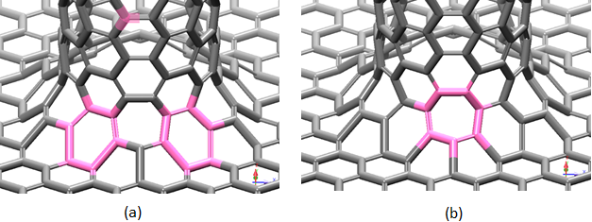
Figure S2: (a) The hexagonal rings in the graphene/CNT junction and (b) the heptagonal ring in between the two hexagonal rings in the graphene/CNT junction
Table S1: System name, unit cell dimensions, volume, and number of carbon atoms per cell
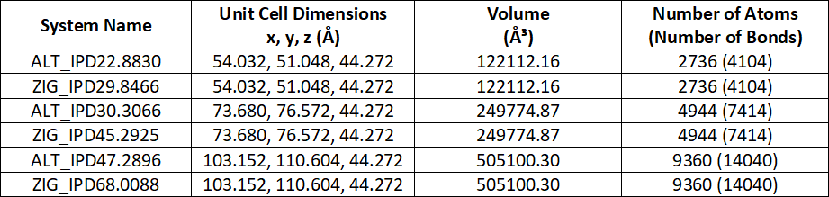

Table S2: Simulation protocol for each of the simulated PGS systems
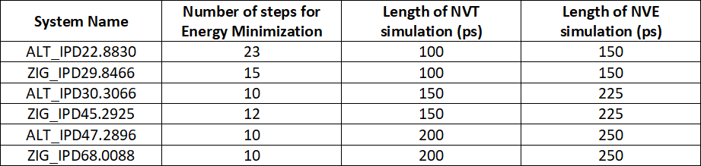

Table S3: Replication of simulated systems to get thermal conductivities along graphene and CNT
System | Number of replications to get thermal conductivity along graphene (along x-axis) | Number of replications to get thermal conductivity along CNT (along z-axis)
ALT_IPD22.8830 | 6 | 6
ZIG_IPD29.8466 | 6 | 6
ALT_IPD30.3066 | 8 | 8
ZIG_IPD45.2925 | 8 | 8
ALT_IPD47.2896 | 10 | 10
ZIG_IPD68.0088 | 10 | 10

S2. Results and Discussion:
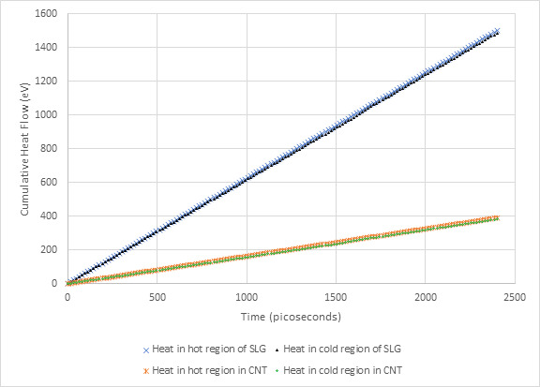
Figure S3: Cumulative heat flow in graphene and CNT in ALT_IPD22.8830 system

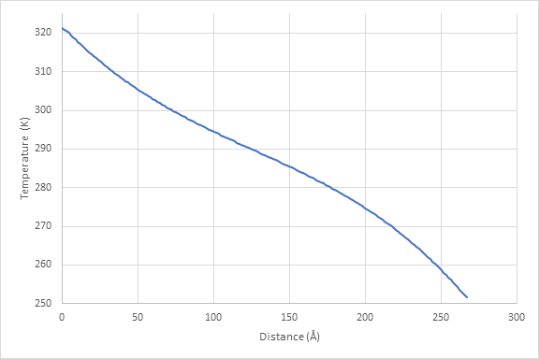
Figure S4: Temperature profile of ALT_IPD22.8830 PGS system. The temperature profile as shown is a function of structure length in Å (from heat source to heat sink). It can be observed that the steady state is reached in the unthermostated zones

