Article Type (Prospectives-Supplementary Material)

Additive Manufacturing for COVID-19: Devices, Materials, Prospects and Challenges

Rigoberto C. Advincula*, John Ryan C. Dizon, Qiyi Chen, Ivy Niu, Jason Chung, Lucas Kilpatrick, Reagan Newman
–––––––––

Prof. R. C. Advincula
University of Tennessee – Knoxville / Oak Ridge National Laboratory Governor’s Chair
E-mail: radvincu@utk.edu

Prof. J. R. C. Dizon
Additive Manufacturing Research Laboratory, Department of Industrial Engineering
College of Engineering and Architecture, Bataan Peninsula State University
City of Balanga, Bataan, 2100, Philippines
E-mail: jrcdizon79@gmail.com

Dr. Qiyi Chen
Oak Ridge National Laboratory
E-mail: qxc45@case.edu

Ivy Niu
University of Tennessee
wniu@utk.edu

Lucas Kilpatrick
University of Tennessee
Lkilpat3@vols.utk.edu

Jason Chung
University of Tennessee
xlr234@vols.ukt.edu

Reagan Newman
University of Tennessee
rnewman6@vols.utk.edu

Table S1 Types of Air-Purifying Respirators [1], [2]
Type | Filter Type | Coverage | Protects Against | Remarks
1) Filtering Facepiece Respirator (FFR) | Filter | Mouth and nose | Fumes, mist, dust | Disposable
2) Elastomeric Hal Facepiece Respirator | Replaceable filters / cartridges | Mouth and nose | Vapors, gases, other particles | Reusable
3) Elastomeric Full Facepiece Respirator | Replaceable, filters, cartridges, cannisters | Mouth, nose, eyes | Vapors, gases, other particles | Reusable
4) Powered Air-Purifying Respirator (PAPR) | Replaceable, filters, cartridges | Mouth, nose, eyes |  | Reusable; Battery-powered; Blower pulls air through filters/cartridges

Table S2. Some open web sources of updating design and .stl files of 3D printed personal protective equipment (PPE)
Organization | Types of PPE | References
Thingiverse-  COVID-19 3D printing health protective designs | Protective Mask/Face Shield/Hand-free door opener  Goggle/Mask accessory | [3]
YouMagine-  COVID-19 | Protective Mask/Face Shield/Hand-free door opener | [4]
NIH 3D Printed Exchange | Protective Mask/Face Shield/Hand-free door opener  Goggle/Mask accessory | [5]
CD3D 3D Printing Center | Protective Mask/Face Shield/Hand-free door opener/personal door opener | [6]
Cults | Protective Mask/Face Shield | [7]
GrabCAD | Face shield / mask / mask strap | [8]

Table S3 ASTM and ISO Standards related with facial mask and ventilators

Organization | Items | Standards | References
ASTM | Facial Mask | ASTM F2299/F2299M-03(2017) Standard Test Method for Determining the Initial Efficiency of Materials Used in Medical Face Masks to Penetration by Particulates Using Latex Spheres | [9]
 |  | ASTM F2101-19 Standard Test Method for Evaluating the Bacterial Filtration Efficiency (BFE) of Medical Face Mask Materials, Using a Biological Aerosol of Staphylococcus aureus | [10]
 |  | ASTM F2100-19 Standard Specification for Performance of Materials Used in Medical Face Masks | [11]
 |  | ASTM F1862/F1862M-17 Standard Test Method for Resistance of Medical Face Masks to Penetration by Synthetic Blood (Horizontal Projection of Fixed Volume at a Known Velocity) | [12]
ISO | Ventilators | ISO 10651-3:1997, Lung ventilators for medical use — Part 3: Particular requirements for emergency and transport ventilators | [13]
 |  | ISO 10651-4:2002, Lung ventilators — Part 4: Particular requirements for operator-powered resuscitators | [14]
 |  | ISO 19223:2019, Lung ventilators and related equipment — Vocabulary and semantics | [15]
 |  | ISO 80601-2-12:2020, Medical electrical equipment — Part 2-12: Particular requirements for basic safety and essential performance of critical care ventilators | [16]
 |  | ISO 80601-2-79:2018, Medical electrical equipment — Part 2-79: Particular requirements for basic safety and essential performance of ventilatory support equipment for ventilatory impairment | [17]
 |  | ISO 80601-2-80:2018, Medical electrical equipment — Part 2-80: Particular requirements for basic safety and essential performance of ventilatory support equipment for ventilatory insufficiency | [18]

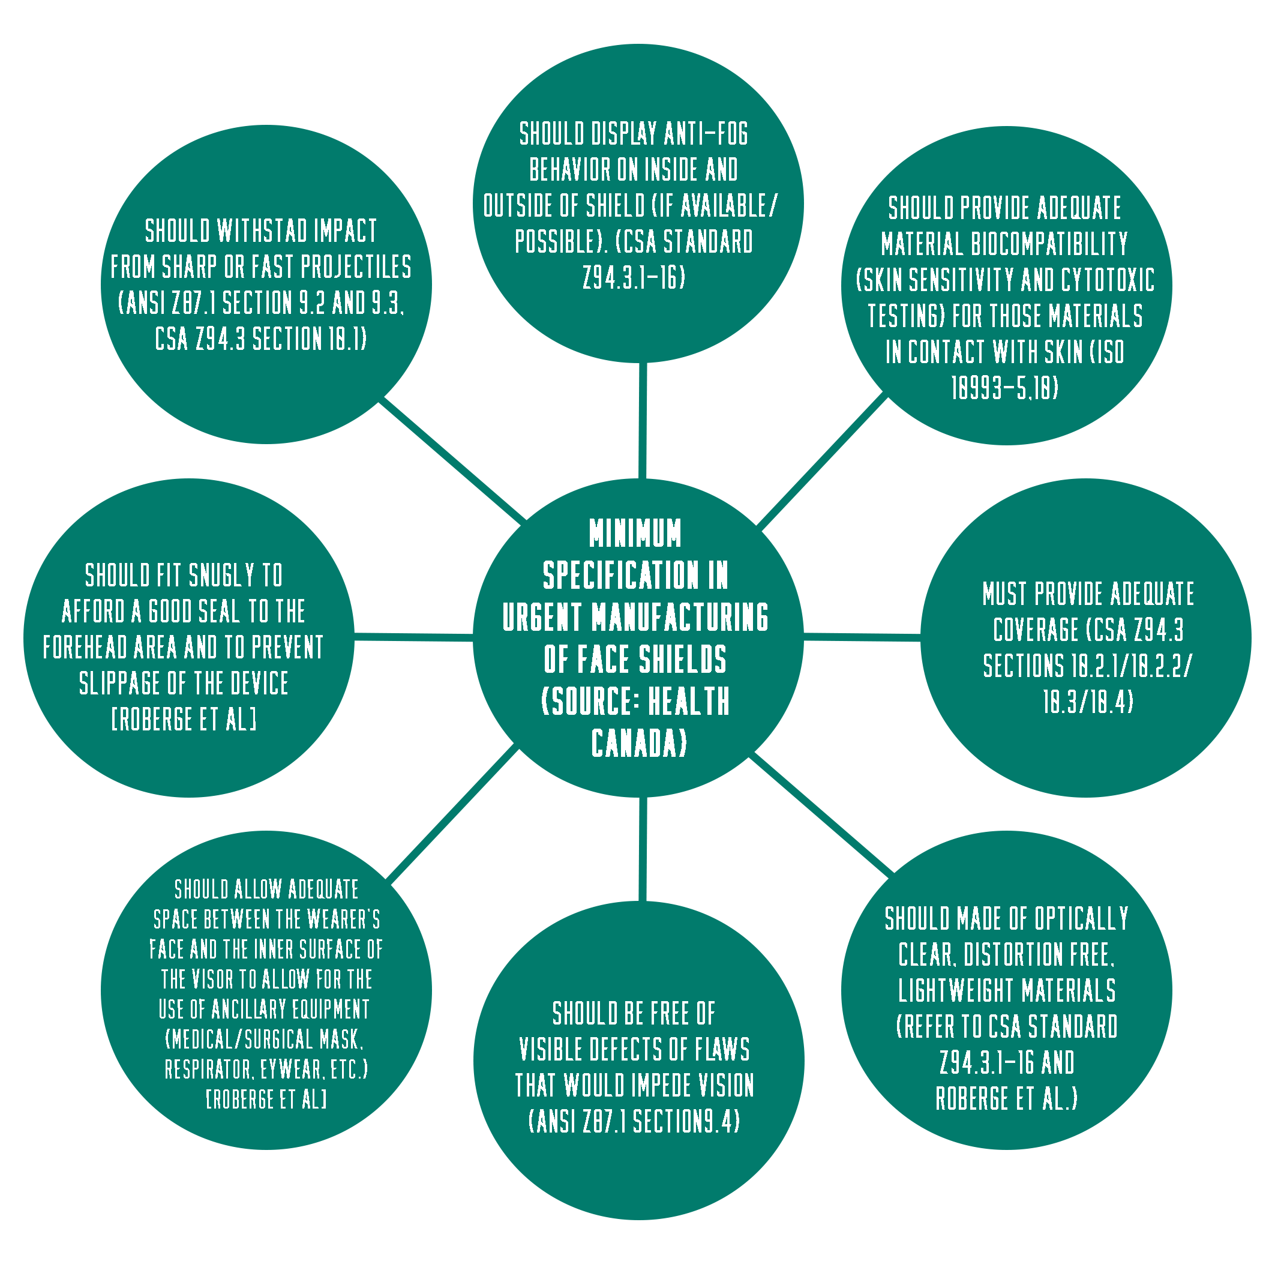
Figure S1. Minimum specifications in urgent manufacturing of face shields [19]

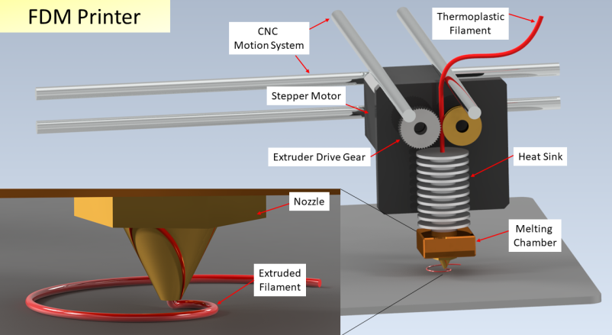
Figure S2 Fused Deposition Modelling (FDM) Operating Principle [22].

5. Types and properties of polymer and plastic materials commonly used for mass production of parts

Polyethylene (PE) is the most common plastic, primarily used in packaging including plastic bags, bottles, membranes etc. [25]. It has the simplest structure of polymer, with repeating units of -CH₂-, as shown in Figure S3. The high symmetry and softness of the linear chain facilitate the crystallization of PE. Depending on the processing conditions, some PE has many branches, which leads to lower crystallinity and lower density, and resulting materials is called low density PE (LDPE), while some PE has very few branches, thus higher crystallinity and higher density are generated, and the resulting material is called high density PE (HDPE). The thermo-mechanical properties of PE are directly related to its crystallinity. Although PE has relatively low strength and hardness, but the partial crystallinity, combined with the soft chain, offers high ductility, impact strength and toughness. The crystalized structure also offers excellent chemical resistance, that PE is resistant to strong acid and base, and gentle oxidizing/reducing. PE is also resistant to organic solvents at room temperature, but can be dissolved by non-polar hydrocarbon solvent, such as xylene and toluene, at elevated temperature.

Polypropylene (PP), another commonly used thermoplastic, has a similar structure of PE with a methyl group on the side Figure S3 [26]. It has many similar properties as PE, especially in solubility and electrical properties. It has low strength and hardness, but high ductility and toughness. The methyl side group, on the other hand, leads to better thermo-mechanical properties, while the chemical resistance is compromised. PP has a high crystallinity, but it is largely affected by the tacticity, which is the location of the methyl side group. When methyl groups all on the same side of the backbone, it is called the Isotactic structure. Macromolecular chain can be easily oriented into a helical shape in the isotactic structure, resulting in high degree of symmetric structure. Therefore, higher isotacticity in the polymer chain offers higher degree of crystallinity, thus higher melting point, hardness, chemical resistance etc. Isotactic PP (iPP) has the highest crystallinity and a high melting point from 185 to 220 ℃. Syndiotactic PP (sPP), with alternating locations of methyl groups, has a lower melting point from 168 to 186 ℃. Atactic PP (aPP), with methyl groups randomly located at the backbones, becomes amorphous with only 15% crystallinity. It is soluble in room temperature and has a much lower density, softening point, and melting point. iPP is currently the most used PP due to its high crystallinity.

When the methyl group of PP is replaced by chloride, the polymer becomes polyvinyl chloride (PVC) [27]. The chloride atom gives very different properties than PP or PE. It has very high hardness, rigidity and mechanical strength, excellent chemical resistance to acid, base, salts etc. The location of chloride atom is mainly random, which give an atactic stereochemistry and low crystallinity, but the density is much higher than PP and PE due to the chloride atom mass. When plasticizers are incorporated into PC, it enlarges the free space between the linear chains, and work as lubricant to facilitate the chain movement. Therefore, Tg of PVC is significantly lowered, the rigidity of PVC dramatically decreases, and PVC becomes much more flexible. Commonly used plasticizers include phthalate, adipates, trimellitates, etc. PVC has been widely used in pipes, electro cable insulation, flooring etc.

Polyamide (PA), also called nylon, is a family of synthetic polymers with repeating unites linked by amide groups [28]. Polyamide is normally produced by the condensation reaction between di-carboxylic acid and di-amine, in which the repeating units will be the alternating of applied di-acid and di-amine chains. It can also be produced by the self-reaction of amino acid or ring-opening polymerization of lactam, producing a mono repeating unit. The amide group (-CO-NH) is highly polar and forms inter-molecular hydrogen bonds which facilitates crystallization of polyamides, thus offering excellent mechanical strength and chemical resistance. Commonly used PA includes PA66, PA6, PA 12, PA 510 etc. PA 66, structure shown below, has a highly regular molecular structure with amide groups line up repeatedly to form strong interchain hydrogen bonds. Therefore, it has the highest melting point of PA, above 260 ℃, and it’s widely applied when high mechanical strength, rigidity and stability is required. PA 6 has similar properties as PA 66, high strength and elasticity, but a lower melting point at 220 ℃.

Polycarbonate (PC) [29] is a thermoplastic family containing carbonate groups in the backbone. Most PC is produced by bisphenol A (BPA) based precursor. The carbonate group (-O-CO-O-) confers high rigidity, and the BPA structure exhibit excellent impact resistance, durability and high temperature resistance. It can be sharply deformed at room temperature without significant cracking or breaking, which is superior than most other thermoplastics. It has a high Tg, around 147 ℃, and high flame retardance, which make it an ideal material for use under some extreme conditions. The rigid backbone offers very low crystallinity, thus visible light transparency is very high, even higher than that of many types of glass. PC are largely used in electronic components owing to its good electrical insulting behavior, as well as excellent thermal stability. Its also an ideal candidate in sunglass, eyeglass lenses, and face shield due to its high transparency. BPA free PC has been developed, which is increasingly served in the food containers due to the improved toxicity.

Polylactic acid (PLA) [30] is a thermoplastic ester, which draws great attention recently due to its renewable resources and biodegradability. It is produced from ring-opening polymerization of lactide, a chemical that has abundant renewable resources. The ester group offers high mechanical strength and hardness, yet it suffers from brittleness and lack of ductility. PLA ranges from an amorphous glassy polymer to a semi-crystalline polymer with a moderate thermal stability, Tg around 60 ℃ and melting point below 200 ℃. The crystallinity of PLA is largely controlled by the ratio of the two enantiomers in lactic acid, L-lactic and D-lactic, and the corresponding product is called PLLA and PDLA. The blending of PDLA an PLLA can enhance the crystallinity, where PDLA works as nucleate agents, to enhance the thermo-mechanical performance, yet the bio-degradability rate becomes slower.
Polyurethane (PU) [31] is a class of polymers with repeating units linked by urethane groups (Fig. S4), which is produced by the reaction between isocyanate and hydroxyl groups. PU can be divided into two categories: crosslinked PU and thermoplastic PU (TPU). The former is synthesized from the isocyanates and polyols with more than 2 functionalities generating un-meltable network, while the latter is synthesized from diisocyanates and diols to form linear PU chains. The large diversity of isocyanates and polyols structures offer PU with wide range of structures and properties. When rigid chains, such as phenol rich structures, and high crosslinking density are incorporated in the crosslinked PU network, it becomes rigid and hard, while soft chains and moderate crosslinking density offers high flexibility. TPU is one of the most important elastomeric polymers. It is consisted of alternating hard segments in which short rigid structures form crystalline domain, and soft segments in which long soft chains generate amorphous domain. Hard segments work as physical crosslinking sites to offer recoverability of deformation, while soft segments confer excellent elasticity. TPU has huge population in footwear, automotive seating, instrument panels and crosslinked PU has a lot of applications in sealings, insulation foam, elastomeric wheels, tires etc.

Silicone [32] also called polysiloxane, refers to polymers that contain siloxane group, consisted of alternating silicon and oxygen atoms. The siloxane chains exhibit excellent heat resistance, low thermal conductivity, low electrical conductivity, low toxicity and high hydrophobicity. When the siloxane groups are crosslinked into a network, silicone becomes a highly elastic rubber with superb properties. Several chemistries have been developed to crosslink silicones. One typical route is through hydrolysis of silane groups. For example, the liquid precursor of moisture cured silicone rubber starts to solidify once it’s in contact with air (moisture in the air). Another route is through the hydrosilylation reaction, where vinyl groups will crosslink with silicon-hydride. This reaction requires the mixture of two silicone precursors to be mixed together to initiate the crosslinking under catalyst. Silicone rubber has very good bio-compatibility and low toxicity, which allow it to be used in bio-medical field, such as implants and wearable electronics. It has very good stability and performs well in the temperature ranging from −70 to 220 °C. Therefore, silicone rubber is largely used in aerospace industry as sealants to stand extreme conditions.

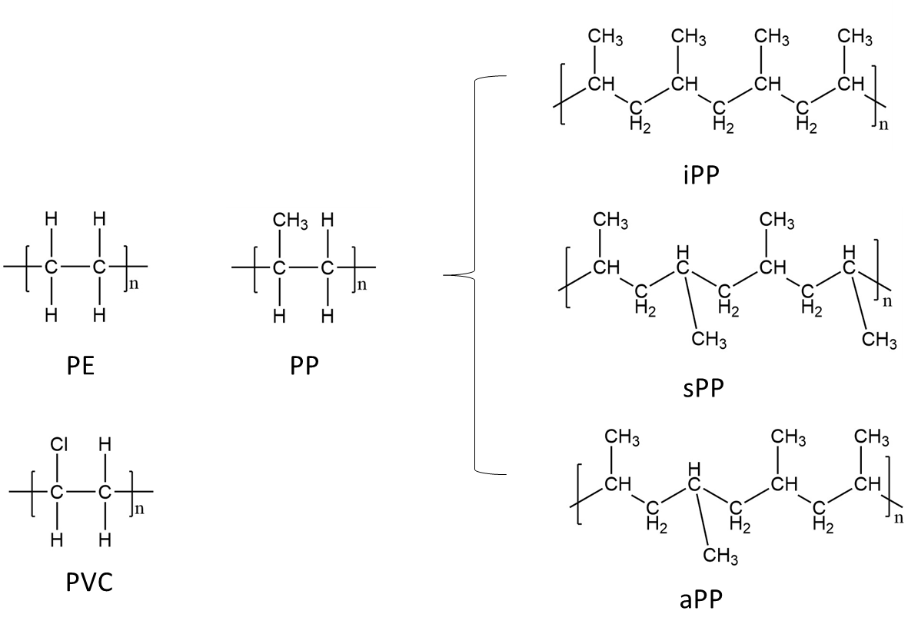

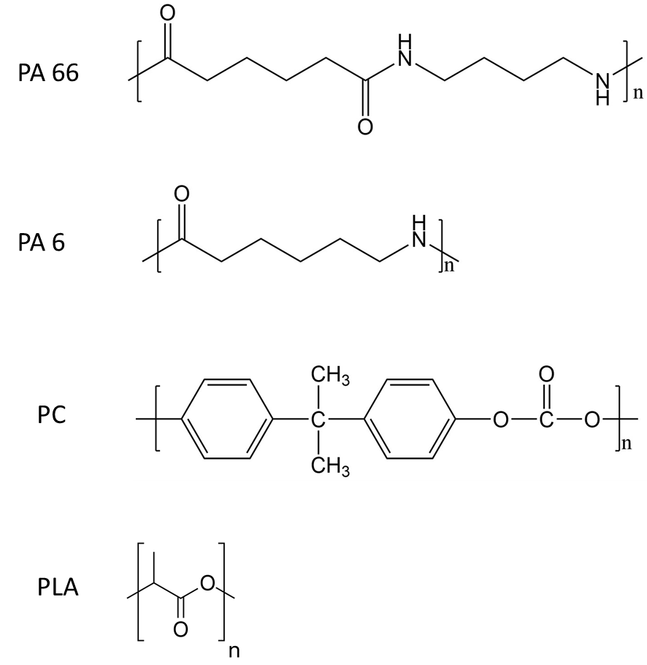
Figure S3. Molecular structures of PE, PP, PVC, PA, PC and PLA.

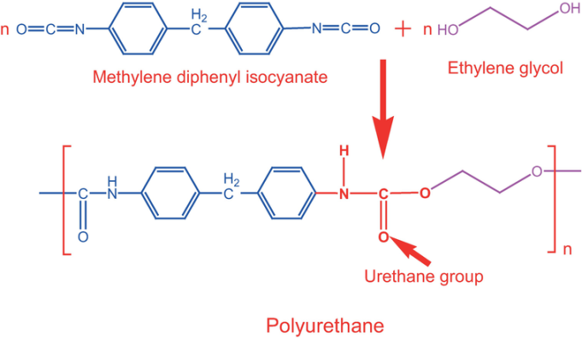
Figure S4. Synthesis route of polyurethane.

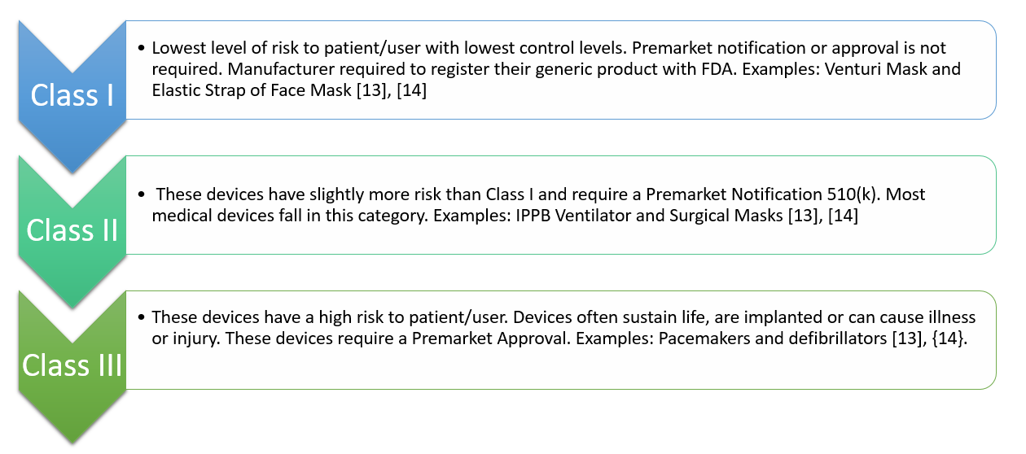
Figure S5- Medical Device Classifications [33], [34]

8. 3d Printing PPEs at Organizations and Universities

At the University of Tennessee, several different protective mask models were 3d-printed through FDM printing using different filament materials. Figure S8a shows the masks printed using the different FDM 3D printers. The most successful one is the BUT-H1 halfmask designed from Brno University of Technology. This design also including two parts: the mask frame and the filter cover as shown in Figure S8b left and right. [35] Filters are sitting between the mask frame and filter cover. Different thickness in between are designed to fit either thin or thick filters. The idea here is involving a disposal latex or nitril glove sleeve on the frame which enable the mask a comfortable and good fit on face. Special design of holding the elastic band on the filter cover also add more of the fitting advantages in contrast to the ones designed on the mask frame itself. The pictures of the mask frame and cover in printing and finally assembled mask are shown in Figure S8c (left), (center) and (right) (filter material- MERV13)

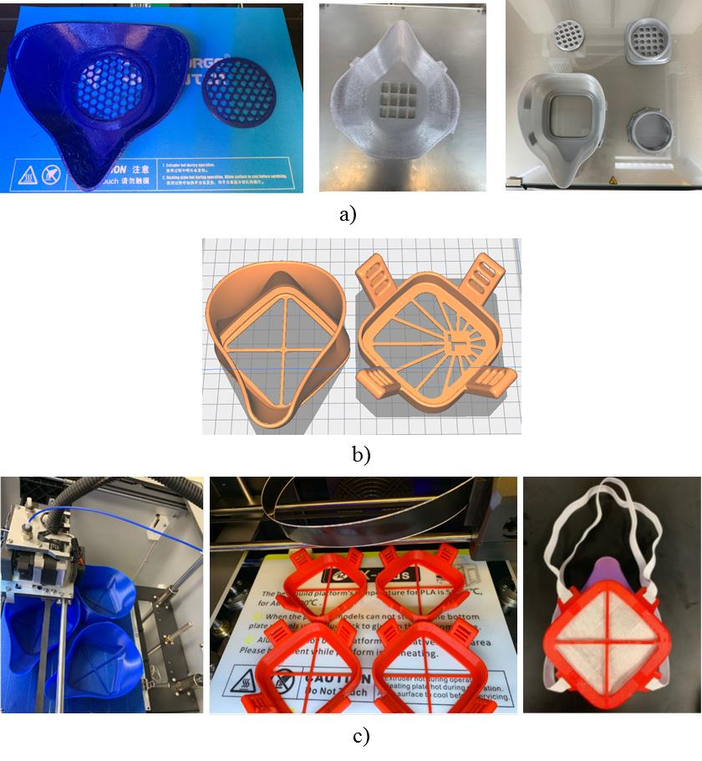
Figure S6. a) Different protective mask printed out in our 3D printing lab at the University of Tennessee based on the open source stl files.; Figure 2. B) Stl file of the mask frame and cover of BUT-H1 mask; c) left and center, BUT-H1 Mask frame during printing in our 3D printing lab at University of Tennessee; right, Assembled mask with filter and glove sleeve on the frame for better fitting on face.

3D Printing Projects at the Additive Manufacturing Research Laboratory at the Bataan Peninsula State University (BPSU-AMReL) (Kokoy)

Figure S7 (a—e) shows the 3d-printing projects at the Additive Manufacturing Research Laboratory at the Bataan Peninsula State University (BPSU-AMReL). Figure S7 a) 3d-printed face shields; b) 3d-printed mask strap; c) 3d-printed hands-free door pull; d) testing of 3d-printed hands-free door pull; e) mask flange.

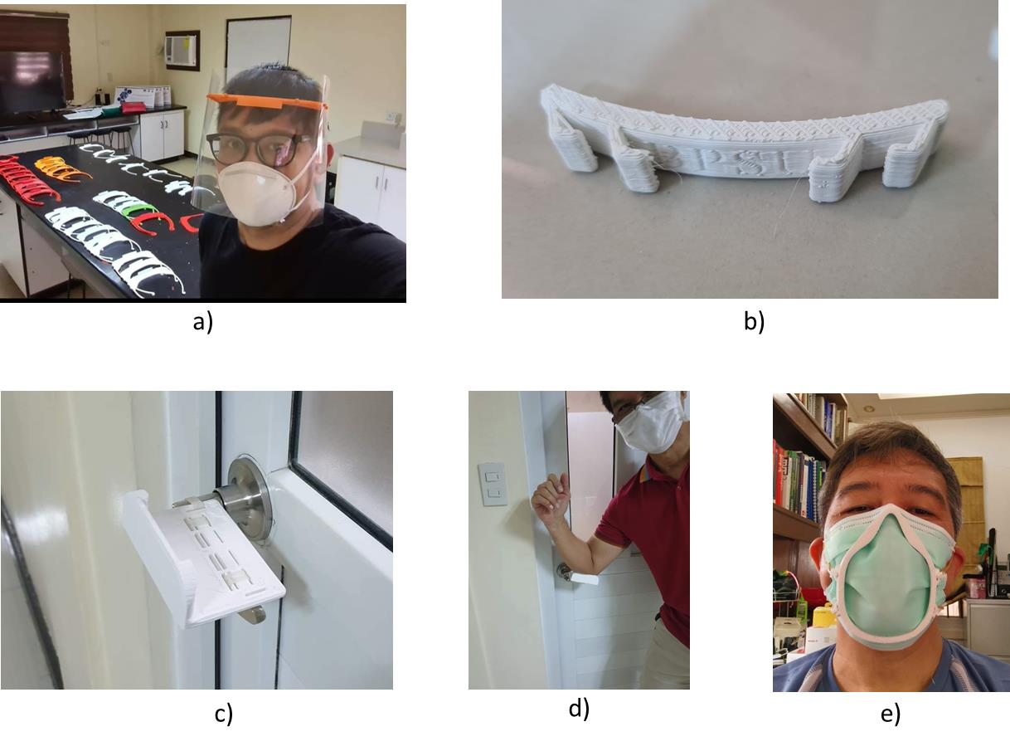
Figure S7 (a—e) 3d-printing projects at the Additive Manufacturing Research Laboratory at the Bataan Peninsula State University (BPSU-AMReL). Figure S7 a) 3d-printed face shields; b) 3d-printed mask strap; c) 3d-printed hands-free door pull; d) testing of 3d-printed hands-free door pull; e) mask flange.
3d printing is a very important equipment in rapid prototyping. 3d printing farms using several printers to print a specific part is one way to do limited production. In the same manner, 3d printing of polymer mods and combining it with a benchtop injection molding machine has also be reported and successfully tried [36], [37]. BPSU-AMReL employs this manufacturing process in producing mask straps. Figure S8 (a-f) shows the details of the production of mask straps at the BPSU-AMReL: a) injection molding machine; b) polypropylene resins (courtesy of Petron Polypropylene Plant); c) 3d-printed injection molds; d) 3d-printed molds encapsulated in an aluminum frame; e) injection-molded mask strap; f) mask strap being worn with a face mask. [38]

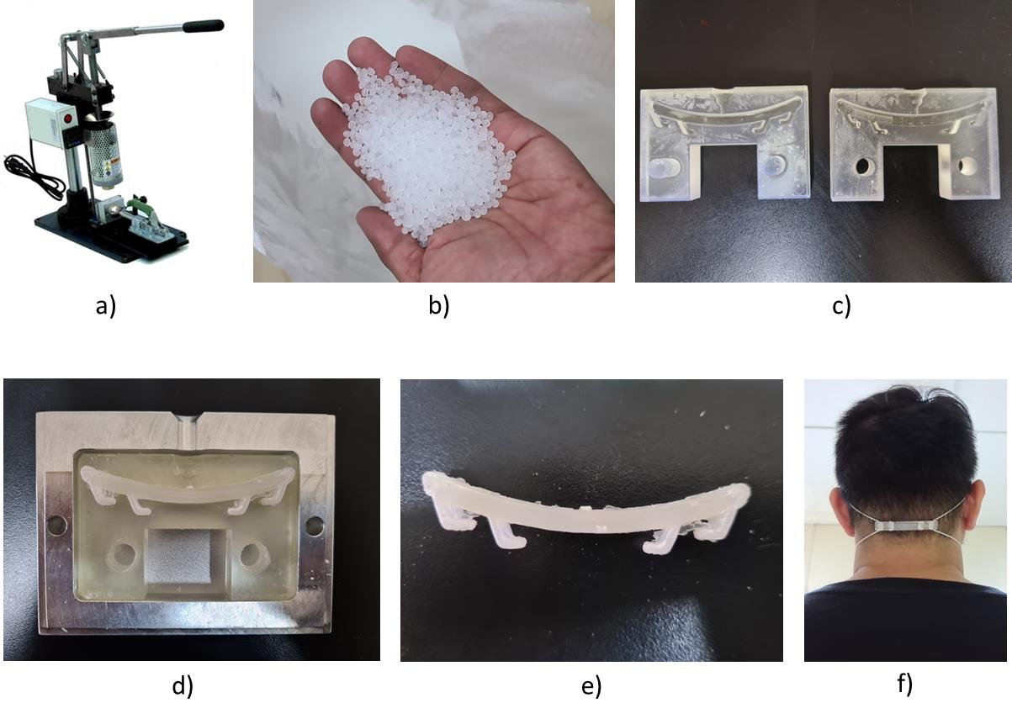
Figure S8 (a-f) Details of the production of mask straps at the BPSU-AMReL: a) injection molding machine; b) polypropylene resins (courtesy of Petron Polypropylene Plant); c) 3d-printed injection molds; d) 3d-printed molds encapsulated in an aluminum frame; e) injection-molded mask strap; f) mask strap being worn with a face mask. [38]
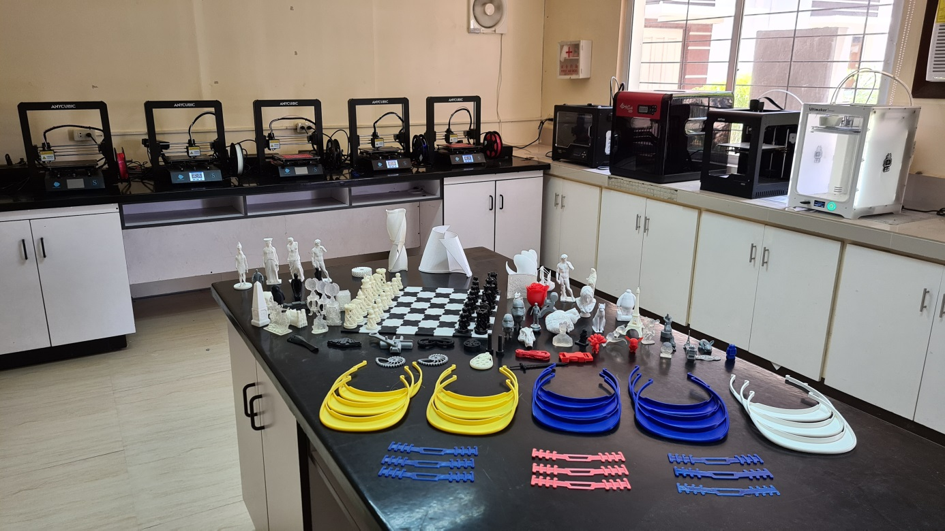
Figure S9. 3D printing farm at the Bataan Penisula State University (Philippines).

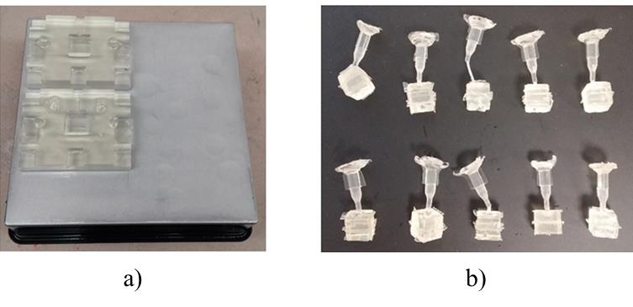
Figure S10. Combination of 3D printing and injection molding; a) 3D printed molds on a build plate printed using the stereolithography technology; b) injection molded cubes using 3d-printed molds. Reproduced with permission from John Ryan C. Dizon, Arnaldo D. Valino, Lucio R. Souza, Alejandro H. Espera, Qiyi Chen, Rigoberto C. Advincula, Three-dimensional-printed molds and materials for injection molding and rapid tooling applications, Vol. 9, Issue 4, 1267-1283. [36]

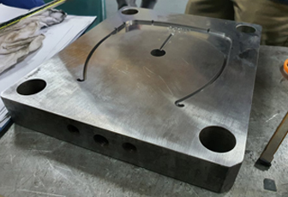
Figure S11. The plastic injection mold for face shield frame which was fabricated at the Die and Mold Solution Center (DMSC) of the DOST Metals Industry Research and Development Center. [40]

References:
[1] C.- NPPTL, “Respiratory Protection Infographics,” 2020. .
[2] C. NPPTL, “NIOSH-Approved Particulate Filtering Facepiece Respirators,” 2018. [Online]. Available: https://www.cdc.gov/niosh/npptl/topics/respirators/disp_part/. [Accessed: 21-Apr-2020].
[3] Thingiverse, “Hack The Pandemic.” [Online]. Available: https://www.thingiverse.com/groups/hackthepandemic. [Accessed: 21-Apr-2020].
[4] Youmagine, “COVID 19.” [Online]. Available: https://www.youmagine.com/ultierik%0A/collections/covid19?state=5%0A. [Accessed: 21-Apr-2020].
[5] National Institutes of Health, “COVID-19 Supply Chain Response.” [Online]. Available: https://3dprint.nih.gov/collections/covid-19-response. [Accessed: 21-Apr-2020].
[6] 3D Printing Center, “COVID-19 3D printing health protective designs.” [Online]. Available: https://3dprintingcenter.net/covid-19-3d-printing-health-protective-designs/. [Accessed: 21-Apr-2020].
[7] Cults, “Useful 3d printed tools against Coronavirus COVID-19.” [Online]. Available: https://cults3d.com/en/collections/useful-3d-printed-coronavirus-covid19-tool. [Accessed: 21-Apr-2020].
[8] GrabCad, “COVID-19 Recent Models.” [Online]. Available: https://grabcad.com/library/tag/covid-19. [Accessed: 21-Apr-2020].
[9] ASTM, “Standard Test Method for Determining the Initial Efficiency of Materials Used in Medical Face Masks to Penetration by Particulates Using Latex Spheres,” vol. 03, no. Reapproved, pp. 1–8, 2010.
[10] ASTM, “Standard Test Method for Evaluating the Bacterial Filtration Efficiency (BFE) of Medical Face Mask Materials, Using a Biological Aerosol of Staphylococcus aureus,” vol. i, no. June, pp. 1–5, 2001.
[11] ASTM, “Standard Specification for Performance of Materials Used in Medical Face Masks,” Test, vol. 11, no. 2018, pp. 19–21, 2005.
[12] ASTM, “Standard Test Method for Resistance of Medical Face Masks to Penetration by Synthetic Blood ( Horizontal Projection of Fixed Volume at a Known Velocity ),” pp. 1–18, 2007.
[13] ISO, “ISO 10651-3:1997 Lung ventilators for medical use — Part 3: Particular requirements for emergency and transport ventilators.” [Online]. Available: https://www.iso.org/standard/21436.html. [Accessed: 06-May-2020].
[14] ISO, “ISO 10651-4:2002 Lung ventilators — Part 4: Particular requirements for operator-powered resuscitators.” [Online]. Available: https://www.iso.org/standard/30712.html. [Accessed: 06-May-2020].
[15] ISO, “ISO 19223:2019 Lung ventilators and related equipment — Vocabulary and semantics.” [Online]. Available: https://www.iso.org/standard/51164.html. [Accessed: 06-May-2020].
[16] ISO, “ISO 80601-2-12:2020 Medical electrical equipment — Part 2-12: Particular requirements for basic safety and essential performance of critical care ventilators.” [Online]. Available: https://www.iso.org/standard/72069.html. [Accessed: 06-May-2020].
[17] ISO, “ISO 80601-2-79:2018 Medical electrical equipment — Part 2-79: Particular requirements for basic safety and essential performance of ventilatory support equipment for ventilatory impairment.” [Online]. Available: https://www.iso.org/standard/68843.html. [Accessed: 06-May-2020].
[18] ISO, “ISO 80601-2-80:2018 Medical electrical equipment — Part 2-80: Particular requirements for basic safety and essential performance of ventilatory support equipment for ventilatory insufficiency.” [Online]. Available: https://www.iso.org/standard/68844.html. [Accessed: 06-May-2020].
[19] G. of Canada, “3D printing and other manufacturing of personal protective equipment in response to COVID-19,” 2020. [Online]. Available: https://www.canada.ca/en/health-canada/services/drugs-health-products/medical-devices/covid-19-unconventional-manufacturing-personal-protective-equipment.html. [Accessed: 21-Apr-2020].
[20] T. N. A. Press, “Characteristics of Respirators and Medical Masks,” in The National Academics of Sciences Engineering Medicine, no. 2006, Washington D.C., 2006, pp. 22–41.
[21] B. on H. S. P. I. of Medicine, “Defining PAPRs and Current Standards,” in The Use and Effectiveness of Powered Air Purifying Respirators in Health Care: Workshop Summary, Washington D.C.: National Academies Press, 2015.
[22] 3D Printing Industry, “3D Printing Processes.” [Online]. Available: https://3dprintingindustry.com/3d-printing-basics-free-beginners-guide#04-processes. [Accessed: 21-Apr-2020].
[23] Formlabs, “3D Printed Test Swabs,” 2020. [Online]. Available: https://formlabs.com/covid-19-response/covid-test-swabs/. [Accessed: 21-Apr-2020].
[24] Carbon3D, “Carbon COVID-19 Response,” 2020. [Online]. Available: https://www.carbon3d.com/covid19/. [Accessed: 21-Apr-2020].
[25] J. V. Gulmine, P. R. Janissek, L. Akcelrud, and H. M. Heise, “Polyethylene characterization by FTIR,” Polym. Test., vol. 21, no. 5, pp. 557–563, 2002.
[26] F. J. Padden and H. D. Keith, “Spherulitic crystallization in polypropylene,” J. Appl. Phys., vol. 30, no. 10, pp. 1479–1484, 1959.
[27] D. E. Winkler, “Mechanism of Polyvinyl Chloride Degradation and Stabilization,” J. Polym. Sci., vol. XXXV, pp. 3–16, 1959.
[28] F. Yang, Y. Ou, and Z. Yu, “Polyamide 6/silica nanocomposites prepared by in situ polymerization,” J. Appl. Polym. Sci., vol. 69, no. 2, pp. 355–361, 1998.
[29] J. D. Keitz, J. W. Barlow, and D. R. Paul, “Polycarbonate blends with styrene/acrylonitrile copolymers,” J. Appl. Polym. Sci., vol. 29, no. 10, pp. 3131–3145, 1984.
[30] R. K. Kulkarni, E. G. Moore, A. F. Hegyeli, and F. Leonard, “Biodegradable Poly(1actic acid) Polymers,” vol. 5, pp. 169–181, 1971.
[31] A. Kausar, “Polyurethane / Epoxy Interpenetrating Polymer Network Polyurethane / Epoxy Interpenetrating Polymer Network,” pp. 1–16.
[32] E. L. Warrick, O. R. Pierce, K. E. Polmanteer, and J. C. Saam, “Silicone Elastomer Developments 1967-1977.,” Rubber Chem Technol, vol. 52, no. 3. pp. 437–525, 1979.
[33] B. Medical, “What’s the Difference Between the FDA Medical Device Classes?,” 2020. [Online]. Available: http://www.bmpmedical.com/blog/whats-difference-fda-medical-device-classes-2/. [Accessed: 21-Apr-2020].
[34] U. FDA, “Product Classification.” [Online]. Available: https://www.accessdata.fda.gov/scripts/cdrh/cfdocs/cfpcd/classification.cfm?start_search=1&Submission_Type_ID=&DeviceName=mask&ProductCode=&DeviceClass=&ThirdParty=&Panel=&RegulationNumber=&Implant_Flag=&Life_Sustain_Support_Flag=&PAGENUM=10&sortcolumn=De. [Accessed: 21-Apr-2020].
[35] B. U. of Technology, “COVID-19 Protection Halfmask BUT-H1.” [Online]. Available: https://www.vutbr.cz/en/but/f19528/d197642.
[36] J. R. C. Dizon, A. D. Valino, L. R. Souza, A. H. Espera, Q. Chen, and R. C. Advincula, “Three-dimensional-printed molds and materials for injection molding and rapid tooling applications,” MRS Commun., vol. 9, no. 4, pp. 1267–1283, 2019.
[37] J. R. C. Dizon, A. D. Valino, L. R. Souza, A. H. Espera, Q. Chen, and R. C. Advincula, “3D Printed Injection Molds using various 3D Printing Technologies,” Mater. Sci. Forum (in Press., 2020.
[38] AMReL, “BPSU Additive Manufacturing Research Laboratory.” [Online]. Available: http://www.findglocal.com/PH/Balanga/592617404574882/BPSU---Additive-Manufacturing-Research-Laboratory. [Accessed: 06-May-2020].
[39] Formlabs, “How a 3D Printer Farm Can Help Your Business,” 2017. [Online]. Available: https://formlabs.com/blog/3d-print-farm-business-benefits/. [Accessed: 30-Apr-2020].
[40] D. M. I. R. and D. Center, “Face shield for COVID-19 frontliners: Now mass-produced by the DOST-MIRDC,” 2020. [Online]. Available: http://www.mirdc.dost.gov.ph/2-uncategorised/201-face-shields-for-covid-19-frontliners-now-mass-produced-by-the-dost-mirdc. [Accessed: 26-Apr-2020].

