Supplementary Material
Thermal transport properties enhancement of paraffin via encapsulation into Boron nitride nanotube: A molecular dynamics study
Nastaran Barhemmati-Rajab¹, Thiruvillamalai Mahadevan², Jincheng Du², Weihuan Zhao^{1, *}
¹ Department of Mechanical and Energy Engineering, University of North Texas, Denton, Texas, USA
² Department of Materials Science and Engineering, University of North Texas, Denton, Texas, USA
* Corresponding author: Tel: +1 940-369-5929; Fax: +1 940-369-8675; Email: weihuan.zhao@unt.edu

S1. Results and discussion
The thermal conductivity converges within 50 ps for pure n-hentriacontane and encapsulated n-hentriacontane in different diameters of BNNTs at 298 K, as shown in Figure S1. Thermal conductivity value of pure n-hentriacontane converges faster than that of encapsulated paraffin in BNNT. Moreover, encapsulated paraffin has higher thermal conductivity than pure paraffin. It is because of higher thermal conductivity and longer relaxation time in BNNT added to paraffin.
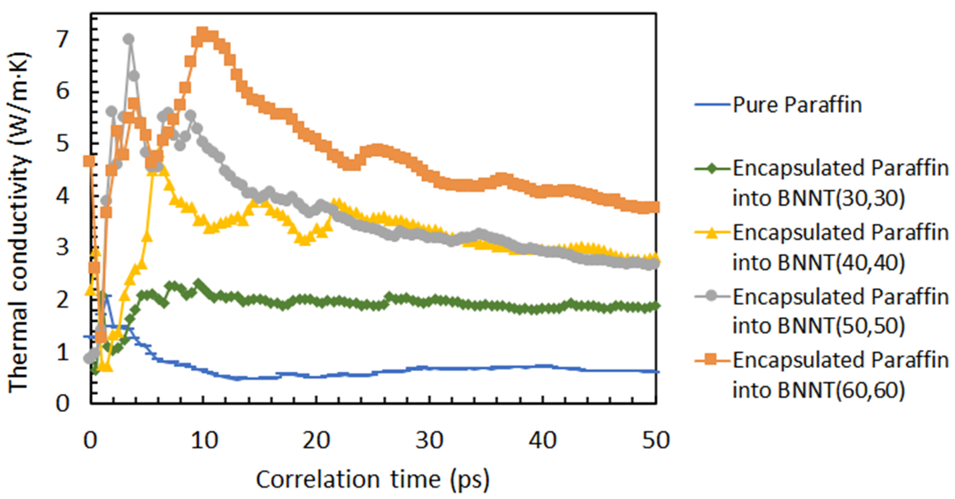
Figure S1. Thermal conductivity of pure n-hentriacontane and encapsulated n-hentriacontane in different diameters of BNNT at 298 K as a function of correlation time.

