Yttria-stabilized Barium Zirconate (BZY) Surface Reactivity at Elevated Temperatures
Märtha M. Welander¹, Daniel M. Goettlich,^{1,2} Tanner Henning² and Robert A. Walker^{1,2} *
Department of Chemistry and Biochemistry
Montana Materials Science Program
Montana State University
Bozeman, MT USA 59715

Supporting Information

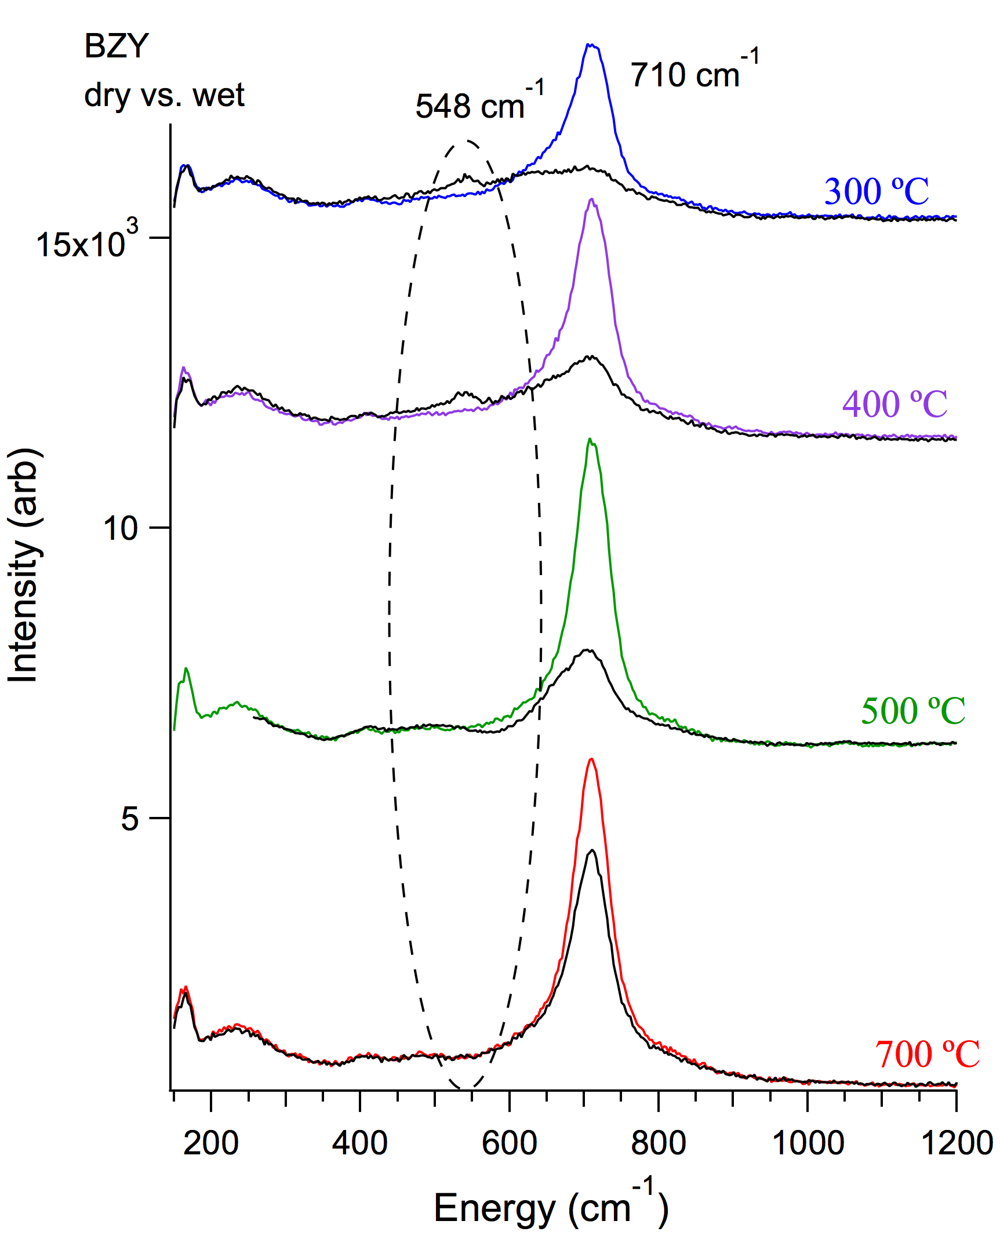
SI Figure 1. Raman spectra of BZY showing the appearance of the 548 cm⁻¹ vibrational feature at 300 °C and 400 °C.

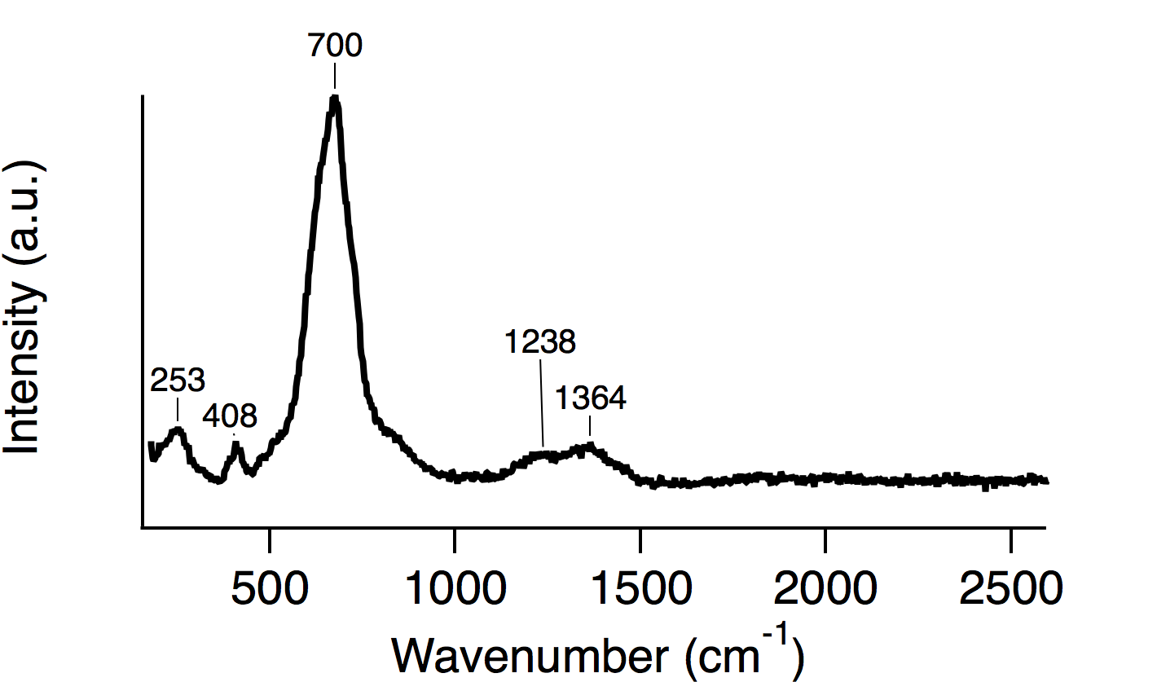
SI Figure 2. Raman spectrum of BZY at room temperature showing the prominent feature at around 700 cm⁻¹.
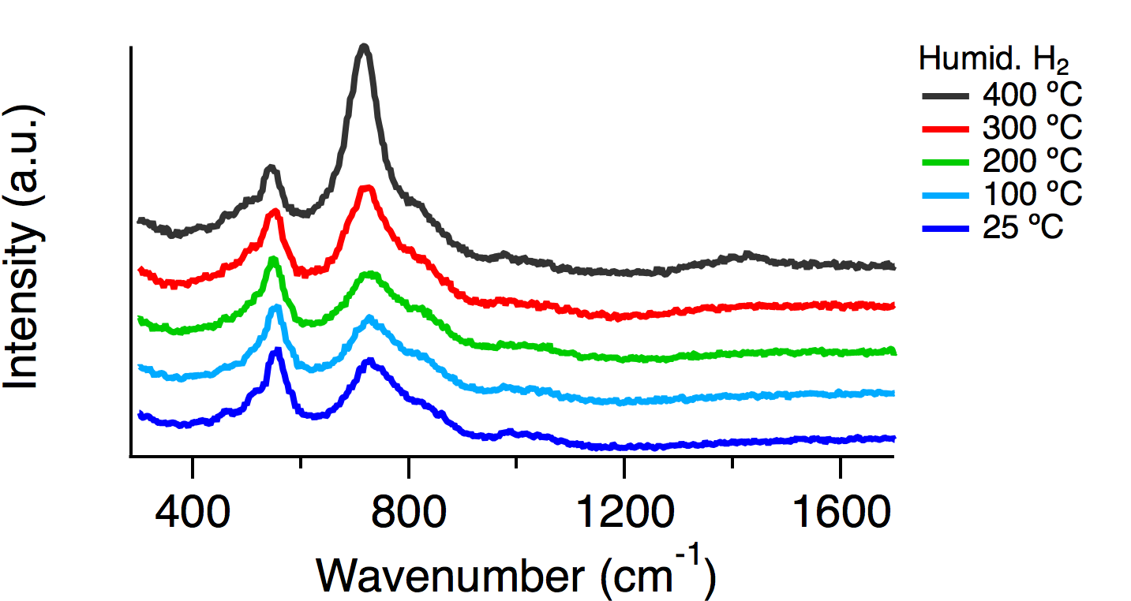
SI Figure 3. Raman spectra collected upon cool-down of a BZY sample under humidified H₂. The vibrational feature at 548 cm⁻¹ persists as the sample is cooled down to room temperature.

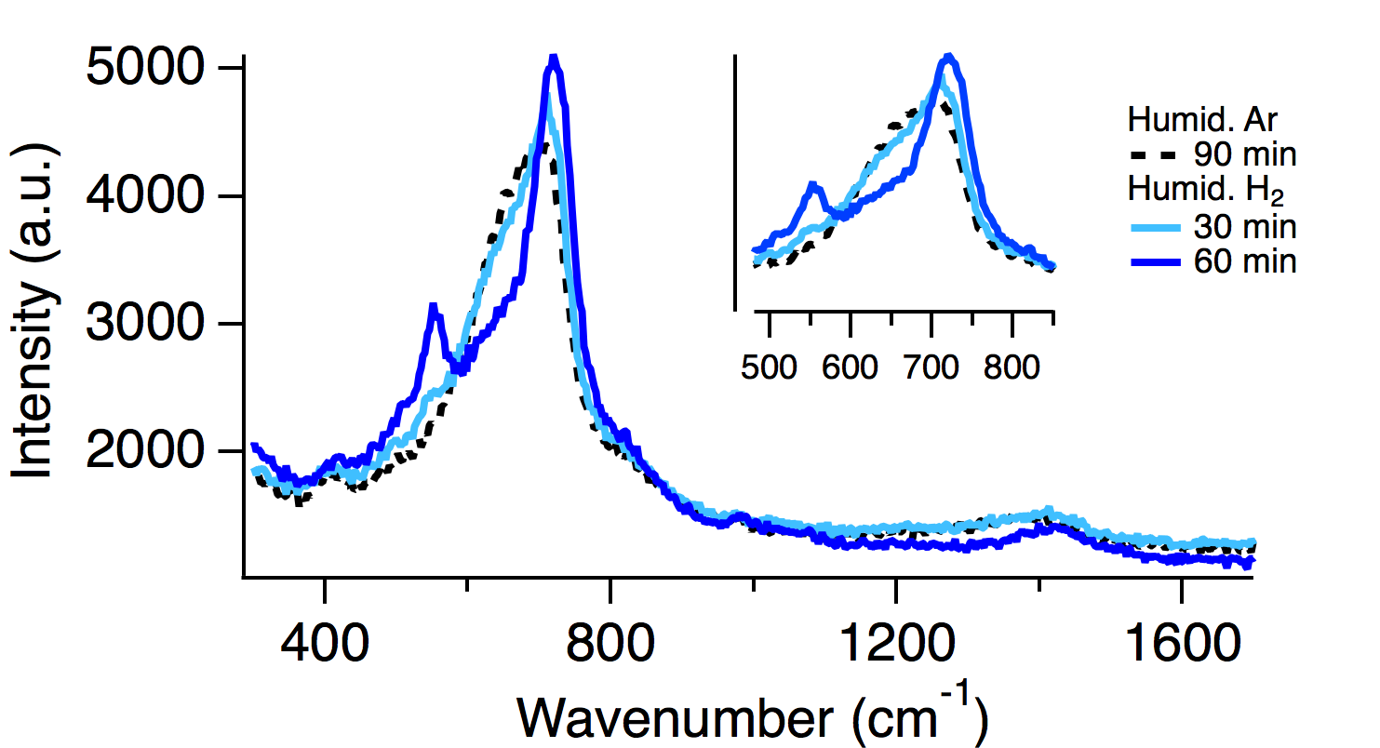
SI Figure 4. BZY sample initially exposed to huhmidified Ar at 400 °C. Under these conditions no 548 cm⁻¹ feature is apparent in the spectra. The 548 cm⁻¹ vibrational feature starts to grow in as the environment is switched to humidified H₂.

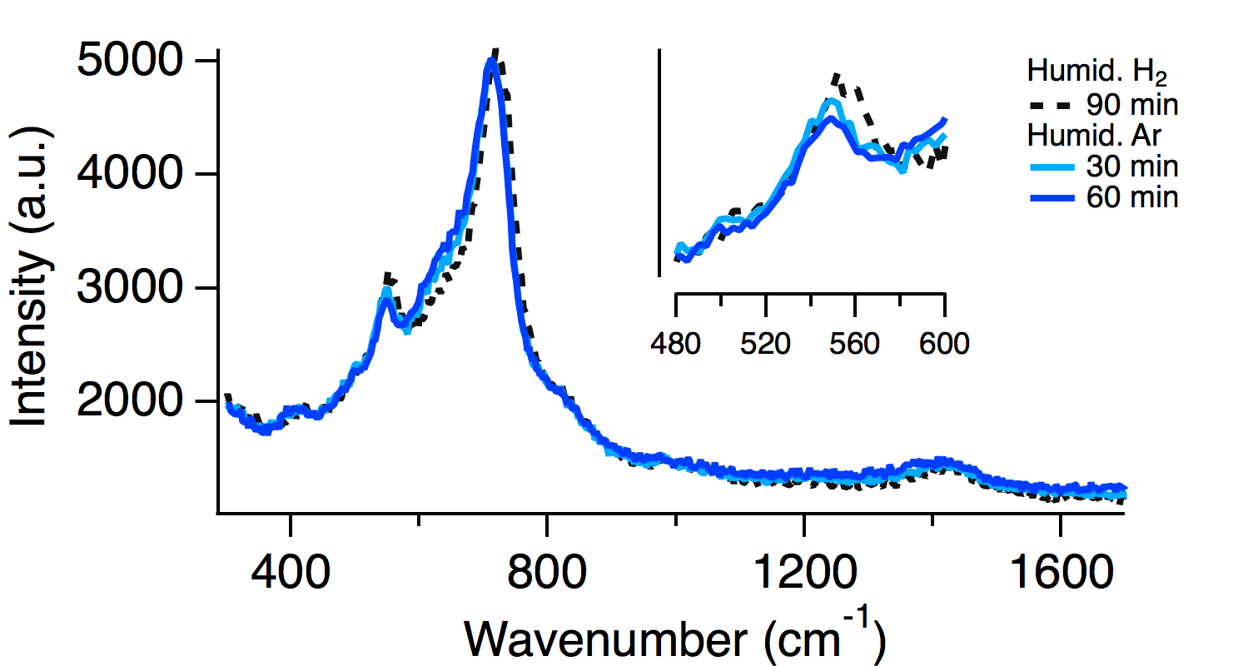
SI Figure 5. Raman spectra showing the slight decrease in 548 cm⁻¹ peak intensity with time as conditions are switched from humidified H₂ to humidified Ar.

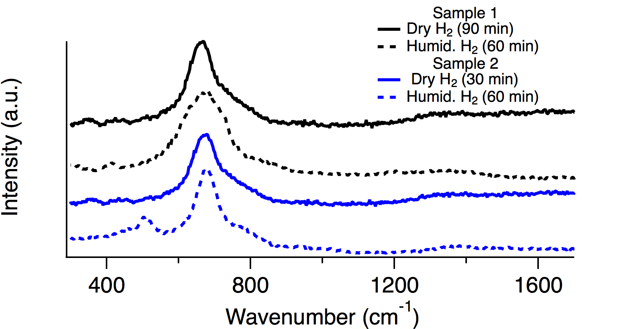
SI Figure 6. Raman spectra comparing how sample history affects the appearance of the vibrational feature at 548 cm⁻¹. If samples are exposed to dry H₂ for times >30 minutes, the new feature will not appear (black). If exposure to dry H₂ is limited to < 30 minutes the new feature will appear.

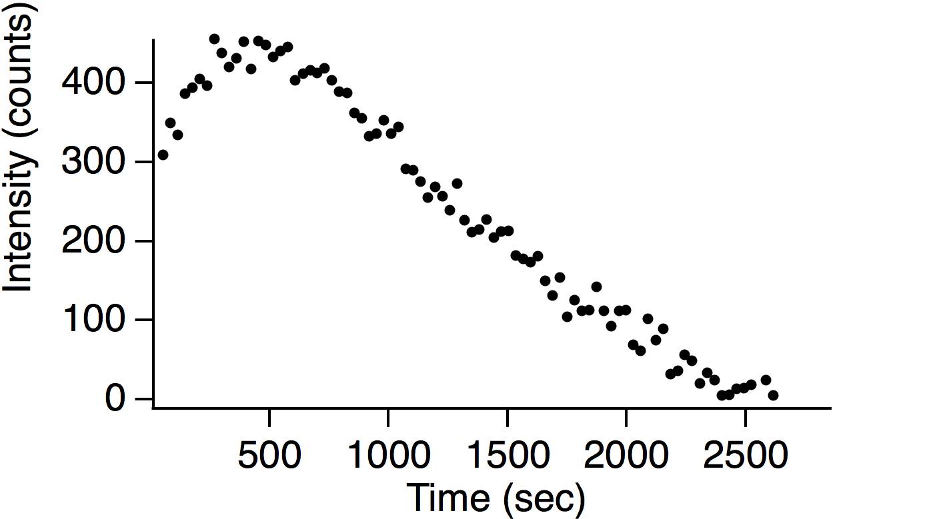
SI Figure 7. Kinetics of the 548 cm⁻¹ vibrational feature removal as conditions are switched from humidified H₂ to dry H₂. The gas phase environment is changed from humidified to dry H₂ at t=0 with gas residence time in the chamber < 30 sec.
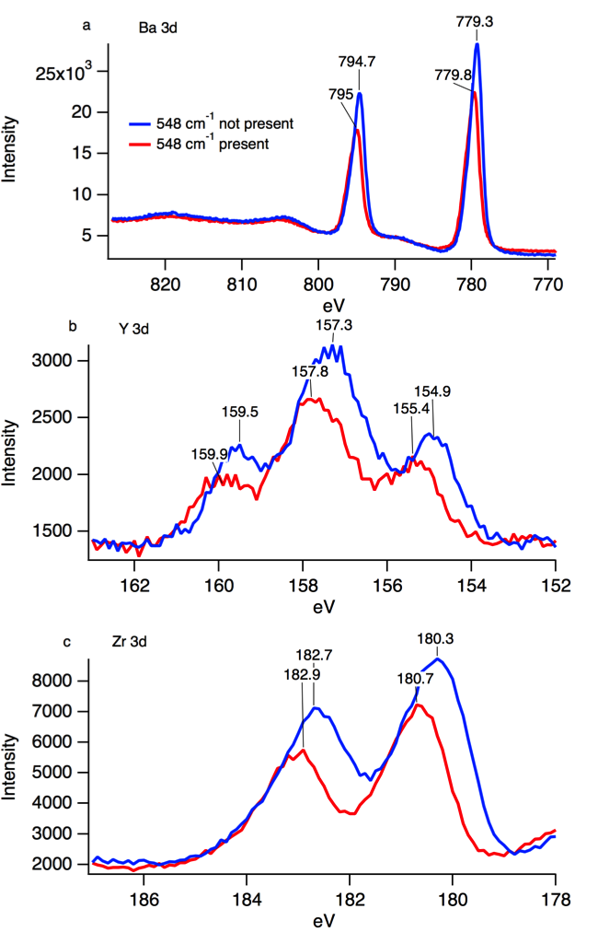
SI Figure 8. XPS multiplex scans for the 3d electrons of Ba, Y and Zr. Slight shifts to higher energies for samples containing the 548 cm⁻¹ vibrational feature are expected as these samples have more surface oxygen present and, presumably a higher degree of oxidation. Spin-orbit splitting is responsible for the doublets observed in both Ba and Zr spectra. The more complicated structure for Y implies a degree of mixed valence and/or heterogeneous chemical environments.

