Organic Superhydrophobic Coatings with Mechanical and Chemical Robustness
Sajia Afrin^{1,2}, David Fox^{1,2}, Lei Zhai^{1,2,3,*}
¹ NanoScience Technology Center; University of Central Florida
² Department of Chemistry; University of Central Florida
³ Department of Materials Science and Engineering; University of Central Florida
* Address all correspondence to Lei Zhai at lzhai@ucf.edu

Supporting Material

Figure S1. Selected Fingerprint region of TCFS FTIR spectrum.
Figure S2. Selected Fingerprint region of GPTMS FTIR spectrum.

Figure S3. Selected Fingerprint region of the FTIR spectrum of superhydrophobic coatings.

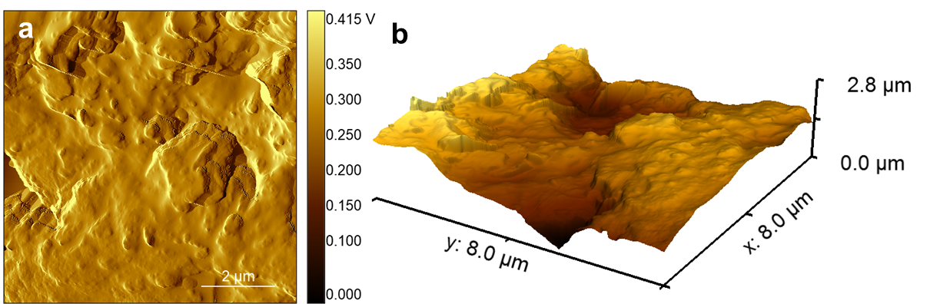
Figure S4. AFM diagram of the superhydrophobic films from GPTMS/TCFS suspension. (a) is a height image, and (b) is a 3D height image.

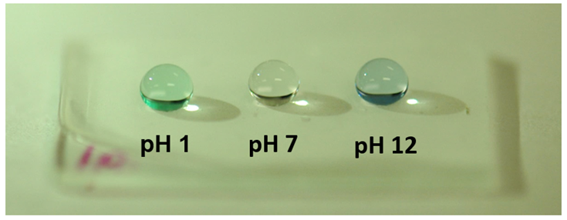
Figure S5. A photograph of droplets of different pH sitting on a superhydrophobic surface exposed to acidic and basic solutions.

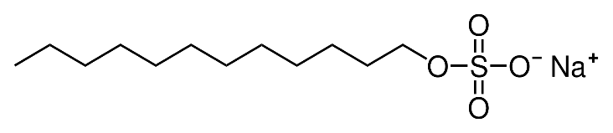

Sodium dodecyl sulfate (SDS)
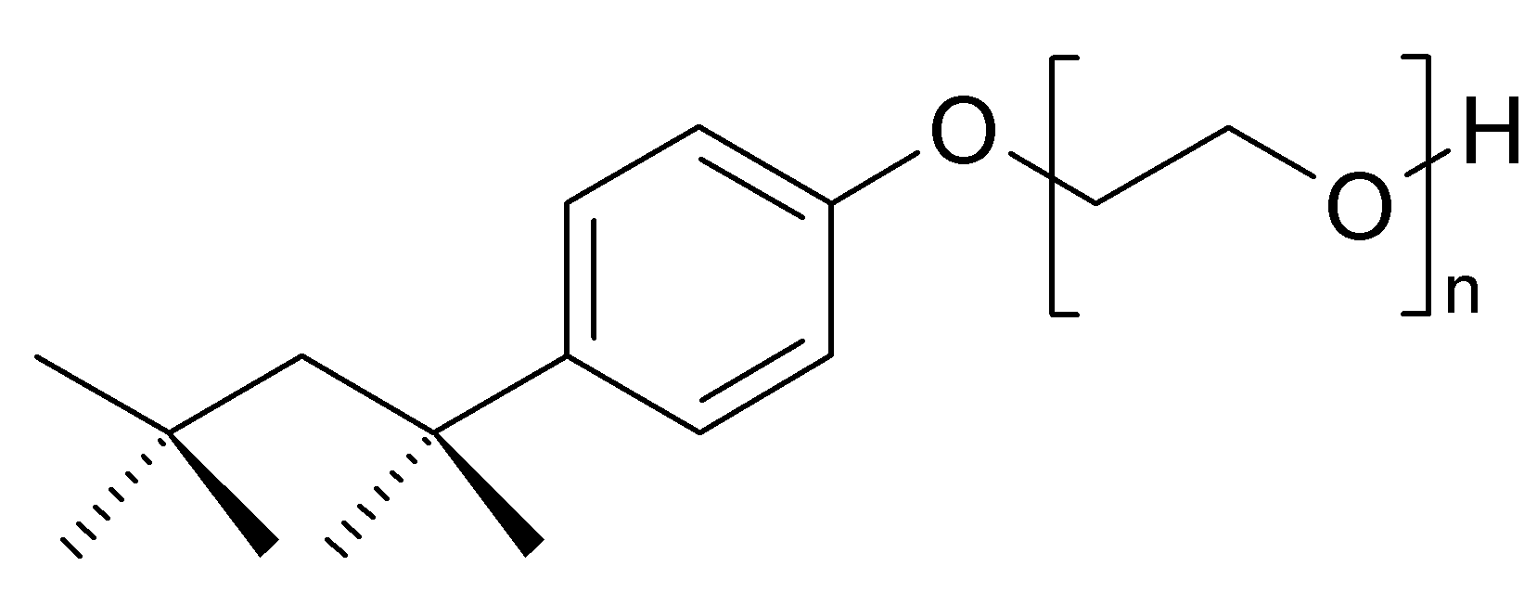

2-[4-(2,4,4-trimethylpentan-2-yl)phenoxy]ethanol (Triton X-100)
Figure S6. Chemical structures of SDS and Triton X-100.

