Supplementary material
Small-Scale High-Cycle Fatigue Testing by Dynamic Microcantilever Bending
Stefan Gabel, Friedrich-Alexander-Universität Erlangen-Nürnberg (FAU), Materials Science & Engineering, Institute I, Martensstr. 5, D-91058 Erlangen, Germany, email: stefan.s.gabel@fau.de
Benoit Merle, Friedrich-Alexander-Universität Erlangen-Nürnberg (FAU), Materials Science & Engineering, Institute I, Martensstr. 5, D-91058 Erlangen; and Interdisciplinary Center for Nanostructured Films (IZNF), Cauerstr. 3, D-91058 Erlangen, Germany, email: benoit.merle@fau.de

Data correction for the penetration of the indenter
The penetration of the indenter into the cantilevers has to be considered. Multiple indents were made with a wedge indenter on FIB-milled H-bars of different sizes as shown in FIG S1.
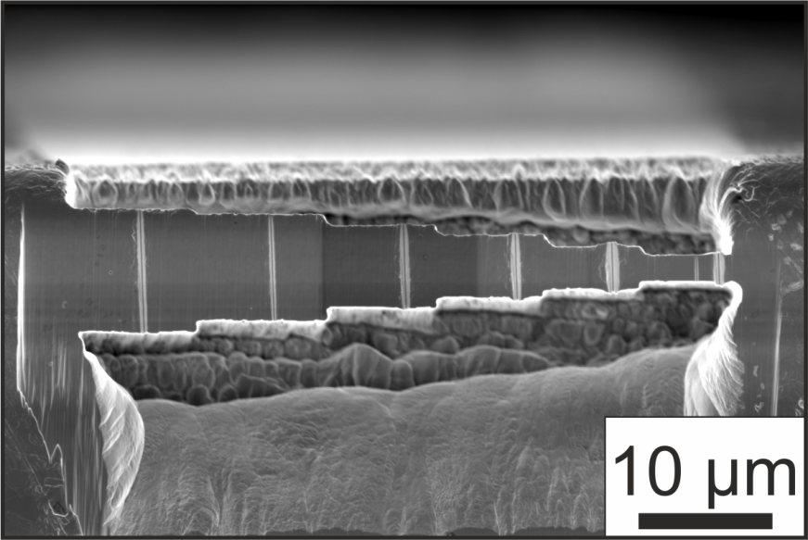
FIG S1: SE-micrograph of an H-Bar with varying width in ufg-Cu after indentation with a wedge indenter.

The resulting contact stiffness-load behavior was normalized by the length of the indent and is shown in FIG S2. The relationship between normalized loading force and stiffness can be described by a polynomial fit. The experimentally measured harmonic stiffness S_{measured} is a combination of the imprint contact stiffness S_{imprint} and the stiffness for the bending of the cantilever S_{cantilever}. The correlation of this system is given by the model of two springs connected in series, as described by Kupka and Lilleodden [40]
 | $$S_{cantilever}=\frac{S_{imprint}-S_{measured}}{S_{imprint}*S_{measured}}$$ | (S.1)
As the excitation force remains constant during the experiment, the initial force was used to calculate the imprint stiffness S_{imprint} for the correction of the continuously recorded cantilever stiffness. Due to creep and accumulation of cyclic damage, the indentation depth increases during cyclic testing, which also increases S_{imprint}. As the experiments took place ex-situ, this effect could not be considered in the results. However its influence is rather small, as the initial S_{imprint} in each experiment is at the stage with shallow slope in Fig A2. Therefore an increase of the penetration depth would only lead to a small increase of S_{imprint}. Furthermore S_{imprint} at the start of the experiment exceeded S_{measured} and S_{cantilever} by two orders of magnitude. Therefore even an increase from the stiffness S_{imprint} from the beginning of the experiment to the maximal value in Fig A2 by further indentation depth would only lead to a variation of S_{cantilever} by <0.5 %, which is much smaller than the hardening effect and the failure criterion.

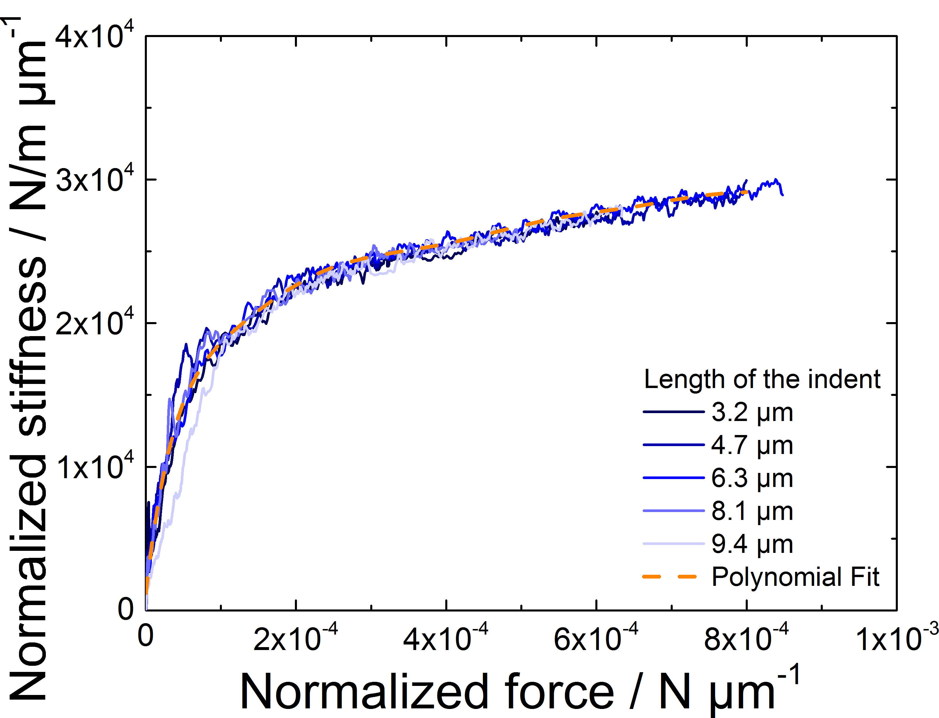
FIG S2: Normalized stiffness-force behavior of the reference indents in the H-Bars.

