Monolithic Quartz Platform for Cellular Contact Guidance
Supporting Information
Michael C. Robitaille¹, Joseph A. Christodoulides¹, Jinny L. Liu¹, Wonmo Kang², Jeff M. Byers¹, Katarina Doctor¹, Dmitry Kozak¹, and Marc P. Raphael^{1*}

¹ Naval Research Laboratory, 4555 Overlook Ave SW, Washington D.C. 20375-5320
² School for Engineering of Matter, Transport and Energy, Arizona State University, Tempe AZ, 85287
* Corresponding author email: Marc.Raphael@nrl.navy.mil

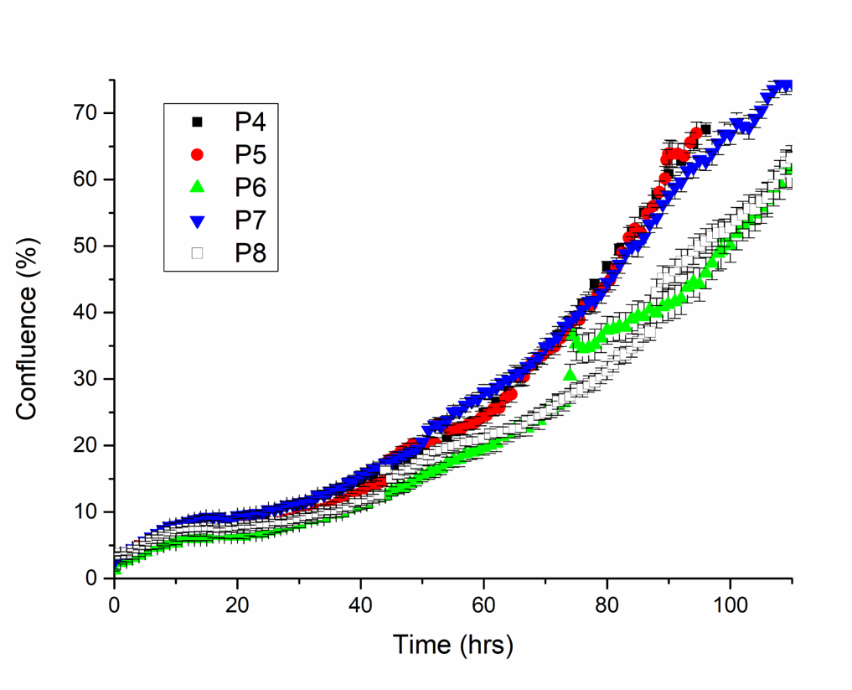
Figure S1: Growth curves of Hs27 fibroblasts from passage 4 - passage 8 taken via Essen Incucyte.
Figure S2: CellProfiler focal adhesion analysis pipeline. Raw fluorescent image highlighting vinculin distribution is imported (left) into the pipeline first. Moving left to right, the image estimates fluorescent tag background noise via Regular Illumination Function (median filter). The background noise is then subtracted from the original image. Next, a Gaussian filter (r = 2 pixels) smooths out the image, at which point a global threshold strategy is used to identify focal adhesions (outlined in green). The final image on the right overlays the detected focal adhesions in red on top of the original fluorescent image.

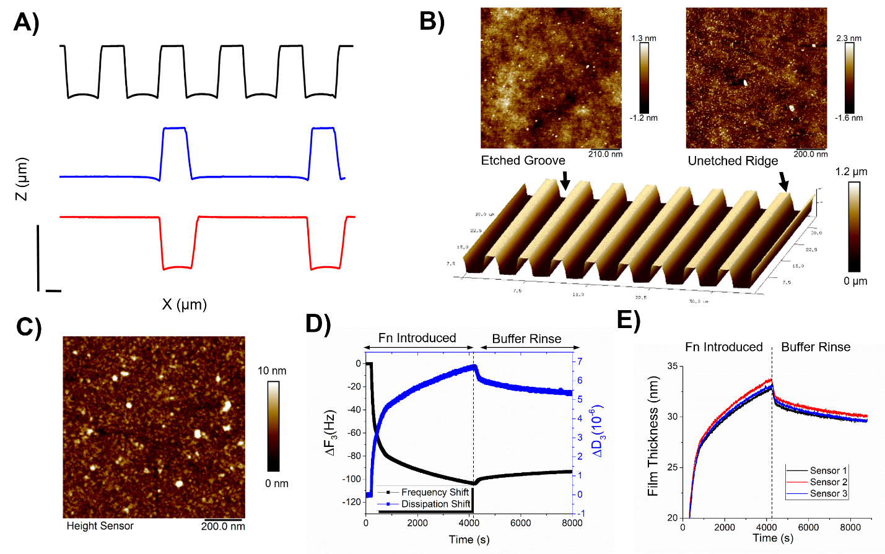
Figure S3: Contact Guidance Chip Characterization. A) AFM cross-sections of the three topographical conditions (scale bars = 1 μm). B) Roughness measurements of the etched grooves and unetched ridges. C) AFM characterization of adsorbed fibronectin (FN) on flat SiO₂ portions of the contact guidance chip. D) QCM-D measurements highlighting the 3rd harmonic shift in frequency and dissipation for 25 μg/mL FN on bare SiO₂. E) Corresponding adsorbed FN film thickness estimates.

Figure S4: Box plot showing the total migration distance traveled for fibroblasts for each topographical condition.

