SUPPLEMENTAL INFORMATION
General Synthesis Methods
All reagents and solvents were purchased from Sigma-Aldrich® and used as received with no further purification. COF-5 used for solution study and film formation was synthesized following a previously documented procedure.
Supplemental Figures and Data
Scanning Electron Microscopy (SEM) and Energy Dispersive X-ray Spectroscopy (EDS) data:
SEM images taken with a Hitachi High-TechTM SU8020 and EDS maps generated using an Oxford InstrumentsTM X-MAXTM EDS. An accelerating voltage of 15 keV and load current of 10 μA was used for SEM.
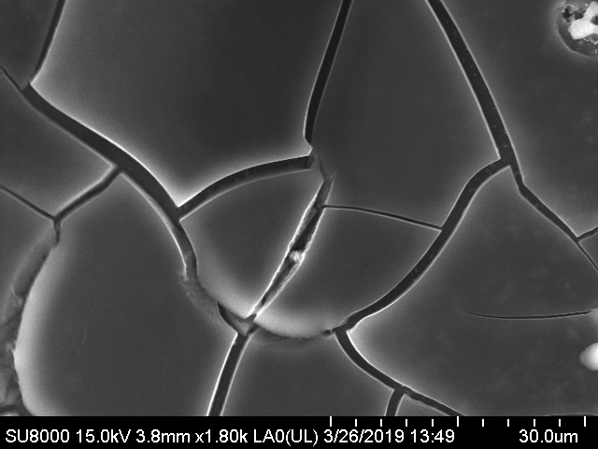
Figure S1 SEM image of COF-5 + FeCl₃ film as deposited.
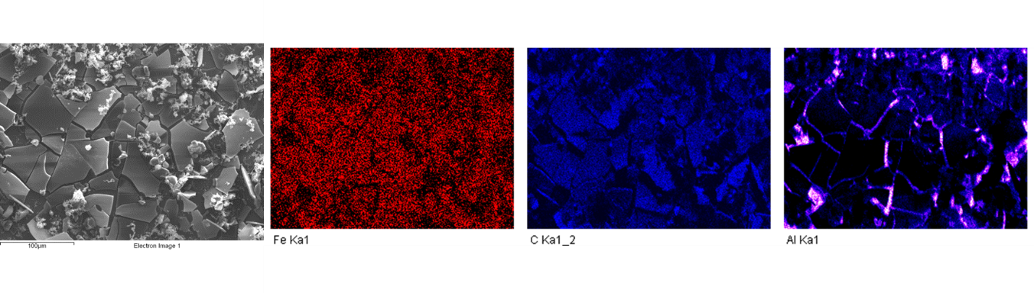
Figure S2 From left to right: SEM image of COF-5 + FeCl₃ film as deposited; EDS color map for elemental iron (ionic additive); EDS color map for elemental carbon (bulk component of COF-5); EDS color map for elemental aluminum (polished aluminum tab used as substrate).
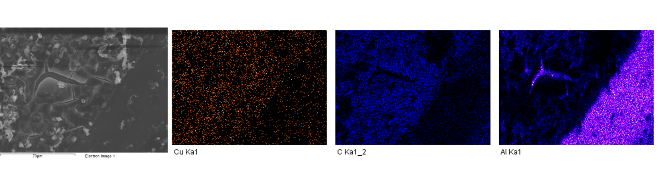
Figure S3 From left to right: SEM image of COF-5 + CuCl₂ film as deposited; EDS color map for elemental copper (ionic additive); EDS color map for elemental carbon (bulk component of COF-5); EDS color map for elemental aluminum (polished aluminum tab used as substrate).
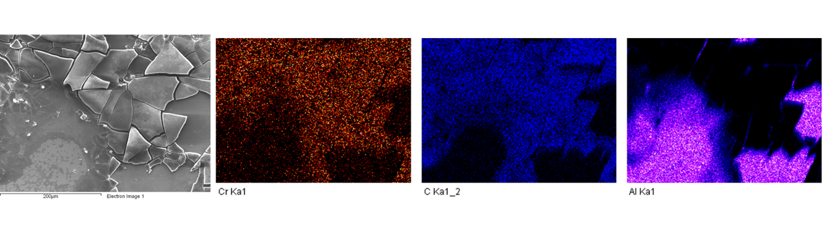
Figure S4 From left to right: SEM image of COF-5 + CrCl₃ film as deposited; EDS color map for elemental chromium (ionic additive); EDS color map for elemental carbon (bulk component of COF-5); EDS color map for elemental aluminum (polished aluminum tab used as substrate).
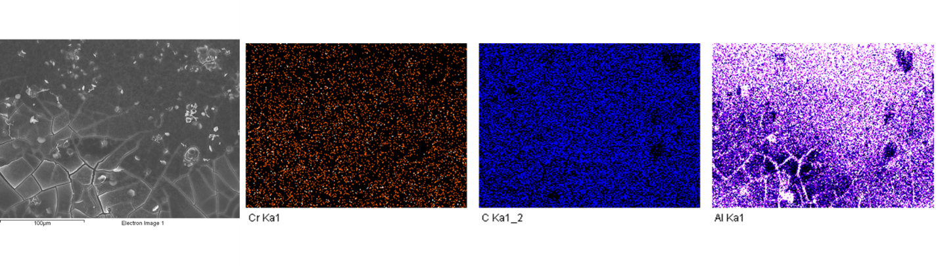
Figure S5 From left to right: SEM image of COF-5 + CrCl₃ film as deposited; EDS color map for elemental chromium (ionic additive); EDS color map for elemental carbon (bulk component of COF-5); EDS color map for elemental aluminum (polished aluminum tab used as substrate). This figure shows an alternative location on the same sample depicted in figure S4.
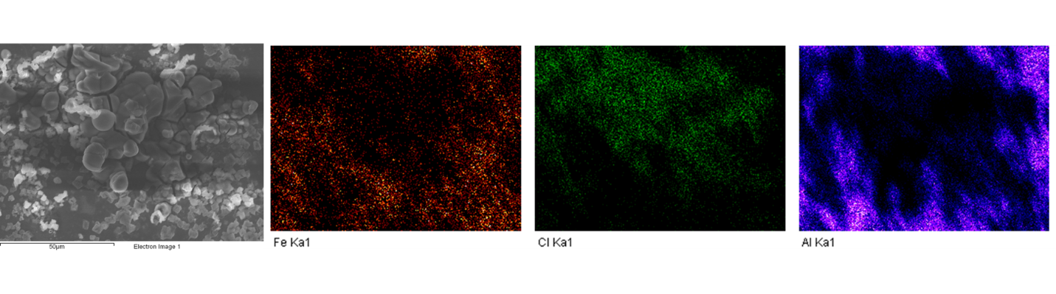
Figure S6 From left to right: SEM image of FeCl₃ deposited in the same manner as films; EDS color map for elemental iron; EDS color map for elemental chlorine; EDS color map for elemental aluminum (polished aluminum tab used as substrate). SEM image included to demonstrate morphological differences between COF-5 films containing ionic additives and ionic additives without COF-5 matrix.

Fourier Transform Infrared Spectroscopy (FTIR) Spectra:
FTIR spectra were taken using a Fisher Thermo ScientificTM NicoletTM iSTM 50 infrared spectrometer. Colloidal synthesis COF-5 spectrum (Figure S6) was measured by the Attenuated Total Reflectance (ATR) accessory. COF-5 + metal ion samples were deposited via film deposition method mentioned in paper onto NaCl plates and measured by IR transmittance.
Figure S7 FTIR transmittance spectrum for COF-5 prepared via the colloidal synthesis method. Notable peaks are labeled with respective wavenumbers.
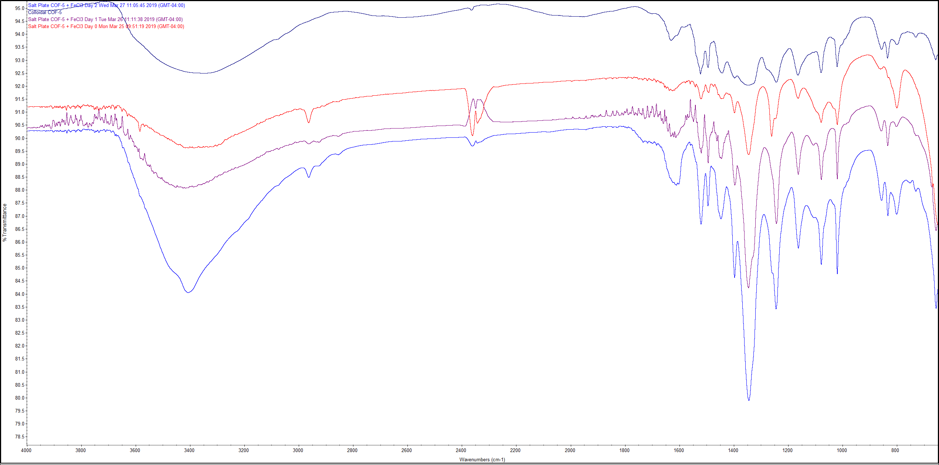
Figure S8 FTIR transmittance spectra for COF-5 + FeCl₃ films overlaid for comparison: orange curve – film deposited immediately after solution mixing; purple curve – film deposited after 24 hours of reaction in solution; light blue curve – film deposited after 48 hours of reaction in solution; dark blue curve – COF-5 prepared via colloidal synthesis method for reference.
Figure S9 FTIR transmittance spectra for COF-5 + CuCl₂ films overlaid for comparison: orange curve – film deposited immediately after solution mixing; purple curve – film deposited after 24 hours of reaction in solution; green curve – film deposited after 48 hours of reaction in solution; pink curve – COF-5 prepared via colloidal synthesis method for reference.

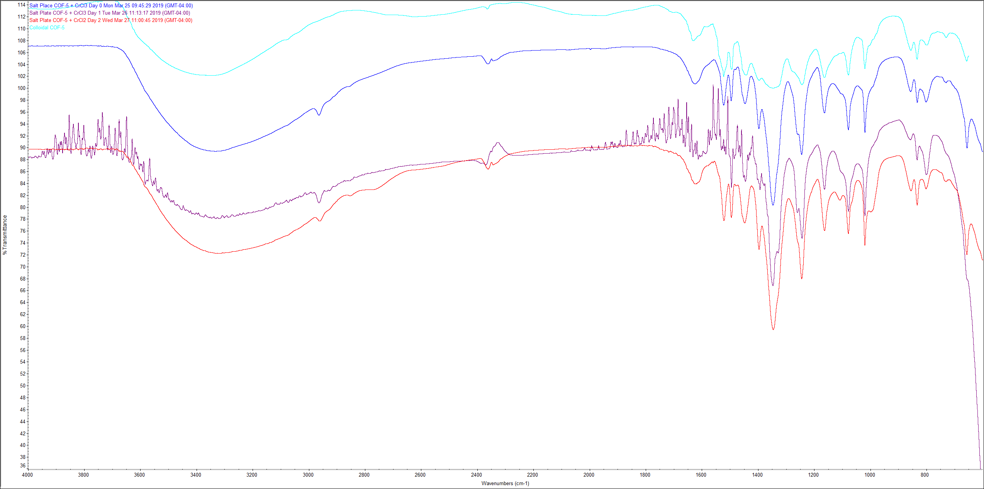
Figure S10 FTIR transmittance spectra for COF-5 + CrCl₃ films overlaid for comparison: dark blue curve – film deposited immediately after solution mixing; purple curve – film deposited after 24 hours of reaction in solution; orange curve – film deposited after 48 hours of reaction in solution; light blue curve – COF-5 prepared via colloidal synthesis method for reference.
Powder X-Ray Diffraction Patterns:
PXRD patterns were generated with a BrukerTM D8 Advance Series II powder X-ray diffractometer with a Cu source at an operating current of 40 mA and an operating voltage of 40 kV. A time step of 0.2 s was used with no delay time.

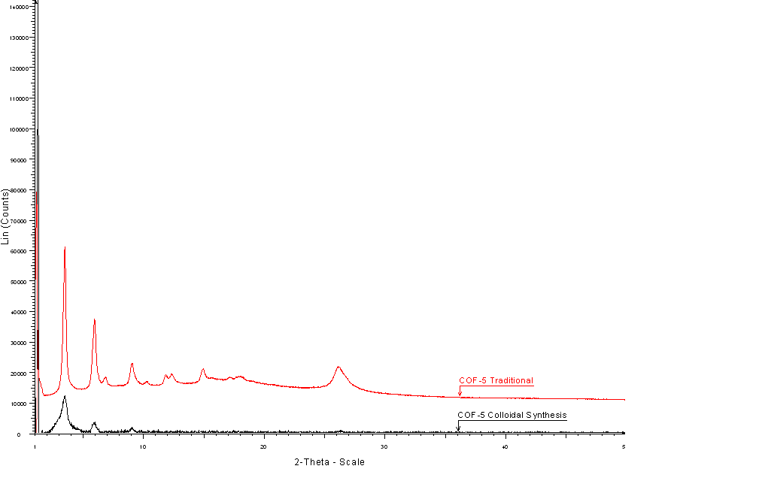
Figure S11 PXRD spectra for traditionally prepared and colloidal synthesis COF-5.
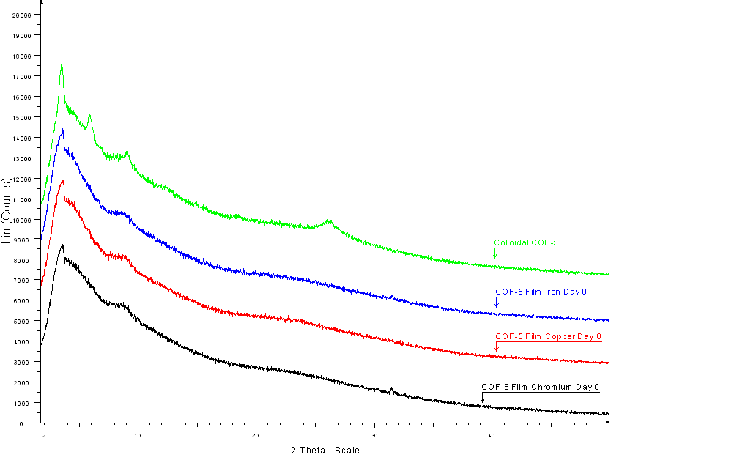
Figure S12 PXRD spectra for COF-5 + metal ion films and colloidal COF-5 for comparison.

High Resolution Optical Microscopy Imaging and Depth Profiling:
High resolution optical microscopy images were obtained using a HIROXTM high-resolution microscope. Color mapping and depth profiling were performed using a built in focal-point depth profiling function.

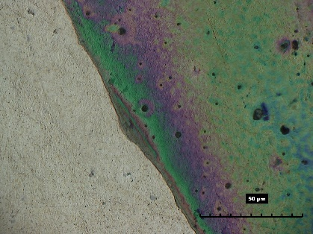
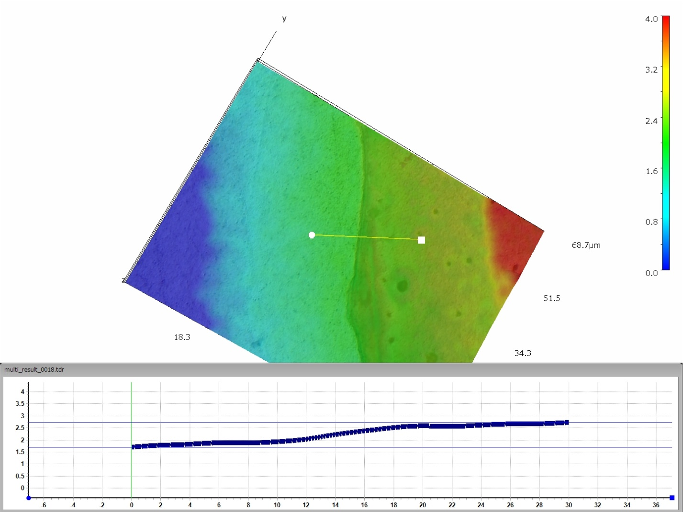
Figure S13 High resolution microscopy image of COF-5 + FeCl₃ film on aluminum tab substrate overlaid with color map showing depth profile for film thickness. Plot (bottom, blue line) shows the depth profile following the yellow line on the image. Contour indicates film thickness between 1 and 3 μm for on-film and off-film points. Other films were analyzed in a similar manner to yield thicknesses between 1 and 5 μm.

Visible Spectrum Absorption Profiles:
Visible spectrum absorption profiles were obtained using a StellarNet, Inc.® EPP2000TM spectroradiometer. Solution absorption profiles were measured in an attached cuvette holder using 1 cm methacrylate cuvettes. Film absorption profiles were measured using a glass slide holder.

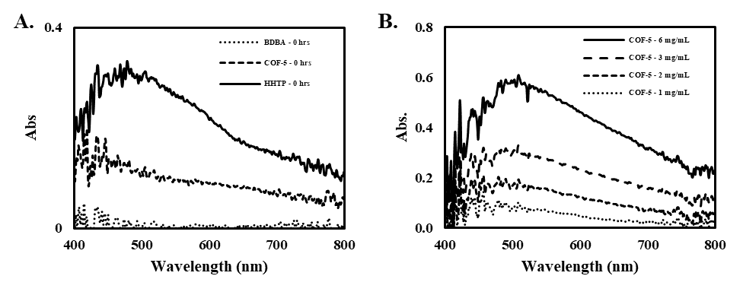
Figure S14 (A) Visible absorption spectra for COF-5 (4.2 mM), HHTP (1.4 mM), and BDBA (2.1 mM); concentrations were selected to ensure the amount of HHTP and BDBA present in solution is identical to the amount of corresponding monomer subunits in COF-5. (B) Visible absorption spectra for COF-5 (1, 2, 3, and 6 mg/mL) showing the presence of nonbonding to π* transition at ~500 nm.

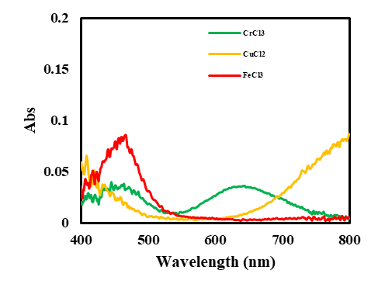
Figure S15 Visible absorbance spectra for CrCl₃, CuCl₂, and FeCl₃ in MeOH solution. Pure methanol in a methacrylate cuvette was used to zero the spectrometer prior to measurement of samples.

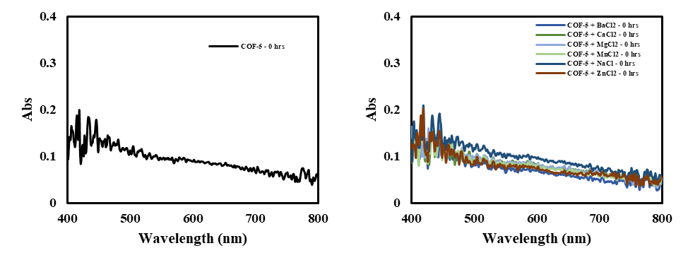
Figure S16 Visible absorbance spectra for COF-5 in MeOH and COF-5 in the presence of BaCl₂, CaCl₂, MgCl₂, MnCl₂, NaCl, and ZnCl in MeOH. No spectral changes were observed for these species with COF-5.

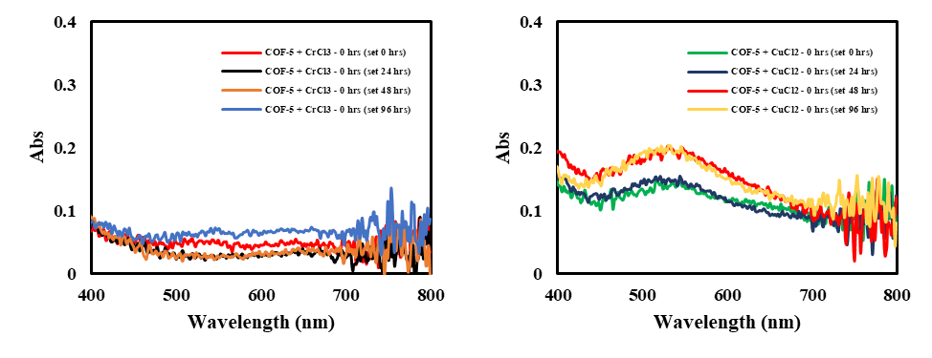
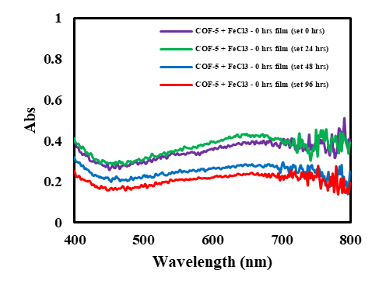

Figure S17 Visible absorbance spectra for COF-5 films in the presence of CrCl₃, CuCl₂ and FeCl₃ deposited immediately after solution mixing and measured periodically over a four-day period.

