Supplemental Information:
Response of neuroglia to hypoxia-induced oxidative stress using enzymatically-crosslinked hydrogels

Samantha G. Zambuto^{1*}, Julio F. Serrano^{2,3*}, Avery C. Vilbert⁴, Yi Lu^{2,4,5}, Brendan A.C. Harley^{2,3**}, Sara Pedron^{2,3**}

¹ Dept. of Bioengineering, University of Illinois at Urbana-Champaign, Urbana, IL
² Carl R. Woese Institute for Genomic Biology, University of Illinois at Urbana-Champaign, Urbana, IL
³ Dept. Chemical and Biomolecular Engineering, University of Illinois at Urbana-Champaign, Urbana, IL
⁴ Pacific Northwest National Laboratory, Richland, WA
⁵ Dept. of Chemistry, University of Illinois at Urbana-Champaign, Urbana, IL

*These authors contributed equally to this work
**Co-corresponding authors

Corresponding Authors:
S. Pedron
Dept. of Chemical and Biomolecular Engineering
Carl R. Woese Institute for Genomic Biology
University of Illinois at Urbana-Champaign
1260 W Gregory Dr.
Urbana, IL 61801
Phone: (217) 300-9012
Fax: (217) 265-6800
e-mail: spedron@illinois.edu

B.A.C. Harley
Dept. of Chemical and Biomolecular Engineering
Carl R. Woese Institute for Genomic Biology
University of Illinois at Urbana-Champaign
110 Roger Adams Laboratory
600 S. Mathews Ave.
Urbana, IL 61801
Phone: (217) 244-7112
Fax: (217) 333-5052
e-mail: bharley@illinois.edu

Table S1. Hydrogel composition, polymerization conditions and Young’s moduli.
 | GelFA  (%wt) | GelHPA  (%wt) | HRP  (U/ml) | H₂O₂  (mM) | Laccase  (U/ml) | E  (kPa)
FA525 | 5 | - | - | - | 25 | 10 ± 8
FA325 | 3 | - | - | - | 25 | 12 ± 3
FA310 | 3 | - | - | - | 10 | 16 ± 9
FA3HRP | 3 | - | 0.1 | 1 | - | 7 ± 1
GelHPA | - | 2 | 0.25 | 2 | - | 3 ± 1

Table S2. Cell media composition.

Medium Type | Formulation | Concentration
Rat Fetal Neural Stem Cell Growth Medium | KnockOut DMEM/F-12  GlutaMAX-I Supplement  bFGF (prepared as 100 μg/mL stock)  EGF (prepared as 100 μg/mL stock)  StemPro Neural Supplement  Penicillin/Streptomycin | 1X  2 mM  20 ng/mL  20 ng/mL  2%  1%
Rat Fetal Neural Stem Cell Neural Differentiation Medium | Neurobasal Medium  B-27 Supplement (50X), serum free  GlutaMAX-I Supplement  Penicillin/Streptomycin | 1X  2%  2 mM  1%
Rat Fetal Neural Stem Cell Astrocyte Differentiation Medium | DMEM  N-2 Supplement  GlutaMAX-I Supplement  FBS  Penicillin/Streptomycin | 1X  1%  2 mM  1%  1%
Rat Fetal Neural Stem Cell Oligodendrocyte Differentiation Medium | Neurobasal Medium  B-27 Supplement (50X), serum free  GlutaMAX-I Supplement  T3  Penicillin/Streptomycin | 1X  2%  2 mM  30 ng/mL  1%
Normal Human Astrocyte Medium | ABM Basal Medium (Lonza CC-3187)  AGM Single Quots Supplement Pack (CC-4123) | 1X  1X
Mouse Embryonic Oligodendrocyte Medium | Mouse Oligodendrocytes Cell Culture Complete Media with Serum.  Cat# M11004-02 – Celprogen Inc. | 1X

Table S3. Complete list of antibodies used for immunofluorescent staining.

Antibody | Vendor | Part Number | Host Species | Dilution
Anti-Nestin Antibody, Clone Rat-401 | Millipore Sigma | MAB353 | Mouse | 1:200
Anti-Tubulin β3 (TUBB3) Antibody | BioLegend | 801213 | Mouse | 5 μg/mL
Anti-GFAP Antibody | Sigma-Aldrich | SAB4300647 | Rabbit | 1:500
Anti-O1 Antibody | Millipore Sigma | MAB344 | Mouse | 20 μg/mL
Anti-Myelin Basic Protein (MBP) Antibody | Sigma-Aldrich | M3821 | Rabbit | 1:200
Anti-O4 Antibody, Clone 81 | Millipore Sigma | MAB345 | Mouse | 20 μg/mL
Anti-CNPase Antibody, clone 11-5B | Millipore Sigma | MAB326 | Mouse | 10 μg/mL
Goat Anti-Mouse IgG (H+L) Cross-Adsorbed Secondary Antibody, Alexa Fluor 488 | ThermoFisher | A-11001 | Goat | 1:500
Goat Anti-Rabbit IgG (H+L) Cross-Adsorbed Secondary Antibody, Alexa Fluor 555 | ThermoFisher | A-21428 | Goat | 1:500

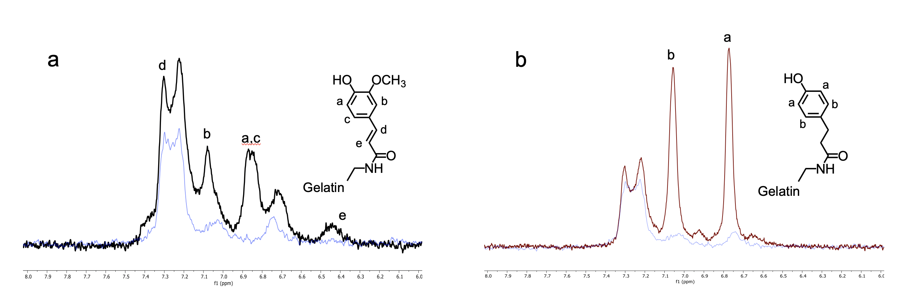
Figure S1. NMR characterization of gelatin-ferulic acid (GelFA) and gelatin-hydroxyphenylpropionic acid (GelHPA) conjugates. (a) ¹H NMR spectra of GelFA (black) and gelatin (blue) (500 MHz, D₂O, rt): δ 7.35 – 7.28 (m, 1H), 7.12 – 7.00 (m, 1H), 6.95 – 6.79 (m, 2H), 6.51 – 6.40 (m, 1H). (b) ¹ H NMR spectra of GelHPA (red) and gelatin (blue) (500 MHz, D₂O, rt): δ 7.11 – 7.00 (m, 2H), 6.82 – 6.70 (m, 2H).

Figure S2. Glial fibrillary acidic protein (GFAP) expression in astrocytes. Normal human astrocytes cultured in 2wt% GelHPA hydrogels in (a) normoxia and (b) hypoxia (1% O₂) for 24h. GFAP (green) and Hoechst (blue, nuclei).

