**SUPPLEMENTAL MATERIAL**

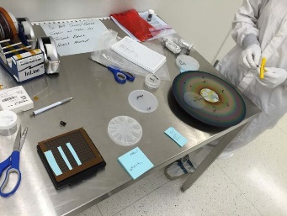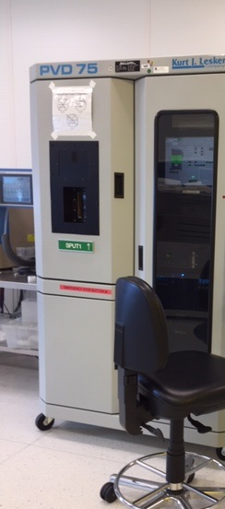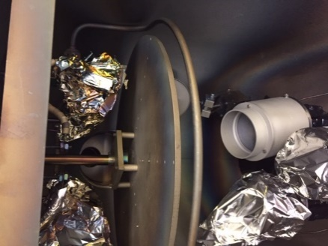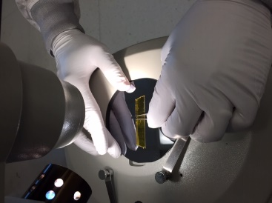

Figure S1. A collage of digital images indicating the equipment used during the RF-sputtering deposits.

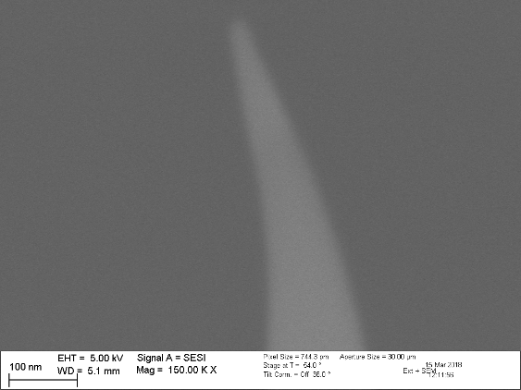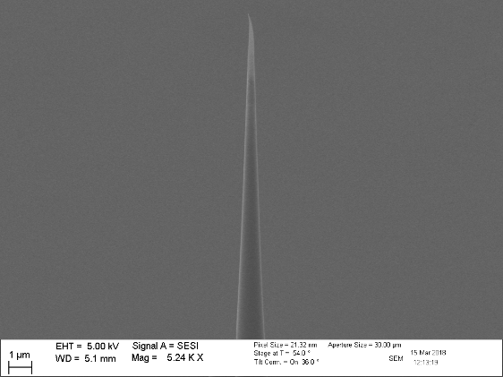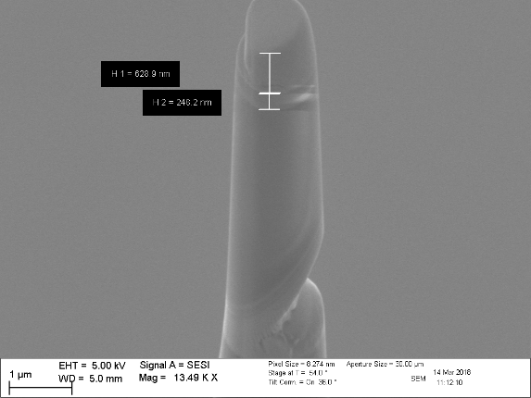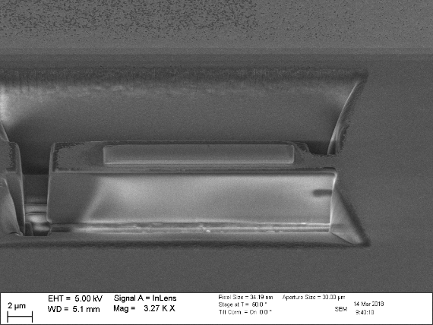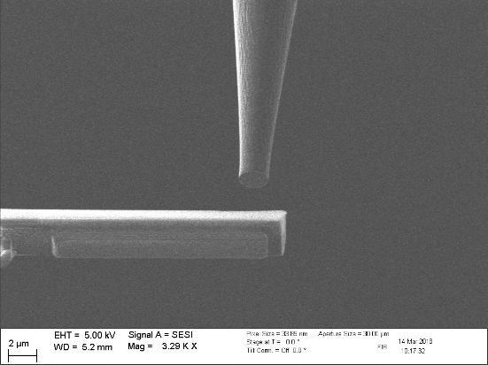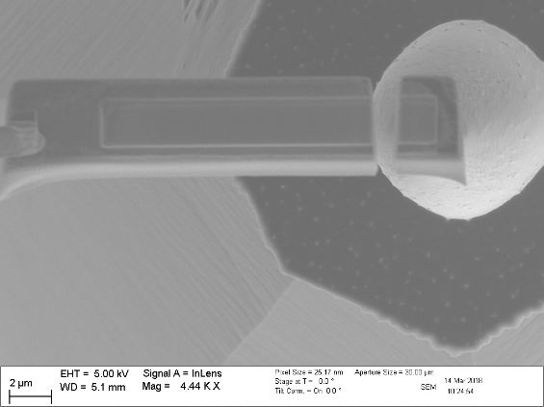

Figure S2. FIB lift-out process, it was possible to determine sample damage as observed on the bottom images, due to sensitive nature of semiconducting MoS2 material to electron beam.

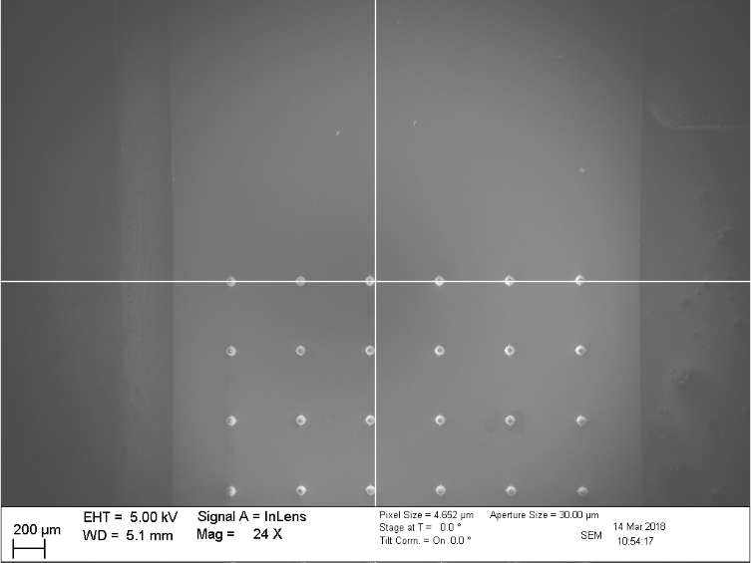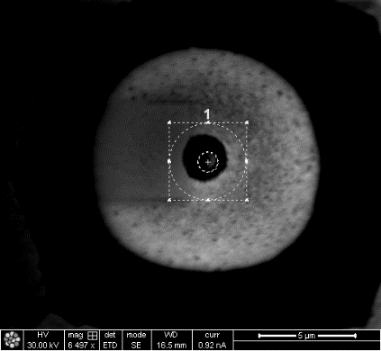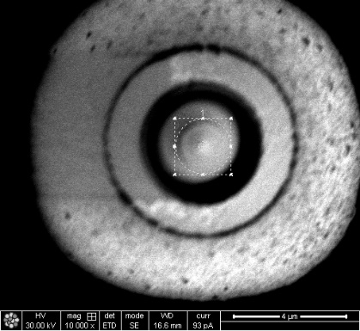

Figure S3. Left: Atom Probe Tomography coupons, made from Silicon and designed with patterned locations at specific cartesian coordinates. Center: An enlargement of one location used to perform the needle shaping, and which contains the ITO and MoS2 layers. Right: A more detailed image of the same location.

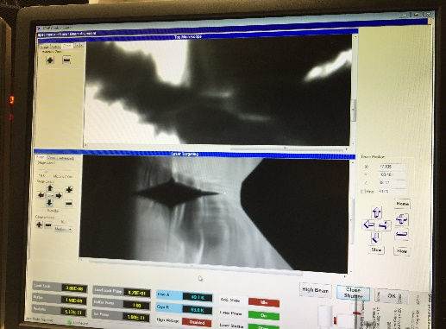

Specimen Counter Electrode

Figure S4. **Left:** Schematic drawing of time of flight pulse laser Atom Probe Tomography machine. **Right:** An actual digital photograph of the chamber where it is possible to observe the sample getting closer to the counter electrode.