Supplementary material: Anisotropic behavior of tensile properties in a hot-extruded polycrystalline nickel-base superalloy

Xiaotao Liu, State Key Laboratory for Powder Metallurgy, Central South University, Changsha, Hunan, 410083, China; National Center for Electron Microscopy, Molecular Foundry, Lawrence Berkeley National Laboratory, Berkeley, CA 94720, USA
Zaiwang Huang, State Key Laboratory for Powder Metallurgy, Central South University, Changsha, Hunan, 410083, China
Liang Jiang, State Key Laboratory for Powder Metallurgy, Central South University, Changsha, Hunan, 410083, China; Institute for Advanced Studies in Precision Materials, Yantai University, Yantai, Shandong, 264005, China

Address all correspondence to Zaiwang Huang at huangzaiwang@csu.edu.cn

Table S1
Nominal composition of the nickel-base superalloy (wt.%).
Element | Cr | Al | Co | Mo | Nb | Ti | W | Zr | B | C | Ta | Ni
Content | 15.8 | 2.04 | 12.4 | 3.97 | 0.49 | 3.31 | 2.39 | 0.001 | 0.001 | 0.032 | 0.01 | Bal.

Figure S1 shows the equilibrium phase diagram of the nickel-base superalloy at the temperature of 760 ℃ which is essentially the aging temperature of the heat treatment regime. Primary parameters based on the calculated equilibrium phase diagram are summarized in the accompanying Tab. S2. As suggested, the fraction of γ′ phase is 44.09% which agrees well with the experimental results.
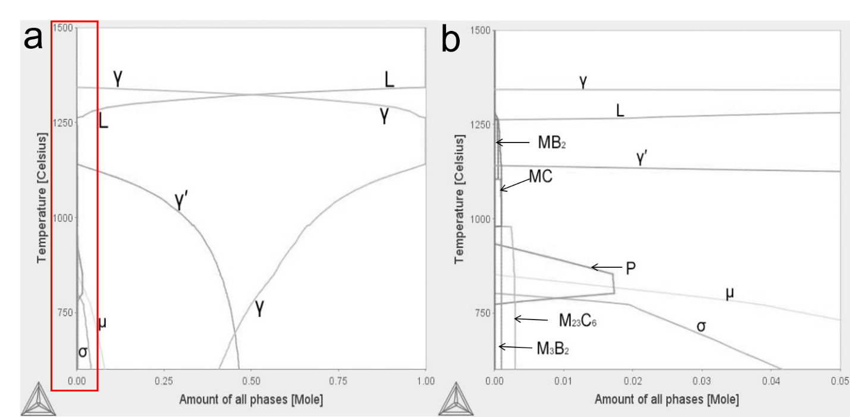
Figure S1. Thermo-Calc calculated equilibrium phase diagram of the nickel-base at the aging temperature of 760 ℃ (a) and zoomed image correponding to the red boxed area (b).
Table S2. Primary parameters of the nickel-base superalloy at the equilibrium state (760 ℃) calculated by Thermo-Calc.
Fraction of γ′ phase at the equilibrium state (wt. %) | Temperature for completely dissolving γ′ phase（℃） | Temperature of the solid line（℃） | Temperature of the liquid line（℃）
44.09 | 1139 | 1262 | 1342

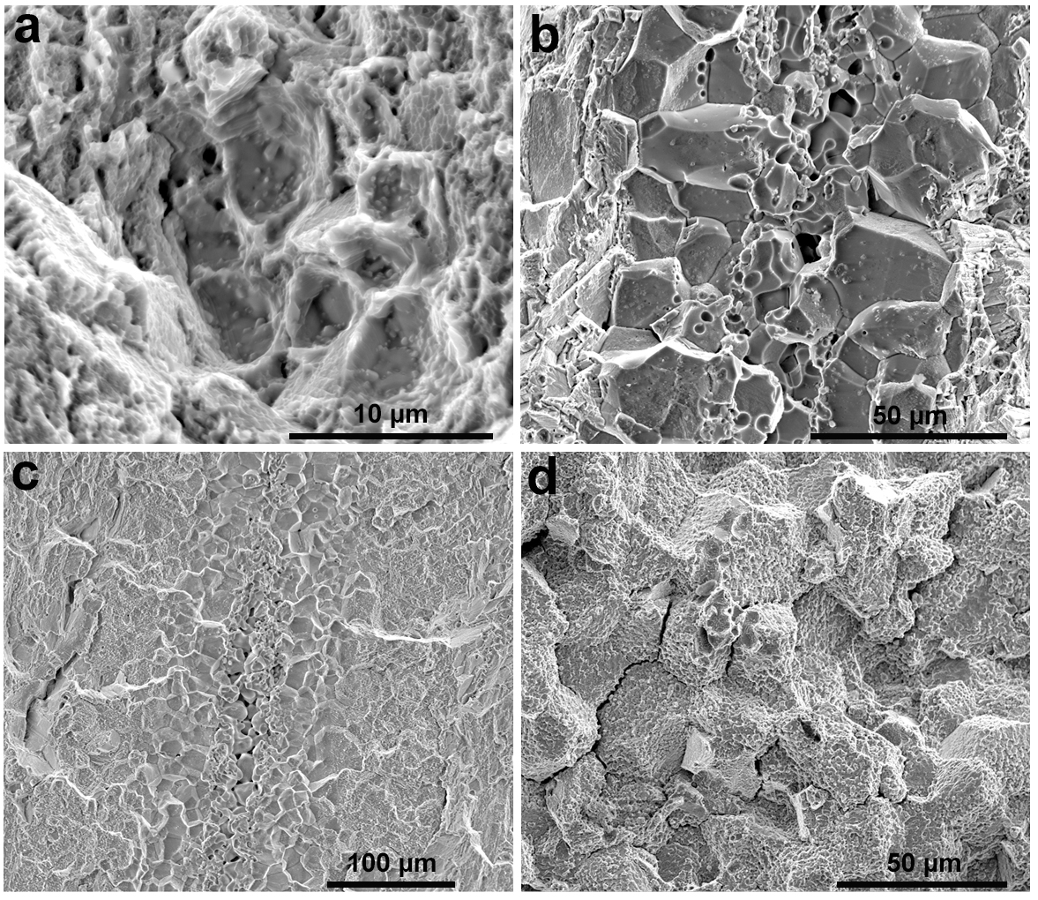Figure S2. SEM micrographs of tensile fracture surfaces of the transverse specimens deformed at 25 ℃ (a), 400 ℃ (b), 650 ℃ (c) and 700 ℃ (d).

