Supplementary Information

Optimized mixed phases to achieve improved performance of organic solar cells

Yanlin Yi ^{a,b}, Xu Gaoª, Jian Yuan^{c}, Jiangang Liu^{a*}, Wei Ma^{c*}, Yanchun Han^{a*}
(ª State Key Laboratory of Polymer Physics and Chemistry, Changchun Institute of Applied Chemistry, Chinese Academy of Sciences, Changchun 130022, China;
^{b} State Key Laboratory of Fine Chemicals, School of petroleum and chemical engineering, Dalian University of Technology, Panjin, Liaoning 124221, China;
^{c} State Key Laboratory for Mechanical Behavior of Materials, Xi’an Jiaotong University, Xi’an 710049, China)
* corresponding authors: niitawh@ciac.ac.cn; msewma@mail.xjtu.edu.cn; ychan@ciac.ac.cn
Materials
DRTB-T(5Z,5'E)-5,5'-((4,4',4'',8,8',8''-hexakis(5-(2-ethylhexyl)thiophen-2-yl)-[2,2':6',2''-terbenzo[1,2-b:4,5-b']dithiophene]-6,6''-diyl)bis(methanylylidene))bis(3-ethyl-2-thioxothiazolidin-4-
one) and IDIC^{[1]} 2-((Z)-2-((7-(((1E,2Z)-1-(cyano(isocyano)methylene)-3-oxo-1,3-dihydro-2H-inden-2-ylidene)methyl)-4,4,9,9-tetrahexyl-4,9-dihydro-s-indaceno[1,2-b:5,6-b']dithiophen-2-yl)methylene)-3-oxo-2,3-dihydro-1H-inden-1-ylidene)malononitrile were purchased from Solarmer Materials Inc. The structure and energy level of which are shown in Scheme S1. Chloroform (CF) was purchased from Beijing Chemical Factory and was used after distillation and purification. Zinc acetate, ethylene glycol monomethyl ether, and ethanolamine were purchased from Sigma-Aldrich. Cinene was purchased from Maclin. Dichloromethane was purchased from Aladdin.
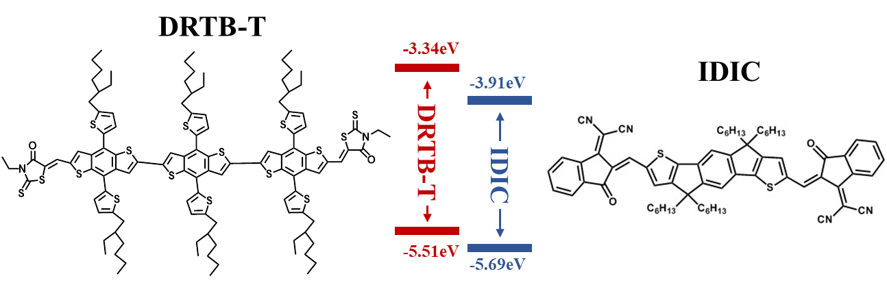
Scheme S1. The chemical structures and energy levels of DRTB-T and IDIC
Measurements
The solvent vapor annealing
The active layer films were placed in a glass tube that contained dichloromethane (DCM) at the bottom. The stable vapor gradient can be obtained at around 10min since the DCM location was fixed. The total tube length is about 3 cm and the DCM liquid height is 0.2 cm. All the processes were operated in an N₂-filled glovebox.
OSCs device fabrication and testing
The devices were fabricated with the structure of indium tin oxide (ITO)/ZnO/DRTB-T: IDIC/MoO₃/Al. The ITO glass was washed under sonication for 15 min by deionized water, acetone, and isopropanol, and then drying in the dedicated oven in 120 ℃. After UV-ozone treated for 25 min, the ZnO layer was spin-coated on the top of the ITO glass. A solution with DRTB-T/IDIC 10 mg/12.5 mg·mL⁻¹ CF was spin-coated on the substrate at a speed of 3200 r min⁻¹ to obtain the active layer of about 120nm. Then the device was prepared by the interface layer of MoO₃(10 nm)/Al(100 nm) on the top of the active layer through thermal evaporation under a vacuum of 2×10⁻⁴ Pa. The evaporation process finally resulted in four solar cell devices with an area of 7.2 mm². The energy diagram of the device is shown in Scheme S2. The current density−voltage (J−V) curves of the devices were measured under AM1.5G illumination at 100 mW cm⁻² from a calibrated solar simulator using a computer controlled 2400 source meter. The external quantum efficiency (EQE) data of the device were obtained using a QER3011 (Enli Technology Co., Ltd.) and the monochromatic light was obtained from a xenon lamp.
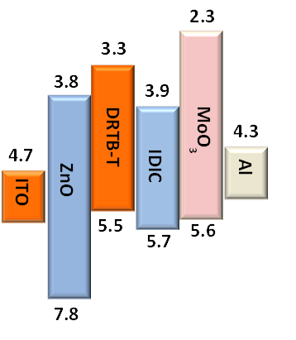
Scheme S2. The energy diagram of the device

Characterization
The preparation of the film for characterization is consistent with the device active layer film. The photoluminescence (PL) of the active layer were recorded by Hitachi F-7000 spectrophotometer. The light source is a xenon lamp and the excitation wavelength of PL source is 532nm. The Atomic Force Microscope (AFM) images were measured by a SEIKO SPA300HV Nanoscope in tapping mode. A silicon microcantilever was used for the scanning with a spring constant of 2 N m⁻¹ (resonant frequency ≈ 70 kHz, Olympus, Japan). The transmission electron microscope (TEM) images were performed by TEM-1011 (JEOL Co., Japan), and the accelerating voltage is 100 kV.
The out-of-plane grazing incidence X-ray diffraction (GIXD) using a Bruker D8 Discoverreflector with an X-ray generation power of 40 kV tube voltage and 40 mA tube current was carried out. The films were measured at a step-scan rate of 0.05° per 5 s with the scattering angle 2 theta ranging from 2 to 30°. And the grazing incidence wide-angle X-ray scattering (GIWAXS) was performed at the beamline 7.3.3 advanced light source (ALS; Lawrence Berkeley National Laboratory). The films were prepared on a Si substrate. The 10 keV X-ray beam was incident at a grazing angle of 0.12−0.16°, selected to maximize the scattering intensity from the samples. A photon-counting detector (Dectris Pilatus 2M) was employed to detect the scattered X-rays and used silver behenate (AgB) to calibrate.
Cyclic voltammetry (CV) measurements using CHI600 electrochemical analyzer (chinstruments, china) to analyze. The electrolyte used was 0.01 M tetrabutylammonium hexafluorophos-phate (TBA HFP) in acetonitrile. The counter electrode was a platinum wire, and the reference electrode was a calomel electrode. The reference molecule was Ferrocene, and the working electrode was the clean ITO substrate. The scan rate of the measurement was performed at 10 mV/s.
The phase purity was analyzed by an RSoXS transmission measurement, which was performed at beamline 11.0.1.2 at the advanced light source (ALS). The films for RSoXS measurements were prepared on a PEDOE-PSS-modified Si substrate. Then, the film was transferred by floating in the water to a Si₃N₄ membrane (Norcada Inc.). The two-dimensional scattering patterns were recorded on an in-vacuum CCD camera (Princeton Instrument PI-MTE). The sample detector distance was calibrated from the diffraction peaks of poly- (isoprene-b-styrene-b-2-vinyl pyridine), and it had a known spacing of 391 Å. The beam size at the sample was 100 × 200 μm².

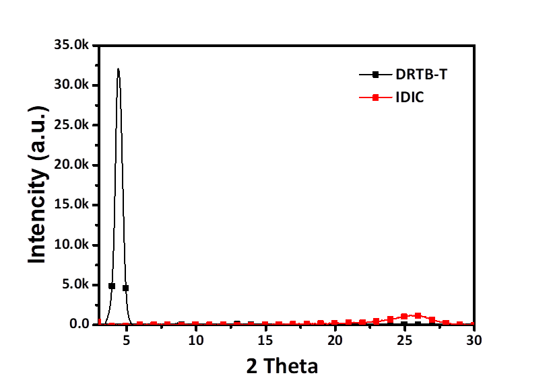
Figure S1. GIXD profiles for neat DRTB-T and IDIC film.

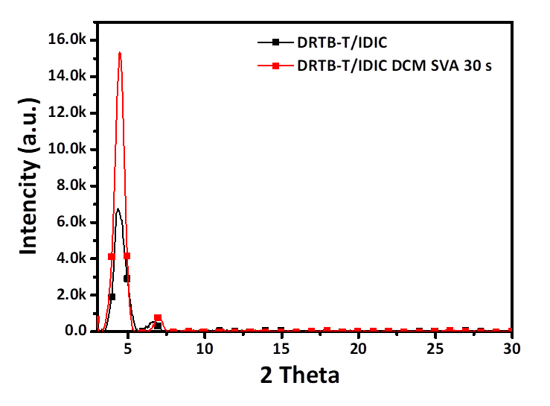
Figure S2. GIXD profiles for DRTB-T/IDIC film without DCM SVA, and with DCM SVA 30 s.

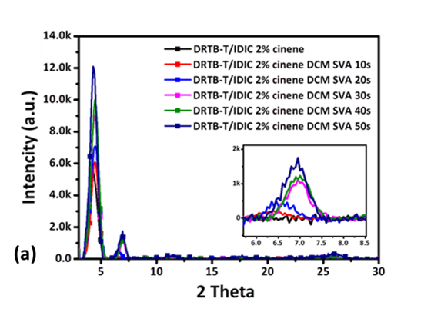
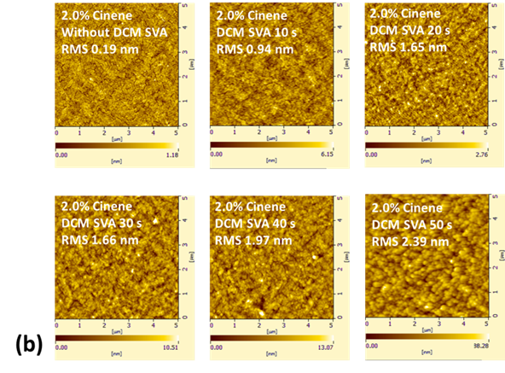
Figure S3. (a) The GIXD of DRTB-T/IDIC with 2% cinene and with DCM SVA 0 s to 50 s. (b) The AFM images of DRTB-T/IDIC with 2% cinene and with DCM SVA 0 s to 50 s.

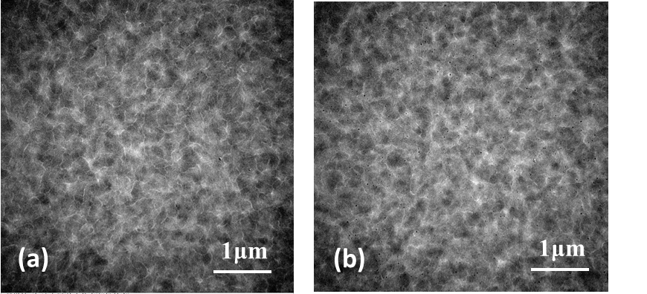
Figure S4. The TEM images of DRTB-T/IDIC with 2% cinene(a) and with DCM SVA 30 s(b).

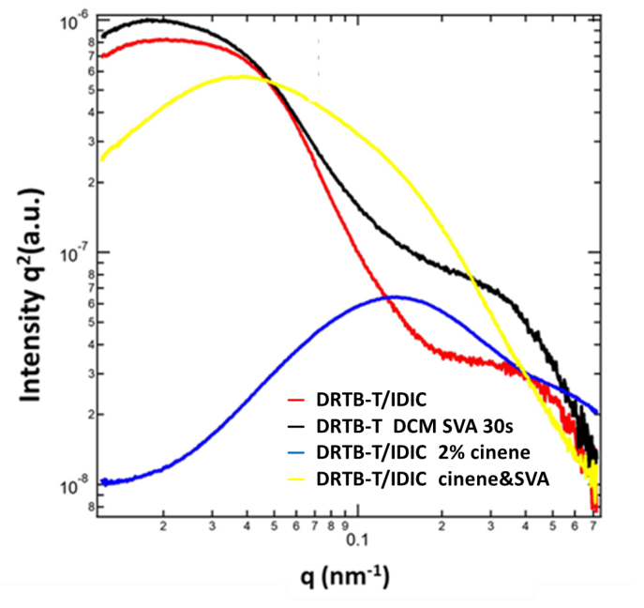
Figure S5. RSoXS profiles of DRTB-T/IDIC, with 2% cinene, with DCM SVA 30 s, with 2% cinene and with DCM SVA 30 s.
Table S1. Peak position and ΔE of oxidation features of the film with six different SVA time.
Time(s) | First Peak(P₁)(V) | Last Peak(P₃)(V) | ΔE(eV)
0 | 1.057 | 1.586 | 0.529
10 | 1.057 | 1.575 | 0.518
20 | 1.057 | 1.564 | 0.507
30 | 1.057 | 1.555 | 0.498
40 | 1.057 | 1.542 | 0.485
50 | 1.057 | 1.534 | 0.477

References
1. L. Yang, S. Zhang, C. He, J. Zhang, H. Yao, Y. Yang, Y. Zhang, W. Zhao and J. Hou: New Wide Band Gap Donor for Efficient Fullerene-Free All-Small-Molecule Organic Solar Cells. J Am Chem Soc. 1958-1966,139 (2017).

