Supplementary information

Dual-light emitting Yb³⁺,Er³⁺-doped La(IO₃)₃ iodate nanoparticles:
Up-conversion & Second Harmonic Generation

Sylvain Regny¹, Kévin Bredillet², Jérémy Riporto², Isabelle Gautier-Luneau¹, Yannick Mugnier², Ronan Le Dantec², Géraldine Dantelle¹

¹ Univ. Grenoble Alpes, CNRS, Grenoble INP, Institut Néel, F – 38000 Grenoble, France
² Univ. Savoie Mont Blanc, SYMME, F –74000, Annecy, France

Figure S1. Power-dependence of SHS signal for α-La_{0.88}Yb_{0.1}Er_{0.02}(IO₃)₃ nanocrystals dispersed in ethylene glycol
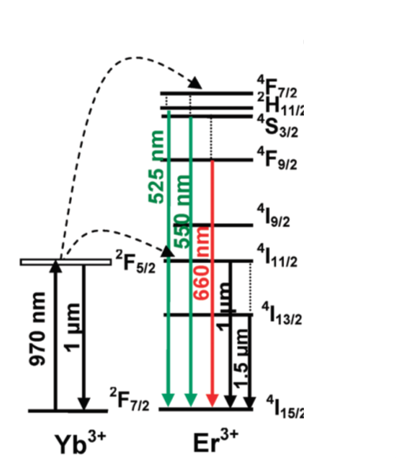

Figure S2. Schematic of the energy level diagram of Yb³⁺ and Er³⁺ and some examples of energy transfers between the two ions.

