Supplementary Materials
Ultrasonic-induced morphological change of micro/nanodeposits and current change in electrochemical migration
Yusuke Endo, Yasuhiro Kimura, and Masumi Saka
Department of Finemechanics, Graduate School of Engineering, Tohoku University, Aoba 6-6-01, Aramaki, Aoba-ku, Sendai 980-8579, Japan

Section S.1 Drastic increment in current resulting in short circuit
As previously described, filaments sometimes grew longer with time until a short circuit occurred when longer deposits eventually formed a bridge, because not all of them were fragmented. When the formation of filament-like nanostructures results in the shortening of the distance between the electrodes, the current drastically increases as shown in Fig. S1. Figure S1 shows the relationship between current and time in the case of pulsed irradiation. In the case of Fig. 3, the short circuit was not caused, but, in the case of Fig. S1, the current drastically increased showing the short circuit: the same experimental conditions were used. These differences would be due to just experimental error. The gradual increase in current in Fig. 3 obviously differs from the drastic increase due to the formation of short circuit in Fig. S1.
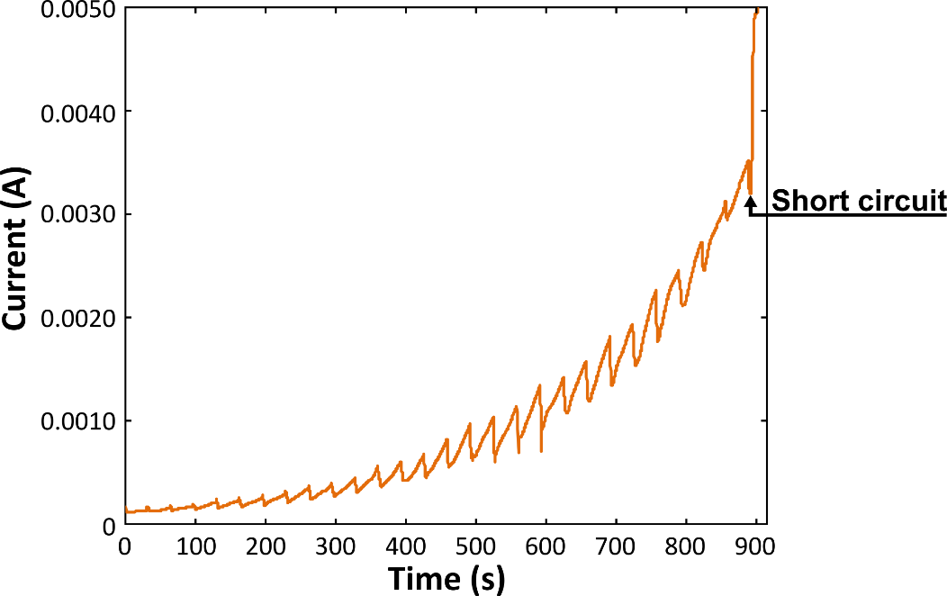
Figure S1. The relationship between current and time of ECM via WDT with pulsed ultrasonic irradiation resulting in the short circuit.

E-mail address: kimura@ism.mech.tohoku.ac.jp

