Supporting Information
Scalable Laser Powder Bed Fusion Processing of NiTi Shape Memory Alloy
Ian McCue¹, Christopher Peitsch¹, Tim Montalbano¹, Andrew Lennon¹, Joseph Sopcisak¹, Morgana M. Trexler*¹ Steven Storck*¹
¹Research and Exploratory Development Department, The Johns Hopkins University Applied Physics Laboratory (JHU/APL), Laurel, MD 20723, USA
Morgana.trexler@jhuapl.edu
Steven.storck@jhuapl.edu

Figure S1. Analysis of NiTi powder used in this study. a) Representative electron micrograph of NiTi powders used in this study. b) For the Nitinol powder, 80% of the particles are between 12.2 to 42.6 μm. c) These metrics indicate the volume percent of particles below the specified diameter, e.g. D (90) = 42.5 ± 0.1 µm indicates that 90% of the particles were less than 42.5 ± 0.1 µm
Figure S2. XRD results of part built under identical laser processing conditions as Figure3 b) on a Ti-6-4 build plate, with NiTi and NiTi intermetallic peaks identified.

Figure S3. XRCT images starting at the Ti-6-4 build plate and moving up through the cylindrical sample a-f), showing build plate a) and initial porosity and effects of laser tracks and powder b), intermetallic formation c) and d), and transition to a mostly solid sample e) and nice quality single tracks f).
Figure S4. Electron micrograph meltpool cross-sections of representative stable single tracks: a) Pt/d = 110.1 J/m, b) Pt/d = 140.0 J/m, c) Pt/d = 166.67 J/m. (insets) EDS line collected at the midplane of the track (solid and dashed blue lines) demonstrating the changes in Ni composition from base to top of meltpool; (solid and dashed orange line) EDS line collected from a meltpool built on a NiTi baseplate under similar laser processing conditions.

Figure S5. XRCT images showing representative outcome of two variable types explored for improving substrate adhesion: a) modifying laser parameters on Ti-6-4 build plate, and b) tailoring build plate composition.

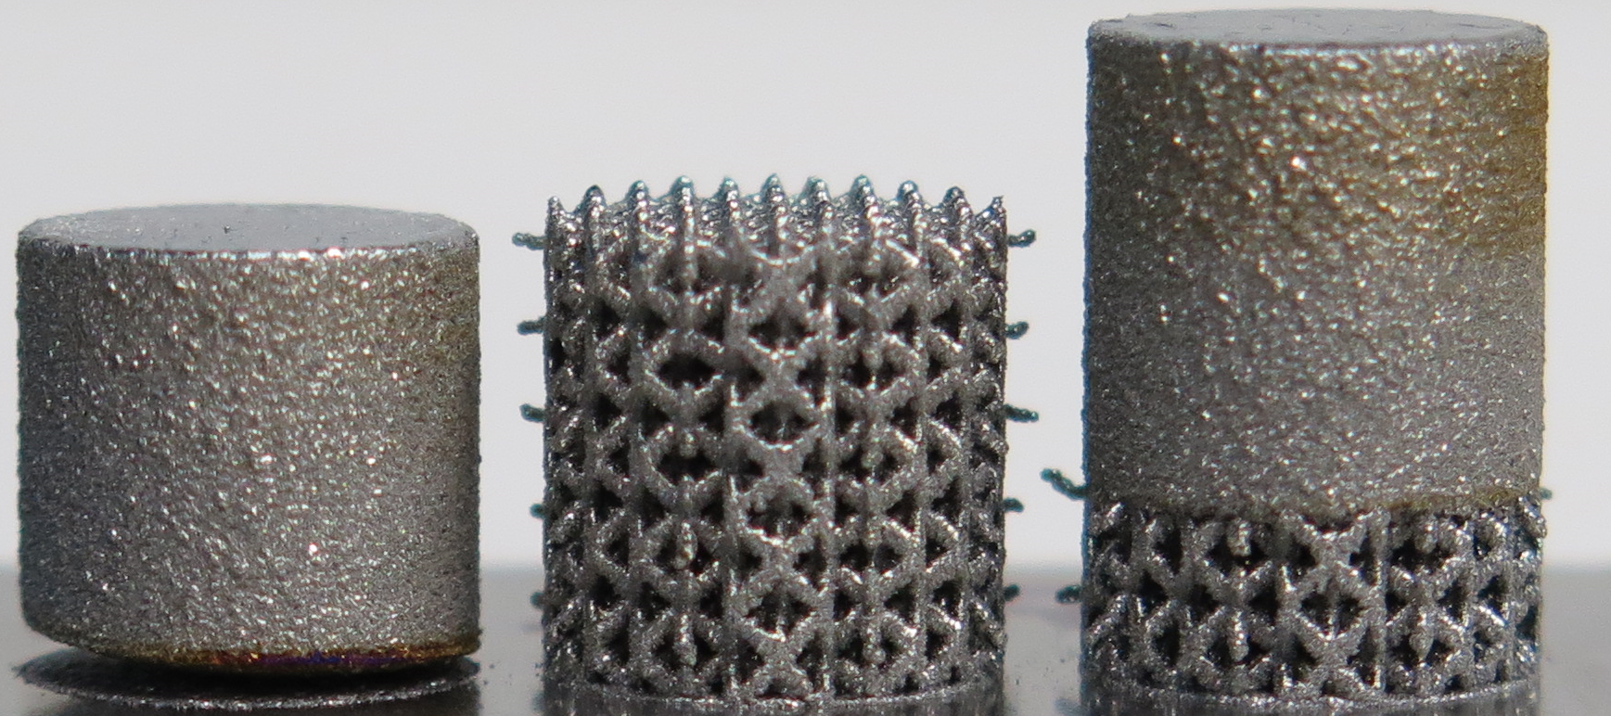
Figure S6: 10 mm diameter NiTi cylinders built (left) directly onto Ti-6-4 build plate and resulting in delamination, (middle) with lattice structure and exhibiting good build plate adhesion, and (right) with initial lattice structure transitioning to solid part and maintaining good adhesion and thermal flow throughout.

Table S1. Chemical composition of NiTi powder used in this study.
Element (solid) | Weight Percent | Element (gas) | Weight Percent
Nickel | 55.2 | Oxygen | 0.04
Titanium | 44.7 | Nitrogen | 0.002
Carbon | 0.003 | Hydrogen | 0.002
All other elements | < 0.4

Table S2. Full laser parameter, linear energy density, and optical width measurements for NiTi single tracks.
Sample | Power | Point  Distance | Hatch  Distance | Layer  Thickness | Exposure  Time | (P*t)/d | Optical  Width | Width error
 | (W) | (um) | (um) | (um) | (us) | (J/m) | (um) | (um)
1 | 100.00 | 30.00 | 105.00 | 30.00 | 50.00 | 166.67 | 136.50 | 11.93
2 | 100.00 | 40.00 | 105.00 | 30.00 | 50.00 | 125.00 | 149.20 | 10.25
3 | 100.00 | 60.00 | 105.00 | 30.00 | 50.00 | 83.33 | 127.40 | 14.32
4 | 180.00 | 30.00 | 105.00 | 30.00 | 50.00 | 300.00 | 196.60 | 13.14
5 | 180.00 | 40.00 | 105.00 | 30.00 | 50.00 | 225.00 | 172.90 | 17.48
6 | 180.00 | 50.00 | 105.00 | 30.00 | 50.00 | 180.00 | 171.10 | 15.22
7 | 180.00 | 60.00 | 105.00 | 30.00 | 50.00 | 150.00 | 145.60 | 10.69
8 | 180.00 | 70.00 | 105.00 | 30.00 | 50.00 | 128.57 | 129.20 | 13.11
9 | 160.00 | 30.00 | 105.00 | 30.00 | 50.00 | 266.67 | 178.40 | 20
10 | 160.00 | 40.00 | 105.00 | 30.00 | 50.00 | 200.00 | 162.00 | 10.05
11 | 160.00 | 50.00 | 105.00 | 30.00 | 50.00 | 160.00 | 152.90 | 11.54
12 | 160.00 | 60.00 | 105.00 | 30.00 | 50.00 | 133.33 | 142.00 | 10.4
13 | 160.00 | 70.00 | 105.00 | 30.00 | 50.00 | 114.29 | 118.40 | 17.58
14 | 180.00 | 55.00 | 105.00 | 30.00 | 20.00 | 65.45 | 87.40 | 18.1
15 | 180.00 | 55.00 | 105.00 | 30.00 | 30.00 | 98.18 | 100.10 | 18.69
16 | 180.00 | 55.00 | 105.00 | 30.00 | 40.00 | 130.91 | 125.60 | 17.24
17 | 180.00 | 55.00 | 105.00 | 30.00 | 60.00 | 196.36 | 162.00 | 10.04
18 | 180.00 | 55.00 | 105.00 | 30.00 | 70.00 | 229.09 | 167.50 | 11.93
19 | 160.00 | 55.00 | 105.00 | 30.00 | 20.00 | 58.18 | 91.00 | 19.1
20 | 160.00 | 55.00 | 105.00 | 30.00 | 30.00 | 87.27 | 109.20 | 18.41
21 | 160.00 | 55.00 | 105.00 | 30.00 | 40.00 | 116.36 | 116.50 | 15.28
22 | 160.00 | 55.00 | 105.00 | 30.00 | 60.00 | 174.55 | 147.40 | 11.26
23 | 160.00 | 55.00 | 105.00 | 30.00 | 70.00 | 203.64 | 174.70 | 13.69
24 | 140.00 | 30.00 | 105.00 | 30.00 | 50.00 | 233.33 | 136.50 | 16.76
25 | 140.00 | 40.00 | 105.00 | 30.00 | 50.00 | 175.00 | 149.20 | 11.85
26 | 140.00 | 50.00 | 105.00 | 30.00 | 50.00 | 140.00 | 136.50 | 12.11
27 | 140.00 | 60.00 | 105.00 | 30.00 | 50.00 | 116.67 | 127.40 | 17.44
28 | 140.00 | 70.00 | 105.00 | 30.00 | 50.00 | 100.00 | 123.80 | 13.98
29 | 140.00 | 55.00 | 105.00 | 30.00 | 20.00 | 50.91 | 89.20 | 17.47
30 | 140.00 | 55.00 | 105.00 | 30.00 | 30.00 | 76.36 | 142.00 | 11.81
31 | 140.00 | 55.00 | 105.00 | 30.00 | 40.00 | 101.82 | 114.70 | 12.78
32 | 140.00 | 55.00 | 105.00 | 30.00 | 60.00 | 152.73 | 160.20 | 11.97
33 | 140.00 | 55.00 | 105.00 | 30.00 | 70.00 | 178.18 | 172.90 | 22.86
34 | 180.00 | 45.00 | 105.00 | 30.00 | 20.00 | 80.00 | 109.20 | 18.96
35 | 180.00 | 45.00 | 105.00 | 30.00 | 30.00 | 120.00 | 127.40 | 13.43
36 | 180.00 | 45.00 | 105.00 | 30.00 | 40.00 | 160.00 | 145.60 | 13.08
37 | 180.00 | 45.00 | 105.00 | 30.00 | 60.00 | 240.00 | 165.60 | 14.25
38 | 180.00 | 45.00 | 105.00 | 30.00 | 70.00 | 280.00 | 189.30 | 16.91
39 | 180.00 | 65.00 | 105.00 | 30.00 | 20.00 | 55.38 | 91.00 | 18.68
40 | 180.00 | 65.00 | 105.00 | 30.00 | 30.00 | 83.08 | 100.20 | 18.12
41 | 180.00 | 65.00 | 105.00 | 30.00 | 40.00 | 110.77 | 111.00 | 10.1
42 | 180.00 | 65.00 | 105.00 | 30.00 | 60.00 | 166.15 | 143.80 | 13.67
43 | 180.00 | 65.00 | 105.00 | 30.00 | 70.00 | 193.85 | 174.70 | 15.62
43 | 200.00 | 30.00 | 105.00 | 30.00 | 50.00 | 333.33 | 151.00 | 10.61
43 | 200.00 | 40.00 | 105.00 | 30.00 | 50.00 | 250.00 | 170.00 | 14.68
43 | 200.00 | 55.00 | 105.00 | 30.00 | 50.00 | 181.82 | 150.00 | 11.1
43 | 200.00 | 60.00 | 105.00 | 30.00 | 50.00 | 166.67 | 157.00 | 13.08
43 | 220.00 | 55.00 | 105.00 | 30.00 | 50.00 | 200.00 | 160.00 | 13.14
43 | 240.00 | 55.00 | 105.00 | 30.00 | 50.00 | 218.18 | 186.00 | 8.43

