**SUPPLEMENTARY INFORMATION**

**Printable Ionizing Radiation Sensors Fabricated from Nanoparticulate Blends of Organic Scintillators and Polymer Semiconductors**

Darcie Anderson,a Sophie Cottam,a,b Heidianne Heim,b Huiming Zhang,c   
Natalie P. Holmes,b Matthew J. Griffith,a,b,*

a School of Mathematical and Physical Sciences, University of Newcastle, Callaghan, NSW, 2308, Australia.

b Centre for Organic Electronics, University of Newcastle, Callaghan, NSW, 2308, Australia.

c School of Environmental and Life Sciences, University of Newcastle, Callaghan, NSW, 2308, Australia.

**EXPERIMENTAL METHODS**

**Materials**

1-phenyl-3-mesityl-2-pyrazoline was purchased from Tokyo Chemical Industry Co. Ltd. (TCI). Violanthrone-79, anhydrous chloroform and sodium dodecyl sulfate (SDS) were purchased from Sigma Aldrich. Indium-doped tin oxide (ITO) electrodes were pre-patterned to produce a source-drain channel 3 mm by 20 µm (Kintec Company, Rsheet < 15 Ω -1)

**Nanoparticle Fabrication**

The miniemulsion organic phase (‘oil’ phase) was prepared by dissolving 30 mg of organic electronic material in 1.8 mL of chloroform. For the blended nanoparticles a ratio of 1:1 was employed such that 15 mg of scintillator and 15 mg of semiconductor were added to the same 1.8 mL of chloroform. The miniemulsion aqueous phase was prepared by dissolving either 5 mg or 33 mg of sodium dodecyl sulfate (SDS) surfactant in 2.8 mL of milliQ filtered water. A macroemulsion was generated by combining the organic and aqueous phases and stirring at a speed of 1100 rpm and temperature of 33 °C for 1 hour. A miniemulsion was subsequently generated using ultrasonication with a Hielscher UP400S ultrasonic processor (7 mm diameter horn tip). Sonication was applied for 2 mins at an amplitude of 40% and 25 W power. The samples were immersed in an ice bath during sonication in order to prevent overheating. Following sonication, the miniemulsions were transferred immediately to a hot plate for chloroform solvent evaporation. This process was achieved by heating for 12 hours at 60 °C whilst stirring the samples at 1300 RPM.

**Photophysical Characterisation**

*UV-visible Spectrophotometry*

UV-visible absorption spectra were measured using a Varian Cary 6000i spectrophotometer. Solution state spectra were performed on samples that had been diluted multiple times to provide a series of samples with concentrations in the range of 110-7 – 110-5 mol L-1. All samples were measured in 1 cm path-length quartz cuvettes.

Solid state measurements were performed on thin films prepared by spin coating materials onto quartz slides from 20 mg mL-1 chloroform solutions. Films were spun at 5000 rpm for a time period of 1 min to provide films with a thickness of 70 $±$ 15 nm, which were then masked to an active area of 5 mm x 5 mm for measurement of UV-vis spectra.

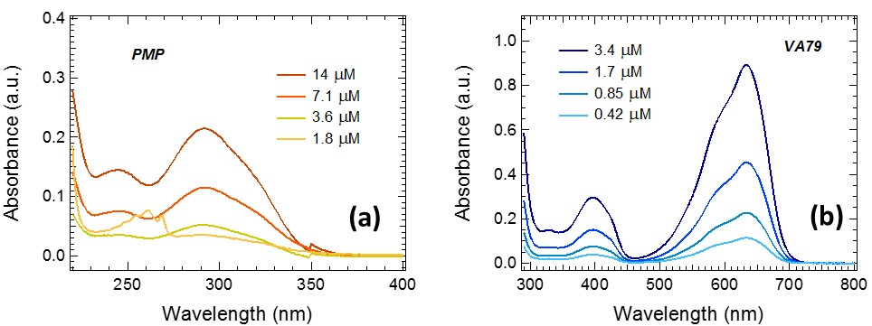

**Figure 1:** The UV-visible absorbance spectra for chloroform solutions containing different concentrations of (a) PMP, and (b) VA79.

*Steady State Photoluminescence Spectroscopy*

Steady state photoluminescence measurements were acquired using a Varian Cary Eclipse fluorescence spectrophotometer with an excitation wavelength of 315 nm. Solution state samples were measured in a 1 cm path-length quartz cuvette, whilst solid state samples were measured for films spun onto quartz slides and placed at an angle of 30° to the incident excitation beam.

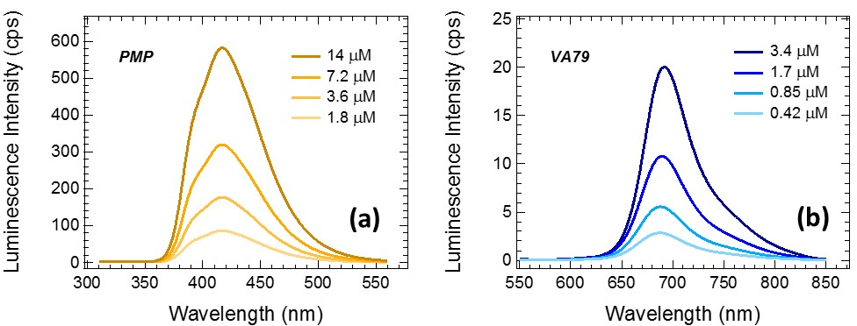

**Figure S2:** The photoluminescence spectra for chloroform solutions containing different concentrations of (a) PMP, and (b) VA79.

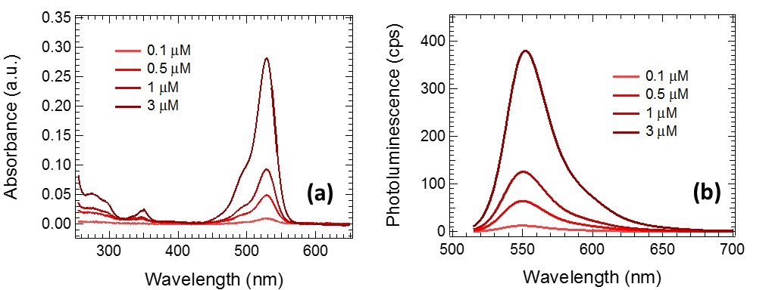

**Figure S3:** The (a) UV-visible absorbance spectra, and (b) photoluminescence spectra for ethanol solutions containing different concentrations of rhodamine 6G for calculation of the photoluminescence quantum yield of PMP.

When performing quantitative analysis of the PMP and VA79 mixtures, the raw photoluminescence data was corrected to account for the differing amounts of VA79 in each mixed sample and for the number of incident photons absorbed. The first step of this quantification was achieved by multiplying the absorbance of all mixed samples by a factor *A*650 in order to account for the reduced VA79 content in the mixture and create identical absorbance values at 650 nm where the VA79 has an absorbance peak but the PMP exhibits only negligible absorption. This correction ensures all samples have the same nominal amount of VA79 molecules. To separate the PMP and VA79 absorbance components at the excitation wavelength, the VA79 absorbance ($A_{VA79(315 nm)}$) was predicted by dividing the absorbance value of the pure VA79 absorbance sample by the previously determined correction factors, *A*650 to account for the reduced VA79 content in the mixed samples. The photoluminescence spectra were subsequently normalized by the linear VA79 absorptance, [$1- {10}^{-A_{VA79(315 nm)}}$], of each of the mixed samples. The corrected photoluminescence spectra then represented the emission output from VA79 after ensuring an identical number of photons were absorbed by the VA79 component of each sample, and also that there is an identical amount of VA79 molecules present for emission in all samples. A similar process was performed for normalizing the spectra to examine the quantitative output for the PMP photoluminescence. The absorbance at 315 nm was determined by subtracting the predicted VA79 absorbance, $A_{VA79(315 nm)}$), from the total sample absorbance at 315 nm to leave the pure PMP component of the absorbance, $A_{PMP(315 nm)}$. The photoluminescence spectra were subsequently normalized by the linear PMP absorptance, [$1- {10}^{-A_{PMP(315 nm)}}$].

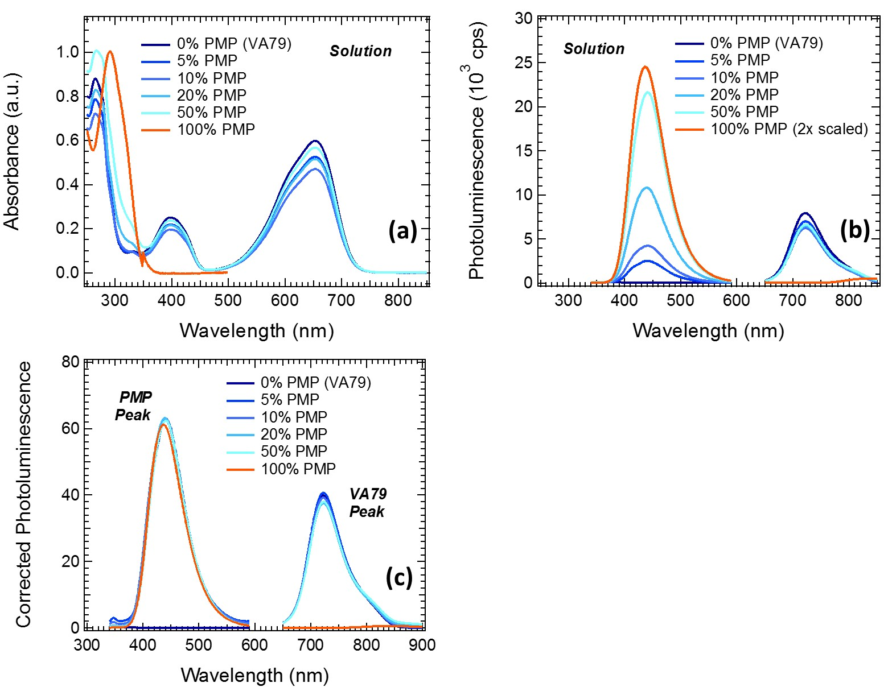

**Figure S4:** (a) The UV-visible absorbance spectra for chloroform solutions containing different mixture ratios of VA79 and PMP. (b) The raw photoluminescence spectra for chloroform solutions containing different mixture ratios of VA79 and PMP. (c) Photoluminescence spectra corrected for the varying amount of VA79 and PMP molecules in each sample and the number of photons absorbed by each component at the excitation wavelength of 315 nm.

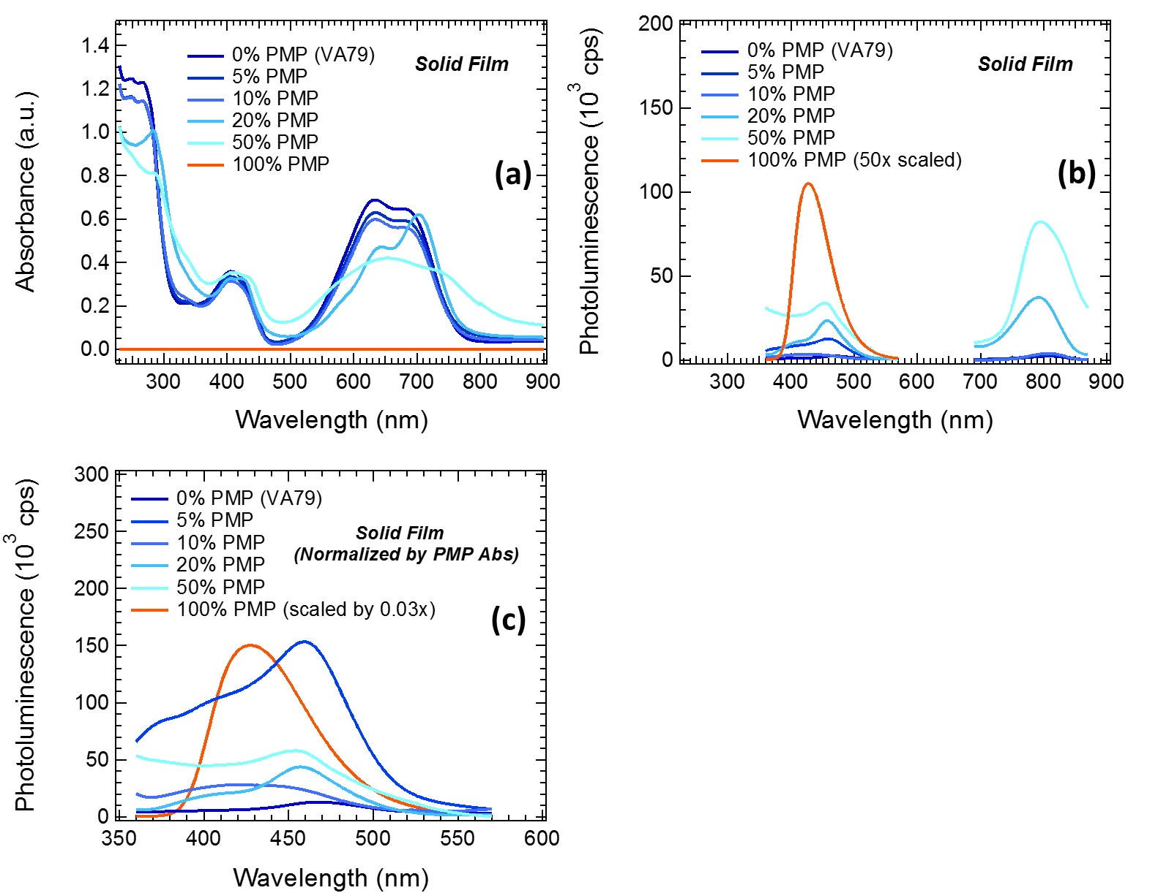

**Figure S5:** (a) The UV-visible absorbance spectra for solid films containing different mixture ratios of VA79 and PMP. (b) The raw photoluminescence spectra for solid films containing different mixture ratios of VA79 and PMP. (c) Photoluminescence spectra corrected for the varying amount of VA79 and PMP molecules in each sample and the number of photons absorbed by PMP at the excitation wavelength of 315 nm.

*Time-Resolved Photoluminescence Spectroscopy*

Photoluminescence decay kinetics were measured using the time-correlated single photon counting (TCSPC) detection method with a Jobin Yvon IBH Fluorocube spectrofluorimeter (instrument response 250 ps FWHM). Samples were excited at 340 nm by a NanoLED pulsed source with a time resolution of less than 1 ns. PMP emissions were monitored at 410 nm, whilst those of VA79 were monitored at 730 nm for solution samples and 770 nm for solid and nanoparticle ink samples. The instrument response was measured with highly scattering alumina colloids dispersed in chloroform for solution state samples, and an alumina colloid film cast onto a quartz substrate for the solid state samples. In both cases the instrument response was ~250 ps. Photons were detected across 1,024 individual time channels, which were distributed evenly over a 200 ns time window to provide a resolution of 0.19 ns per channel. Photon decay curves were fitted to double exponential curves for solid films or single exponentials for solutions to obtain the photoluminescence decay lifetimes.

**Table S1:** Time constant parameters with relative weightings extracted from double exponential fits to the photoluminescence decay lifetime data for solid state films. All samples were excited at 340 nm. The 0% PMP sample was detected at an emission wavelength of 770 nm, whilst all other samples were detected at an emission wavelength of 410 nm.

|  |  |  |  |  |
| --- | --- | --- | --- | --- |
| **PMP Content (%)** | **τ1 (ns)** | **τ1 Weighting (%)** | **τ2 (ns)** | **τ2 Weighting (%)** |
| 0 | 4.51 | 9.5 | 2.92 | 90.5 |
| 5 | 4.28 | 19.2 | 2.10 | 80.8 |
| 10 | 3.61 | 30.0 | 1.44 | 70.0 |
| 20 | 2.28 | 39.2 | 1.38 | 60.8 |
| 50 | 1.87 | 14.2 | 1.22 | 85.8 |
| 100 | 5.22 | 5.1 | 3.09 | 94.9 |

**Table S2:** Time constant parameters with relative weightings extracted from double exponential fits to the photoluminescence decay lifetime data for nanoparticle ink suspensions. All samples were excited at 340 nm. The VA79 samples were detected at an emission wavelength of 770 nm, whilst all other samples were detected at an emission wavelength of 410 nm.

|  |  |  |  |  |
| --- | --- | --- | --- | --- |
| **PMP Content (%)** | **τ1 (ns)** | **τ1 Weighting (%)** | **τ2 (ns)** | **τ2 Weighting (%)** |
| VA79 (33 mg) | 2.3 | 8.5 | 9.0 | 91.5 |
| VA79 (5 mg) | 1.7 | 6.9 | 4.9 | 93.1 |
| Blend (33 mg) | 0.5 | 8.2 | 3.7 | 91.8 |
| Blend (5 mg) | 0.8 | 45.4 | 3.7 | 54.6 |
| PMP (33 mg) | 0.4 | 90.2 | 4.6 | 9.8 |
| PMP (5 mg) | 0.3 | 94.9 | 5.0 | 5.1 |

**Nanoparticle Characterisation**

*Electron Microscopy*

Samples were prepared for scanning electron microscopy (SEM) by spin coating 2.5 μL of the various nanoparticluate ink suspensions onto highly doped silicon substrates from ProSciTech (Type P (boron), <111> crystal orientation, resistance of 1 - 30 Ω, roughness of 2 nm, substrate dimension 5 x 5 mm2). Prior to spin coating the doped silicon substrates were UV-ozone treated for 10 min in order to decrease the contact angle of the ink on the substrate. Nanoparticle inks were deposited onto the treated silicon substrates at a spin speed of 3000 rpm with a low acceleration of 112 rpm/s for a total time of 1 min. SEM images were then acquired on a Zeiss Sigma VP FESEM operating at an accelerating voltage of 2 kV. SEM images obtained for the nanoparticle sample are shown in Figure S6.

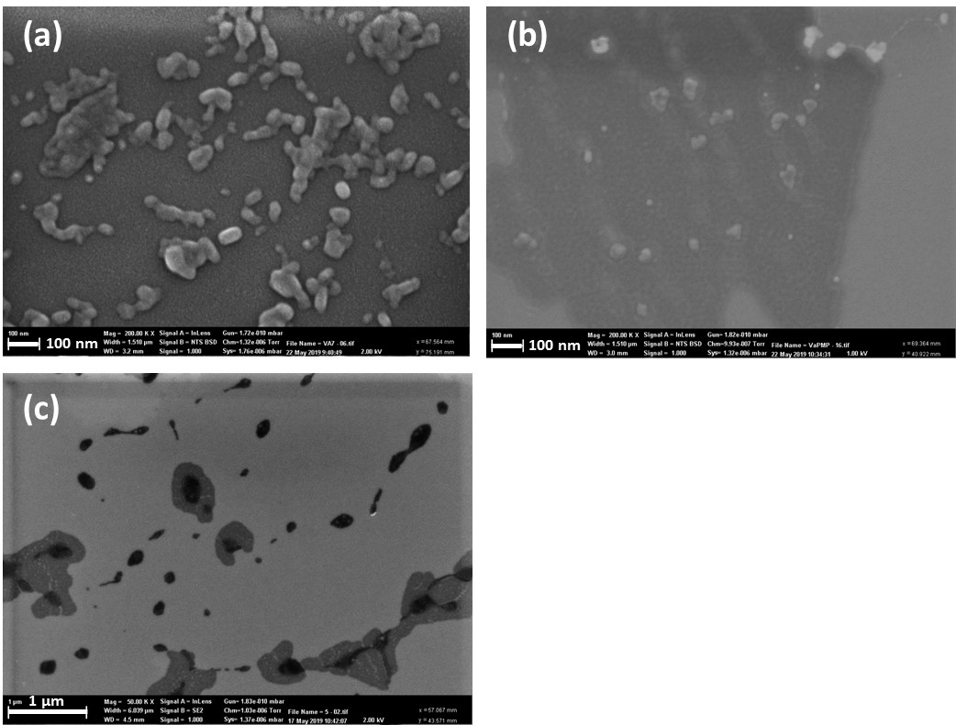

**Figure S6:** SEM images of nanoparticles prepared with 5 mg of SDS surfactant for (a) VA79, (b) the VA79/PMP blend, and (c) PMP.

Samples were prepared for transmission electron microscopy (TEM) by spin coating 2.5 μL of nanoparticle ink onto low stress silicon nitride (Si3N4) membranes with a silicon dioxide (SiO2) coating, purchased from Norcada, Canada). The Si3N4 window dimensions were 0.25 × 0.25 mm2 with a membrane thickness of 10 nm. The SiO2 coating thickness was 5 nm. The silicon substrate frame dimensions were 5 × 5 mm2 and the frame thickness was 200 μm. The nanoparticulate ink was deposited by spin coating at 3000 rpm using a low acceleration of 112 rpm/s for a total time of 1 min. Prior to spin coating the Si3N4 membrane substrates were UV-ozone treated for 10 min to decrease the contact angle of the ink on the substrate. Samples were air dried overnight before loading into the TEM instrument. TEM imaging was performed on a JEOL 1200 EXII microscope operating at an accelerating voltage of 80 kV over varying magnification ranges.

*Dynamic Light Scattering*

The hydrodynamic diameter of the particles in the nanoparticle suspensions were measured using a NanoSeries ZetaSizer Nano-ZS (Malvern Instruments, UK). Samples were illuminated with a helium-neon laser operated at a wavelength of 633 nm and a power of 4.0 mW. Samples were prepared by diluting 2 μL of the stock nanoparticulate inks into 3 mL of Milli-Q water. The diluted samples were then placed into a plastic disposable cuvette (Malvern Instruments). The hydrodynamic radius of the particles were determined from the detected interference pattern with the laser source using the Einstein-Stokes equation. Analysis software was used to report the number distribution of particles as a function of their size (Zaverage).

**Radiation Sensor Fabrication and Characterisation**

Patterned ITO electrodes were cleaned by successive sonication in milli-Q water and isopropanol then dried under a compressed nitrogen stream and subjected to a UV-ozone treatment for 15 minutes. Devices were subsequently completed by spin coating VA79 or a VA79/PMP solutions onto the ITO electrodes with a spin speed of 5000 rpm for 1 min. Films were subsequently dried for 5 mins on hotplate at 50 °C to produce layers of 70 $±$ 15 nm. Testing was performed using a Keithley 2400 source measure unit controlled by customized LabVIEW software. A bias voltage systematically scanned between -50 V and +50V was applied across the ITO electrodes and the resulting current was measured using a second Keithley 2400 source measure unit.

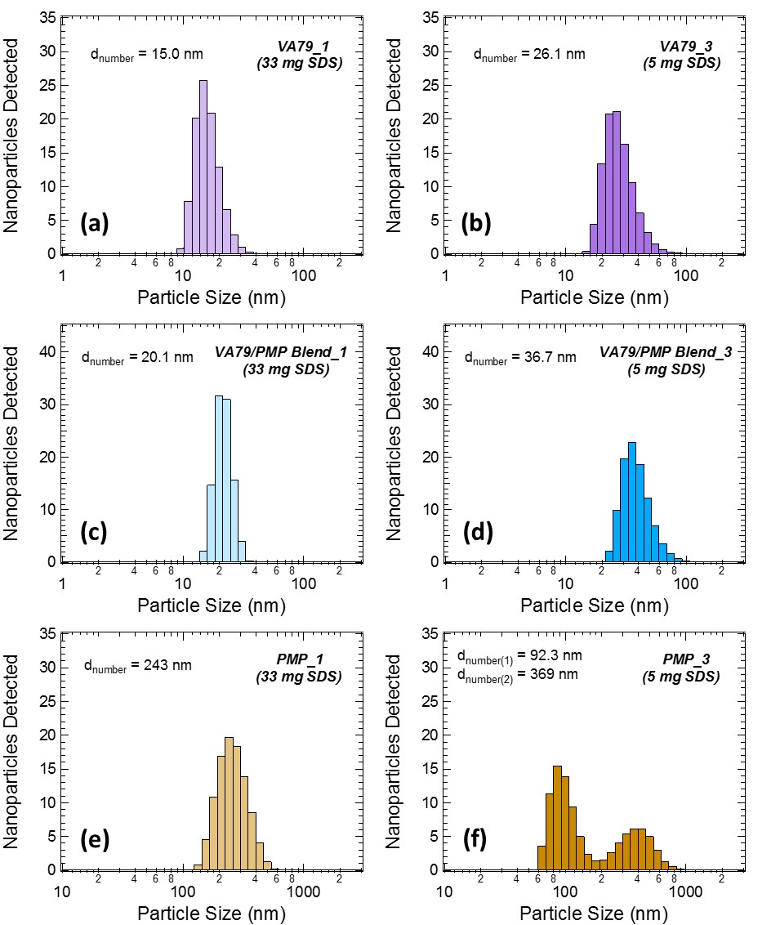

Intensity

Intensity

Intensity

Intensity

Intensity

Intensity

**Figure S7:** DLS data showing the number of particles detected in the samples as a function of the particle size for nanoparticle inks prepared with (a) VA79 and 33 mg of SDS, (b) VA79 and 5 mg of SDS, (c) VA79/PMP blend and 33 mg of SDS, (d) VA79/PMP blend and 33 mg of SDS, (e) PMP and 33 mg of SDS, and (f) PMP and 5 mg of SDS.

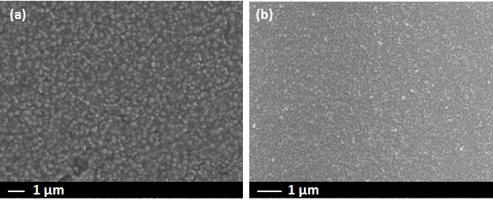

**Figure S8:** SEM images of solid films fabricated from VA79/PMP blend nanoparticles by spin casting layers onto ITO-glass electrodes from (a) 5 mg SDS suspensions and (b) 33 mg SDS suspensions.

** **

**(b)**

**(a)**

**Figure S9:** (a) The current response of side-by-side device prepared with a pure VA79 organic layer in the dark (black circles), under illumination from a Xenon lamp (green squares) and under irradiation from a 5 μCi 137Cs source. (b) The visible light photocurrent and gamma irradiation photocurrent for the device in (a) after subtraction of the dark current background.



**Figure S10:** (a) The current response of side-by-side device prepared with a blended VA79/PMP organic layer in the dark (black circles), under illumination from a Xenon lamp (green squares) and under irradiation from a 5 μCi 137Cs source.



**Figure S11:** The current response of sandwich device prepared with a blended VA79/PMP organic layer in the dark (black circles), under illumination from a Xenon lamp (green squares) and under irradiation from a 137Cs source with dose rate 0.5 mGy s-1