Preparation of Graphene Oxide Reinforced Calcium Phosphate/Calcium Sulfate/Methylcellulose-based Injectable Bone Substitutes
Öznur Demir Oğuz¹, Duygu Ege^{1*}
¹Boğaziçi University, Institute of Biomedical Engineering, Istanbul, 34684, Turkey
*Corresponding author e-mail: duygu.ege@boun.edu.tr
Supplementary Document

XRD Analysis

Fig. S1 shows the XRD pattern of 0GO and 2GO samples after 24 hours of setting. Samples possessed the same XRD pattern independent of incorporation of GO because of the small content of GO. Depending on the qualitative analysis, no new crystal structure was obtained after setting of the samples, only the added raw powders, namely, TTCP, DCPD and CSD were detected which matched with JCPDS files no 72-1240, 70-1379 and 74-1905, respectively.

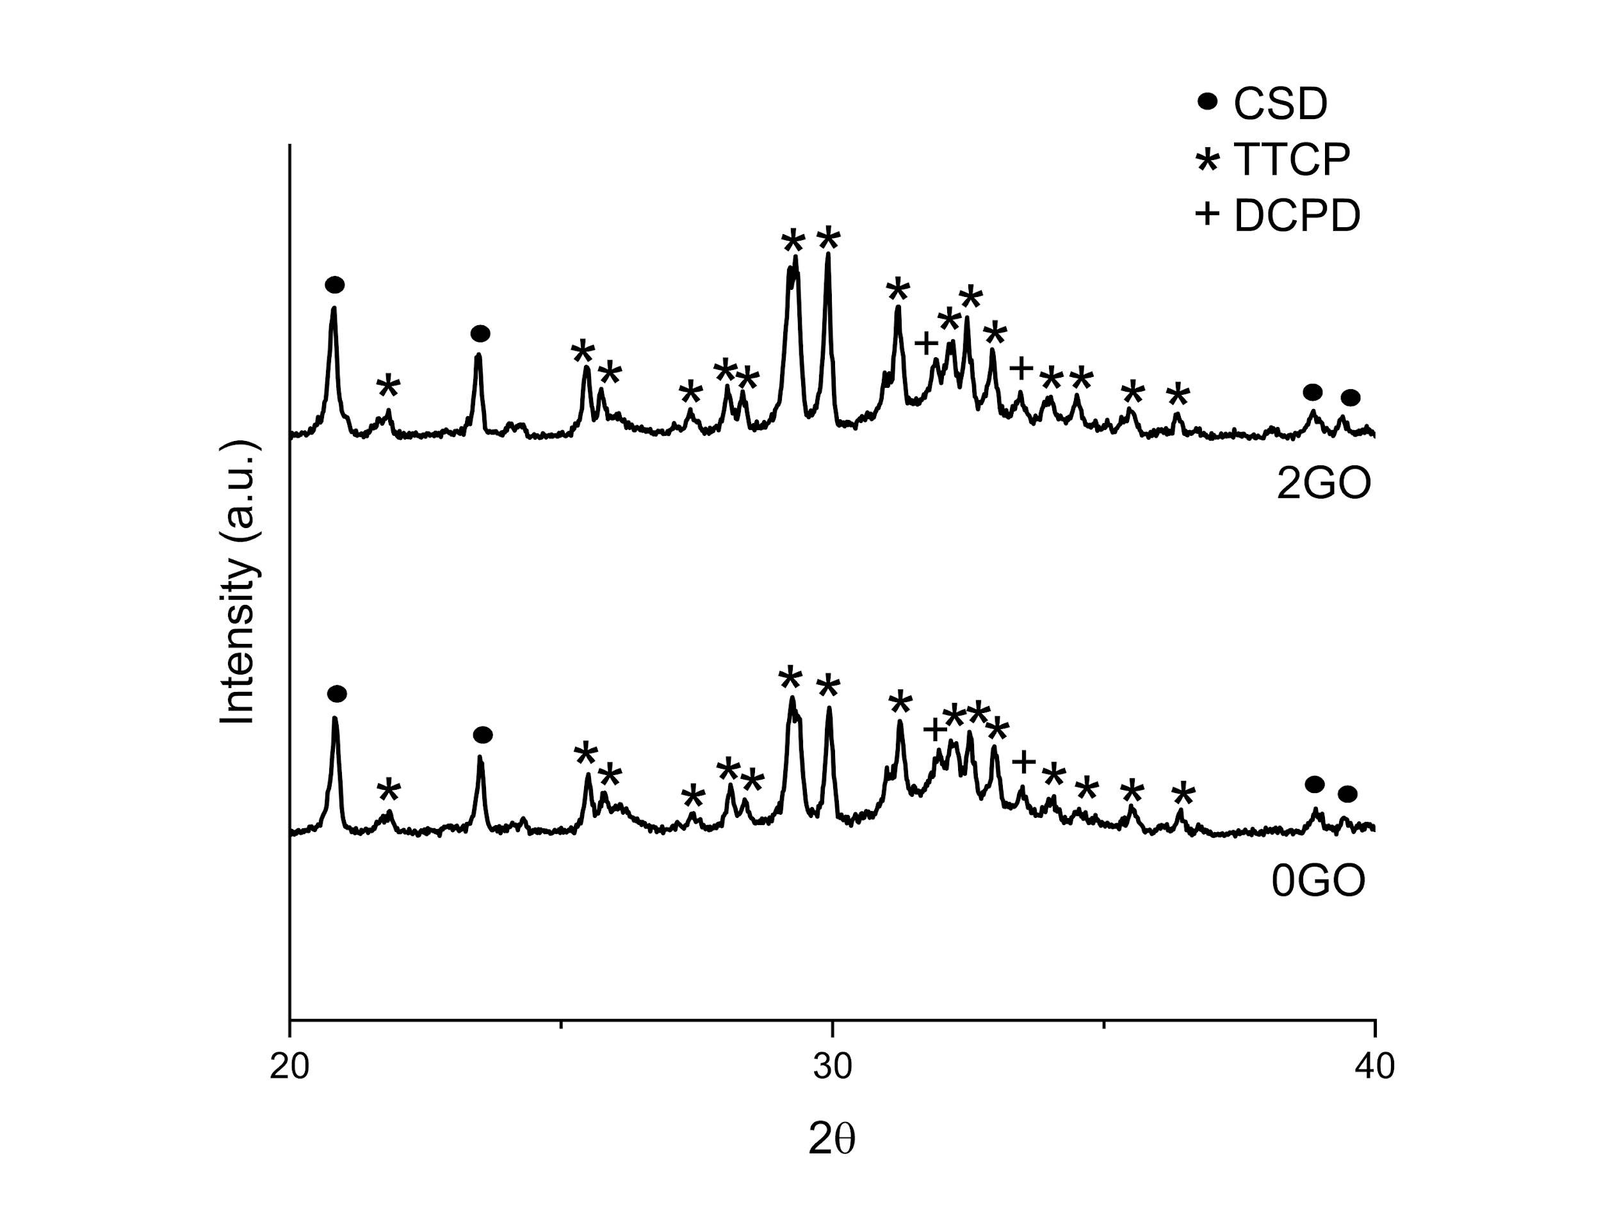
Figure S 1: XRD pattern of 0GO and 2 GO samples after setting.

FTIR Analysis

Figure S2 shows the FTIR spectrum of GO, MC, polymer phase with 2 wt% GO, 0GO and 2GO. In FTIR spectra of GO, there were carboxyl C=O stretching bands at 1729 and 1616 cm⁻¹, O-H deformation vibration at 1404 cm⁻¹, and also C-O stretching vibration at 1032 cm⁻¹.^{[1,2]} FTIR spectrum of MC had bands at around 1451, 1367 and 936 cm⁻¹ due to C-H stretching of CH₂ and CH₃ group.^{[3]} Also, the intense band around 1103-1030 cm⁻¹ was associated with the C-O-C stretching bond from glucosidic units.^{[4]} FTIR spectrum of the GO/polymeric phase had very similar peaks with MC’s FTIR spectrum. This is due to higher wt% of MC being present in the polymer phase in comparison with gelatin. Despite that, there were additional peaks at 1649 and 1566 cm⁻¹ due to C=O and N-H bonds, respectively. ^{[5]}
In the 0GO and 2GO spectra, none of the peaks of the polymeric phase was present. This is due to much more dominant signals of the powder phase and its higher weight fraction. In the spectrum of 0GO and 2GO samples, the broad band at around 1636 cm⁻¹ was associated with H-O-H bending.^{[6]} Another broad band at 1416 cm⁻¹ was associated with C-O-H plane bending (6). In all spectra, the bands of PO₄³⁻ were detected at around 1086-1085, 1016-1014 and 960 cm⁻¹. While the band at 960 cm⁻¹ was associated with the symmetric stretching mode ν1 of PO₄³⁻, bands at 1019-1015 and 1086-1085 cm⁻¹ were corresponding to the vibration mode ν3 of PO₄³⁻. Bands between 598 and 559 cm⁻¹ were associated with bending modes of PO₄³⁻ .^{[7]} Since a small amount of GO was added when compared to the powder phase weight percentages, the same peaks were observed after GO incorporation into the calcium phosphate cement-based composites.^{[6–8]} There was a shift of the peak to lower wavenumbers at around 1014 cm⁻¹ from 1016 cm⁻¹ with the addition of GO. These could result due to the non-covalent interactions between GO and the powder phase.^{[9]}

Figure S 2: FTIR patterns of GO, MC, polymer phase with 2wt% GO, 0GO and 2GO.

References
- Z. Çiplak, N. Yildiz, A. Calimli: Investigation of graphene/Ag nanocomposites synthesis parameters for two different synthesis methods. Fullerenes ,Nanotubes Carbon Nanostructures 23, 4, 361–70 (2015).
- D. He, Z. Peng, W. Gong, Y. Luo, P. Zhao, L. Kong: Mechanism of a green graphene oxide reduction with reusable potassium carbonate. RSC Adv. 5, 16, 11966–72 (2015).
- M. Nadour, F. Boukraa , A.Ouradi, A. Benaboura: Effects of Methylcellulose on the Properties and Morphology of Polysulfone Membranes Prepared by Phase Inversion Mater Res. 20, 2, 339–48 (2017).
- R. L. Oliveira, J. G. Vieira, H. S. Barud, R. M. N. Assunção, G. R. Filho, S. J. L. Ribeiro, Y. Messadeqq: Synthesis and characterization of methylcellulose produced from bacterial cellulose under heterogeneous condition. J. Braz. Chem. Soc. 29, 9, 1861–70 (2015).
- C. N. Quiroz-Reyes, E. Ronquillo-de Jesús, N. E. Duran-Caballero, M. Á. Aguilar-Méndez: Development and characterization of gelatin nanoparticles loaded with a cocoa-derived polyphenolic extract. Fruits 69, 6, 481–9 (2014).
- N. Nasrollahi N, A. N. Dehkordi, A. Jamshidizad , M. Chehelgerdi: Preparation of brushite cements with improved properties by adding graphene oxide. Int J Nanomedicine 14, 3785–97 (2019).
- D. Depan, T. C. Pesacreta, R. D. K. Misra: The synergistic effect of a hybrid graphene oxide-chitosan system and biomimetic mineralization on osteoblast functions. Biomater Sci. 2, 2, 264–74 (2014).
- Y. Yan, X. Zhang, H. Mao, Y. Huang, Q Ding, X. Pang: Hydroxyapatite/gelatin functionalized graphene oxide composite coatings deposited on TiO 2 nanotube by electrochemical deposition for biomedical applications. Appl Surf Sci 329, 76–82 (2015)
- M. Nair, D. Nancy, A. G. Krishnan, G. S. Anjusree, S. Vadukumpully, S. V. Nair: Graphene oxide nanoflakes incorporated gelatin-hydroxyapatite scaffolds enhance osteogenic differentiation of human mesenchymal stem cells. Nanotechnology 26, 16 (2015).

