Supplementary online material

**A Method for Quantitative Nanoscale Imaging of Dopant Distributions Using Secondary Ion Mass Spectrometry– An Application Example in Silicon Photovoltaics**

Santhana Eswara1*, Alisa Pshenova1, Esther Lentzen2, Gizem Nogay3, Mario Lehmann3, Andrea Ingenito3, Quentin Jeangros3, Franz-Josef Haug3, Nathalie Valle2, Patrick Philipp1, Aïcha Hessler-Wyser3, Tom Wirtz1

1Advanced Instrumentation for Nano-Analytics (AINA), Materials Research and Technology Department, Luxembourg Institute of Science and Technology, 41, rue du Brill, L-4422 Belvaux, Luxembourg

2Materials Characterisation and Testing Platform, Materials Research and Technology Department, Luxembourg Institute of Science and Technology, 41, rue du Brill, L-4422 Belvaux, Luxembourg

3Ecole Polytechnique Fédérale de Lausanne (EPFL), Institute of Microengineering (IMT) Photovoltaics and Thin-Film Electronics Laboratory (PV-Lab), Rue de la Maladière 71b, 2002 Neuchâtel, Switzerland

*Corresponding Author: santhana.eswara@list.lu

**Simulation of boron implantation in silicon: method and results**

Simulations of B implantation into Si were carried out using the SDTRIMSP code [1] which is based on the simulation codes TRIM [2, 3] and TRIDYN [4, 5]. The irradiation was simulated for 190 keV B impacts at 7° incidence with respect to surface normal with a fluence of up to 1016 ions/cm2 which corresponds to the experimental conditions used for the preparation of the samples. During the simulations, the KrC potential has been used for interatomic interactions, an equipartition of the Lindhard-Scharﬀ and the Oen–Robinson models for electronic stopping and the Gauss–Mehler method with 16 pivots for integration. The surface binding energy for B is calculated using sbeB = qB∙EsB + qC∙0.5∙(EsB + EsSi) and the surface binding energy for Si is calculated using sbeSi = qB∙0.5∙(EsB + EsSi) + qSi∙EsSi, sbeB and sbeSi are the surface binding energy of B and Si atoms in the target, EsB and EsSi are the atomic surface binding energies for B and Si and qB and qSi are the atomic fractions [1].

To adjust the implantation depths to experimental values, correction coefficients needed to be applied to the electronic stopping. Reference values for 190 keV implantation for all four combinations of B and Si have been obtained by TRIM (Table SII). Correction coefficients in SDTRIMSP have been adjusted until these mean implantation depths had been reproduced (Table SI). The correction coefficients are shown in table SI.

To compare how sputtering and atomic mixing influence the B profile, the simulations have been carried out in the static mode modelling 106 impacts and in the dynamic mode by simulating the implantation in 100 steps of 104 impacts up to a maximum fluence of 1016 ions/cm2. Differences between both modes are negligible, so that only the results from the static simulation are used for comparison with the experimental results.

Table SI: Correction factors for electronic stopping for 190 keV B implantation into Si using SDTRIMSP.

|  |  |  |  |  |
| --- | --- | --- | --- | --- |
| **Implantation** | **Correction coefficient ck_elec** | | | |
| **B, B** | **B, Si** | **Si, B** | **Si, Si** |
| B in B | 1.855 |  |  |  |
| Si in B | 1.855 | 1.530 | 1.725 | 1.270 |
| B in Si | 1.855 | 1.530 | 1.725 | 1.270 |
| Si in Si |  |  |  | 1.270 |

Table SII: Implantation depths for TRIM and SDTRIMSP for 190 keV B implantation into Si.

|  |  |  |
| --- | --- | --- |
| **Implantation** | **Mean implantation depth (nm)** | |
| **TRIM** | **SDTRIMSP** |
| B in B | 371 | 372 |
| Si in B | 194 | 195 |
| B in Si | 551 | 552 |
| Si in Si | 259 | 259 |

Profiles of the implanted boron in silicon are shown in Fig. S1 and S2. Figure S1 displaying the concentration in a linear scale shows that atomic mixing and sputtering are negligible as both profiles overlay perfectly. In Fig. S2, the static simulations gives information down to lower concentrations which is related to the 106 impacts in this mode to the 104 impacts per step of fluence in the dynamic mode, i.e. the former producing a better statistics.



Figure S1: Comparison of B implantation profiles on the linear scale obtained by SDTRIMSP in the static and dynamic modes.



Figure S2: Comparison of B implantation profiles on the logarithmic scale obtained by SDTRIMSP in the static and dynamic modes.

**Evaluation of the detection limit:**

The voxel with an average of 1 count is taken to indicate the detection limit. Note the pixel size is 39 nm while the probe size is ~ 400 nm. As mentioned in the main text, the SIMS intensity profile is a convolution of the concentration profile (ignoring matrix effect, etc.) and the probe profile. To illustrate this effect, a 400 nm window (spanning ~ 10 voxels) centered at the point where an average of 1 count per voxel is detected (x = 1250 nm) is superposed on the corresponding section of SIMS depth profile as shown in Fig. S3. A Gaussian profile of primary ion intensity of the probe used for SIMS imaging is also shown schematically. The secondary ion counts assigned to the voxel indicated by an arrow could come from any part of this range with a high likelihood to come from the midpoint where the primary ion intensity is the largest. Nevertheless, a conservative estimate for the concentration corresponding to this voxel covering the full range is obtained as 3 (±2) × 1017 at. /cm3.

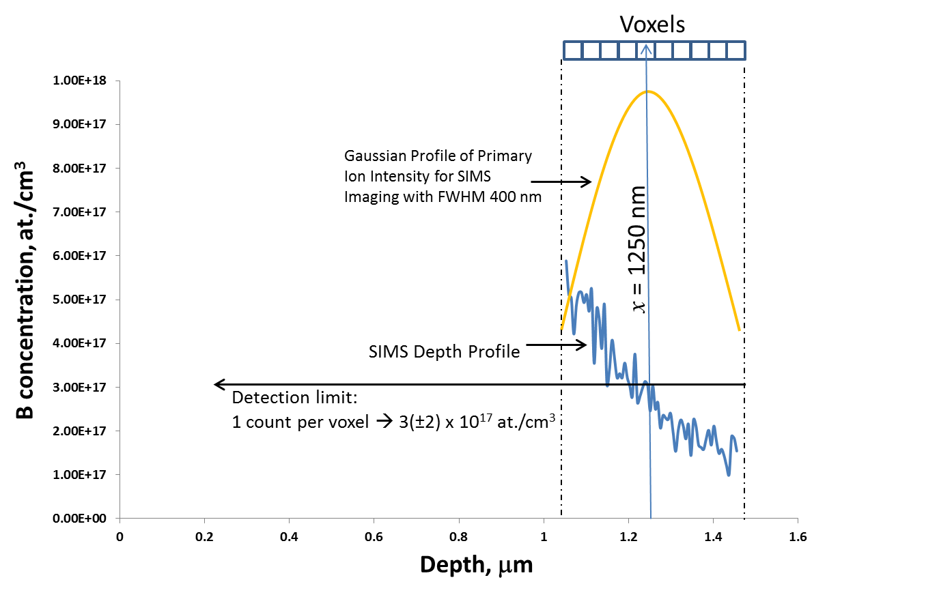

Figure S3: An illustration of the convolution of concentration profile in the sample and the Gaussian profile of the primary ion probe. A 400 nm window corresponding to the probe size (spanning ~ 10 voxels) is centered on the voxel containing an average of 1 count and superposed on the relevant section of the SIMS depth profile. The Gaussian probe profile with a FWHM of 400 nm is also shown schematically. From this, the detection limit is estimated to be 3 (±2) × 1017 at. /cm3.

**References**:

1. SDTRIMSP, Version 5.00; Max-Planck-Institut für Plasmaphysik: Germany, 2011.

2. Biersack, J. P.; Haggmark, L. G. Nucl. Instrum. Methods 1980, 174, 257. doi:10.1016/0029-554X(80)90440-1

3. Eckstein, W.; Möller, W. Nucl. Instrum. Methods Phys. Res., Sect. B 1985, 7–8, 727–734. doi:10.1016/0168-583X(85)90460-4

4. Möller, W.; Eckstein, W. Nucl. Instrum. Methods Phys. Res., Sect. B 1984, 2, 814–818. doi:10.1016/0168-583X(84)90321-5

5. Möller, W.; Eckstein, W.; Biersack, J. P. Comput. Phys. Commun. 1988, 51, 355–368. doi:10.1016/0010-4655(88)90148-8