Supplementary Material

Role of nanoparticles interaction in magnetic heating
Ramanujam Lenin,¹ Ajit Singh,¹ and Chandan Bera ^{1, a)}
Institute of Nano Science and Technology, Habitat Center, Phase-X, Mohali,
Punjab - 160062, India

A. Particle size distribution from TEM analysis
Figure S1. Particle size distribution histogram from TEM image (black bars) and the Gaussian fitted histogram (red line)
The particle size histogram shows the slight narrow size distribution of the particles between 5 to 14 nm sizes with the average size of 9.4 nm. The size observed from TEM image is slightly larger than the crystallite size (8 nm) observed from the powder X-ray diffraction studies. The larger size from the TEM image is attributed to the amorphous layer and the surfactant molecules present on the surface of the nanoparticle.
B. Infrared Spectroscopy studies
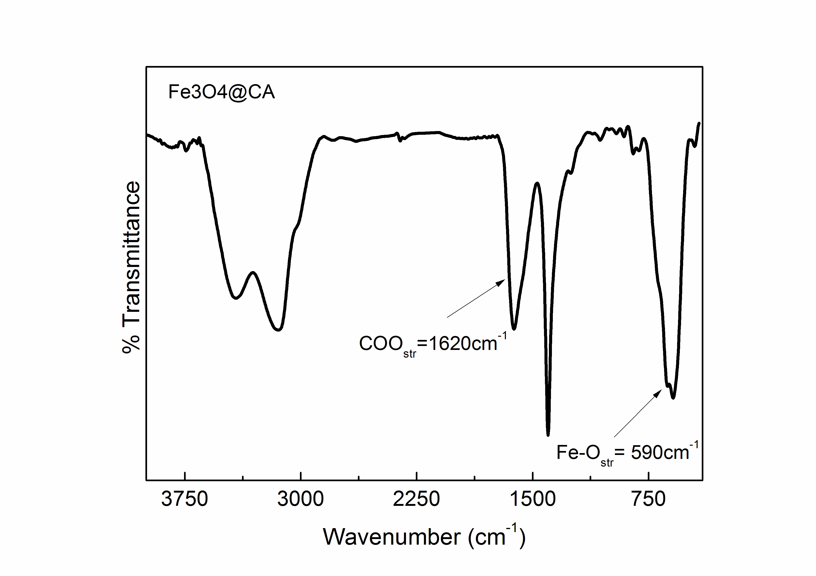
Figure S2: Infrared spectra of the citric acid coated magnetite nanoparticles
Surface coating on the surface of the magnetite nanoparticles were studied by the Infrared spectroscopy (Fig. S2). The band at 1620cm⁻¹ indicates that the carboxylic group in the citric acid is attached with the surface of the magnetite nanoparticle. The band at 1400cm⁻¹ is corresponds to the C-O stretching frequency of the carboxylate group in the citric acid on the surface of the nanoparticle.¹ The strong band at 585cm⁻¹ corresponds to the Fe-O stretching frequency, which indicates that the attachment of the oxygen atom of the carboxylic acid group to the iron atom in the nanoparticle.²
C. Field dependant magnetization measurement
Room temperature magnetization measurement of the prepared solid sample shows no remanence and coercivity indicates the formation of superparamagnetic nanoparticles i.e. the magnetic moment inside the particles is completely fluctuated by the thermal energy at room temperature.³⁻⁵ The maximum magnetization observed is 47.7emu/g at 14T applied magnetic field (Fig. S3) which is much lower than the saturation magnetization of the bulk magnetite (~90emu/g).
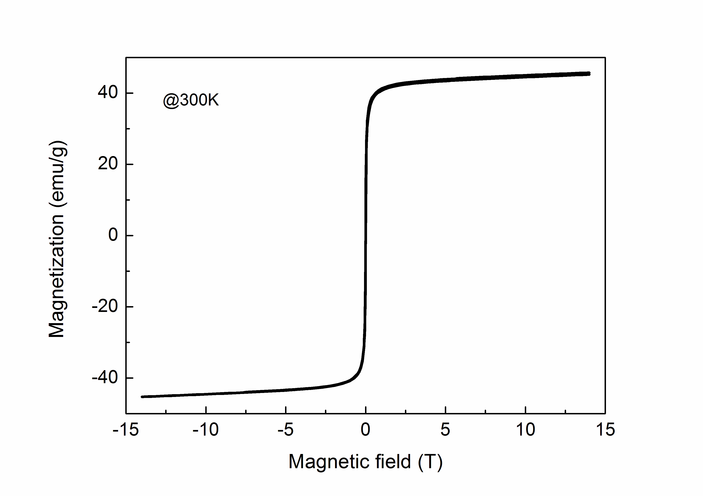
Figure S3: Room temperature magnetization measurement of citric acid coated magnetite nanoparticles (solid sample)
D. Heating effect of magnetic fluids at different concentrations
The heating effect of the magnetic fluids was studied for different concentrations at different applied AC magnetic field (up to 260Oe) and at a particular frequency (101 kHz). The temperature rise of the magnetic fluids with time at AC field of 260G at the frequency of 101 kHz is shown in the Fig. S4. The temperature rise increases almost linearly with the time for all the studied concentrations. The increase in the temperature of the fluid with time is attributed to the heat dissipation of the magnetic nanoparticles in the fluid. Moreover, the observed temperature rise is higher for the highly concentrated fluid sample. When the concentration of the fluid increases, the particles in the fluid are closer together and lead to increase in interparticle interaction. The increased interparticle interaction leads to increase in the anisotropy energy of the system which is clear from the magnetic measurements i.e., increasing in blocking temperature with the concentration of the particles.⁴ The increase in the anisotropy energy of the system leads to increase in the relaxation time of the particles in fluid.
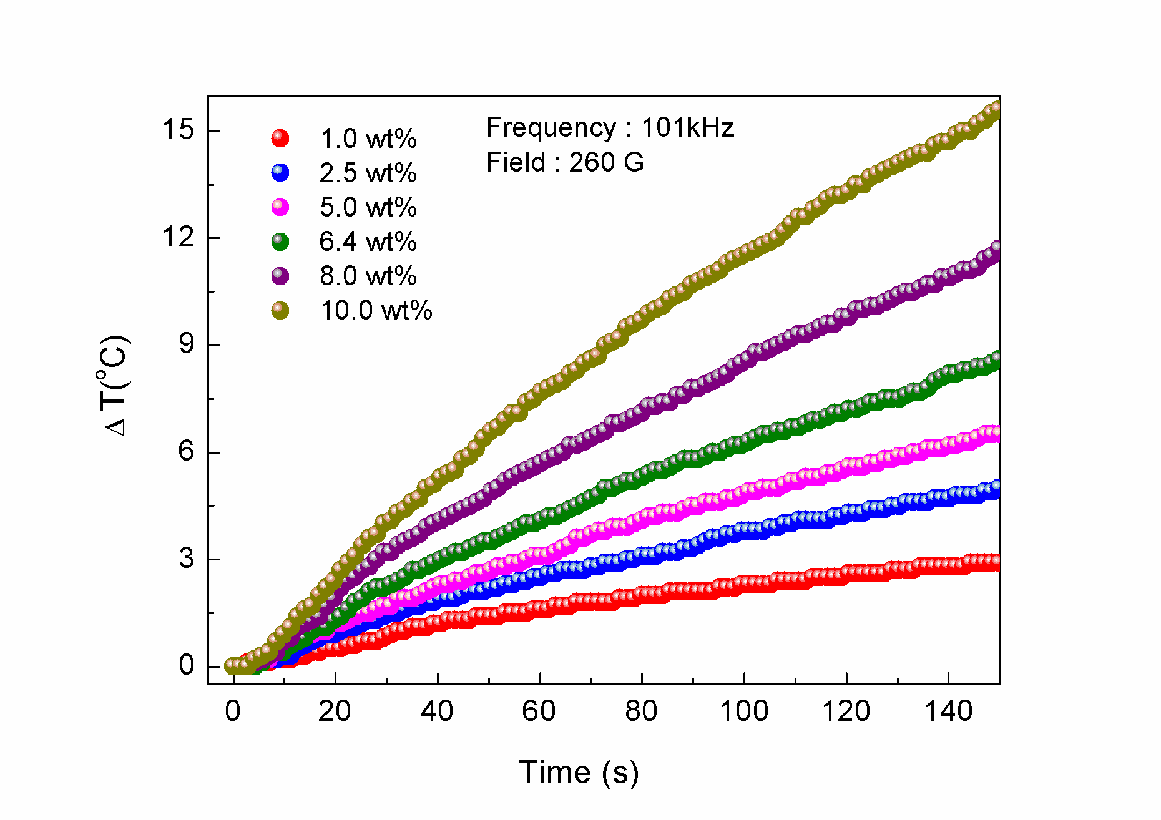
Figure S4: Temperature rise in magnetic fluid samples of different concentrations with time

E. Heating effect of magnetic fluids at different magnetic field
Temperature rise in magnetic fluids were measured at different magnetic field. Figure S5 shows temperature rise in the magnetic fluid of 10wt% particle concentration at 101kHz frequency and for different applied magnetic field (40Oe to 260Oe at 20Oe interval). The results show that almost linear increase in temperature rise with time for all magnetic fluids were observed. But at any particular time, the temperature rise increases linearly with the applied AC magnetic field. This increase is attributed to the increase in absorption of the field energy by the magnetic nanoparticle due to the increasing strength of the applied AC magnetic field.
Figure S5. Temperature rise in magnetic fluid sample with time at different applied magnetic field

F. Calculation of Neel’s and Brownian relaxation time
 | $$τ=\frac{τ_{B}τ_{N}}{τ_{B}+τ_{N}}$$ | (1)
 | $$τ_{B}={3ηV_{hyd}}/{k_{B}T}$$ | (2)
 | $$τ_{N}=τ_{0}e^{{KV}/{k_{B}T}}$$ | (3)
The total relaxation (τ) of the particle in a fluid is the sum of the Neel’s and Brownian relaxation of the particles (see equation 1).⁶ The Brownian relaxation (τ_{B}) of the particles in fluid calculated from the hydrodynamic diameter (d_{h}) of the particles, using the equation 2, is 1.332 X 10⁻⁶ s. The Neel relaxation (τ_{N}) of the particles in fluid calculated from the blocking temperature (T_{B}) obtained from the zero field cooled magnetization measurements of the fluid samples with different concentrations as shown in the Fig.3. The Neel’s relaxation is calculated using blocking temperature and the measurement time of the instrument using the following relation (see equation 3 to 5).⁷
 | $$E_{b}=KV=\ln\left(\frac{τ_{m}}{τ_{0}}\right)k_{B}T$$ | (4)
 | $$KV=23.03k_{B}T_{B}$$ | (5)
Where η is the dynamic viscosity of the fluid, V_{hyd} hydrodynamic diameter of the particles K is the anisotropy constant, V is the volume of the particle, τ₀ is the time constant (10⁻¹⁰s), τ_{m} is the measurement time, k_{B} is the Boltzmann constant, T_{B} is the blocking temperature and T is the temperature. The calculated total relaxation time (τ) for different fluid samples is given in the Table 1.
The Brownian relaxation was calculated from the hydrodynamic volume of the particles in fluid.
$$τ_{B}=\frac{3ηV_{hyd}}{k_{B}T}$$
Where, dynamic viscosity of water η = 8.9 x 10⁻⁴ Kgm⁻¹s⁻¹, hydrodynamic diameter d_{h} = 15.8 x 10⁻⁹ m, Boltzmann constant k_{B} = 1.38 x 10⁻²³ m²kgs⁻²K⁻¹, temperature T = 300K, and hydrodynamic volume V_{hyd} = 2065.2 x 10⁻²⁷. The calculated Brownian relaxation time for the particles is 1.332 x 10⁻⁶. The required calculation of Brownian relaxation of the nanoparticles is included in the supplementary information.
Table S1. Blocking temperature, Neel's relaxation time and the total relaxation time of the magnetic fluids at different concentrations
S. No. | Weight % of Fe₃O₄ | Blocking Temperature, T_{B} (K) | Neel’s relaxation time, τ_{N} (s) | Total relaxation time, τ (s)  $$τ=\frac{τ_{B}τ_{N}}{τ_{B}+τ_{N}}$$
1. | 1.0 | 178 | 8.4 X 10⁻⁵ | 1.311 x 10⁻⁶
2. | 2.5 | 180 | 9.8 X 10⁻⁵ | 1.314 x 10⁻⁶
3. | 5.0 | 181 | 1.06 X 10⁻⁴ | 1.315 x 10⁻⁶
4. | 6.4 | 201 | 4.9 X 10⁻⁴ | 1.328 x 10⁻⁶
5. | 8.0 | 210 | 9.8 X 10⁻⁴ | 1.33 x 10⁻⁶
6. | 10.0 | 250 | 2.1 X 10⁻² | 1.33 x 10⁻⁶
7. | Solid | 259 | 4.2 X 10⁻² | 4.2 x 10⁻²
Brownian relaxation considered as 1.33 x 10⁻⁶ s

References
1. Răcuciu, M.; Creangă, D.; Airinei, A. Eur. Phys. J. E 2006, 21, 117.
2. Waldron, R. D. Phys. Rev. 1955, 99, 1727.
3. Bean, C.; Livingston, J., Superparamagnetism. J. Appl. Phys. 1959, 30, S120-S129.
4. Lenin, R.; Joy, P. A. Colloids Surf., A 2017, 529, 922-929.
5. Lu, A. H.; Salabas, E. e. L.; Schüth, F. Angew. Chem. Int. Ed. 2007, 46, 1222.
6. Kötitz, R.; Fannin, P.; Trahms, L. J. Magn. Magn. Mater. 1995, 149, 42.
7. Armijo, L. M.; Brandt, Y. I.; Mathew, D.; Yadav, S.; Maestas, S.; Rivera, A. C.; Cook, N. C.; Withers, N. J.; Smolyakov, G. A.; Adolphi, N. L.; Monson, T. C.; Huber, D. L.; Smyth, H. D.; Osinski, M. Nanomaterials (Basel) 2012, 2, 134.

