Supporting Information

**The Impact of Powerful Retarding Additive Synergies on the Kinetic Profile of Cementitous Mineralogical Transformations at High Temperature**

Peter J. Boul,* Diana K. Rasner, Kenneth D. Johnson, and Carl J. Thaemlitz

Aramco Services Company -- Aramco Research Center, Houston, Texas 77084, United States

Table of Contents

Background 3

EXPERIMENTAL SECTION 4

Materials 4

Cement Blending Method 4

HPHT Consistometer / UCA Testing 7

XRD Sample Preparation and Analysis 8

Results 9

References 24

# Background

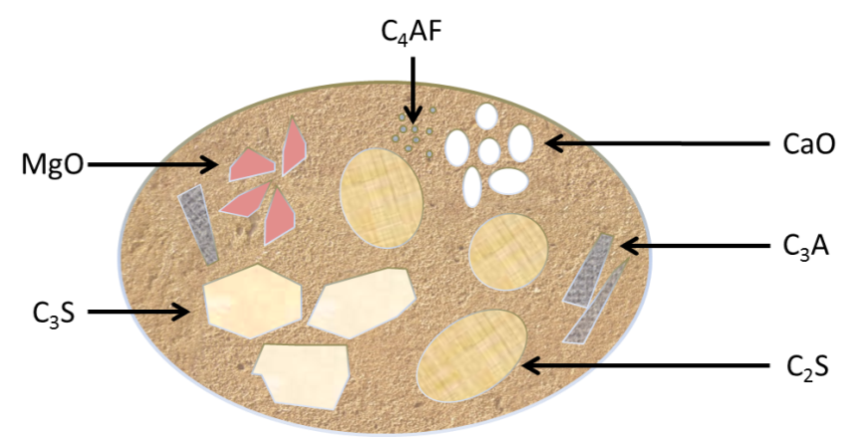

Figure S-1. The basic composition of a grain of Portland cement represented pictorially and described in cement shorthand.

Table S-1.

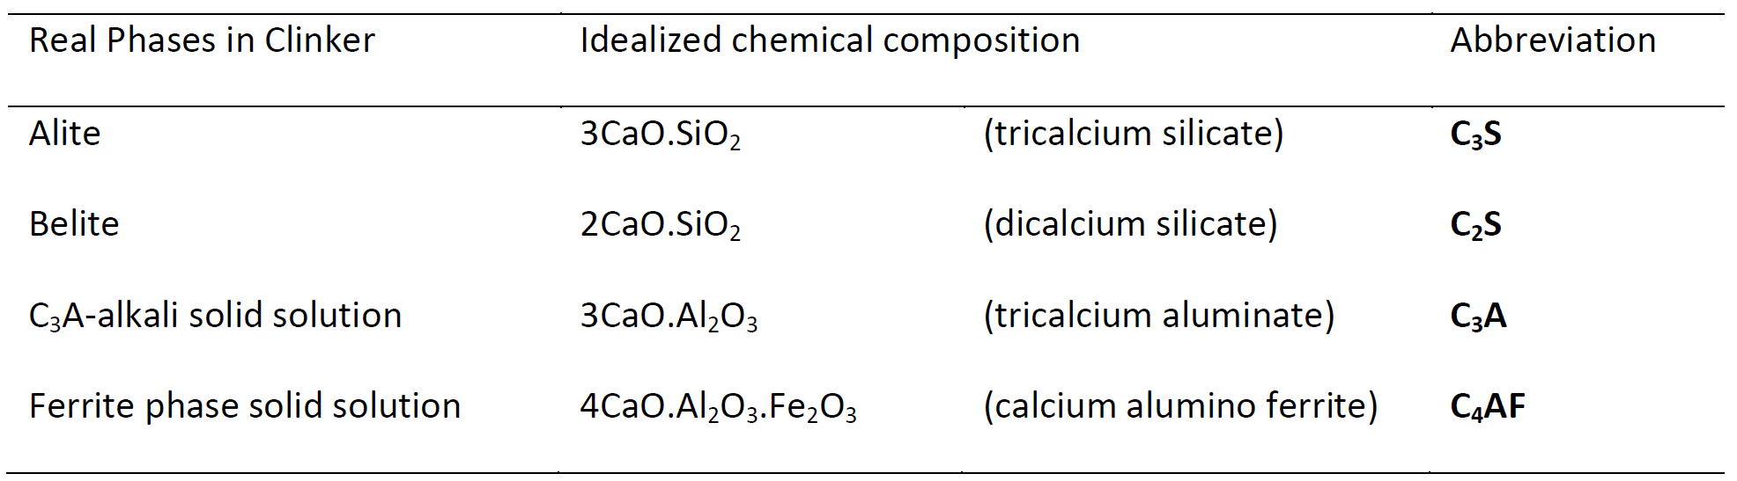

# EXPERIMENTAL SECTION

## Materials

Diethylenetriamine penta (methylene phosphonic acid) (DTPMP) was obtained from Italmatch Chemicals as an aqueous solution with 25% active DTPMP acid. Zinc oxide was purchased from Alfa Aesar as powder with purity of ≥ 99%. Nanosilica was obtained from Nissan Chemical USA and was an NaOH stabilized aqueous colloidal suspension of SiO2 with an average particle size of 4-6 nm. Silica Flour was obtained from Fritz Corporation with an average particle diameter of 31.65 ± 25.74 µm as measured using a Microtrac BLUEWAVE laser diffraction analyser (Figure S-2). Acrylamido-*tert*-butyl-sulfonate/ acrylate (ATBS / AA) copolymer was obtained from Fritz Corporation as a solid. Saudi class G cement was obtained from Saudi Cement Company. The Saudi G cement has a composition (from XRD) described in Table S-3.

Figure S-2. Particle size distribution of silica flour.

## Cement Blending Method

Saudi Class G had phase compositions estimated using powder X-ray diffraction with accompanying Rietveld refinement. Figure S-5 and S-6 shows the XRD patterns and Rietveld refinement of Saudi G Table S-3 gives us the X-ray fluorescence (XRF) determined compositions of Saudi G.

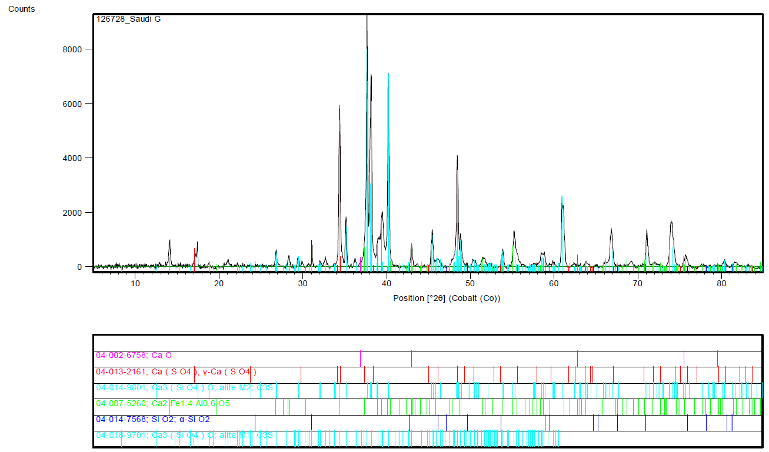

Figure S-3. Raw XRD diffraction pattern and match of Saudi G cement

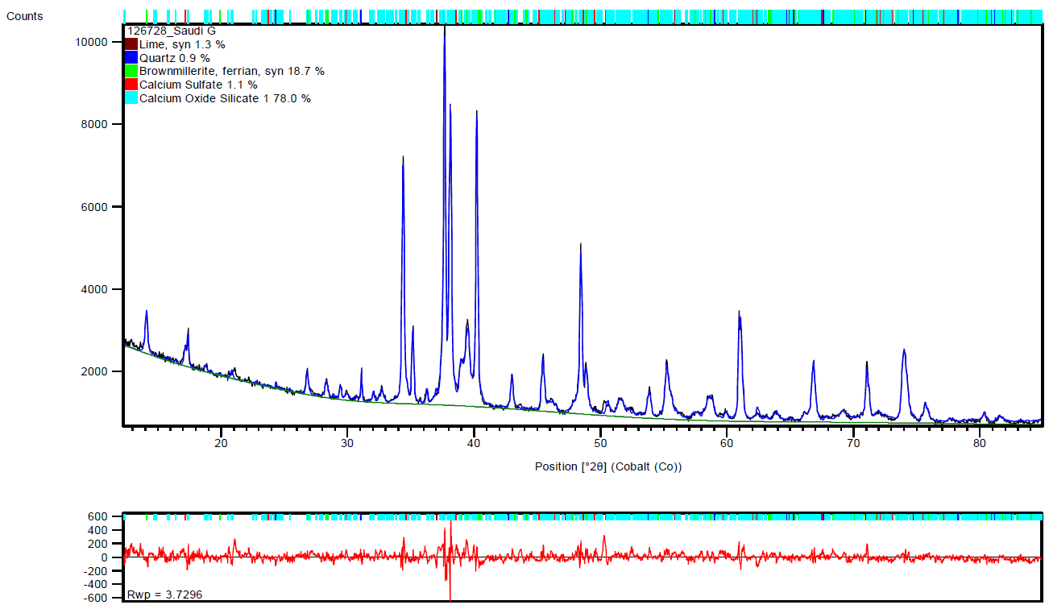

Figure S-4. Rietveld refinement of Saudi G diffraction pattern

Table S-2. WDXRF Semi-Quantitative Composition of Saudi G



Table S-3. XRD Semi-Quantitative Composition of Saudi G

|  |  |
| --- | --- |
| **Phase** | **Concentration (wt.%)** |
| C3S | 60.1 |
| C2S | 20.1 |
| C3A | 1.2 |
| C4AF | 14.5 |
| SO3 | 2.3 |

The mixture designs are shown in Tables S-4. The slurry was mixed at room temperature (about 21 °C) in a Fann 686CS cement stand mixer using deionized water. Standard mixing procedures, i.e. mixing 15 s at 4000 rpm and 35 s at 12,000 rpm, as outlined in API RP 10B,[1] were employed.

Table S-4. Cement Slurry Designs for UCA and Thickening Times



Table S-5. Cement Slurry Designs for UCA with Nanosilica



Table S-6. Cement Slurry Designs for Testing



## HPHT Consistometer / UCA Testing

The tests used to investigate the retarder system are high pressure / high temperature (HPHT) ultrasonic cement analyzer (UCA) experiments, HPHT consistometer testing, and X-ray Diffraction (XRD). The UCAs used were Chandler 4265 HT. All tests were carried out according to API Recommended Practice 10B.[1] The pressure in all tests with the UCA was set to 20.7 MPa. The temperature ramps were set to ramp to the target temperatures in 1 hour. There were four different target temperatures set in the UCA experiments [180°C =, 205°C (0.85 h), 260°C (1.15 h), and 290°C (1.15 h)]. The HPHT consistometers were Chandler Model 8340.

## XRD Sample Preparation and Analysis

After UCA samples were completed, the resulting cement was allowed to cool to close to room temperature and removed from the UCA sample vessel and broken into smaller more manageable pieces. The set cement pieces were then ground with a mortar and pestle until a resulting powder particle size of ~ 150µm was achieved.

The cement powder was then packed into a 2.0 mm depth sample holder provided by Rigaku. The sample x-ray diffraction patterns were collected using a Rigaku Miniflex 600 benchtop x-ray diffraction unit with a Cu x-ray tube within two hours of the completion of the UCA test Theta/2Theta scan was run from 5° to 90° at a rate of 6°/min for each sample. Resulting diffraction patterns were quantitatively analyzed crystalline phases using Rietveld refinement with an internal standard of zinc oxide.

# Results



Figure S-5. Comparison of the HPHT thickening time of cement slurry E (in Table S-5) with 0.94% bwoc ATBS / AA copolymer with how compressive strength builds (as per the UCA test) at 205°C.

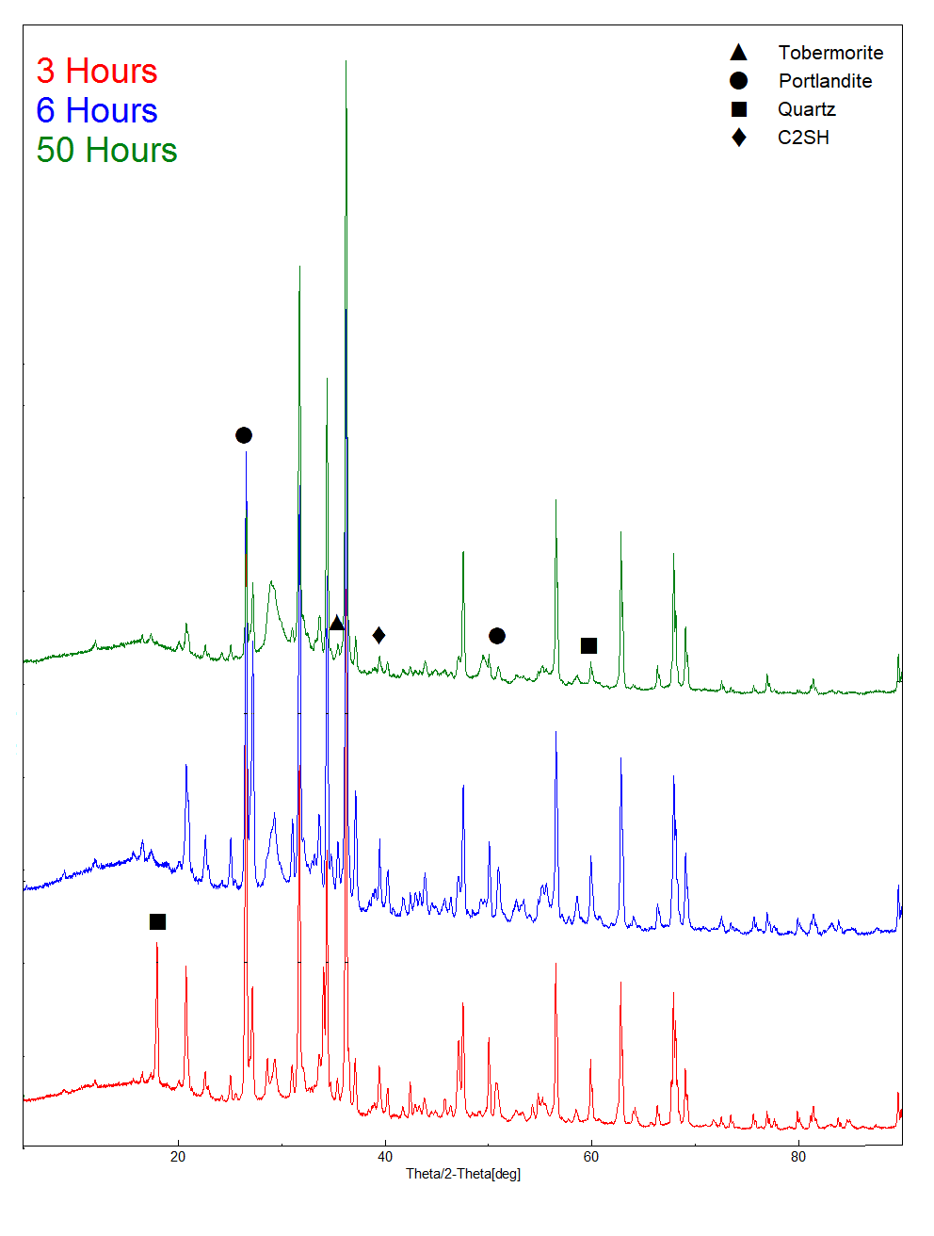

Figure S-6. Raw XRD diffraction patterns of DTPMP cement slurry design over time

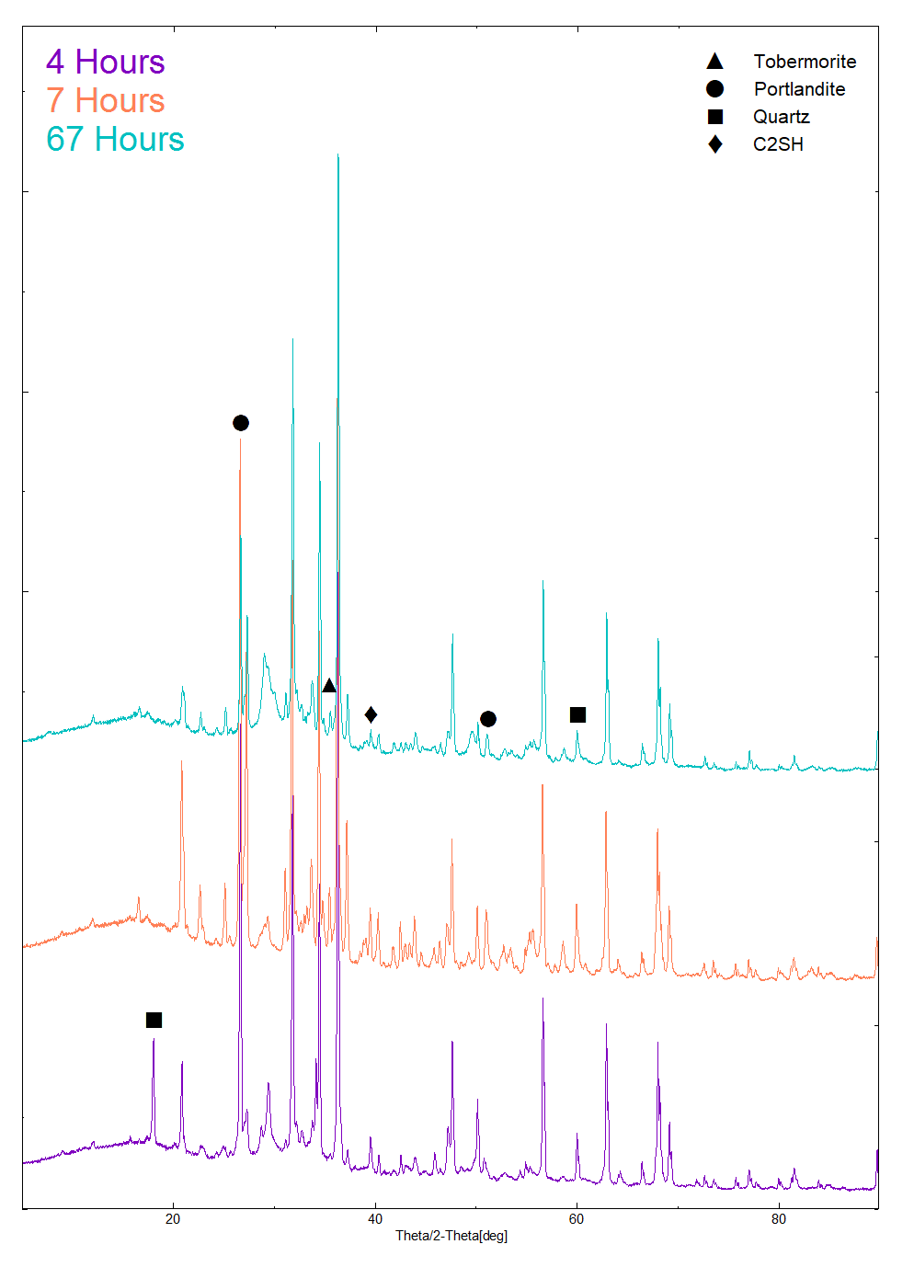

Figure S-7. Raw XRD diffraction patterns of ATBS/AA cement slurry design over time

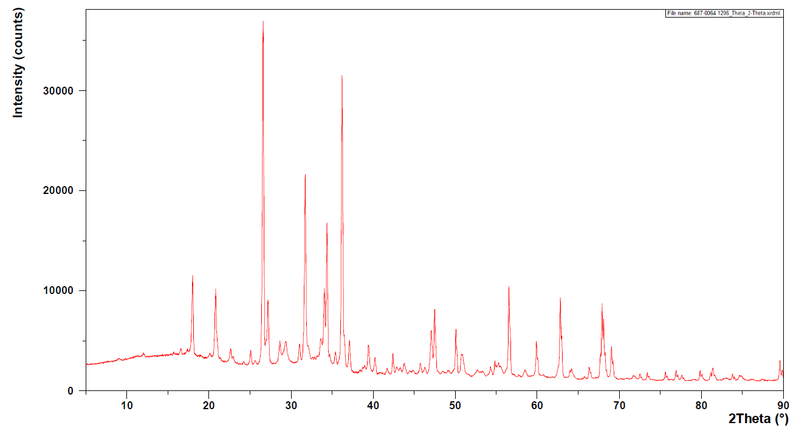

Figure S-8. Raw XRD Diffraction Pattern 3 Hour DTPMP Slurry

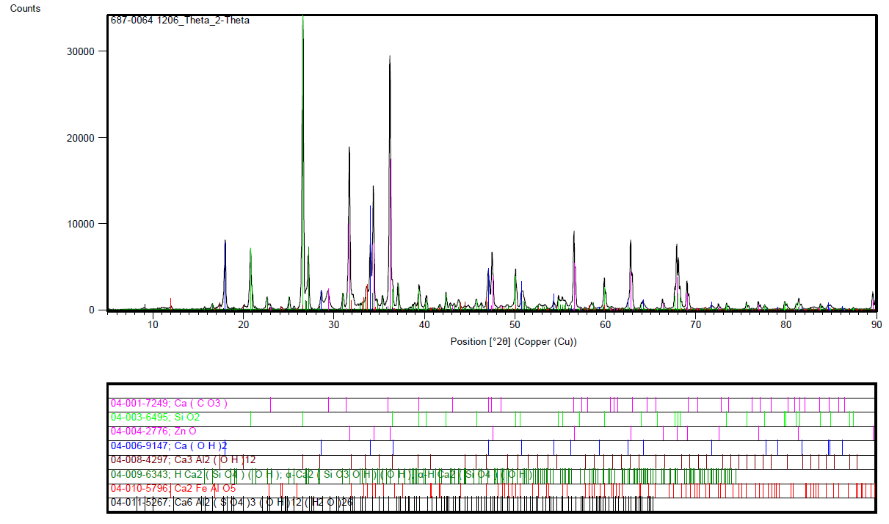

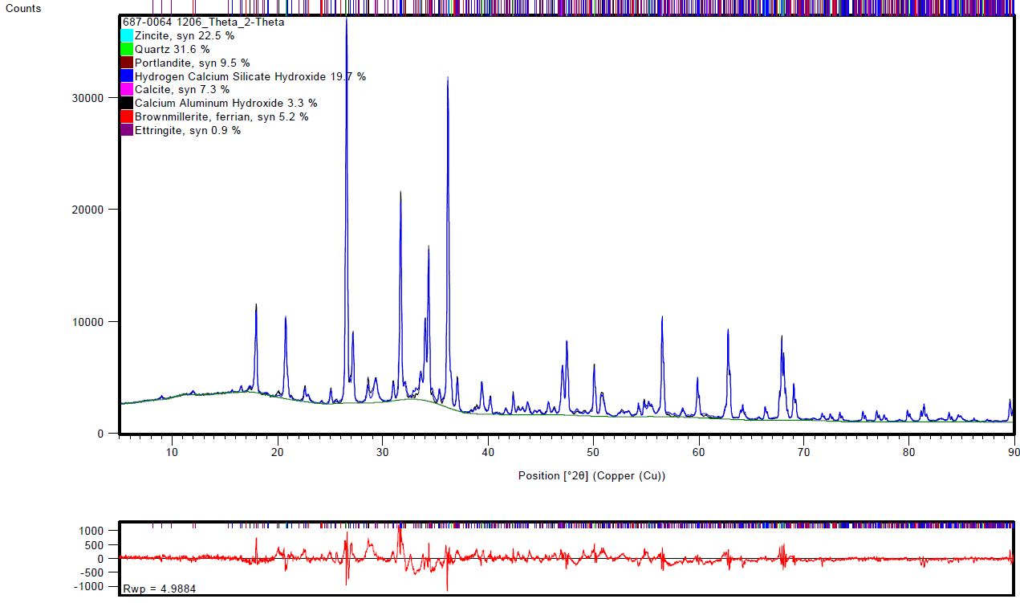

Figure S-9. Initial fit and Rietveld Refinement of 3 Hour DTPMP Slurry

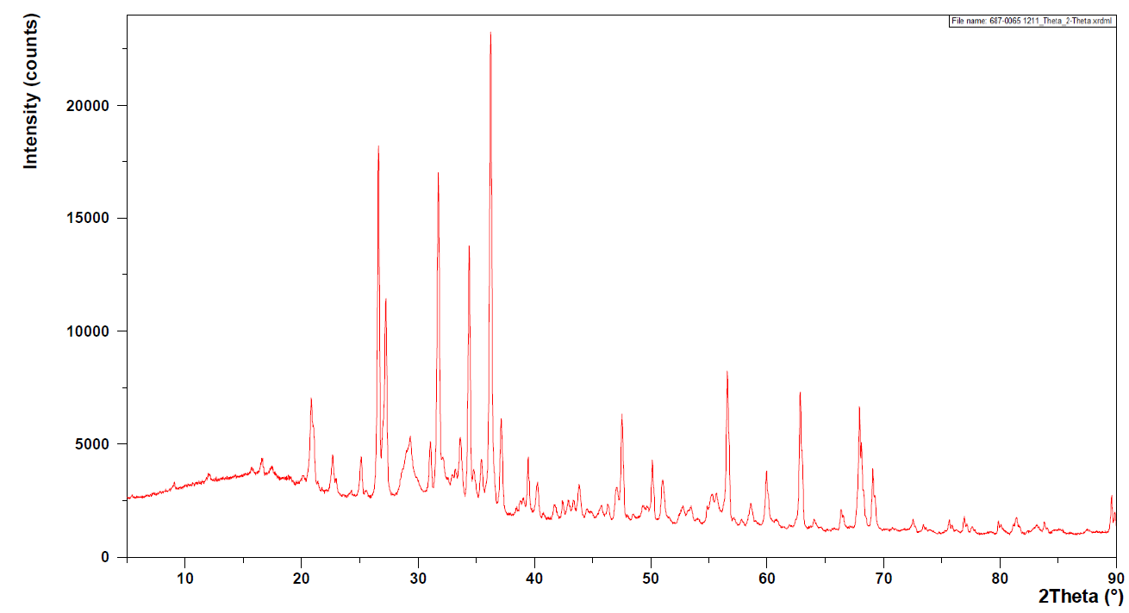Figure S-10. Raw XRD Diffraction Pattern 6 Hour DTPMP Slurry

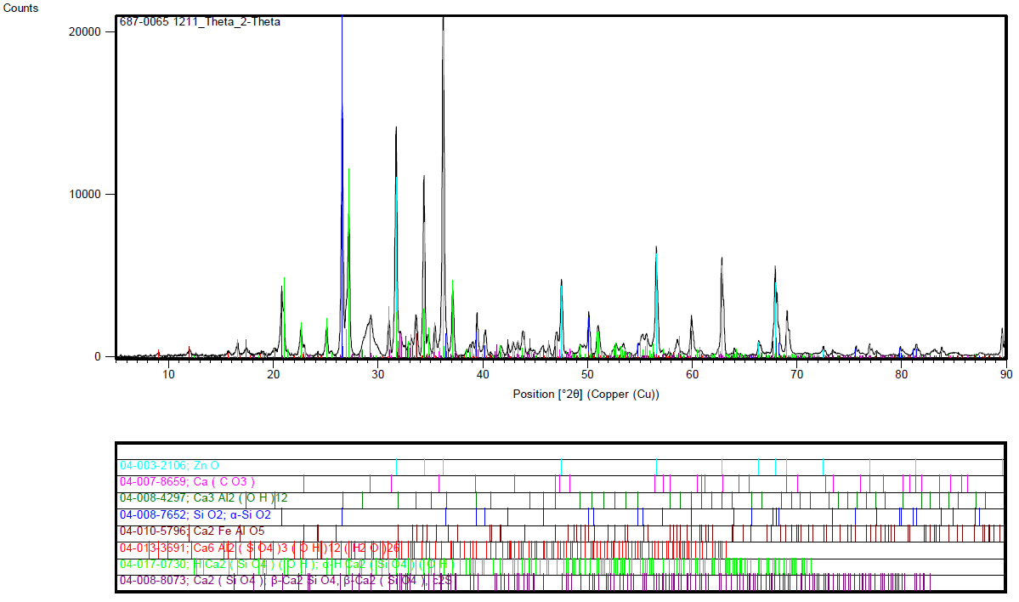

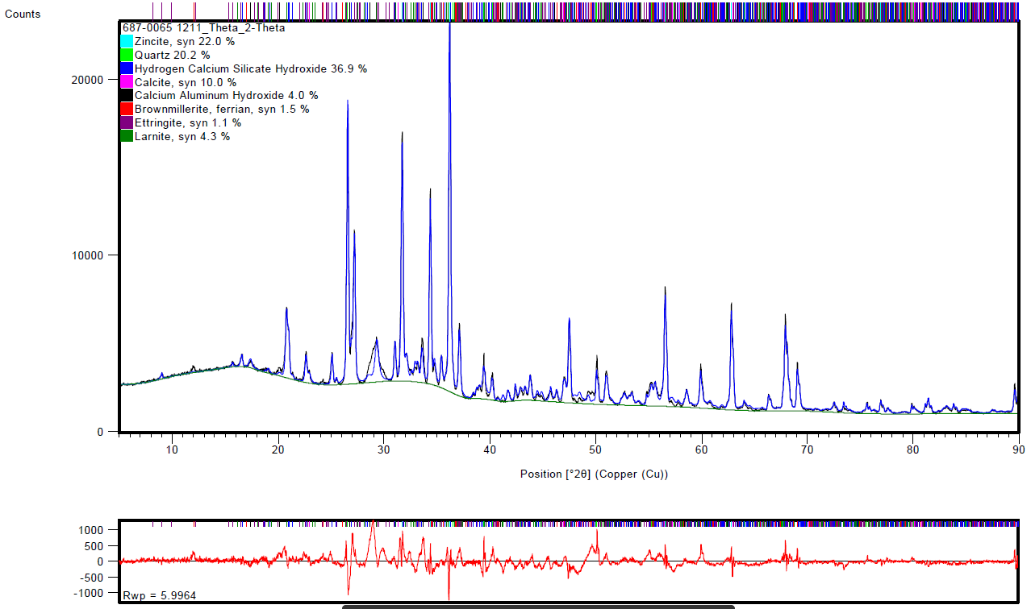

Figure S-11. Initial fit and Rietveld Refinement of 6 Hour DTPMP Slurry

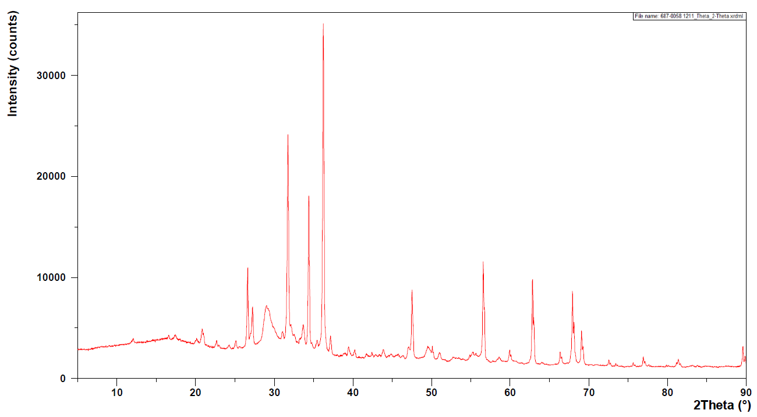

Figure S-12. Raw XRD diffraction pattern of 50 Hour DTPMP Slurry

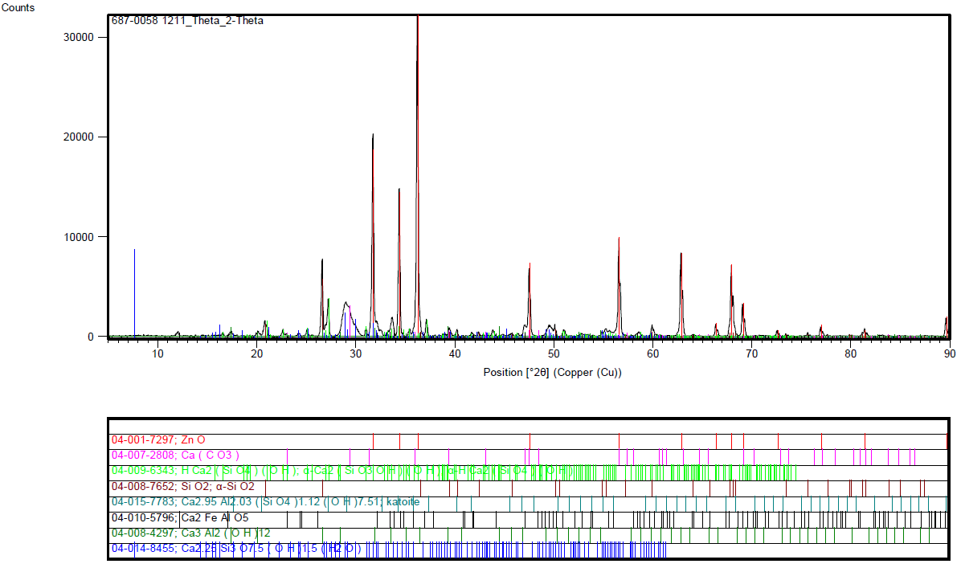

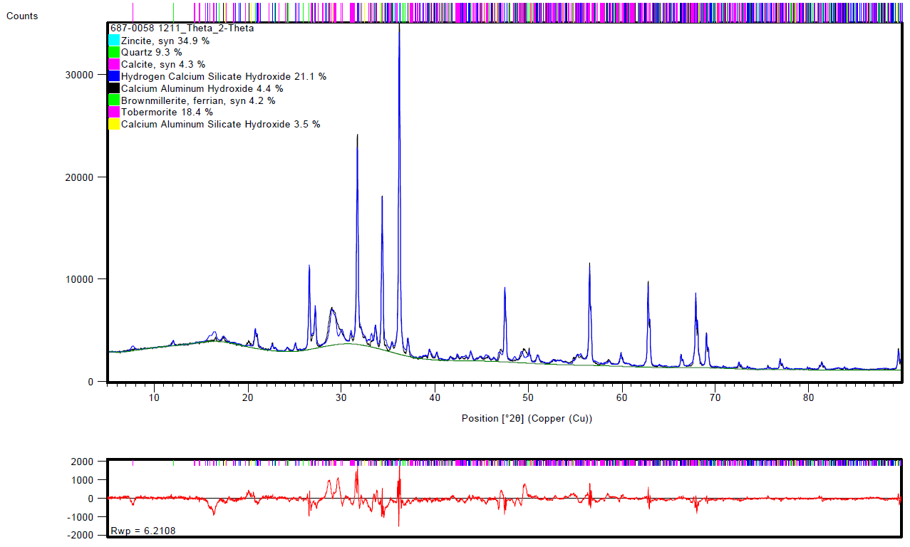

Figure S-13. Initial fit and Rietveld Refinement of 50 Hour DTPMP Slurry

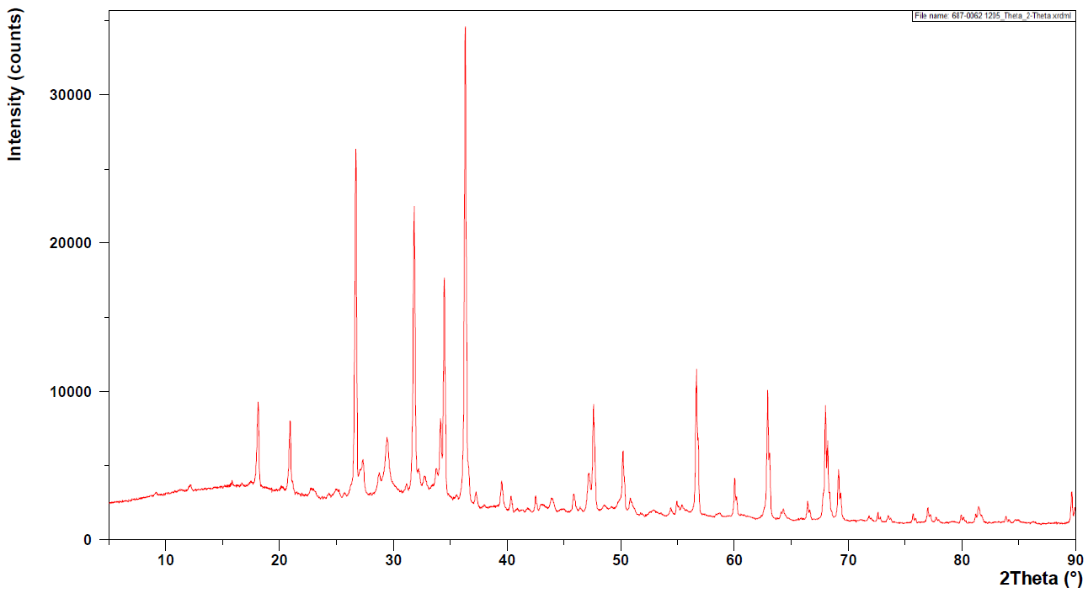

Figure S-14. Raw XRD diffraction pattern of 4 Hour ATBS/AA Slurry

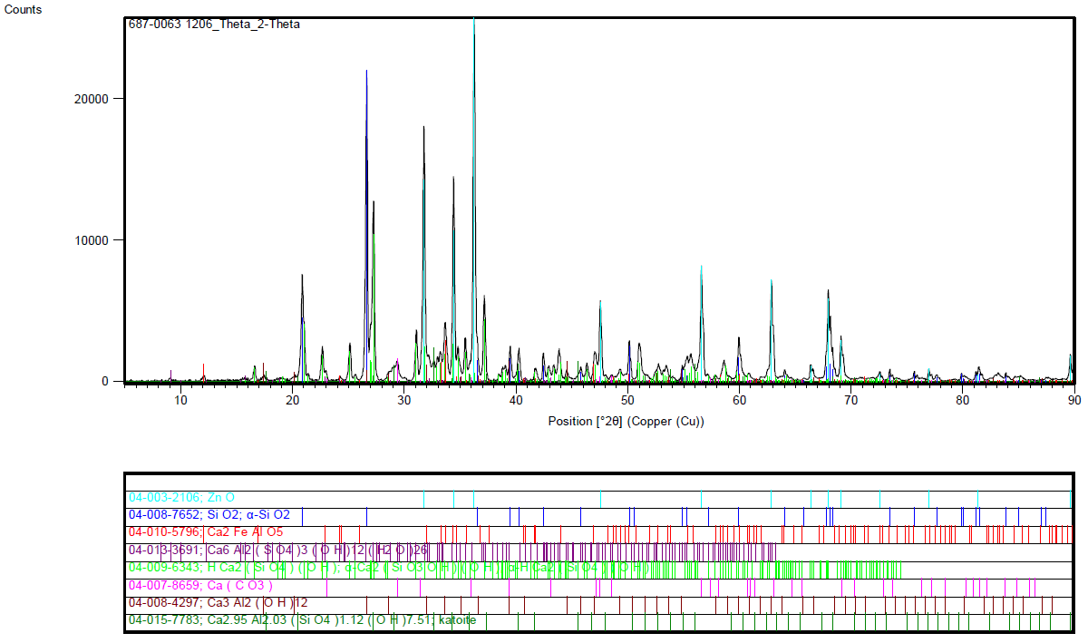

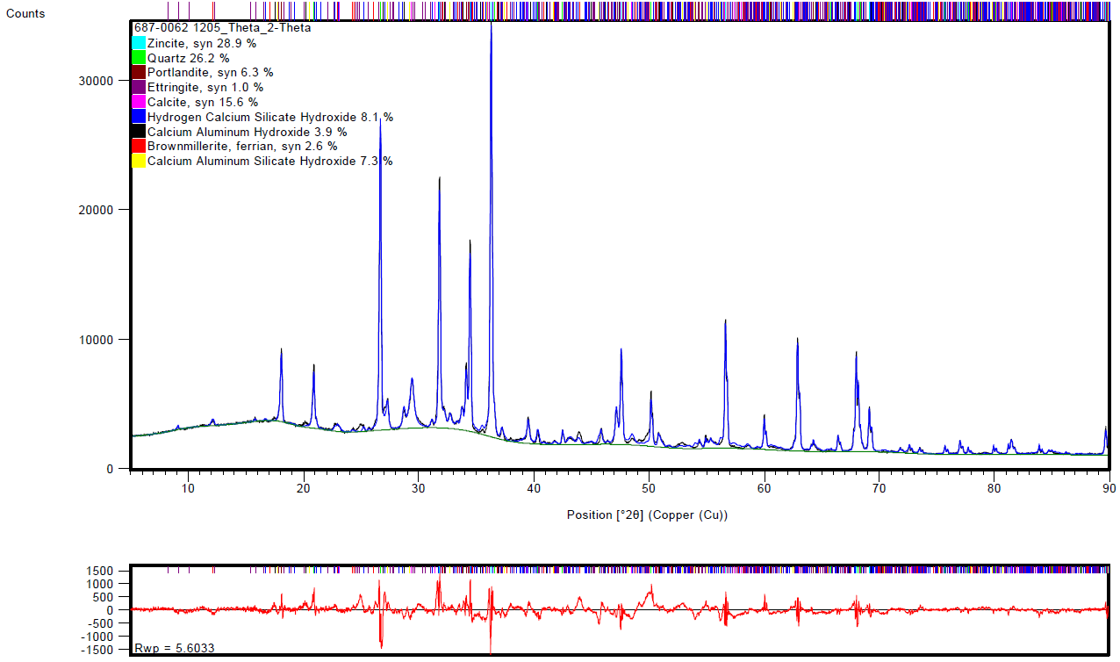

Figure S-15. Initial fit and Rietveld Refinement of 4 Hour ATBS/AA Slurry

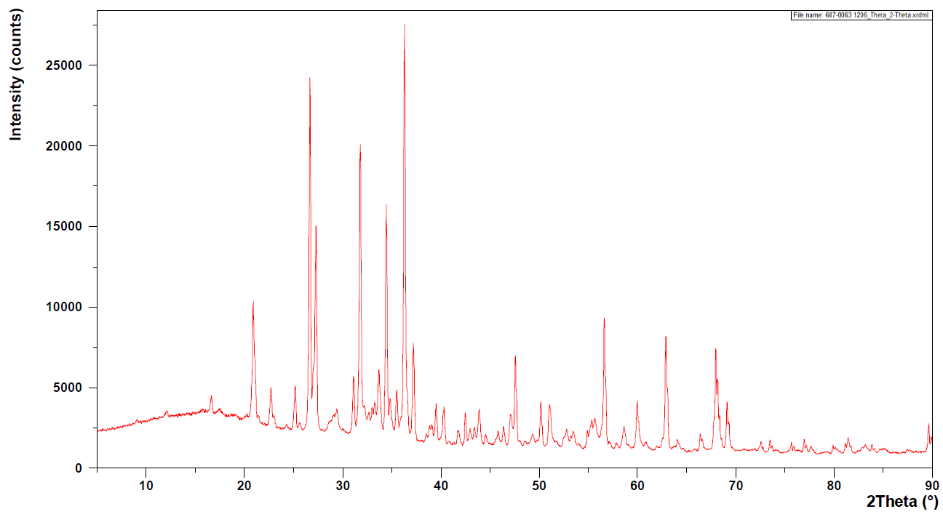

Figure S-16. Raw XRD diffraction pattern of 7 Hour ATBS/AA Slurry

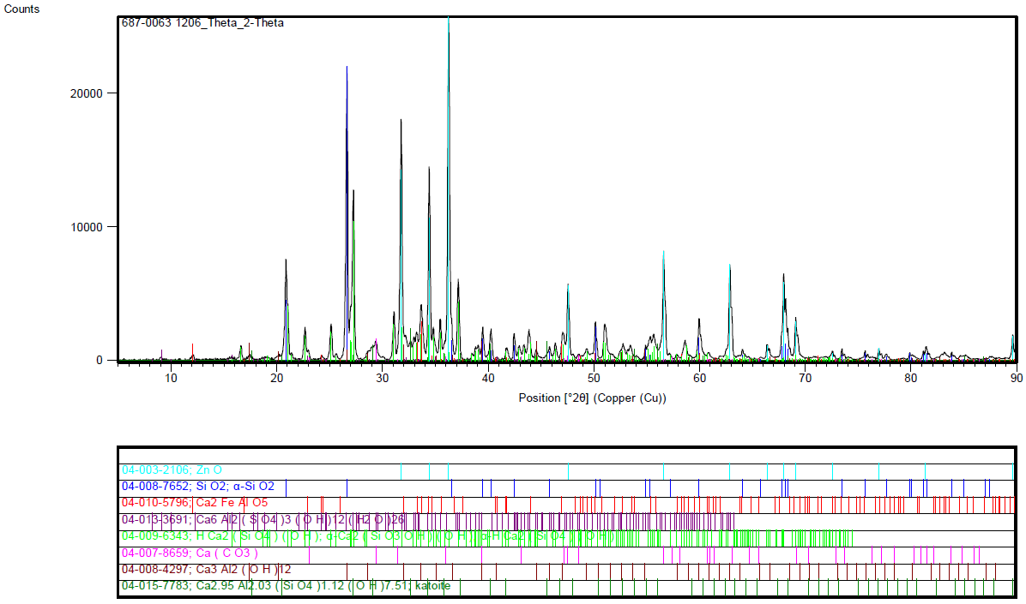

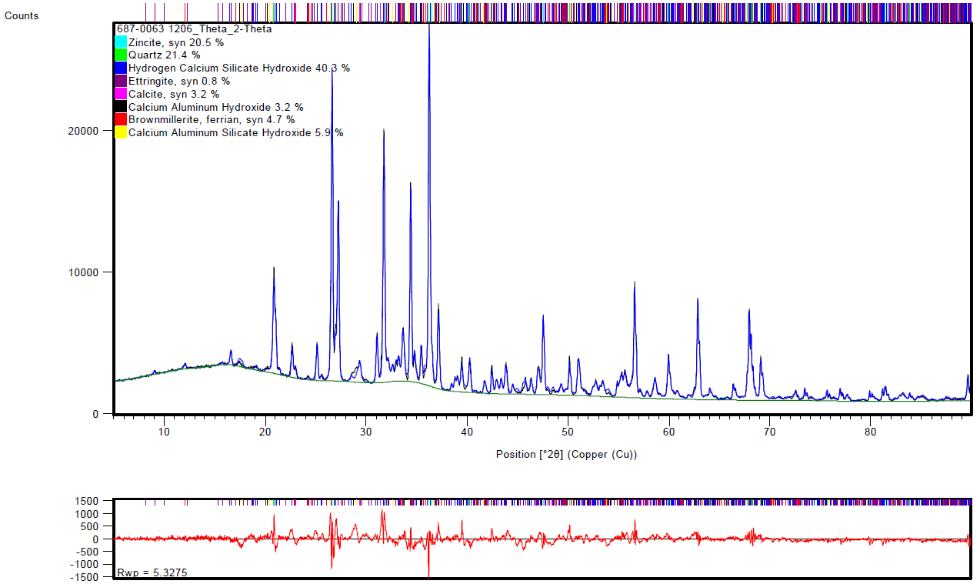

Figure S-17. Initial fit and Rietveld Refinement of 7 Hour ATBS/AA Slurry

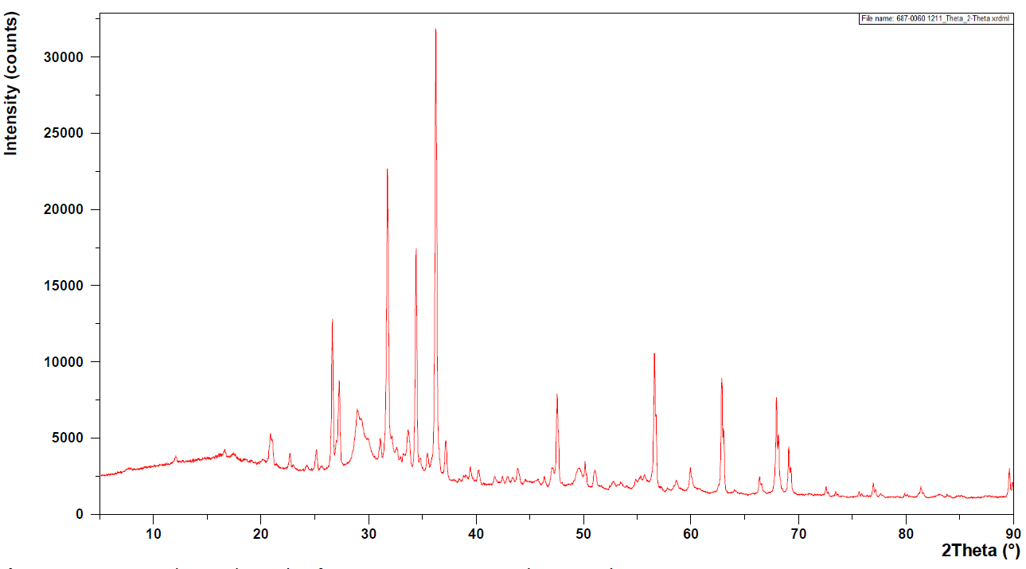

Figure S-18. Raw XRD diffraction pattern of 67 Hour ATBS/AA Slurry

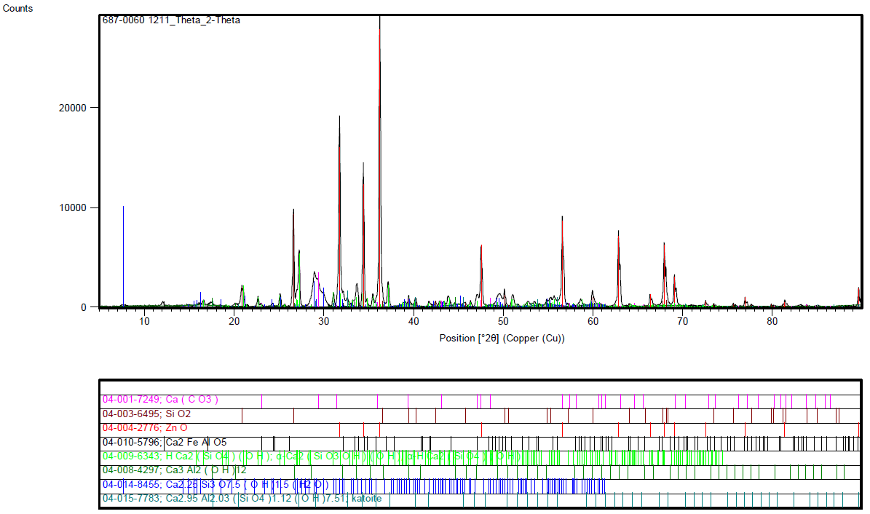

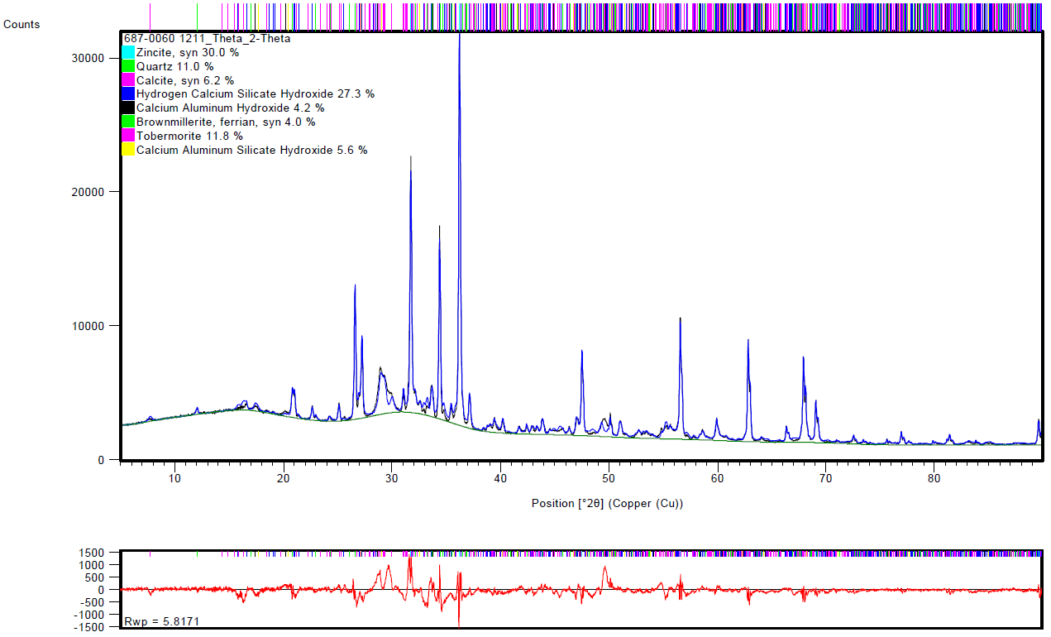

Figure S-19. Initial fit and Rietveld Refinement of 67 Hour ATBS/AA Slurry

# References

[1] API Recommended Practice 10B, Recommended Practice for Testing Well Cements, 2nd edition American Petroleum Institute, 2013.