The effect of substrate roughness on the properties of RF sputtered AZO thin film

Kairi Hamada, Takaya Ogawa, Hideyuki Okumura, Keiichi N Ishihara*

Graduate School of Energy Science, Kyoto University,

Yoshida-Honmachi, Sakyo-ku, Kyoto-shi, Kyoto, 606-8501, Japan

*Email: ishihara@energy.kyoto-u.ac.jp

1. **Surface cracks of AZO films on the quartz plate**

As mentioned in 3.1, the sheet resistance of AZO on the quartz sample monotonously increased day by day. The possible cause would be the difference in CTEs between AZO and quartz. The CTE of quartz is 5.5 × 10−7 /K and the CTE of ZnO is 39 × 10−7 /K. The difference would induce the internal tensile stress when the sample was cooled after sputtering. Although the sample was not heated during the deposition process, the temperature should, in general, increase due to the high-energy of atomic bombardment during the sputtering. This may lead to formation of cracks in the film as the time passes, as shown in Figures S1-S2.

Figure S1 shows the SEM plan views of AZO films on the roughened and not-roughened substrates of quartz plate and glass slides. Formation of cracks is confirmed for the AZO film on the quartz plate, as shown in Figure S1(a), while we cannot detect the crack for the AZO on the glass slide (Figure S1(c)). It is considered that the internal tensile stress became somewhat relieved by the surface roughness due to many high-angle grain boundaries, derived from randomly-orientated crystal growth as confirmed by XRD results (Fig. 1). Thus, the sheet resistance was not largely increased for the AZO film on the quartz plate roughened by 220P abrasive paper. We can also confirm crack formation from the digital microscope images, as shown in Figure S2 (especially in (a)).

Figure S3 shows the effect of the internal tensile stress on the band gap properties. We measured the optical properties of AZO films on roughened and non-roughened quartz plates at two different periods: as- deposited (followed by post-annealing) and 7 months later. As shown in Figure S3, both samples exhibit the same absorption edges, while the bandgap is only changed with each plate condition: i.e., roughened or not-roughened. Although the internal tensile stress deteriorates the conductivity as the time passes, the optical properties are not changed. It may suggest that the internal tensile stress in the AZO film does not significantly affect the band gap property.



Figure S1. SEM plan view images showing surface conditions of AZO films, deposited on: (a) not-roughened quartz plate, (b) quartz plate roughened by 220P abrasive paper, (c) not-roughened glass slide.



Figure S2. Optical micrographs showing surface conditions of AZO films, deposited on: (a) not-roughened quartz (as-deposited), (b) not-roughened quartz (7 months later) (c) not-roughened glass slide (7 months later)



Figure S3. Spectral characteristics measured by spectrometer, showing optical absorption edges of AZO films on roughened and non-roughened substrates at two different periods: as deposited (followed by post-annealing) and 7 months later

1. **Tauc plot**

The band gap was estimated from the result of spectrometer (Figure 2), as shown below in Figure S4.



Figure S4 Typical examples of the Tauc plot

1. **Result of spectrometer of different angles and different CTE**

As mentioned in 3.3, we measured optical properties of AZO films on pristine (not roughened) glass slides, with varying incident light angles (Fig.S5). As shown in Figure S6, absorption edges were not modified with varying the angles from 0°~17.4°, where the light interference effect is rightly varied.

Figure S7 show optical properties (transmittance) of AZO films on four kinds of substrates with various CTEs, measured by the spectrometer. All four absorption edges coincide well.



Figure S5 Schematic diagram of spectroscopic measurement with an incident light angle (θ)

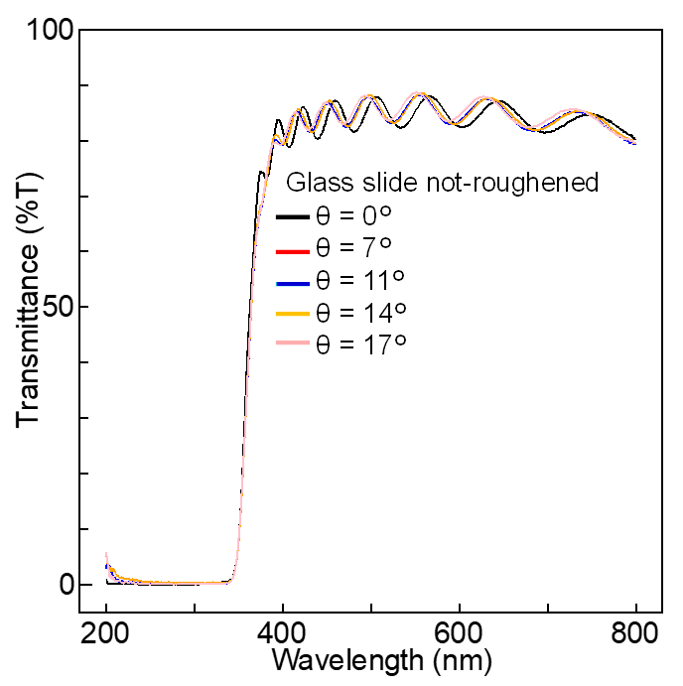

Figure S6 Optical properties of AZO films on not-roughened glass slide substrates, measured with various angles.

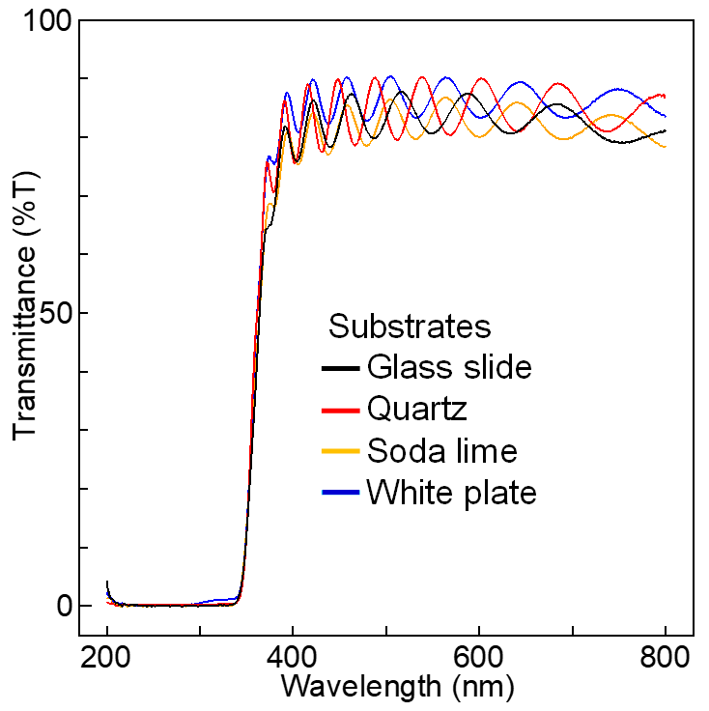

Figure S7 Optical properties (transmittance) of AZO films on four kinds of substrates

1. **Quantification of surface roughness**

To confirm the effect of surface roughness, we quantified the roughness by measuring RMS(Root Mean Square) roughness with AFM. We randomly selected 10 points from our sample, measured the roughness and calculated the average. In addition, to further clarify the effect of roughness, we also prepared AZO films on the frost glass, and evaluated their properties. Table S1 shows the RMS roughness, sheet resistance, transmittance, and haze value of AZO films, on quartz plate roughened by 220P abrasive paper and on frost glass. As shown in Table S1, the haze value was increased as the RMS roughness was increased. Thus, it is considered that there is the relationship between surface roughness and the haze value.

Table S1 Electrical and optical properties of AZO films

|  |  |  |  |  |
| --- | --- | --- | --- | --- |
|  | RMS | Sheet resistance | Transmittance | Haze |
| 220P(Quartz) | 173 nm | 16.5 Ω/sq | 87.6 % | 27.3 % |
| Frost glass | 1537 nm | 50 Ω/sq | 81.4 % | 69.2 % |