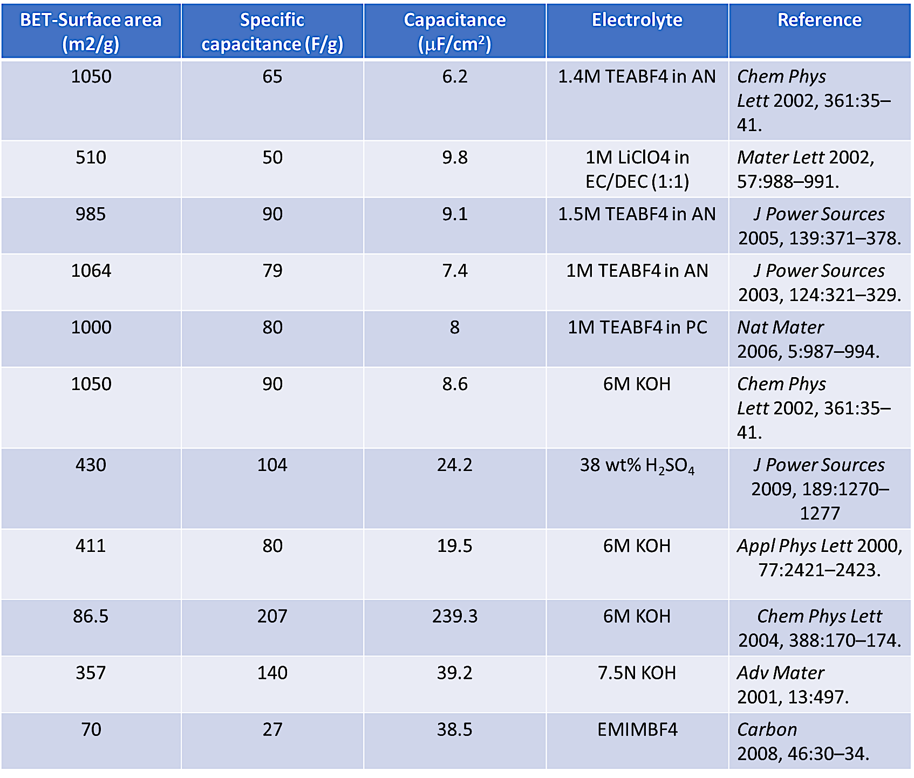
[S1] Table I: Comparison of specific surface area, specific capacitance, capacitance, and electrolyte of symmetric capacitors.

[S2] Table II: Comparison of voltage range and maximum energy density of asymmetric capacitors.
