Supplementary Information for
Fluorescence Loss of Commercial Aqueous Quantum Dots during Preparation for Bioimaging
Kil Ho Lee^{1†}, Thomas Porter^{1†}, Jessica O. Winter^{1,2}*
¹William G. Lowrie Department of Chemical and Biomolecular Engineering, The Ohio State University, 151 W. Woodruff Ave. Columbus, OH 43210
²Department of Biomedical Engineering, The Ohio State University, 151 W. Woodruff Ave. Columbus, OH 43210
†Equally contributing authors

* Corresponding Author: Dr. Jessica O. Winter
Professor, Chemical and Biomolecular Engineering, Biomedical Engineering
453 CBEC, 151 W. Woodruff Ave. Columbus, OH 43210
614-247-7668
winter.63@osu.edu

Supplementary Figures
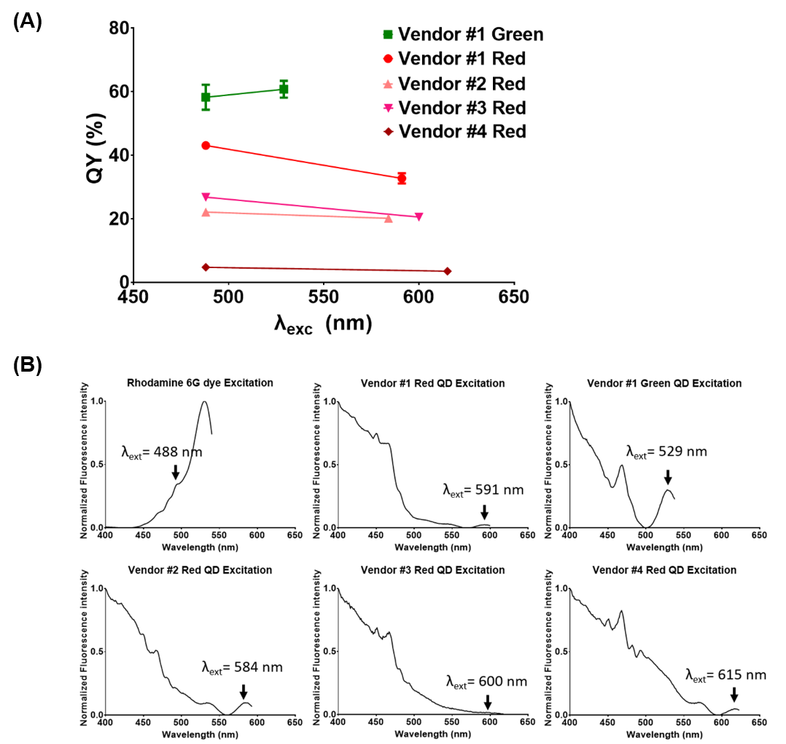
Figure S1. (a) Photoluminescence QY wavelength dependence for QDs from 4 vendors excited at 488 nm and at the first exciton wavelength. (b) Excitation spectra for Rhodamine 6G and QDs from 4 vendors.

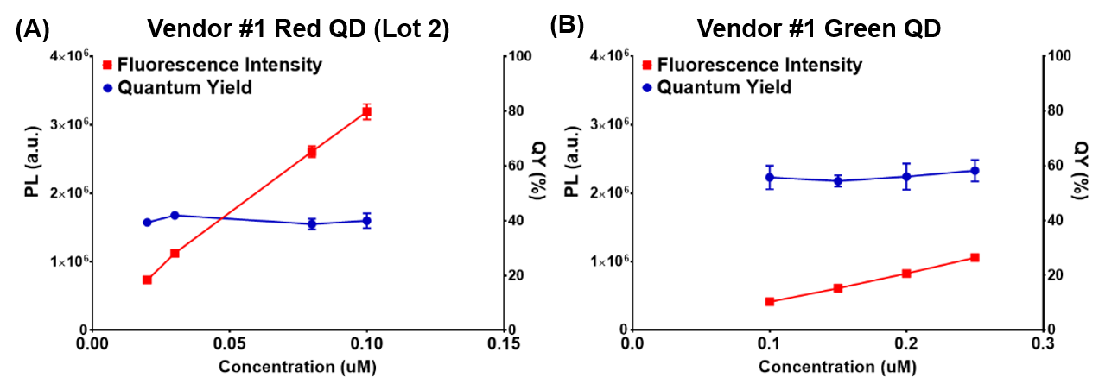
Figure S2. Photoluminescence intensity (PL) and QY of QDs from Vendor 1 as a function of diluted concentration: (A) red QDs, Lot 2 and (B) green QDs.

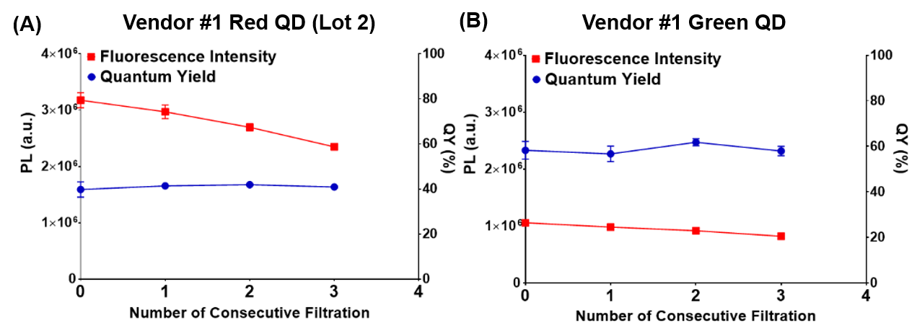
Figure S3. Photoluminescence (PL) intensity and QY of QDs from Vendor 1 after centrifugal filtration repeated up to 3 times (fixed concentration): (A) red QDs, lot 2, and (B) green QDs.

Figure S4. Representative images of QDs (0.1 µM) from Vendor #1 show substantial aggregation in pH 4.7, 0.1 M MES buffer. QDs from Vendor 1 (Lot 1) dispersed in (A) a compatible buffer (i.e., pH 9, 50 mM borate buffer) and (B) in an incompatible buffer (i.e., pH 4.7, 0.1 M MES buffer). QDs from Vendor #1, regardless of lot number or color, aggregated and precipitated in MES buffer.

Figure S5. QY of QDs from Vendor 1 (Lot 2) (0.1 µM), Vendor 2 (0.1 µM), and Vendor 3 (0.15 µM) in pH 7.26 and pH 9, 50 mM borate buffer.

