**Supplemental Information:**

**Scanning thermal probe calibration for accurate measurement of thermal conductivity of ultrathin films**

Adam A. Wilson1,2*

1. National Academy of Sciences, National Research Council

500 E. 5th Street NW, Washington, DC, USA 20001

2) Sensors and Electron Devices Directorate, US Army Research Laboratory, 2800 Powder Mill Rd, Adelphi, MD, USA 20783

*Corresponding author email: adam.a.wilson6.ctr@mail.mil

1. **Vetting self-consistency and predictive capability of each probe calibration method**

To vet the calibration strategies for accurate thermal conductivity measurement, each strategy must meet two requirements: the calibration must be self-consistent (i.e. the calibration predicts its own thermal conductivity accurately) and predictive ability (i.e. the calibration predicts other samples’ thermal conductivity values accurately). To this end, each of the three calibration techniques were vetted in this manner. Table S1 vets the implicit method for self-consistency and predictive capability, table S2 vets the step method, and table S3 vets the intersection method. In each case, the rows labeled “SC” check for self-consistency and those labeled “P” check for predictive ability.

*Table S1 – Self-consistency and predictive capability of the intersection method for probe calibration.*

P

SC

|  |  |  |  |  |
| --- | --- | --- | --- | --- |
| **kref (Wm-1K-1)** | **bint (nm)** | **RthC (K/W)** | **kfound (Wm-1K-1)** | **% var** |
| 0.2 | 54 | 5.33x106 | 0.199 | 0.5% |
| 146 | 54 | 5.33x106 | 148.3 | 1.6% |
| 1.14 | 54 | 5.33x106 | 1.21 | 6.1% |

*Table S2 – Self-consistency and predictive capability of the intersection method for probe calibration.*

SC

P

|  |  |  |  |  |
| --- | --- | --- | --- | --- |
| **kref (Wm-1K-1)** | **bint (nm)** | **RthC (K/W)** | **kfound (Wm-1K-1)** | **% var** |
| 0.2 | 54 | 5.33x106 | 0.199 | 0.5% |
| 146 | 54 | 5.33x106 | 148.3 | 1.6% |
| 1.14 | 54 | 5.33x106 | 1.21 | 6.1% |

*Table S3 – Self-consistency and predictive capability of the intersection method for probe calibration.*

P

SC

|  |  |  |  |  |
| --- | --- | --- | --- | --- |
| **kref (Wm-1K-1)** | **bint (nm)** | **RthC (K/W)** | **kfound (Wm-1K-1)** | **% var** |
| 0.2 | 54 | 5.33x106 | 0.199 | 0.5% |
| 146 | 54 | 5.33x106 | 148.3 | 1.6% |
| 1.14 | 54 | 5.33x106 | 1.21 | 6.1% |

1. **Film-on-substrate model**

To decouple the effective thermal conductivity of a film-on-substrate sample ($k_{eff}$) into its contribution from the film ($k_{film}$) and the substrate ($k_{sub}$), an isothermal disc on film-on-substrate model proposed by Dryden et. al. [4] was used:

$R_{S,foS}^{th}=\frac{1}{πk_{film}b}\int_{ξ}^{∞}{\left[\frac{λ_{2}e^{\frac{ξt_{film}}{b}}+λ_{1}e^{-\frac{ξt_{film}}{b}}}{λ_{2}e^{\frac{ξt_{film}}{b}}-λ_{1}e^{-\frac{ξt_{film}}{b}}}\frac{J_{1}\left(ξ\right)\sin\left(ξ\right)}{ξ^{2}} \right]dξ}$ (S1)

where $R_{S,foS}^{th}=\frac{1}{4k_{eff}b}$ is the film-on-substrate thermal resistance, $λ_{1}=\frac{1-\frac{k_{sub}}{k_{film}}}{2}$, $λ_{2}=\frac{1+\frac{k_{sub}}{k_{film}}}{2}$, $J_{1}$ is a Bessel function of the first kind, $t_{film}$ is film thickness, and $ξ$ is a dummy variable of integration.

Here, $k_{eff}$ or $R_{S,foS}^{th}$ may be entered into the analytical model along with $b$ in order to decouple the film thermal conductivity from substrate thermal conductivity. , $k_{film}$ is used as a free parameter in the model until the model’s value of $R_{S,foS}^{th}$ matches the input value, as depicted in figure S1.

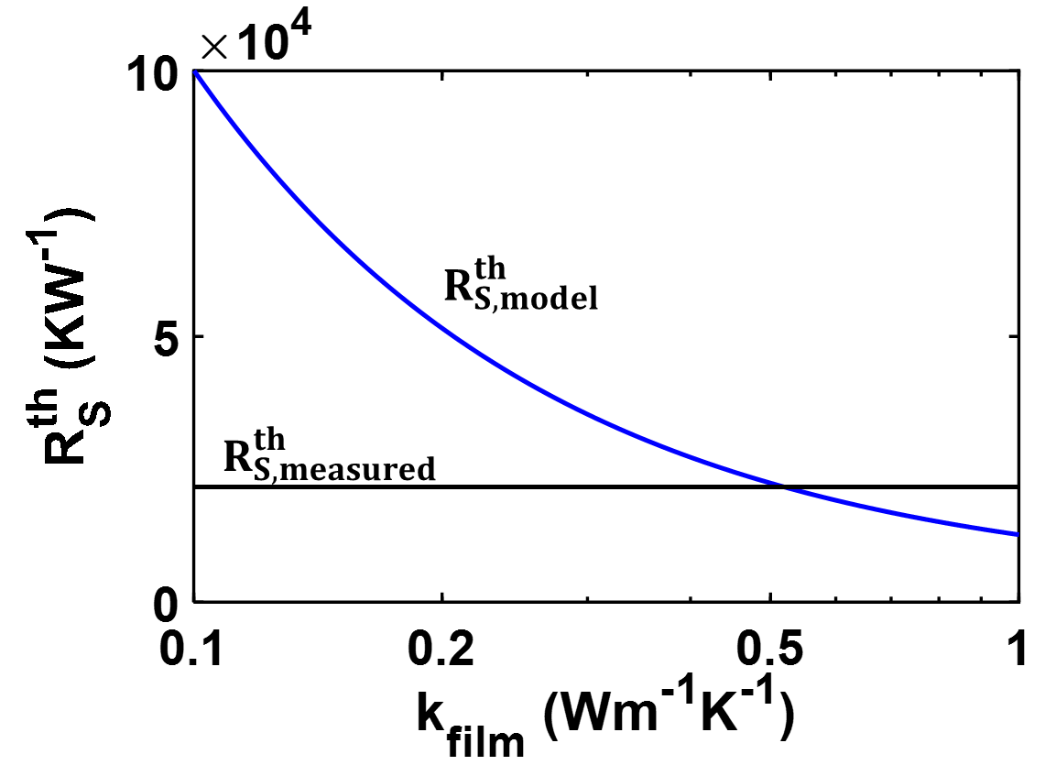

Figure S1 – Example determination of kfilm from Dryden film-on-substrate model

**References**

[1] A. Kaźmierczak-Bałata, J. Bodzenta, M. Krzywiecki, J. Juszczyk, J. Szmidt, and P. Firek, "Application of scanning microscopy to study correlation between thermal properties and morphology of BaTiO3 thin films," *Thin Solid Films,* vol. 545, pp. 217-221, 2013.

[2] E. Puyoo, S. Grauby, J. M. Rampnoux, E. Rouviere, and S. Dilhaire, "Thermal exchange radius measurement: application to nanowire thermal imaging," *Review of Scientific Instruments,* vol. 81, p. 073701, Jul 2010.

[3] Y. Zhang, C. L. Hapenciuc, E. E. Castillo, T. Borca-Tasciuc, R. J. Mehta, C. Karthik*, et al.*, "A microprobe technique for simultaneously measuring thermal conductivity and Seebeck coefficient of thin films," *Applied Physics Letters,* vol. 96, p. 062107, 2010.

[4] J. R. Dryden, "The effect of surface coating on the constriction resistance of a spot on an infinite half-plane," *Journal of Heat Transfer,* vol. 105, pp. 408-410, 1983.