Supporting Information

**Dynamic Covalent Hexahydrotriazine Breakdown through Nucleophilic Attack by Phosphine**

Peter J. Boul,* ,† Diana Rasner, † Peter D. Jarowski,‡ Carl J. Thaemlitz†

†Aramco Research Center, Houston, Texas 77061, United States

‡ChemAlive LLC, 1003, Lausanne, Switzerland

Table of Contents

EXPERIMENTAL SECTION 3

Model Study of HT Breakdown 3

Samples A through D 3

Triggered Release Study 3

UV / Vis Method 3

Computational Studies 4

Results 5

Reaction Mechanisms 5

Scheme S-1. Condensation pathway for the reaction of an amine with formaldehyde. 5

Scheme S-2. Route 2 for the decomposition of triazine in the presence of phosphine. Reaction energies (Grxn in kcal/mol) derived from B3LYP/6-31+G(d) level of theory in DMF solvent (COSMO) are presented by the appropriate arrow and direction. 5

Coordinates and Energies 6

Table S-1. SCF electronic energies in gas-phase and in DMF solvent for compounds I to XIV. Thermal corrections for enthalpy and entropy are taken from gas-phase hessian. 6

Table S-2. Coordinates in Angstroms (XYZ) and SCF energies in gas-phase and in DMF solvent. 13C NMR isotropic tensors are also provided. 6

NMR Spectra 24

Figure S-1 24

Figure S-2 25

Figure S-3 26

Triggered Release Study 27

Figure S-4 27

Figure S-5 27

Figure S-6 28

# EXPERIMENTAL SECTION

Materials. N-methyl pyrrolidone (NMP), paraformaldehyde and aluminum chloride hexahydrate were purchased from Fisher Scientific Co. LLC. HT was obtained from Aldrich Chemical Co.

## Model Study of HT Breakdown

NMR Experimental: Carbon 13 spectra collected on a Bruker Ascend Aeon 500 MHz NMR with standard preset experimental parameters provided in TopSpin 3.6 In the NMR analysis, the integral area of the aldehydic DMF-d7 (solvent) proton at 8.03 ppm is set to 1.0 for all spectra. All integral areas are relative to this signal. This helps to distinguish changes in concentrations of molecular species as they form or disappear with time.

### Samples A through D

The preparation and 13C-NMR results for Samples A through D are indicated below:

1. HT + 2 equ TCEP + 1.2 equ AlCl3·6H2O 0.0579 g of HT.

0.0579 g of HT, 0.0744 g of AlCl3·6H20 and 0.1523 g of TCEP was dissolved in d7 DMF and transferred to a clean NMR tube for analysis.

13C NMR (126 MHz, DMF) δ(ppm) = 173.4 (d, J = 55 Hz), 89.8, 89.3 (d, J = 45 Hz), 81.7, 78.3, 76.0, 72.4, 67.9, 67.6, 63.5, 58.8, 57.8, 57.4, 55.6 (d, J = 20 Hz), 48.7 (d, J = 270 Hz), , 46.4 (d, J = 40 Hz), 43.1, 42.5, 27.1, 26.8 (d, J = 15 Hz), 19.0, 14.4 (d, J = 200 Hz), and 14.1 ppm (d, J = 190 Hz).

1. HT + TCEP

0.1087 g of HT and 0.25 g of TCEP was dissolved in DMF-d7 and transferred to a clean NMR tube for analysis.

13C NMR (126 MHz, DMF) δ(ppm) = 175.7 (d, J = 35.0 Hz), 174.5 (dd, J = 50 Hz), 172.3 (d, J = 15 Hz), 89.5 (d, J = 45 Hz), 73.2, 63.7, 61.5, 59.5, 59.1, 57.5, 55.8 (d, J = 19.6 Hz), 55.2, 54.7 (d, J = 45 Hz), 49.5, 48.9, 43.2, 41.5, 41.0, 27.8, 19.2, 15.1 (d, J = 200 Hz), and 14.9 (d, J = 200 Hz).

1. HT + AlCl3

0.0558 g of s-triazine 1,3,5 triethanol and 0.0722 g of AlCl3·6H20 was dissolved in DMF-d7 and transferred to a clean NMR tube for analysis.

13C NMR (126 MHz, DMF) δ(ppm) = 87.02, 75.27, 70.79, 67.64, 60.57, 57.63, 56.26, 52.43, 19.24.

1. HT

0.0375 g of s-triazine 1,3,5 triethanol was dissolved in DMF- d7 and transferred to a clean NMR tube for analysis.

13C NMR (126 MHz, DMF) δ(ppm) = 75.70, 60.86, 56.51.

HSQC-TCSY of Samples B and D are presented in Figures 1 and 2, respectively, in the supporting information.

## Triggered Release Study

UV / Vis Method:

Using a glass vial as a mold, 0.10 g of paraformaldehyde was added to 4.12 g of NMP and stirred at 70ºC for 30 minutes. 3.20 g of Jeffamine T-5000 and 0.25 g of Lomar D was added to the heated mixture and stirred with a magnetic stirbar for an additional 30 minutes, removed from the heat and allowed to cool to room temperature where a gel would form.

The gel was broken up and an addition of 0.19 g of AlCl3·6H2O was added to the broken gel pieces. The gel was allowed to break down into a liquid state overnight. The next morning the liquid gel was heated again to 70ºC for 1 hour and cooled to room temp where a thermodynamic gel would form.

The samples are then broken from their glass molds with the stir-bar still intact in the thermodynamic gel, resulting in a uniformly shaped gel sample.

The gels were tested either in neat NMP or in an NMP/TCEP mixture. 5.0 g of TCEP was added to 95 g neat NMP and allowed to dissolve until clear. UV Vis spectra were collected from 800 nm to 200 nm at 600 nm / min, with a background being taken of either the neat NMP or the TCEP / NMP mixture before starting the experiment. Upon experiment start, the gel sample would be placed into solution on top of a stir plate set to 100 RPM where the gel sample would stir using the still intact stir bar from earlier. Spectra were collected every 5 minutes to study the release of Lomar D from the gel samples.

# Computational Studies

Density functional theory computations were carried out using the software NWChem as implemented with structural automation tool ConStruQt. Throughout, all structures were structurally optimized using the common Becke-Li-Yang Parr hybrid functional (B3LYP) with vibrational frequency analysis and thermal corrections calculated on these structures (all energies presented in the main text are free-energies at 298.15 K). For HCNO atoms the split-valence basis set with diffuse functions (6-31+g(d)) was applied. COSMO solvent model for water (dielectric constant of 78) was applied as a single-point energy correction. All structural coordinates can be found in the supporting information (SIX) along with thermal corrections and single point SCF energies for solvation considerations.

# Results

## Reaction Mechanisms

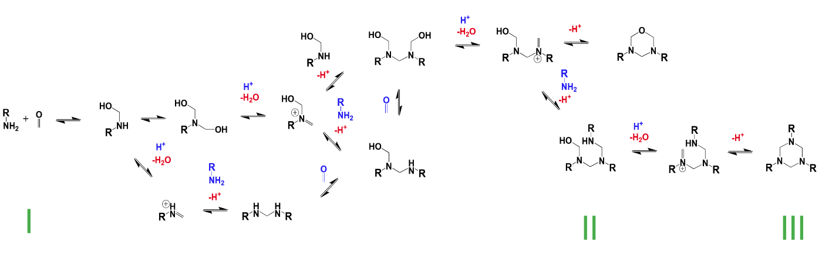

### Scheme S-1. Condensation pathway for the reaction of an amine with formaldehyde.



### Scheme S-2. Route 2 for the decomposition of triazine in the presence of phosphine. Reaction energies (Grxn in kcal/mol) derived from B3LYP/6-31+G(d) level of theory in DMF solvent (COSMO) are presented by the appropriate arrow and direction.

## Coordinates and Energies

### Table S-1. SCF electronic energies in gas-phase and in DMF solvent for compounds I to XIV. Thermal corrections for enthalpy and entropy are taken from gas-phase hessian.

|  |  |  |  |  |
| --- | --- | --- | --- | --- |
| Compound Number | Electronic Energy (Gas-phase) (Hartrees) | Single-Point Electronic Energy (COSMO, DMF) (Hartrees) | H (kcal/mol, 298 K) | S (kcal/mol K) |
| **I** | -401.897718 | -401.912424 | 144.20 | 92.52 |
| **II** | -402.276102 | -402.362205 | 154.17 | 96.62 |
| **III** | -863.401054 | -863.482831 | 229.88 | 144.37 |
| **Iva** | -863.681490 | -863.937560 | 239.16 | 142.52 |
| **IVb** | -863.693016 | -863.948880 | 239.53 | 140.29 |
| **V** | -1228.956725 | -1229.189623 | 270.42 | 158.04 |
| **VI** | -729.436893 | -729.513906 | 181.50 | 120.32 |
| **VII** | -595.464189 | -595.547319 | 132.48 | 102.17 |
| **VIII** | -1094.962278 | -1095.217968 | 220.84 | 139.34 |
| **IX** | -729.694700 | -729.972609 | 190.09 | 118.34 |
| **X** | -960.968164 | -961.254147 | 172.66 | 121.19 |
| **XI** | -229.829123 | -229.838748 | 91.88 | 79.57 |
| **I-Al** | -632.275269 | -632.902231 | 200.78 | 128.44 |
| **II-Al** | -632.197607 | -633.324756 | 207.90 | 126.66 |
| **III-Al** | -1093.481491 | -1094.465536 | 284.51 | 162.54 |
| **III-Al(-)** | -1093.444164 | -1093.999554 | 275.43 | 160.95 |
| **XII** | -402.265805 | -402.348632 | 152.63 | 106.28 |
| **XIII** | -268.288162 | -268.375731 | 103.54 | 88.81 |
| **XIV** | -134.299451 | -134.402705 | 54.60 | 60.97 |

### Table S-2. Coordinates in Angstroms (XYZ) and SCF energies in gas-phase and in DMF solvent. 13C NMR isotropic tensors are also provided.

|  |  |  |  |  |  |  |  |  |
| --- | --- | --- | --- | --- | --- | --- | --- | --- |
|  |  | |  | |  | |  |  |
|  | | X | | Y | | Z |  | Isotropic NMR Tensor |
|  |  | |  | |  | |  |  |
| **I** |  | |  | |  | |  |  |
|  |  | |  | |  | |  |  |
| C | -0.26487 | | 2.76249 | | 0.16412 | |  | 137.3 |
| N | -0.16387 | | 1.38487 | | -0.29349 | |  | 189.2 |
| C | -1.24543 | | 0.56447 | | 0.23260 | |  | 107.8 |
| N | -1.14936 | | -0.79705 | | -0.27390 | |  | 189.4 |
| C | -2.24528 | | -1.62550 | | 0.20590 | |  | 137.4 |
| C | 0.14371 | | -1.37714 | | 0.05872 | |  | 103.6 |
| N | 1.22474 | | -0.55703 | | -0.46809 | |  | 209.5 |
| C | 1.12893 | | 0.80399 | | 0.03903 | |  | 103.5 |
| C | 2.52667 | | -1.14344 | | -0.18802 | |  | 142.7 |
| H | -0.18463 | | 2.86591 | | 1.26529 | |  | 29.2 |
| H | 0.53134 | | 3.35876 | | -0.29465 | |  | 28.5 |
| H | -1.22641 | | 3.18266 | | -0.15028 | |  | 29.2 |
| H | -2.20058 | | 0.99304 | | -0.09032 | |  | 28.3 |
| H | -1.23219 | | 0.56819 | | 1.35591 | |  | 27.7 |
| H | -2.25973 | | -1.73735 | | 1.30909 | |  | 29.2 |
| H | -3.19919 | | -1.18712 | | -0.10661 | |  | 29.2 |
| H | -2.16965 | | -2.62391 | | -0.23839 | |  | 28.5 |
| H | 0.24643 | | -1.49703 | | 1.17100 | |  | 28.5 |
| H | 0.20780 | | -2.37417 | | -0.39075 | |  | 28.1 |
| H | 1.91568 | | 1.40852 | | -0.42558 | |  | 28.5 |
| H | 1.29522 | | 0.82323 | | 1.14988 | |  | 28.2 |
| H | 2.74396 | | -1.23253 | | 0.89576 | |  | 29.6 |
| H | 3.30997 | | -0.52904 | | -0.64506 | |  | 29.7 |
| H | 2.57915 | | -2.14388 | | -0.63104 | |  | 30.2 |
|  |  | |  | |  | |  |  |
| **II** |  | |  | |  | |  |  |
|  |  | |  | |  | |  |  |
| C | -1.05574 | | 2.60733 | | -0.35178 | |  |  |
| N | -0.51496 | | 1.24663 | | -0.40828 | |  |  |
| C | -1.53562 | | 0.19164 | | -0.29781 | |  |  |
| N | -0.86796 | | -1.10771 | | -0.19485 | |  |  |
| C | -1.12028 | | -1.92363 | | 0.99565 | |  |  |
| C | 0.35273 | | -1.18296 | | -0.85858 | |  |  |
| N | 1.42649 | | -0.11942 | | -0.26197 | |  |  |
| C | 0.61986 | | 0.98204 | | 0.42154 | |  |  |
| C | 2.47471 | | -0.72044 | | 0.61548 | |  |  |
| H | -0.26192 | | 3.32944 | | -0.56290 | |  |  |
| H | -1.51084 | | 2.84774 | | 0.62228 | |  |  |
| H | -1.82095 | | 2.71257 | | -1.12621 | |  |  |
| H | -2.16876 | | 0.32192 | | 0.59457 | |  |  |
| H | -2.17696 | | 0.24611 | | -1.18680 | |  |  |
| H | -0.76192 | | -1.46489 | | 1.93053 | |  |  |
| H | -2.19548 | | -2.09676 | | 1.09221 | |  |  |
| H | -0.64023 | | -2.89806 | | 0.87158 | |  |  |
| H | 0.27675 | | -0.88382 | | -1.90595 | |  |  |
| H | 0.82476 | | -2.16094 | | -0.76365 | |  |  |
| H | 1.88052 | | 0.31159 | | -1.07383 | |  |  |
| H | 1.25869 | | 1.86422 | | 0.50450 | |  |  |
| H | 0.39621 | | 0.60944 | | 1.43376 | |  |  |
| H | 3.12095 | | 0.06870 | | 1.00873 | |  |  |
| H | 1.98989 | | -1.24449 | | 1.44048 | |  |  |
| H | 3.07030 | | -1.42317 | | 0.02937 | |  |  |
|  |  | |  | |  | |  |  |
| **III** |  | |  | |  | |  |  |
|  |  | |  | |  | |  |  |
| C | 4.69851 | | -1.26638 | | -0.59729 | |  | 142.4 |
| N | 3.89696 | | -0.49743 | | 0.36024 | |  | 214.2 |
| C | 3.35148 | | 0.77134 | | -0.12668 | |  | 105.2 |
| N | 1.94125 | | 0.73532 | | -0.52290 | |  | 184.3 |
| C | 1.05809 | | 0.37862 | | 0.55803 | |  | 99.8 |
| N | -0.31105 | | 0.89928 | | 0.32525 | |  | 216.4 |
| C | -1.28889 | | 0.33625 | | 1.23429 | |  | 127.5 |
| P | -2.63720 | | -0.51465 | | 0.28293 | |  | 275.9 |
| C | -3.91541 | | -1.13255 | | 1.42549 | |  | 173.9 |
| C | -3.39386 | | 0.64109 | | -0.89805 | |  | 174.8 |
| C | -1.92437 | | -1.91213 | | -0.63363 | |  | 174.3 |
| C | -0.35877 | | 2.36673 | | 0.26314 | |  | 142.1 |
| C | 1.66739 | | 0.01121 | | -1.76100 | |  | 143.0 |
| H | 5.12896 | | -2.13407 | | -0.08823 | |  | 29.3 |
| H | 4.06578 | | -1.64117 | | -1.40773 | |  | 29.4 |
| H | 5.52102 | | -0.68480 | | -1.04765 | |  | 29.2 |
| H | 4.43398 | | -0.34391 | | 1.20872 | |  | 30.8 |
| H | 3.44072 | | 1.51598 | | 0.67231 | |  | 27.8 |
| H | 3.91332 | | 1.14758 | | -0.99471 | |  | 28.3 |
| H | 0.97276 | | -0.71392 | | 0.69202 | |  | 28.5 |
| H | 1.47398 | | 0.79300 | | 1.49184 | |  | 28.5 |
| H | -1.75940 | | 1.08715 | | 1.88679 | |  | 28.7 |
| H | -0.85229 | | -0.42483 | | 1.89575 | |  | 28.5 |
| H | -3.47258 | | -1.83035 | | 2.14359 | |  | 30.4 |
| H | -4.36484 | | -0.29881 | | 1.97457 | |  | 30.3 |
| H | -4.70224 | | -1.65289 | | 0.86992 | |  | 30.2 |
| H | -4.13761 | | 0.11672 | | -1.50663 | |  | 30.3 |
| H | -2.61765 | | 1.04782 | | -1.55248 | |  | 30.0 |
| H | -3.88612 | | 1.46130 | | -0.36636 | |  | 30.3 |
| H | -1.10978 | | -1.54939 | | -1.26682 | |  | 29.9 |
| H | -1.53135 | | -2.65902 | | 0.06338 | |  | 30.4 |
| H | -2.69003 | | -2.37934 | | -1.26116 | |  | 30.3 |
| H | -0.12061 | | 2.83072 | | 1.23629 | |  | 30.1 |
| H | -1.35322 | | 2.70219 | | -0.04735 | |  | 29.6 |
| H | 0.37091 | | 2.70674 | | -0.47309 | |  | 29.0 |
| H | 0.65834 | | 0.25189 | | -2.11191 | |  | 28.9 |
| H | 1.74699 | | -1.08493 | | -1.64631 | |  | 29.4 |
| H | 2.37379 | | 0.33073 | | -2.53271 | |  | 29.4 |
|  |  | |  | |  | |  |  |
| **IVa** |  | |  | |  | |  |  |
|  |  | |  | |  | |  |  |
| C | 0.79419 | | 1.34840 | | -1.24244 | |  |  |
| N | -0.02230 | | 0.32537 | | -0.55552 | |  |  |
| C | -1.35818 | | 0.19537 | | -1.14865 | |  |  |
| P | -2.68433 | | 1.26929 | | -0.38986 | |  |  |
| C | -4.19787 | | 0.95696 | | -1.34754 | |  |  |
| C | -2.28490 | | 3.04168 | | -0.46559 | |  |  |
| C | -2.93779 | | 0.78359 | | 1.34243 | |  |  |
| H | 1.07424 | | 1.03906 | | -2.26204 | |  |  |
| H | 1.70292 | | 1.56273 | | -0.67178 | |  |  |
| H | 0.24321 | | 2.28727 | | -1.30610 | |  |  |
| H | -1.35959 | | 0.39243 | | -2.23290 | |  |  |
| H | -1.73684 | | -0.82559 | | -1.02163 | |  |  |
| H | -4.05865 | | 1.25680 | | -2.39145 | |  |  |
| H | -5.02377 | | 1.53913 | | -0.92487 | |  |  |
| H | -4.46492 | | -0.10421 | | -1.31151 | |  |  |
| H | -2.11211 | | 3.35661 | | -1.49958 | |  |  |
| H | -3.13592 | | 3.60803 | | -0.07047 | |  |  |
| H | -1.40626 | | 3.27173 | | 0.14384 | |  |  |
| H | -3.25254 | | -0.26319 | | 1.40256 | |  |  |
| H | -3.72122 | | 1.40816 | | 1.78495 | |  |  |
| H | -2.01516 | | 0.92241 | | 1.91308 | |  |  |
| C | 0.66820 | | -0.95341 | | -0.47095 | |  |  |
| N | 1.79962 | | -0.94533 | | 0.52806 | |  |  |
| H | 1.11557 | | -1.26105 | | -1.42924 | |  |  |
| H | -0.02213 | | -1.73171 | | -0.13734 | |  |  |
| C | 1.39183 | | -0.57057 | | 1.91761 | |  |  |
| H | 0.97392 | | 0.43546 | | 1.91532 | |  |  |
| H | 2.28061 | | -0.61076 | | 2.54886 | |  |  |
| H | 0.64687 | | -1.28932 | | 2.26784 | |  |  |
| C | 2.58944 | | -2.36746 | | 0.52353 | |  |  |
| N | 3.79702 | | -2.25743 | | 1.20050 | |  |  |
| H | 2.69820 | | -2.58741 | | -0.54300 | |  |  |
| H | 1.87201 | | -3.04846 | | 0.98786 | |  |  |
| C | 5.06605 | | -2.21212 | | 0.45249 | |  |  |
| H | 5.28879 | | -3.16088 | | -0.05079 | |  |  |
| H | 5.87324 | | -1.98309 | | 1.15079 | |  |  |
| H | 5.03644 | | -1.41004 | | -0.29194 | |  |  |
| H | 3.84904 | | -2.76239 | | 2.07706 | |  |  |
| H | 2.51270 | | -0.27394 | | 0.22368 | |  |  |
|  |  | |  | |  | |  |  |
| **IVb** |  | |  | |  | |  |  |
|  |  | |  | |  | |  |  |
| C | 0.85199 | | 1.25234 | | -1.02050 | |  |  |
| N | -0.07707 | | 0.26968 | | -0.44038 | |  |  |
| C | -1.35332 | | 0.22220 | | -1.14830 | |  |  |
| P | -2.69335 | | 1.27630 | | -0.39536 | |  |  |
| C | -4.15021 | | 1.14747 | | -1.47658 | |  |  |
| C | -2.20244 | | 3.02144 | | -0.25768 | |  |  |
| C | -3.09868 | | 0.63907 | | 1.25717 | |  |  |
| H | 1.17031 | | 0.96971 | | -2.03890 | |  |  |
| H | 1.73274 | | 1.33929 | | -0.38171 | |  |  |
| H | 0.38115 | | 2.23601 | | -1.07046 | |  |  |
| H | -1.26701 | | 0.50685 | | -2.20968 | |  |  |
| H | -1.76705 | | -0.79375 | | -1.13559 | |  |  |
| H | -3.92079 | | 1.53728 | | -2.47367 | |  |  |
| H | -4.97553 | | 1.73062 | | -1.05466 | |  |  |
| H | -4.46976 | | 0.10410 | | -1.56569 | |  |  |
| H | -1.95165 | | 3.43056 | | -1.24130 | |  |  |
| H | -3.04046 | | 3.59493 | | 0.15358 | |  |  |
| H | -1.34602 | | 3.12703 | | 0.41423 | |  |  |
| H | -3.46423 | | -0.39041 | | 1.18746 | |  |  |
| H | -3.88052 | | 1.25819 | | 1.70940 | |  |  |
| H | -2.21148 | | 0.66751 | | 1.89602 | |  |  |
| C | 0.53004 | | -1.05913 | | -0.30270 | |  |  |
| N | 1.63264 | | -1.05208 | | 0.66727 | |  |  |
| H | 0.93676 | | -1.41817 | | -1.26384 | |  |  |
| H | -0.26286 | | -1.75368 | | 0.01431 | |  |  |
| C | 1.21323 | | -0.78179 | | 2.05424 | |  |  |
| H | 0.67802 | | 0.16805 | | 2.08507 | |  |  |
| H | 2.08826 | | -0.69126 | | 2.70471 | |  |  |
| H | 0.56360 | | -1.57746 | | 2.45031 | |  |  |
| C | 2.58239 | | -2.10099 | | 0.52582 | |  |  |
| N | 4.02427 | | -1.52695 | | 0.47196 | |  |  |
| H | 2.46511 | | -2.65339 | | -0.40915 | |  |  |
| H | 2.60113 | | -2.80958 | | 1.36230 | |  |  |
| C | 5.11512 | | -2.56216 | | 0.35544 | |  |  |
| H | 5.06532 | | -3.22172 | | 1.22307 | |  |  |
| H | 6.08027 | | -2.05404 | | 0.32527 | |  |  |
| H | 4.96068 | | -3.13091 | | -0.56269 | |  |  |
| H | 4.17560 | | -0.95724 | | 1.31257 | |  |  |
| H | 4.07100 | | -0.86835 | | -0.31396 | |  |  |
|  |  | |  | |  | |  |  |
| **V** |  | |  | |  | |  |  |
|  |  | |  | |  | |  |  |
| C | 0.83564 | | 1.39096 | | -1.12349 | |  | 141.6 |
| N | -0.46570 | | 0.77252 | | -0.82448 | |  | 209.2 |
| C | -1.45016 | | 1.01151 | | -1.87390 | |  | 125.1 |
| P | -2.59238 | | 2.44120 | | -1.52802 | |  | 275.7 |
| C | -3.67744 | | 2.63913 | | -2.97468 | |  | 173.8 |
| C | -1.68225 | | 3.98974 | | -1.24771 | |  | 173.2 |
| C | -3.59116 | | 2.06235 | | -0.05843 | |  | 174.1 |
| H | 1.31803 | | 0.93188 | | -2.00370 | |  | 30.0 |
| H | 1.49312 | | 1.28003 | | -0.26002 | |  | 29.0 |
| H | 0.71181 | | 2.45837 | | -1.31840 | |  | 29.5 |
| H | -0.99370 | | 1.18362 | | -2.86232 | |  | 28.6 |
| H | -2.11679 | | 0.14783 | | -1.98919 | |  | 28.6 |
| H | -3.08560 | | 2.88250 | | -3.86305 | |  | 30.2 |
| H | -4.38980 | | 3.45134 | | -2.79579 | |  | 30.2 |
| H | -4.23798 | | 1.71745 | | -3.16157 | |  | 30.3 |
| H | -1.08135 | | 4.24633 | | -2.12572 | |  | 30.2 |
| H | -2.39906 | | 4.79829 | | -1.06755 | |  | 30.2 |
| H | -1.03261 | | 3.89807 | | -0.37274 | |  | 30.0 |
| H | -4.21247 | | 1.17958 | | -0.23993 | |  | 30.4 |
| H | -4.24482 | | 2.90949 | | 0.17380 | |  | 30.3 |
| H | -2.93529 | | 1.87444 | | 0.79635 | |  | 29.9 |
| C | -0.34350 | | -0.65260 | | -0.49289 | |  | 94.9 |
| N | 0.42148 | | -0.86011 | | 0.74301 | |  | 209.0 |
| H | 0.17238 | | -1.20372 | | -1.29773 | |  | 28.7 |
| H | -1.36505 | | -1.05946 | | -0.40003 | |  | 28.7 |
| C | -0.25800 | | -0.30045 | | 1.92198 | |  | 141.8 |
| H | -0.42116 | | 0.76730 | | 1.76859 | |  | 29.0 |
| H | 0.36378 | | -0.42193 | | 2.81151 | |  | 29.5 |
| H | -1.22982 | | -0.78906 | | 2.10933 | |  | 30.1 |
| C | 0.80121 | | -2.25591 | | 0.92703 | |  | 124.9 |
| P | 2.55964 | | -2.49995 | | 1.48986 | |  | 275.3 |
| H | 0.74040 | | -2.80392 | | -0.02142 | |  | 28.6 |
| H | 0.14922 | | -2.79197 | | 1.63636 | |  | 28.7 |
| C | 2.89733 | | -1.67222 | | 3.07312 | |  | 172.9 |
| H | 2.21667 | | -2.03494 | | 3.84964 | |  | 30.2 |
| H | 2.79149 | | -0.58870 | | 2.96945 | |  | 30.0 |
| H | 3.92536 | | -1.89457 | | 3.37944 | |  | 30.1 |
| C | 2.82495 | | -4.28911 | | 1.68429 | |  | 173.7 |
| H | 2.62833 | | -4.80897 | | 0.74106 | |  | 30.3 |
| H | 3.86225 | | -4.47991 | | 1.97863 | |  | 30.2 |
| H | 2.16240 | | -4.69101 | | 2.45774 | |  | 30.2 |
| C | 3.68564 | | -1.84526 | | 0.22347 | |  | 174.5 |
| H | 3.56628 | | -2.39928 | | -0.71300 | |  | 30.3 |
| H | 4.72227 | | -1.94579 | | 0.56132 | |  | 30.2 |
| H | 3.46875 | | -0.78763 | | 0.04903 | |  | 29.9 |
|  |  | |  | |  | |  |  |
| **VI** |  | |  | |  | |  |  |
|  |  | |  | |  | |  |  |
| C | 3.03713 | | 0.79057 | | -1.14398 | |  | 148.1 |
| N | 1.74732 | | 0.08698 | | -1.03018 | |  | 201.0 |
| C | 1.80351 | | -1.06307 | | -0.13340 | |  | 102.2 |
| N | 0.45258 | | -1.52950 | | 0.17788 | |  | 201.7 |
| C | -0.27634 | | -0.63321 | | 1.05545 | |  | 122.5 |
| P | -1.22098 | | 0.74200 | | 0.22323 | |  | 273.0 |
| C | -2.72399 | | 0.99139 | | 1.23042 | |  | 170.5 |
| C | -1.74262 | | 0.26528 | | -1.44909 | |  | 173.7 |
| C | -0.33386 | | 2.32859 | | 0.20150 | |  | 169.7 |
| C | 0.43479 | | -2.91898 | | 0.66581 | |  | 136.7 |
| H | 3.86936 | | 0.13497 | | -1.44318 | |  | 29.5 |
| H | 3.29181 | | 1.24625 | | -0.18112 | |  | 29.6 |
| H | 2.94650 | | 1.58924 | | -1.88596 | |  | 29.3 |
| H | 1.47953 | | -0.25115 | | -1.95455 | |  | 30.9 |
| H | 2.35470 | | -1.91208 | | -0.56312 | |  | 28.0 |
| H | 2.34433 | | -0.74964 | | 0.77828 | |  | 29.1 |
| H | -1.05131 | | -1.20366 | | 1.57908 | |  | 28.5 |
| H | 0.35216 | | -0.16134 | | 1.83372 | |  | 28.7 |
| H | -3.30503 | | 1.83282 | | 0.84005 | |  | 30.3 |
| H | -2.45126 | | 1.20896 | | 2.26852 | |  | 30.3 |
| H | -3.34881 | | 0.09286 | | 1.21063 | |  | 30.4 |
| H | -2.21895 | | -0.71915 | | -1.42172 | |  | 30.3 |
| H | -0.87642 | | 0.22075 | | -2.11034 | |  | 30.1 |
| H | -2.45670 | | 1.00280 | | -1.82959 | |  | 30.3 |
| H | -0.97199 | | 3.09761 | | -0.24618 | |  | 30.3 |
| H | -0.08931 | | 2.62720 | | 1.22620 | |  | 30.2 |
| H | 0.58367 | | 2.21207 | | -0.37749 | |  | 29.2 |
| H | 0.91693 | | -3.56245 | | -0.07443 | |  | 29.3 |
| H | 0.95385 | | -3.04507 | | 1.63067 | |  | 29.4 |
| H | -0.59942 | | -3.25685 | | 0.77795 | |  | 29.4 |
|  |  | |  | |  | |  |  |
| **VII** |  | |  | |  | |  |  |
|  |  | |  | |  | |  |  |
| C | 2.90966 | | 0.48130 | | 0.27852 | |  | 143.2 |
| N | 1.80870 | | -0.47958 | | 0.44334 | |  | 237.3 |
| C | 0.88566 | | -0.58213 | | -0.67114 | |  | 130.6 |
| P | -0.79667 | | -0.01228 | | -0.12319 | |  | 275.5 |
| C | -1.96854 | | -0.06253 | | -1.51649 | |  | 174.6 |
| C | -0.67939 | | 1.68297 | | 0.51945 | |  | 176.1 |
| C | -1.37275 | | -1.11301 | | 1.20222 | |  | 175.6 |
| H | 3.53432 | | 0.27730 | | -0.60415 | |  | 29.2 |
| H | 3.53911 | | 0.44664 | | 1.17109 | |  | 29.3 |
| H | 2.50961 | | 1.49689 | | 0.19419 | |  | 29.4 |
| H | 2.16537 | | -1.39272 | | 0.70601 | |  | 30.6 |
| H | 1.18748 | | 0.03034 | | -1.53237 | |  | 28.7 |
| H | 0.77111 | | -1.61054 | | -1.03779 | |  | 28.0 |
| H | -1.63049 | | 0.60177 | | -2.31836 | |  | 30.4 |
| H | -2.96118 | | 0.26119 | | -1.18725 | |  | 30.2 |
| H | -2.04470 | | -1.08145 | | -1.90970 | |  | 30.3 |
| H | -0.38847 | | 2.37338 | | -0.27835 | |  | 30.4 |
| H | -1.64682 | | 1.99668 | | 0.92433 | |  | 30.3 |
| H | 0.06861 | | 1.71214 | | 1.31713 | |  | 30.0 |
| H | -1.50401 | | -2.13011 | | 0.81905 | |  | 30.4 |
| H | -2.32858 | | -0.75775 | | 1.59977 | |  | 30.4 |
| H | -0.63002 | | -1.12203 | | 2.00557 | |  | 30.0 |
|  |  | |  | |  | |  |  |
| **VIII** |  | |  | |  | |  |  |
|  |  | |  | |  | |  |  |
| C | 1.72612 | | 0.92200 | | 0.67425 | |  | 139.7 |
| N | 0.66585 | | 0.21254 | | -0.04937 | |  | 226.1 |
| C | -0.19820 | | 1.00560 | | -0.88918 | |  | 119.4 |
| P | -1.30689 | | 2.37500 | | -0.16472 | |  | 276.5 |
| C | -2.43983 | | 2.85578 | | -1.50656 | |  | 172.6 |
| C | -0.33526 | | 3.83727 | | 0.31976 | |  | 169.0 |
| C | -2.27365 | | 1.79175 | | 1.26422 | |  | 172.4 |
| H | 2.51017 | | 0.22398 | | 0.97537 | |  | 29.2 |
| H | 1.36318 | | 1.42487 | | 1.58472 | |  | 28.9 |
| H | 2.18674 | | 1.66305 | | 0.01511 | |  | 29.3 |
| H | 0.40578 | | 1.53152 | | -1.64057 | |  | 27.9 |
| H | -0.88422 | | 0.35530 | | -1.44305 | |  | 28.1 |
| H | -3.07800 | | 3.68031 | | -1.17088 | |  | 30.3 |
| H | -1.87269 | | 3.19060 | | -2.38157 | |  | 30.3 |
| H | -3.07786 | | 2.01399 | | -1.79395 | |  | 30.4 |
| H | 0.28909 | | 4.17055 | | -0.51571 | |  | 30.0 |
| H | -1.02094 | | 4.64961 | | 0.58540 | |  | 30.1 |
| H | 0.30141 | | 3.62259 | | 1.18202 | |  | 29.9 |
| H | -2.91799 | | 0.95430 | | 0.97881 | |  | 30.2 |
| H | -2.91053 | | 2.60738 | | 1.62444 | |  | 30.1 |
| H | -1.61444 | | 1.48568 | | 2.08217 | |  | 30.0 |
| C | 0.12609 | | -0.96501 | | 0.60417 | |  | 123.0 |
| P | 0.93560 | | -2.57415 | | 0.06579 | |  | 273.7 |
| H | -0.93944 | | -1.09458 | | 0.38149 | |  | 28.1 |
| H | 0.21376 | | -0.91571 | | 1.69995 | |  | 28.2 |
| C | 2.72109 | | -2.56964 | | 0.40928 | |  | 173.1 |
| H | 3.22459 | | -1.79531 | | -0.17669 | |  | 30.0 |
| H | 3.13779 | | -3.54258 | | 0.12557 | |  | 30.1 |
| H | 2.91053 | | -2.40961 | | 1.47541 | |  | 30.2 |
| C | 0.67216 | | -2.80752 | | -1.71687 | |  | 174.9 |
| H | -0.39544 | | -2.90422 | | -1.93870 | |  | 30.3 |
| H | 1.17824 | | -3.72214 | | -2.04417 | |  | 30.2 |
| H | 1.08871 | | -1.96148 | | -2.27198 | |  | 29.9 |
| C | 0.14427 | | -3.92164 | | 0.99664 | |  | 174.2 |
| H | 0.30276 | | -3.78824 | | 2.07186 | |  | 30.3 |
| H | 0.58142 | | -4.88033 | | 0.69728 | |  | 30.1 |
| H | -0.93105 | | -3.95147 | | 0.79299 | |  | 30.4 |
|  |  | |  | |  | |  |  |
| **IX** |  | |  | |  | |  |  |
|  |  | |  | |  | |  |  |
| C | 1.41769 | | 1.63699 | | 0.29450 | |  |  |
| N | 0.16577 | | 0.98301 | | -0.15441 | |  |  |
| C | -0.74676 | | 1.91452 | | -0.76940 | |  |  |
| H | 2.15630 | | 0.88699 | | 0.57807 | |  |  |
| H | 1.24407 | | 2.30881 | | 1.14792 | |  |  |
| H | 1.85783 | | 2.21664 | | -0.52206 | |  |  |
| C | -0.43998 | | 0.13643 | | 0.88076 | |  |  |
| P | 0.18621 | | -1.62153 | | 1.01331 | |  |  |
| H | -1.51247 | | 0.01894 | | 0.68922 | |  |  |
| H | -0.34721 | | 0.57928 | | 1.88591 | |  |  |
| C | 1.93643 | | -1.72161 | | 1.49778 | |  |  |
| H | 2.59211 | | -1.38968 | | 0.68788 | |  |  |
| H | 2.17371 | | -2.76793 | | 1.72233 | |  |  |
| H | 2.12507 | | -1.12539 | | 2.39630 | |  |  |
| C | -0.05708 | | -2.48455 | | -0.56665 | |  |  |
| H | -1.11830 | | -2.50077 | | -0.83526 | |  |  |
| H | 0.29158 | | -3.51885 | | -0.47149 | |  |  |
| H | 0.51787 | | -1.99653 | | -1.35920 | |  |  |
| C | -0.82964 | | -2.39147 | | 2.30963 | |  |  |
| H | -0.67786 | | -1.88285 | | 3.26749 | |  |  |
| H | -0.53731 | | -3.44104 | | 2.42322 | |  |  |
| H | -1.89133 | | -2.35186 | | 2.04545 | |  |  |
| N | -0.45749 | | 2.03431 | | -2.27126 | |  |  |
| H | -1.78314 | | 1.58050 | | -0.69848 | |  |  |
| C | -1.35903 | | 3.00222 | | -3.00784 | |  |  |
| H | -1.23521 | | 3.99473 | | -2.57257 | |  |  |
| H | -2.39145 | | 2.66504 | | -2.90568 | |  |  |
| H | -1.06680 | | 3.01278 | | -4.05906 | |  |  |
| H | 0.52012 | | 2.32047 | | -2.40328 | |  |  |
| H | -0.52627 | | 1.09886 | | -2.68941 | |  |  |
| H | -0.67228 | | 2.93842 | | -0.37984 | |  |  |
|  |  | |  | |  | |  |  |
| **X** |  | |  | |  | |  |  |
|  |  | |  | |  | |  |  |
| P | -1.36087 | | 0.90680 | | -0.27783 | |  | 265.5 |
| C | -1.50017 | | 1.44693 | | 1.45130 | |  | 170.9 |
| H | -2.19387 | | 2.29493 | | 1.49264 | |  | 30.0 |
| H | -0.53612 | | 1.78038 | | 1.84677 | |  | 29.8 |
| H | -1.90283 | | 0.64502 | | 2.07875 | |  | 30.0 |
| C | -0.39930 | | -0.67626 | | -0.43011 | |  | 153.4 |
| P | 1.31185 | | -0.98907 | | 0.22609 | |  | 265.8 |
| H | -0.35605 | | -0.89501 | | -1.50626 | |  | 29.3 |
| H | -1.03285 | | -1.46130 | | 0.00600 | |  | 29.2 |
| C | 1.30598 | | -1.04905 | | 2.04268 | |  | 170.2 |
| H | 0.59181 | | -1.79818 | | 2.40046 | |  | 30.0 |
| H | 1.06510 | | -0.07532 | | 2.47833 | |  | 29.8 |
| H | 2.30699 | | -1.33798 | | 2.38386 | |  | 30.0 |
| C | 1.77521 | | -2.61870 | | -0.43067 | |  | 168.5 |
| H | 1.81105 | | -2.59821 | | -1.52492 | |  | 30.1 |
| H | 2.76900 | | -2.88482 | | -0.05286 | |  | 30.0 |
| H | 1.06157 | | -3.38284 | | -0.10517 | |  | 30.0 |
| C | 2.49712 | | 0.25881 | | -0.35751 | |  | 170.8 |
| H | 2.46629 | | 0.34534 | | -1.44855 | |  | 30.1 |
| H | 3.50496 | | -0.06198 | | -0.06875 | |  | 30.0 |
| H | 2.31052 | | 1.23562 | | 0.09872 | |  | 29.8 |
| C | -0.60843 | | 2.21690 | | -1.28736 | |  | 170.4 |
| H | -0.50960 | | 1.89069 | | -2.32803 | |  | 30.0 |
| H | 0.37086 | | 2.51275 | | -0.90099 | |  | 29.8 |
| H | -1.26497 | | 3.09445 | | -1.26292 | |  | 30.0 |
| C | -3.01277 | | 0.51869 | | -0.92697 | |  | 168.4 |
| H | -3.49398 | | -0.25534 | | -0.32015 | |  | 30.0 |
| H | -2.94851 | | 0.17795 | | -1.96565 | |  | 30.0 |
| H | -3.62992 | | 1.42393 | | -0.89348 | |  | 30.1 |
|  |  | |  | |  | |  |  |
| **XI** |  | |  | |  | |  |  |
|  |  | |  | |  | |  |  |
| C | 1.86852 | | -0.72981 | | 0.14413 | |  |  |
| N | 0.72344 | | -0.24383 | | 0.90719 | |  |  |
| C | 0.03208 | | 0.90490 | | 0.30546 | |  |  |
| N | -0.84533 | | 0.59296 | | -0.80521 | |  |  |
| C | -1.89282 | | -0.38707 | | -0.52325 | |  |  |
| H | 1.52776 | | -1.16637 | | -0.80229 | |  |  |
| H | 2.61171 | | 0.05543 | | -0.09464 | |  |  |
| H | 2.37170 | | -1.52433 | | 0.70477 | |  |  |
| H | 1.00454 | | -0.01593 | | 1.85794 | |  |  |
| H | 0.74520 | | 1.66802 | | -0.05683 | |  |  |
| H | -0.57581 | | 1.36086 | | 1.09716 | |  |  |
| H | -0.31347 | | 0.33115 | | -1.63105 | |  |  |
| H | -2.54500 | | 0.00823 | | 0.26558 | |  |  |
| H | -2.50267 | | -0.52302 | | -1.42294 | |  |  |
| H | -1.51743 | | -1.36612 | | -0.18958 | |  |  |
|  |  | |  | |  | |  |  |
| **I-Al** |  | |  | |  | |  |  |
|  |  | |  | |  | |  |  |
| C | -1.77991 | | -2.37325 | | -0.17160 | |  |  |
| N | -0.87789 | | -1.23661 | | 0.21483 | |  |  |
| C | -1.55155 | | -0.24787 | | 1.11626 | |  |  |
| N | -0.62720 | | 0.92791 | | 1.05459 | |  |  |
| C | -1.23537 | | 2.18580 | | 1.60547 | |  |  |
| C | 0.65810 | | 0.56723 | | 1.73163 | |  |  |
| N | 1.24104 | | -0.44841 | | 0.79979 | |  |  |
| C | 2.69396 | | -0.72312 | | 1.06347 | |  |  |
| C | 0.39970 | | -1.68569 | | 0.85603 | |  |  |
| H | -2.64646 | | -1.98101 | | -0.70840 | |  |  |
| H | -2.12144 | | -2.91045 | | 0.71948 | |  |  |
| H | -1.23482 | | -3.06996 | | -0.81301 | |  |  |
| H | -2.52123 | | 0.02528 | | 0.69328 | |  |  |
| H | -1.69114 | | -0.62740 | | 2.13566 | |  |  |
| H | -1.48830 | | 2.05507 | | 2.66280 | |  |  |
| H | -2.14691 | | 2.42387 | | 1.05284 | |  |  |
| H | -0.52129 | | 3.00617 | | 1.50674 | |  |  |
| H | 1.30670 | | 1.44507 | | 1.77177 | |  |  |
| H | 0.50889 | | 0.17684 | | 2.74553 | |  |  |
| H | 3.07660 | | -1.41210 | | 0.30722 | |  |  |
| H | 2.82358 | | -1.16688 | | 2.05596 | |  |  |
| H | 3.25451 | | 0.21362 | | 1.02469 | |  |  |
| H | 0.86104 | | -2.46797 | | 0.24906 | |  |  |
| H | 0.25681 | | -2.05473 | | 1.87870 | |  |  |
| Al | 0.11214 | | 0.29886 | | -0.80205 | |  |  |
| O | 1.31879 | | 1.75478 | | -1.37125 | |  |  |
| O | 0.71615 | | -0.76095 | | -2.35407 | |  |  |
| O | -1.30134 | | 1.08060 | | -1.94509 | |  |  |
| H | 2.24177 | | 1.91832 | | -1.08301 | |  |  |
| H | 1.06394 | | 2.50062 | | -1.95534 | |  |  |
| H | -1.54142 | | 0.76016 | | -2.84134 | |  |  |
| H | -1.92457 | | 1.80358 | | -1.71991 | |  |  |
| H | 1.42093 | | -0.49118 | | -2.98086 | |  |  |
| H | 0.43495 | | -1.66640 | | -2.60405 | |  |  |
|  |  | |  | |  | |  |  |
| **III-Al(-)** |  | |  | |  | |  |  |
|  |  | |  | |  | |  |  |
| C | 0.42408 | | -1.94329 | | -1.22219 | |  |  |
| N | 0.14319 | | -0.77712 | | -0.33465 | |  |  |
| C | -1.30474 | | -0.67333 | | 0.00149 | |  |  |
| N | 0.23718 | | 2.15011 | | 0.46302 | |  |  |
| C | -0.50967 | | 3.37089 | | 0.76979 | |  |  |
| C | 1.10902 | | 1.65408 | | 1.51803 | |  |  |
| N | 1.83995 | | 0.52414 | | 0.81045 | |  |  |
| C | 3.24602 | | 0.35174 | | 1.29099 | |  |  |
| C | 1.06469 | | -0.74797 | | 0.85228 | |  |  |
| H | -0.20961 | | -1.88607 | | -2.11220 | |  |  |
| H | 0.24044 | | -2.89669 | | -0.71437 | |  |  |
| H | 1.47358 | | -1.93288 | | -1.51873 | |  |  |
| H | -1.17375 | | 3.23112 | | 1.63078 | |  |  |
| H | -1.13734 | | 3.65891 | | -0.08088 | |  |  |
| H | 0.14803 | | 4.22170 | | 1.00096 | |  |  |
| H | 1.85442 | | 2.38552 | | 1.86221 | |  |  |
| H | 0.58568 | | 1.27276 | | 2.40789 | |  |  |
| H | 3.74738 | | -0.42025 | | 0.70094 | |  |  |
| H | 3.26472 | | 0.05951 | | 2.34593 | |  |  |
| H | 3.78158 | | 1.29638 | | 1.18033 | |  |  |
| H | 1.76252 | | -1.58395 | | 0.79166 | |  |  |
| H | 0.51042 | | -0.82390 | | 1.78883 | |  |  |
| Al | 1.04989 | | 1.30956 | | -0.94656 | |  |  |
| O | 2.29947 | | 2.85565 | | -1.42536 | |  |  |
| O | 2.19610 | | 0.39439 | | -2.35005 | |  |  |
| O | -0.22500 | | 1.67493 | | -2.43847 | |  |  |
| H | 2.93317 | | 3.03932 | | -2.14766 | |  |  |
| H | 2.18958 | | 3.68159 | | -0.91385 | |  |  |
| H | 0.02080 | | 2.06304 | | -3.30196 | |  |  |
| H | -1.06660 | | 2.10213 | | -2.17804 | |  |  |
| H | 3.16375 | | 0.27535 | | -2.26799 | |  |  |
| H | 1.90212 | | -0.13327 | | -3.11799 | |  |  |
| P | -2.30870 | | -2.07364 | | 0.79780 | |  |  |
| C | -1.54136 | | -2.75227 | | 2.30125 | |  |  |
| H | -0.58958 | | -3.24514 | | 2.08345 | |  |  |
| H | -2.22241 | | -3.50192 | | 2.72185 | |  |  |
| H | -1.39472 | | -1.97252 | | 3.05497 | |  |  |
| C | -2.65885 | | -3.43135 | | -0.36556 | |  |  |
| H | -1.78040 | | -4.05839 | | -0.53739 | |  |  |
| H | -3.44174 | | -4.05809 | | 0.07811 | |  |  |
| H | -3.03166 | | -3.04856 | | -1.32181 | |  |  |
| C | -3.88303 | | -1.27612 | | 1.24033 | |  |  |
| H | -4.54953 | | -2.03408 | | 1.67064 | |  |  |
| H | -4.37257 | | -0.85328 | | 0.35652 | |  |  |
| H | -3.72975 | | -0.48870 | | 1.98494 | |  |  |
| H | -1.84862 | | -0.47019 | | -0.92873 | |  |  |
| H | -1.43185 | | 0.20700 | | 0.64065 | |  |  |
|  |  | |  | |  | |  |  |
| **II-Al** |  | |  | |  | |  |  |
|  |  | |  | |  | |  |  |
| C | -2.00515 | | -2.84303 | | 1.12139 | |  |  |
| N | -1.21308 | | -1.67541 | | 0.44465 | |  |  |
| C | -1.74513 | | -0.32714 | | 0.91767 | |  |  |
| N | -0.74266 | | 0.78493 | | 0.72415 | |  |  |
| C | -1.36540 | | 2.07267 | | 1.25948 | |  |  |
| C | 0.50440 | | 0.38396 | | 1.45581 | |  |  |
| N | 1.06334 | | -0.59271 | | 0.46236 | |  |  |
| C | 2.53903 | | -0.91999 | | 0.67937 | |  |  |
| C | 0.28605 | | -1.87703 | | 0.62348 | |  |  |
| H | -3.06269 | | -2.70681 | | 0.88143 | |  |  |
| H | -1.83111 | | -2.79609 | | 2.19792 | |  |  |
| H | -1.63793 | | -3.78218 | | 0.69955 | |  |  |
| H | -2.66729 | | -0.11829 | | 0.36911 | |  |  |
| H | -1.97524 | | -0.40995 | | 1.98540 | |  |  |
| H | -1.64773 | | 1.94586 | | 2.31032 | |  |  |
| H | -2.26071 | | 2.31125 | | 0.67933 | |  |  |
| H | -0.63690 | | 2.88357 | | 1.18682 | |  |  |
| H | 1.17213 | | 1.24263 | | 1.57997 | |  |  |
| H | 0.31413 | | -0.05510 | | 2.44346 | |  |  |
| H | 2.89097 | | -1.54652 | | -0.14283 | |  |  |
| H | 2.67171 | | -1.45241 | | 1.62706 | |  |  |
| H | 3.11427 | | 0.00772 | | 0.72368 | |  |  |
| H | 0.61930 | | -2.62321 | | -0.10307 | |  |  |
| H | 0.45575 | | -2.26263 | | 1.63487 | |  |  |
| Al | 0.44665 | | 0.76001 | | -1.04008 | |  |  |
| O | 1.63765 | | 2.26484 | | -0.93513 | |  |  |
| O | 1.28891 | | -0.05145 | | -2.61272 | |  |  |
| O | -0.87702 | | 1.52549 | | -2.22651 | |  |  |
| H | 2.58245 | | 2.29927 | | -0.65054 | |  |  |
| H | 1.42057 | | 3.17356 | | -1.26291 | |  |  |
| H | -0.79227 | | 1.57441 | | -3.20902 | |  |  |
| H | -1.68803 | | 2.03559 | | -1.99609 | |  |  |
| H | 2.10635 | | 0.28994 | | -3.04907 | |  |  |
| H | 1.01021 | | -0.83188 | | -3.14536 | |  |  |
| H | -1.44256 | | -1.78060 | | -0.55234 | |  |  |
|  |  | |  | |  | |  |  |
| **III-Al** |  | |  | |  | |  |  |
|  |  | |  | |  | |  |  |
| C | 0.23434 | | -1.82728 | | -1.19716 | |  |  |
| N | 0.03861 | | -0.64586 | | -0.27552 | |  |  |
| C | -1.40715 | | -0.61220 | | 0.17688 | |  |  |
| N | 0.54222 | | 2.56208 | | 0.47140 | |  |  |
| C | -0.84495 | | 3.08951 | | 0.78938 | |  |  |
| C | 1.17921 | | 1.72074 | | 1.54731 | |  |  |
| N | 1.83255 | | 0.57800 | | 0.79937 | |  |  |
| C | 3.26469 | | 0.36326 | | 1.24633 | |  |  |
| C | 1.03044 | | -0.69259 | | 0.86242 | |  |  |
| H | -0.48072 | | -1.77377 | | -2.02170 | |  |  |
| H | 0.09024 | | -2.76524 | | -0.65495 | |  |  |
| H | 1.24575 | | -1.83247 | | -1.59897 | |  |  |
| H | -1.55714 | | 2.26700 | | 0.84340 | |  |  |
| H | -1.14557 | | 3.78487 | | 0.00087 | |  |  |
| H | -0.82785 | | 3.62452 | | 1.74377 | |  |  |
| H | 1.93441 | | 2.28385 | | 2.09795 | |  |  |
| H | 0.42248 | | 1.37061 | | 2.25138 | |  |  |
| H | 3.71850 | | -0.43331 | | 0.65204 | |  |  |
| H | 3.29303 | | 0.07616 | | 2.30179 | |  |  |
| H | 3.82728 | | 1.28978 | | 1.11329 | |  |  |
| H | 1.71261 | | -1.53353 | | 0.72765 | |  |  |
| H | 0.53814 | | -0.79717 | | 1.83139 | |  |  |
| Al | 1.14953 | | 1.26036 | | -1.02206 | |  |  |
| O | 2.41115 | | 2.72630 | | -1.66938 | |  |  |
| O | 2.32564 | | 0.18102 | | -2.26340 | |  |  |
| O | -0.00957 | | 1.68567 | | -2.54761 | |  |  |
| H | 3.19750 | | 2.55841 | | -2.23066 | |  |  |
| H | 2.39053 | | 3.69739 | | -1.52779 | |  |  |
| H | 0.21981 | | 2.37391 | | -3.21115 | |  |  |
| H | -0.94743 | | 1.44896 | | -2.70319 | |  |  |
| H | 3.20563 | | -0.21392 | | -2.08430 | |  |  |
| H | 2.12144 | | -0.00417 | | -3.20526 | |  |  |
| P | -2.38257 | | -2.12540 | | 0.85665 | |  |  |
| C | -1.55352 | | -2.90586 | | 2.27420 | |  |  |
| H | -0.59126 | | -3.35130 | | 2.00325 | |  |  |
| H | -2.20296 | | -3.71905 | | 2.62653 | |  |  |
| H | -1.43152 | | -2.20063 | | 3.10322 | |  |  |
| C | -2.75043 | | -3.36284 | | -0.42680 | |  |  |
| H | -1.89464 | | -4.00832 | | -0.64185 | |  |  |
| H | -3.55766 | | -3.99879 | | -0.03852 | |  |  |
| H | -3.11212 | | -2.89284 | | -1.34740 | |  |  |
| C | -3.94057 | | -1.36073 | | 1.40161 | |  |  |
| H | -4.58314 | | -2.15691 | | 1.79970 | |  |  |
| H | -4.46999 | | -0.89042 | | 0.56532 | |  |  |
| H | -3.77558 | | -0.62889 | | 2.19909 | |  |  |
| H | -2.01352 | | -0.28236 | | -0.67352 | |  |  |
| H | -1.50824 | | 0.14265 | | 0.95950 | |  |  |
| H | 1.10808 | | 3.41442 | | 0.40313 | |  |  |
|  |  | |  | |  | |  |  |
| **XII** |  | |  | |  | |  |  |
|  |  | |  | |  | |  |  |
| C | 2.98132 | | 1.22087 | | 1.34464 | |  |  |
| N | 2.20223 | | 0.39597 | | 0.40990 | |  |  |
| C | 1.10533 | | -0.32605 | | 1.03672 | |  |  |
| N | 0.14611 | | -0.85934 | | 0.05425 | |  |  |
| C | -0.41022 | | 0.11055 | | -0.80427 | |  |  |
| N | -1.90832 | | 0.37261 | | -0.51444 | |  |  |
| C | -2.52487 | | -0.24900 | | 0.41382 | |  |  |
| C | -2.54323 | | 1.38338 | | -1.37703 | |  |  |
| C | 0.50748 | | -2.14162 | | -0.57247 | |  |  |
| H | 3.79054 | | 1.70881 | | 0.79528 | |  |  |
| H | 2.33795 | | 2.00393 | | 1.76111 | |  |  |
| H | 3.41957 | | 0.65261 | | 2.18067 | |  |  |
| H | 2.82703 | | -0.25357 | | -0.06554 | |  |  |
| H | 1.41694 | | -1.17405 | | 1.66603 | |  |  |
| H | 0.58129 | | 0.38286 | | 1.69033 | |  |  |
| H | 0.07374 | | 1.08792 | | -0.70158 | |  |  |
| H | -0.39631 | | -0.17474 | | -1.86168 | |  |  |
| H | -3.57467 | | -0.04714 | | 0.60661 | |  |  |
| H | -1.95731 | | -0.97600 | | 0.99140 | |  |  |
| H | -2.47074 | | 1.05327 | | -2.41707 | |  |  |
| H | -3.58935 | | 1.51233 | | -1.09847 | |  |  |
| H | -2.00532 | | 2.32870 | | -1.26419 | |  |  |
| H | 1.34559 | | -2.05295 | | -1.27937 | |  |  |
| H | -0.35454 | | -2.55021 | | -1.10905 | |  |  |
| H | 0.78057 | | -2.85524 | | 0.20904 | |  |  |
|  |  | |  | |  | |  |  |
| **XIII** |  | |  | |  | |  |  |
|  |  | |  | |  | |  |  |
| C | 2.39477 | | 0.22585 | | -0.12865 | |  |  |
| N | 1.29094 | | -0.67738 | | 0.19577 | |  |  |
| C | 0.13745 | | -0.80079 | | -0.54995 | |  |  |
| N | -1.09468 | | 0.05694 | | 0.00422 | |  |  |
| C | -2.22724 | | -0.48833 | | 0.22486 | |  |  |
| C | -0.83234 | | 1.48120 | | 0.26094 | |  |  |
| H | 2.36323 | | 0.47327 | | -1.19468 | |  |  |
| H | 2.37062 | | 1.15795 | | 0.45003 | |  |  |
| H | 3.34505 | | -0.27706 | | 0.06876 | |  |  |
| H | 1.41845 | | -1.30713 | | 0.97622 | |  |  |
| H | 0.25742 | | -0.41656 | | -1.56753 | |  |  |
| H | -0.26699 | | -1.81599 | | -0.56919 | |  |  |
| H | -2.36266 | | -1.54896 | | 0.02298 | |  |  |
| H | -3.06156 | | 0.09301 | | 0.61201 | |  |  |
| H | -0.02656 | | 1.55696 | | 0.99388 | |  |  |
| H | -0.51472 | | 1.95125 | | -0.67437 | |  |  |
| H | -1.73192 | | 1.96873 | | 0.63881 | |  |  |
|  |  | |  | |  | |  |  |
| **XIV** |  | |  | |  | |  |  |
|  |  | |  | |  | |  |  |
| C | -1.22756 | | 0.15015 | | -0.00699 | |  |  |
| N | 0.17067 | | -0.19275 | | 0.35791 | |  |  |
| C | 1.20906 | | 0.02760 | | -0.35688 | |  |  |
| H | -1.87775 | | -0.14382 | | 0.81604 | |  |  |
| H | -1.30004 | | 1.22743 | | -0.17186 | |  |  |
| H | -1.50401 | | -0.39540 | | -0.91215 | |  |  |
| H | 0.30544 | | -0.64705 | | 1.26415 | |  |  |
| H | 2.18964 | | -0.26748 | | 0.00865 | |  |  |
| H | 1.10299 | | 0.50910 | | -1.32701 | |  |  |

# NMR Spectra

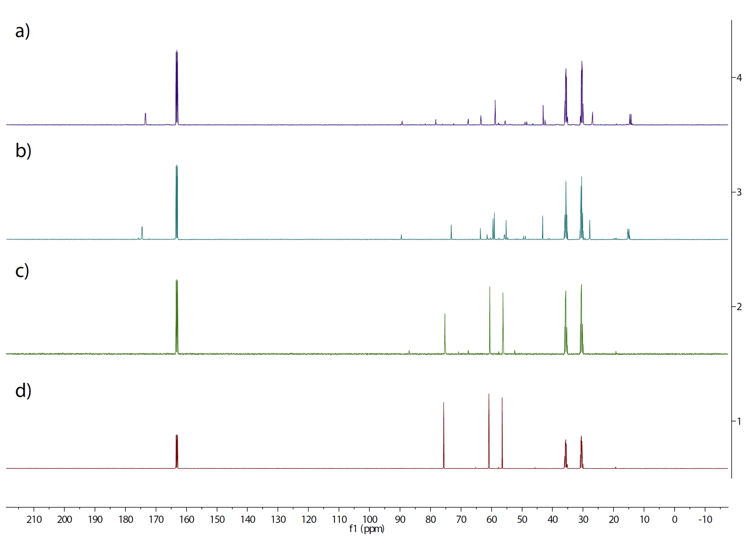

Figure S-1. 13C-NMR of the breakdown of HT with (a) HT complexed to aluminum (III) and reacted with TCEP, (b) HT in the absence of aluminum (III) and reacted with TCEP, (c) HT complexed to aluminum (III), and (d) HT by itself. All NMRs were done in d7-DMF.

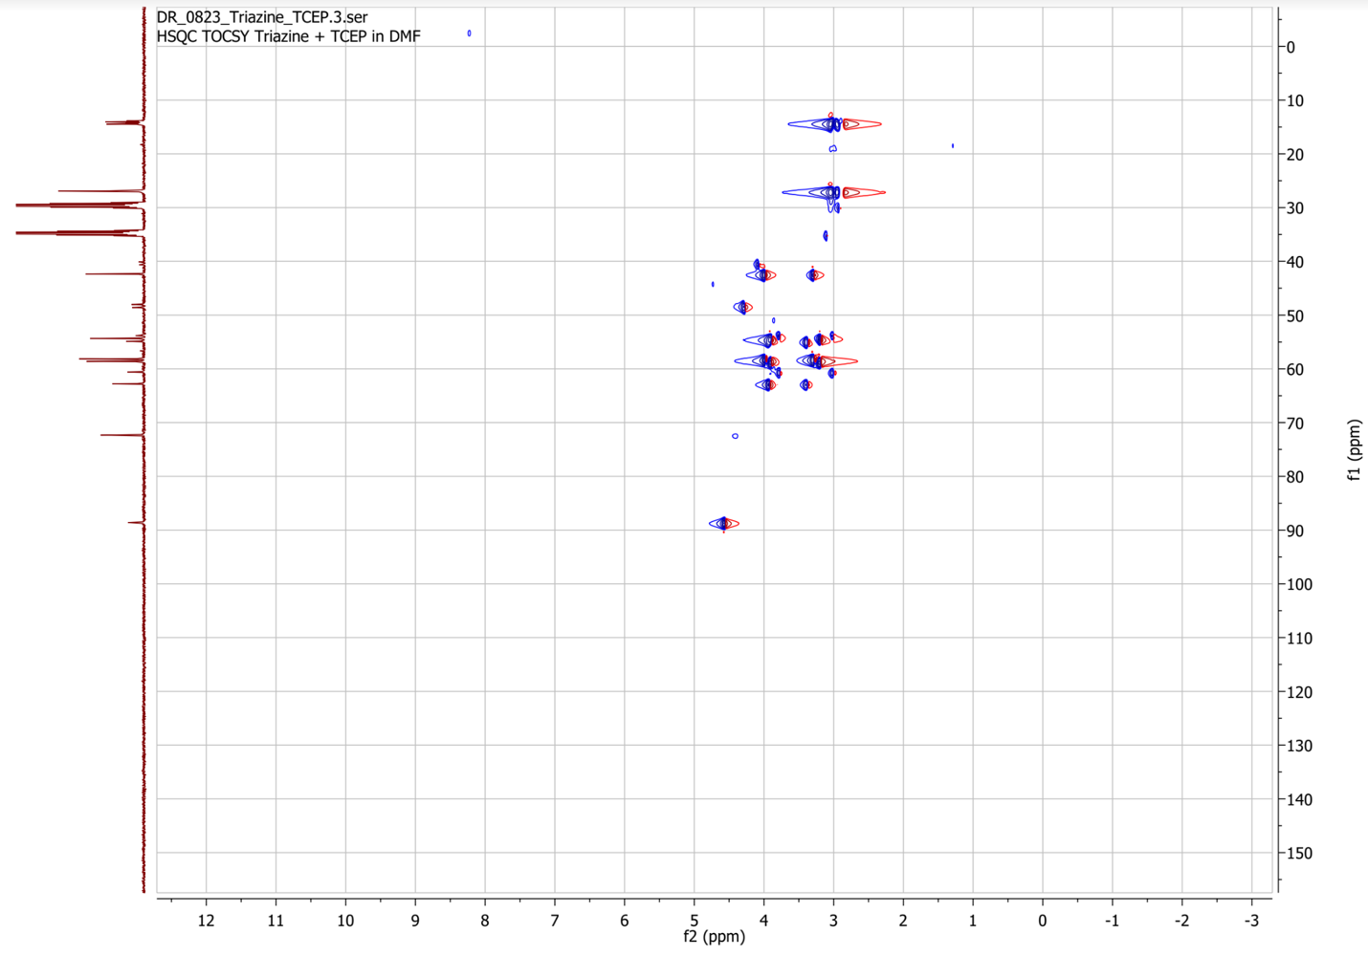

Figure S-2**.** HSQC-TCSY of Sample C.

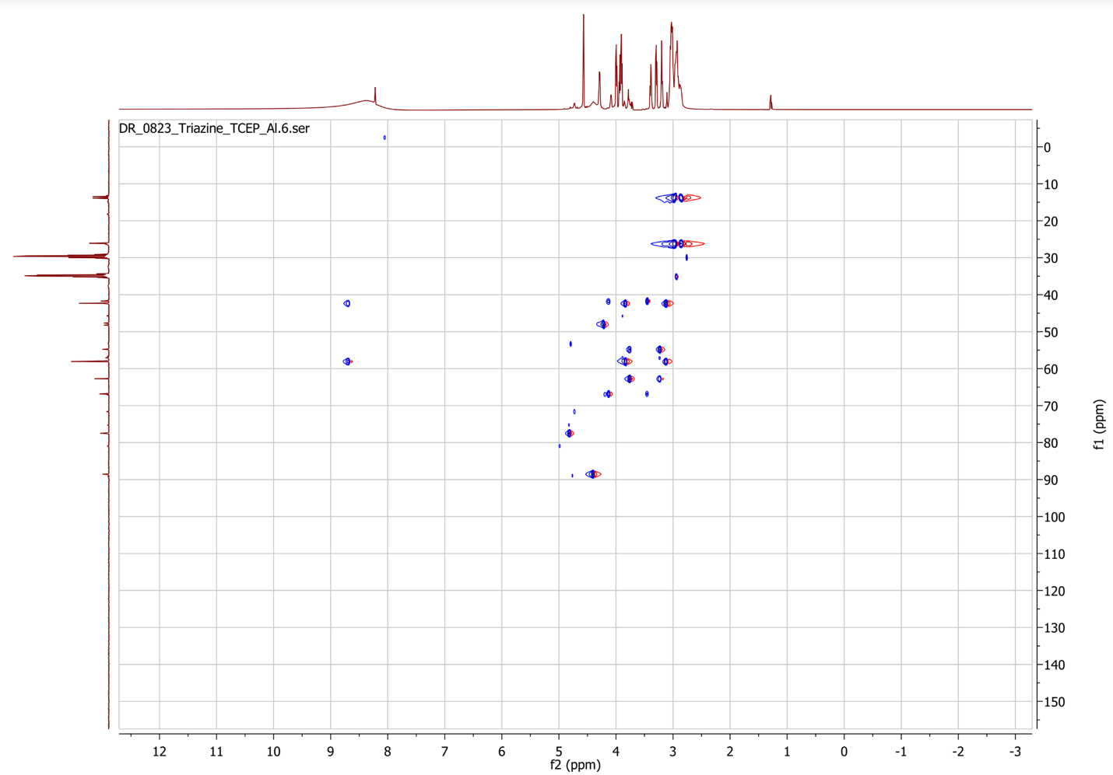

Figure S-3**.** HSQC-TCSY of Sample D.

# Triggered Release Study

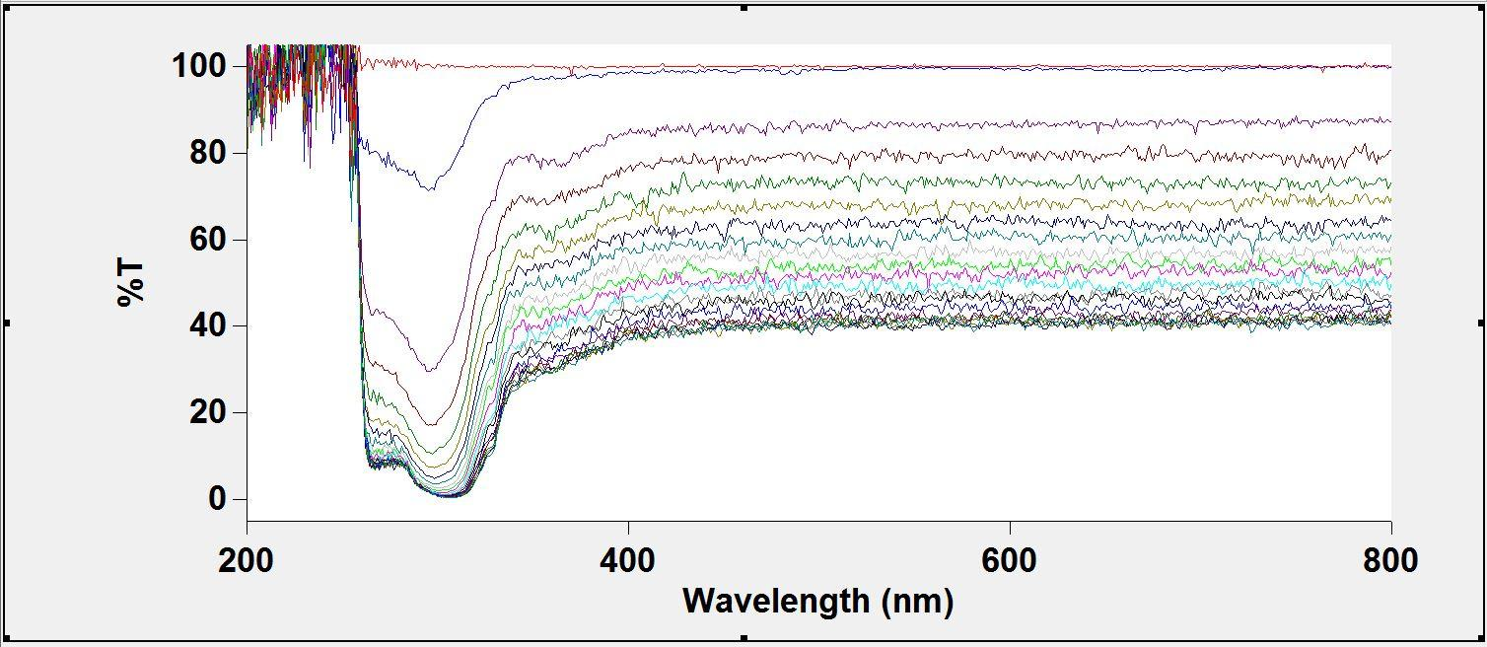

Figure S-4**.** Sample D (without aluminum).

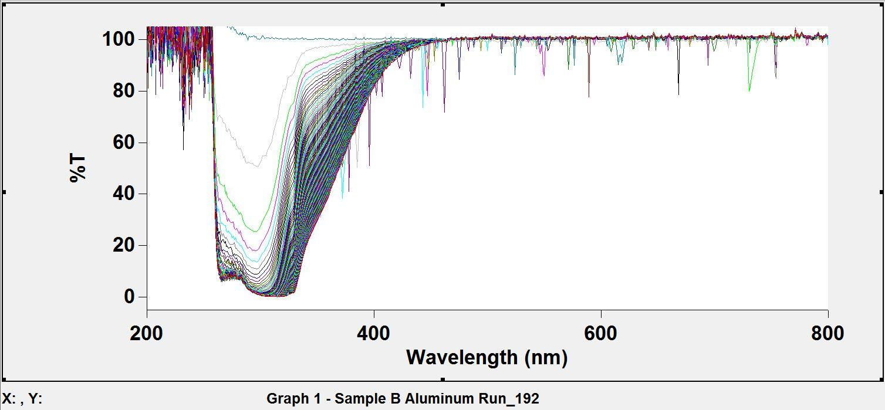

Figure S-5**.** Sample E (with aluminum)

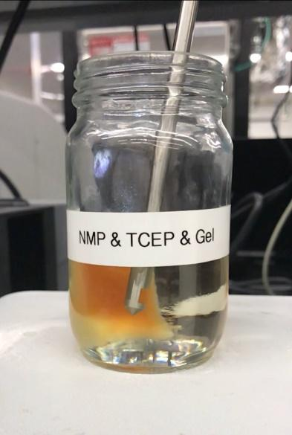 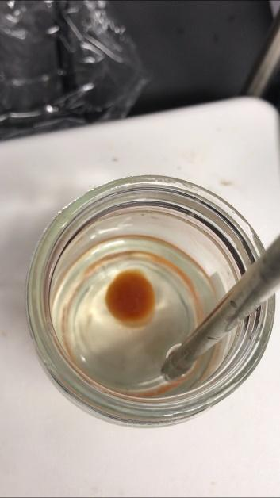

Figure S-6**.**