Supplementary Material

Reliability of inkjet printed silver nanoparticle interconnects on deformable substrates tested through an electromechanical in-situ technique

Martina Aurora Costa Angeliª, Tobias Cramer^{b}, Beatrice Fraboni^{b}, Luca Magagninª, Dario Gastaldiª, Pasquale Venaª

[a] Department of Chemistry, Materials and Chemical Engineering “Giulio Natta”, Politecnico di Milano, Piazza Leonardo da Vinci, 32, 20133, Milano, Italy.
[b] Department of Physics and Astronomy, University of Bologna, Viale Berti Pichat 6/2, 40127, Bologna, Italy.

martinaaurora.costa@polimi.it

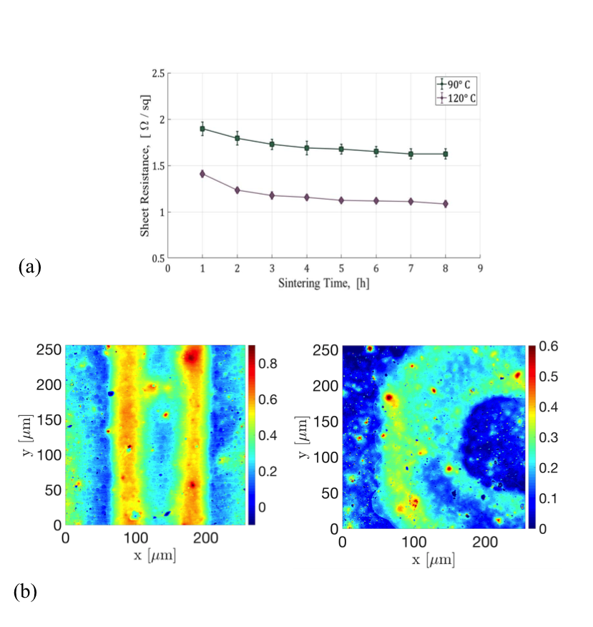

S.1 (a) Sheet resistance as a function of the sintering temperature and time of AgNPs inkjet printed line. (b) Height contrast images of the (left) linear and (right) serpentine interconnect on PET substrate.

S.2 (a) (left) Schematic representation of the PDMS interconnect made using tattoo paper. (right) Cross section view of the three layers structure: Ethyl cellulose (EC) film, printed AgNPs track, and PDMS. (b) CLM colour image of the interconnect after transfer on PDMS.
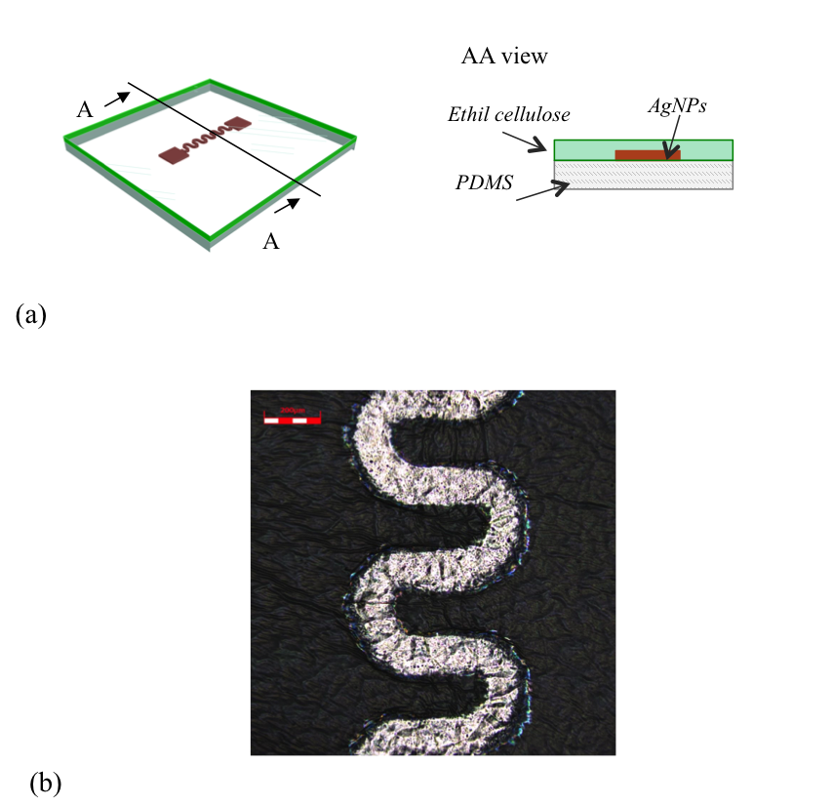
S.3 (a) CLM colour image of the inkjet printed (EC/AgNPs/PDMS) interconnect at 10% strain (b) magnification of the interconnect meander at (left) 0% and (right) 4% strain.
