Supplementary Material
Thermoelectric figure of merit and thermal conductivity of Type-I clathrate alloy nanowires
Prabhjot Kaur,¹ Georg K. H. Madsen,² and Chandan Bera^{1, a)}
¹⁾Institute of Nano Science and Technology, Habitat Center, Phase-X, Mohali,
Punjab - 160062, India
²⁾Institute of Materials Chemistry, TU Wien, A-1060 Vienna,
Austria

Clathrates of type-I have cubic structure with space group Pm$\overline{3}$n. The relaxed structure of cubic clathrates Ba₈Cu₆Si₄₀ and Ba₈Cu₆Ge₄₀ are obtained using VASP¹ with PBE correlation functional². Energy cut off was set to 300.0 eV and k-mesh was converged with k-points 4×4×4. The lattice constant of the cubic clathrates comes out to be 10.38 $\dot{A}$.

The phonon dispersion of the type-I clathrates Ba₈Cu₆Si₄₀, Ba₈Cu₆Ge₄₀ and diamond-Si structures have been calculated using PHONOPY³. The phonon band structure of Ba₈Cu₆Si₄₀, Ba₈Cu₆Ge₄₀ is shown in the Figure S1.

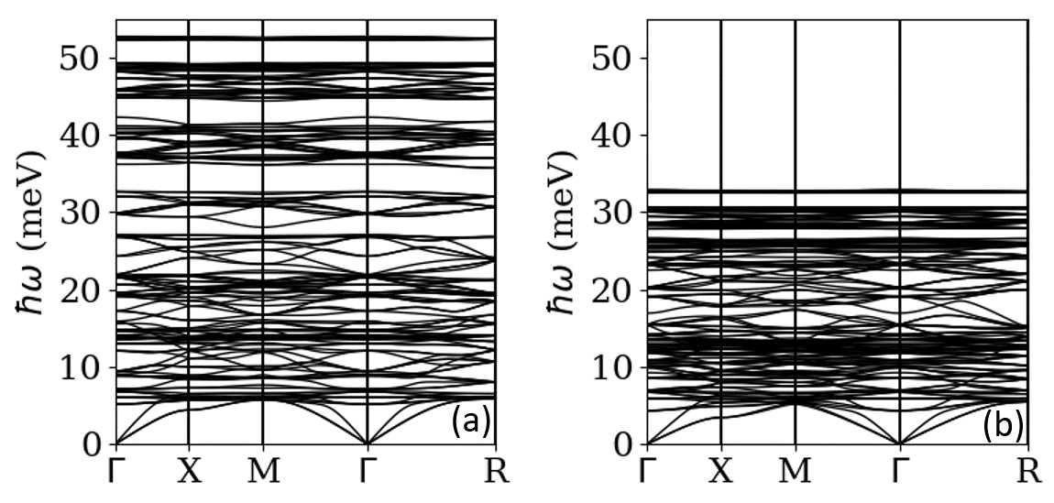

Figure S1. Phonon band structure along high symmetry direction for (a) Ba₈Cu₆Si₄₀ and (b) Ba₈Cu₆Ge₄₀.

The electronic transport coefficients were calculated using the Boltzmann transport equation coded in BoltzTraP software⁴. The data was fitted with the concentration of experimental alloy⁵. The concentration of Ba₈Cu₆Si₄₀ and Ba₈Cu₆Ge₄₀ was chosen to fit the data was 1.12×10²¹ cm⁻³ and 1.57×10²¹ cm⁻³ respectively. The relaxation time fitted with the experimental data⁴ was 1.8 ×10⁻¹⁵ s.

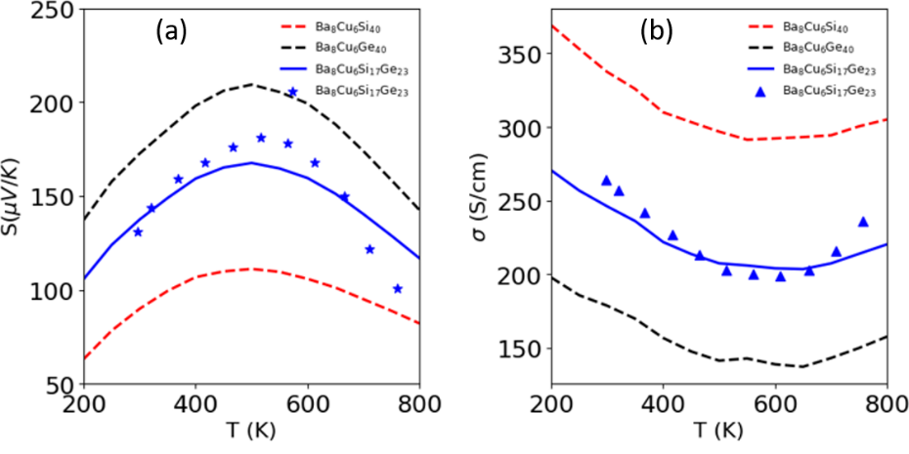

Figure S2. (a)Seebeck coefficient and (b)Electrical conductivity data for Ba₈Cu₆Si₄₀, Ba₈Cu₆Ge₄₀ and Ba₈Cu₆Si₁₇Ge₂₃

The calculation of Seebeck coefficient and electrical conductivity for Ba₈Cu₆Si₄₀, Ba₈Cu₆Ge₄₀ and Ba₈Cu₆Si₁₇Ge₂₃ is shown in Figure S2. The data is sufficiently matching with the experimental data for alloy⁵. The calculation of Seebeck coefficient and electrical conductivity for alloy is done using virtual crystal approximation as done in Ref.6.\

The figure of merit for the alloy is calculated according to the formula as used in Ref.6,

$ZT= \frac{x\left(S_{A}^{2}σ_{A}T\right)+(1-x)(S_{B}^{2}σ_{B}T)}{κ_{T}}$ (1)

where x is the fractional concentration of the pure compound A and rest is of the other pure compound B. In the numerator, the $S_{A}^{2}σ_{A}$ and $S_{B}^{2}σ_{B}$ are power factors for compound A and B respectively. The denominator $κ_{T}$ is total thermal conductivity of clathrate alloy comprising of phonon and electron part as $κ_{T}$ = $κ_{ph}$ + $κ_{el}$. The value of figure of merit for bulk and nanometer size is shown in the Figure S3. The value of figure of merit for bulk clathrate alloy is around 0.17 at temperature ~400K with total thermal conductivity 1.18 W/m-K.

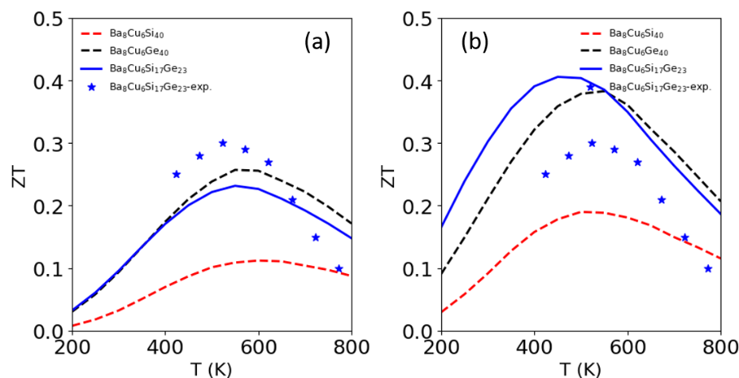

Figure S3. Figure of merit (ZT) with temperature for Ba₈Cu₆Si₄₀, Ba₈Cu₆Ge₄₀ and Ba₈Cu₆Si₁₇Ge₂₃ for (a)Bulk and (b)30nm

In the 30nm size, the total thermal conductivity reduces to 0.51 W/m-K. This reduction in thermal conductivity increases the figure of merit to 0.39 at 400K. This increase in figure of merit is more than 50%.

REFERENCES

¹G. Kresse and D. Joubert, “From ultrasoft pseudopotentials to the projector augmented wave method," Physical Review B 59, 1758-1775 (1999).
²P. E. Blchl, “Projector augmented-wave method," Physical Review B 50, 17953-17979 (1994).
³A. Togo, F. Oba, and I. Tanaka, “First-principles calculations of the ferroelastic transition between rutile-type and CaCl2 -type SiO2 at high pressures,” Physical Review B 78, 134106 (2008).
⁴G. K. Madsen and D. J. Singh, “Boltztrap. a code for calculating band-structure dependent quantities," Computer Physics Communications 175, 67 - 71 (2006).
⁵X. Yan, M. Falmbigl, S. Laumann, A. Grytsiv, E. Bauer, P. Rogl, and S. Paschen, “Structural and thermoelectric properties of Ba₈Cu_{x}Si_{23-x}Ge₂₃," Journal of Electronic Materials 41, 1159-1164 (2012).
⁶P. Kaur and C. Bera, “Effect of alloying on thermal conductivity and thermoelectric properties of CoAsS and CoSbS," Physical Chemistry Chemical Physics 19, 24928-24933 (2017).

