Supplementary Material

Effect of Excessive Pb on the Stability and Performance of Pb-Halide Perovskite Solar Cells Against Photo-Induced Degradation

Aditya S. Yerramilli¹, Yuanqing Chen^{1,3} and T.L. Alford^{1,2*}
¹School for Engineering of Matter, Transport and Energy, Arizona State University, AZ, 85287, USA
²Materials Science and Engineering Program, African University of Science and Technology, Abuja, 900242, Nigeria
³Department of Materials Physics and Chemistry, Xi’an University of Technology, Xi’an, 710048, China
*Corresponding author: Dr. T. L. Alford (ta@asu.edu)
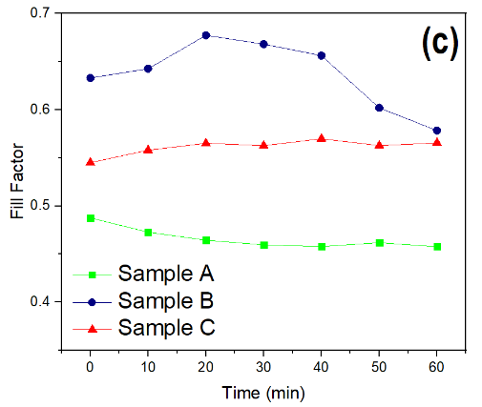
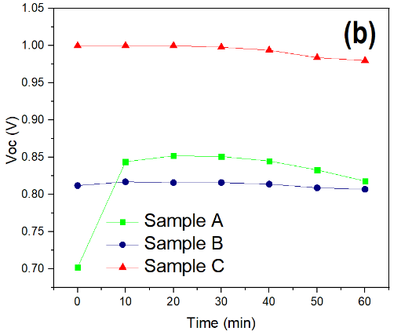
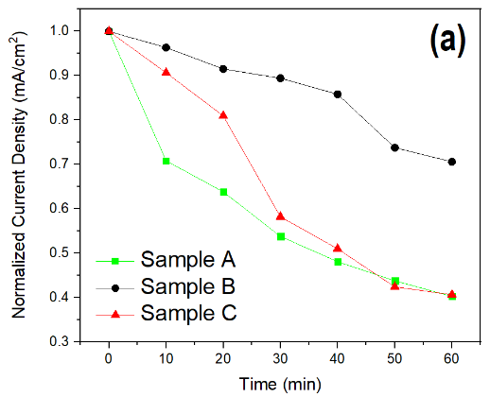

Fig S1. Photo-degradation of photo-voltaic properties of PVS device with illumination time(T),
- Normalized J_{sc}-T curve, (b) V_{oc}-T curve, (c) FF-T curve

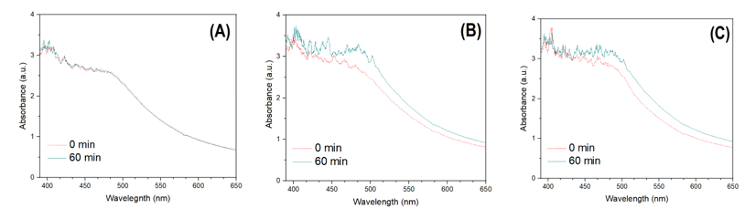

Fig. S2. UV-Vis spectra from Sample A, Sample B, and Sample C

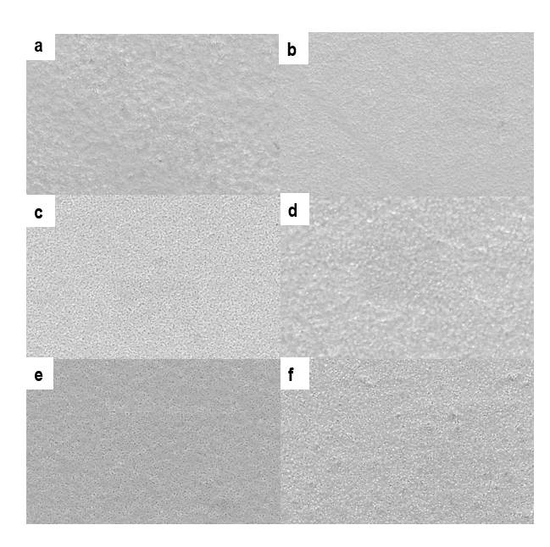
Fig. S3. SEM Images of PVS before and after illumination, (a) Sample A-i, (b) Sample A-d, (c) Sample B-i, (d) Sample B-d, (e) Sample C-i, (f) Sample C-d; with suffix “i” in for the pristine sample and the suffix “d’ is after degradation

