Supplementary Material
PCBM Nanoparticles as a Visible-Light-Driven Photocatalyst for Photocatalytic Decomposition of Organic Dyes

Chanon Pornrungroj$, Tsunenobu Onodera, and Hidetoshi Oikawa *
Institute of Multidisciplinary Research for Advanced Materials, Tohoku University,

2-1-1 Katahira, Aoba-ku, Sendai 980-8577, Japan

* Corresponding author: Hidetoshi Oikawa*

E-mail: hidetoshi.oikawa.e8@tohoku.ac.jp

$ Current affiliation: Department of Chemistry, University of Cambridge, Lensfield Road, Cambridge CB2 1EW, UK, E-mail: cp651@cam.ac.uk

Fig. S1 Histogram showing particle size distribution of as prepared PCBM NPs before (top) and after (bottom) 10 recycles photocatalysis experiments measured by DLS. PDI is the polydispersity index.

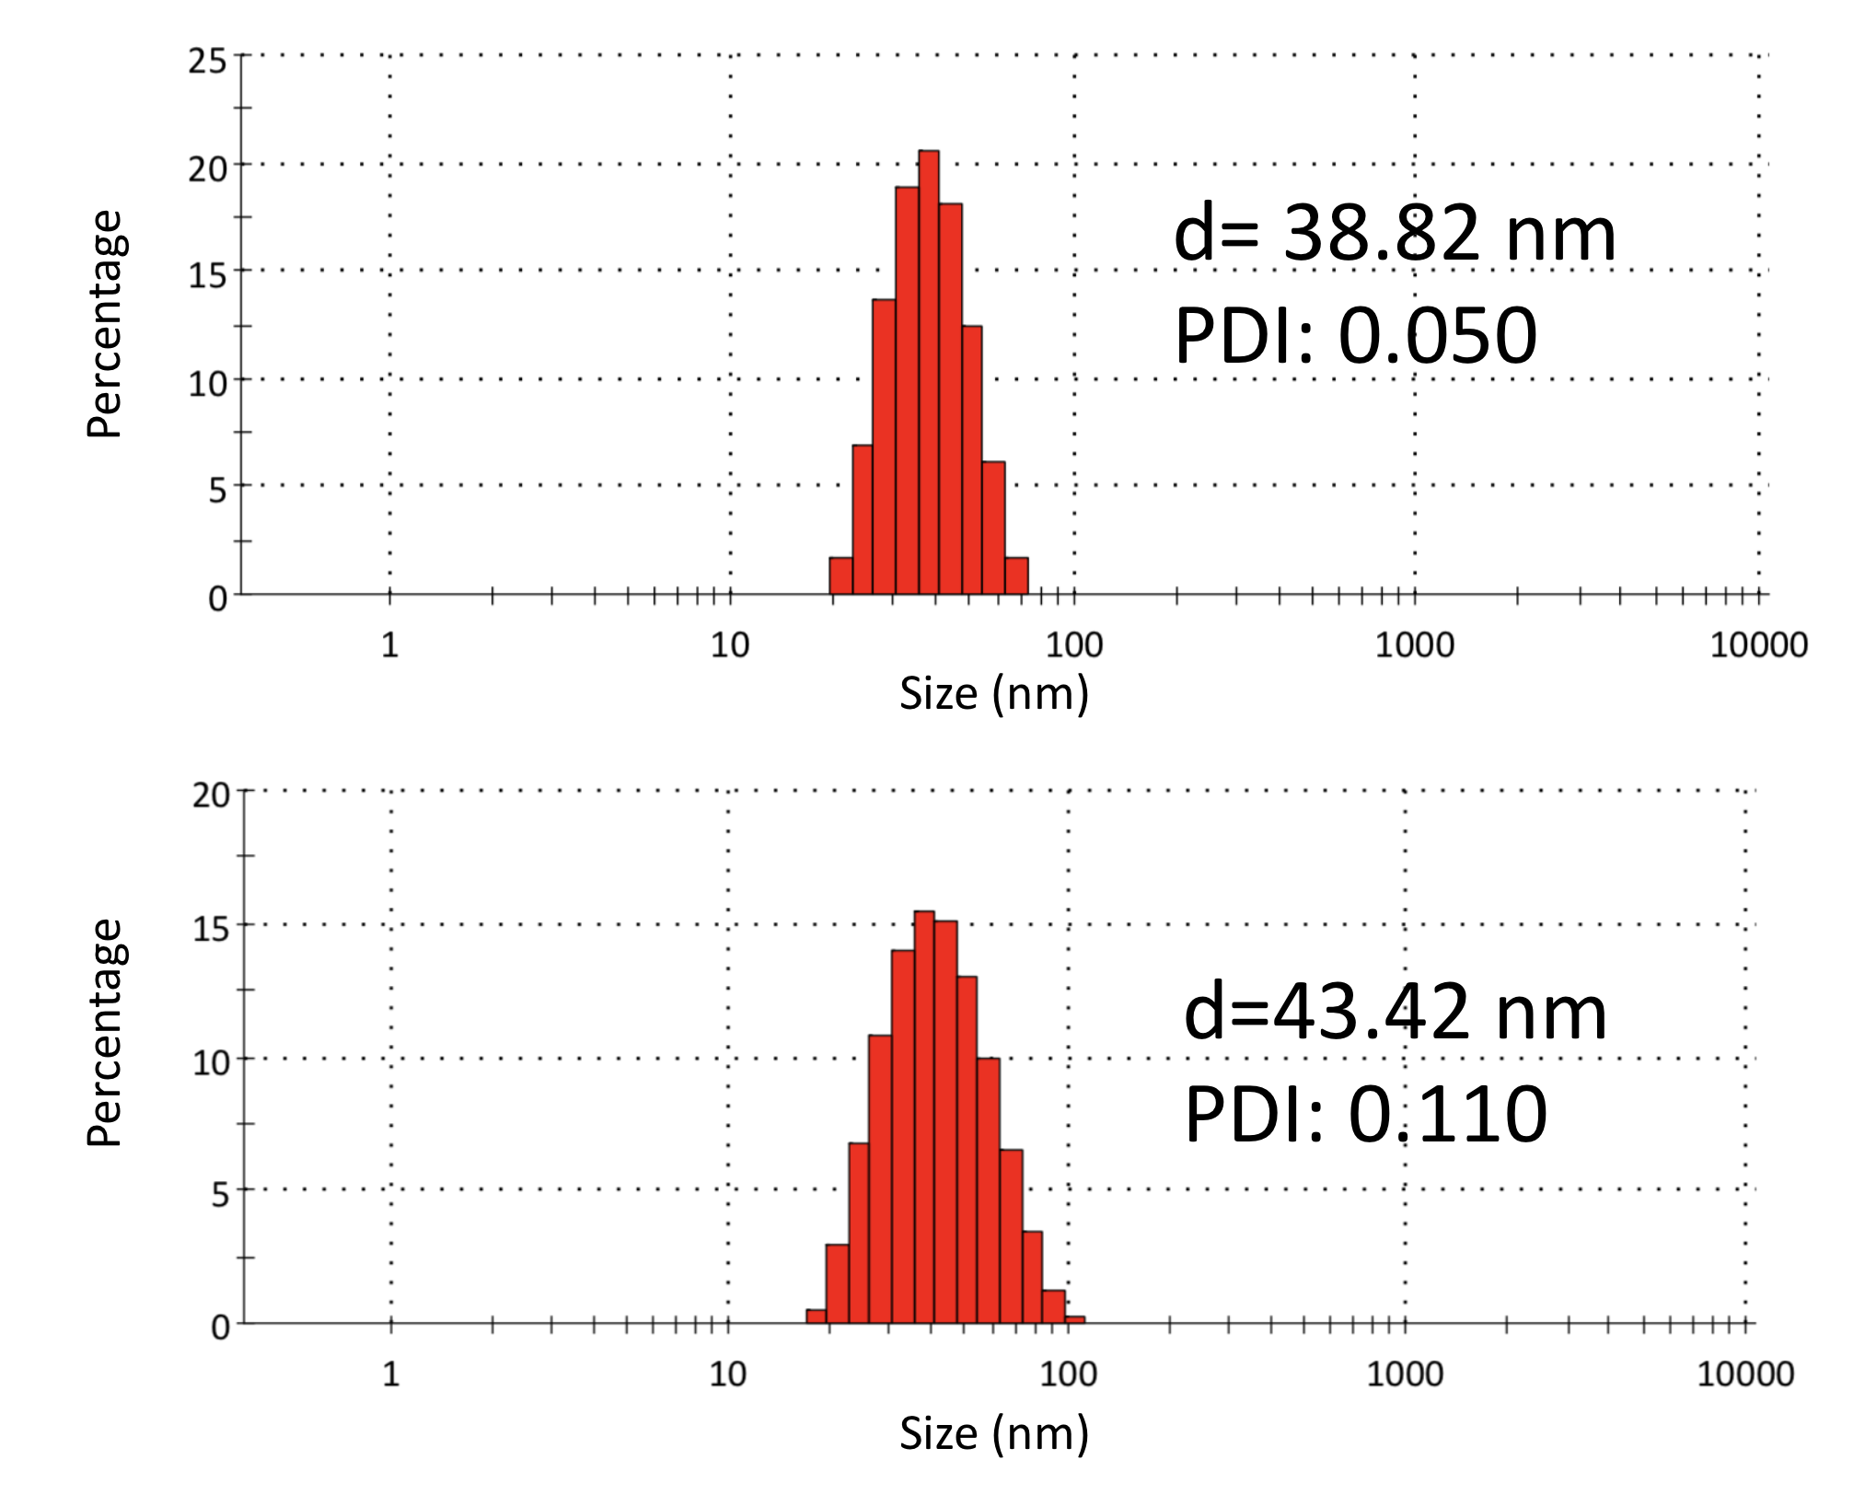

Fig. S2 Photograph of as-prepared PCBM NPs aqueous dispersion.

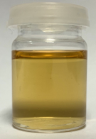

Fig. S3 (a) Powder XRD patterns, and (b) UV-Vis absorption spectra for PCBM NPs before (blue) and after (green) 10 recycled photocatalysis experiments.

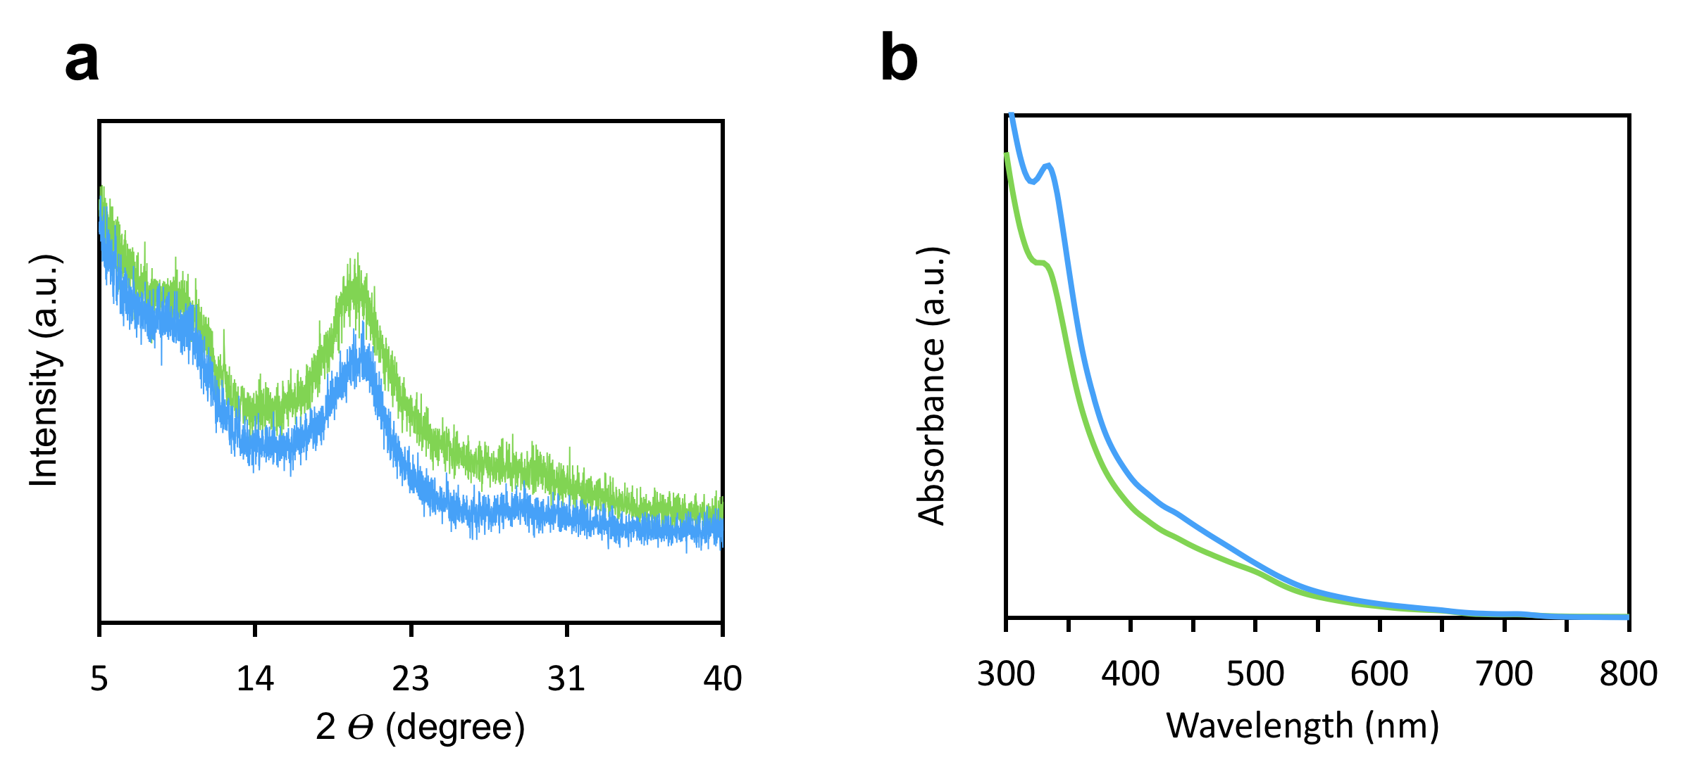

Fig. S4 (a) UV-Vis absorption spectra, (b) HRTEM image, and (c) Histogram showing particle size distribution of annealed PCBM NPs

