SUPPLEMENTAL MATERIALS

INFLUENCE OF ELECTROLYTE SUBSTRATES ON THE Sr-SEGREGATION
AND SrSO₄ FORMATION IN LSCF THIN FILMS
Jeffrey C. De Vero^{1*}, Harumi Yokokawa^{1,2}, Katherine Develos-Bagarinao¹, Shu Sheng Liu¹, Haruo Kishimoto¹, Tomohiro Ishiyama¹, Katsuhiko Yamaji¹, Teruhisa Horita¹
¹Energy Conversion Technology Group, National Institute of Advanced Industrial Science and Technology, Tsukuba, Ibaraki 305-8565, Japan.
²Institute of Industrial Science, The University of Tokyo, Tokyo 153-8505, Japan
*Corresponding author’s email: jeffrey-devero@aist.go.jp

FIGURE AND TABLE LISTS

Fig. S1 X-ray diffraction profiles of LSCF films on (a) BZY and (b) GDC substrates before after annealing at 800ºC to 1000ºC. Reference data files: LSCF- ICSD No. 181673, a = 0.54953 nm, c=1.34125 nm; GDC- JCDPS 075-0161, a = 0.5417 nm; BaZrO₃- ICSD No. 1532743, a = 0.41934 nm; SrSO₄- JCPDS No. 05-0593, a = 0.8359 nm, b = 0.5352, c = 0.6866 nm).
Fig. S2 STEM-EDS analyses of LSCF on (a) GDC and (b) BZY electrolyte substrates after annealing at 800ºC for 300 h in ar.
Fig. S3 SIMS depth profile of as-grown LSCF film on BZY substrate. Cations from LSCF films actively diffused into BZY substrate even during the growth.
Fig. S4 SEM-WDS line-scans of LSCF films grown on BZY substrates before after annealing. Ba diffused into LSCF during the growth in LSCF, whereas La diffuses more evidently in BZY20 after prolonged annealing at high temperatures.
Fig. S5 Estimation of Sr apparent bulk diffusivity in BZY. The apparent bulk diffusivity was determined from the SIMS diffusion profile by fitting with the solution proposed by Crank [30].

Table

Table S1. Evaluated lattice constants of LSCF, GDC and BZY phases from XRD data (Fig. S1). Fore reference the lattice constant for BZY pellet substrate is a= 0.4212 nm and for GDC pellet a= 0.541 nm. Herein the grain size, L, was determined using Scherrer’s equation.

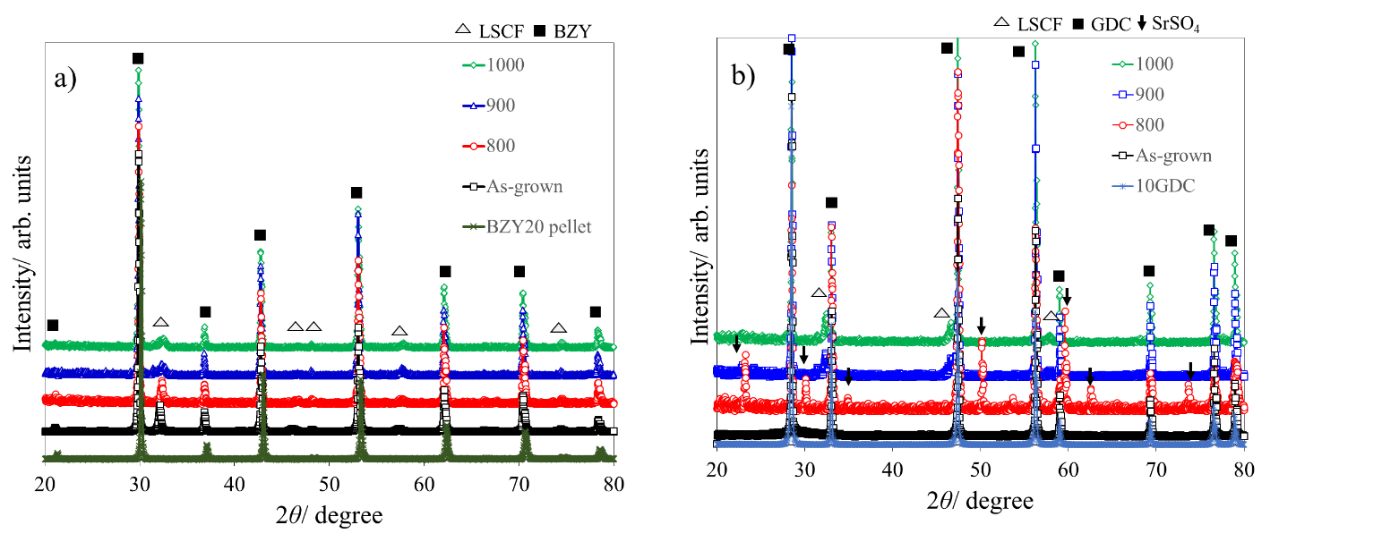

Fig. S1 X-ray diffraction profiles of LSCF films on (a) BZY and (b) GDC substrates before after annealing at 800ºC to 1000ºC. Reference data files: LSCF- ICSD No. 181673, a = 0.54953 nm, c=1.34125 nm; GDC- JCDPS 075-0161, a = 0.5417 nm; BaZrO₃- ICSD No. 1532743, a = 0.41934 nm; SrSO₄- JCPDS No. 05-0593, a = 0.8359 nm, b = 0.5352, c = 0.6866 nm).

Table S1. Evaluated lattice constants of LSCF, GDC and BZY phases from XRD data (Fig. S1). Fore reference the lattice constant for BZY pellet substrate is a= 0.4212 nm and for GDC pellet a= 0.541 nm. Herein the grain size, L, was determined using Scherrer’s equation.
Sample | T/ºC | a_{sub} /nm | a_{LSCF}/nm | c_{LSCF}/nm | L / nm
LSCF/BZY20 | As-prepared | 0.4224 | 0.5571 | 1.3657 | 35.20
 | 800 | 0.4227 | 0.5533 | 1.3545 | 98.00
 | 900 | 0.4224(2) | 0.5538 | 1.3402 | 95.00
 | 1000 | 0.4221 | 0.5515 | 1.3509 | 100.60
LSCF/10GDC | As-prepared | 0.5416 | - | - | -
 | 800 | 0.5415(3) | - | - | -
 | 900 | 0.5417(3) | 0.5585 | 1.3188 | 119.60
 | 1000 | 0.5417 | 0.5529 | 1.3178 | 149.20

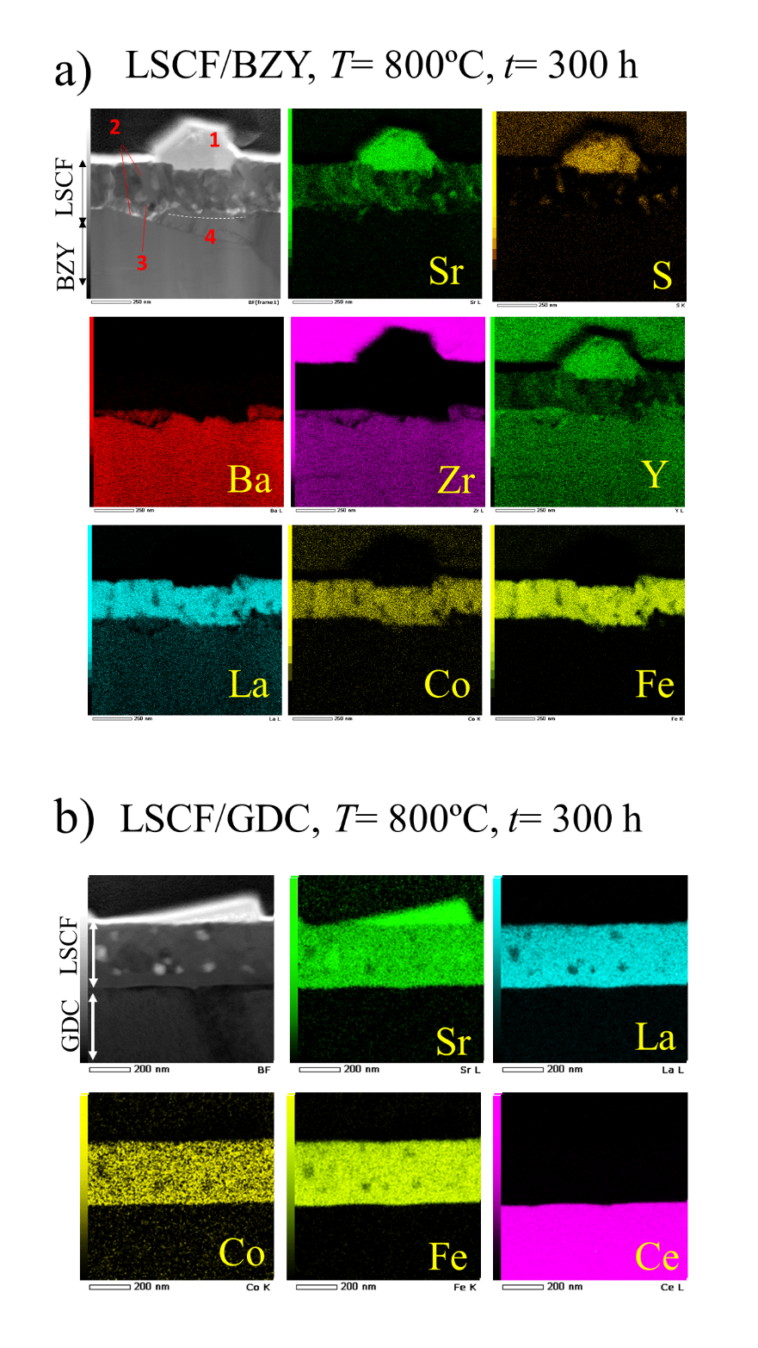

Fig. S2 STEM-EDS analyses of LSCF on (a) GDC and (b) BZY electrolyte substrates after annealing at 800ºC for 300 h in ar.
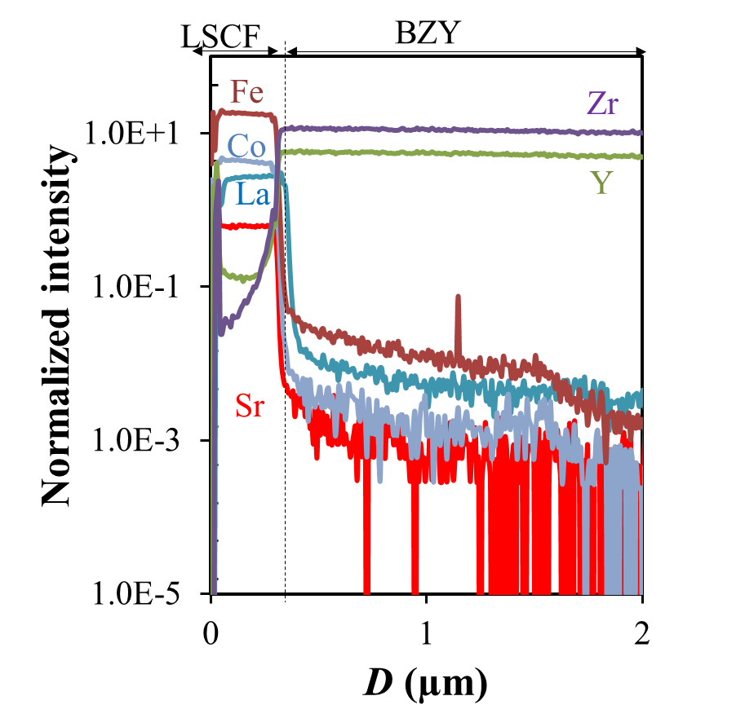

Fig. S3 SIMS depth profile of as-grown LSCF film on BZY substrate. Cations from LSCF films actively diffused into BZY substrate even during the growth.
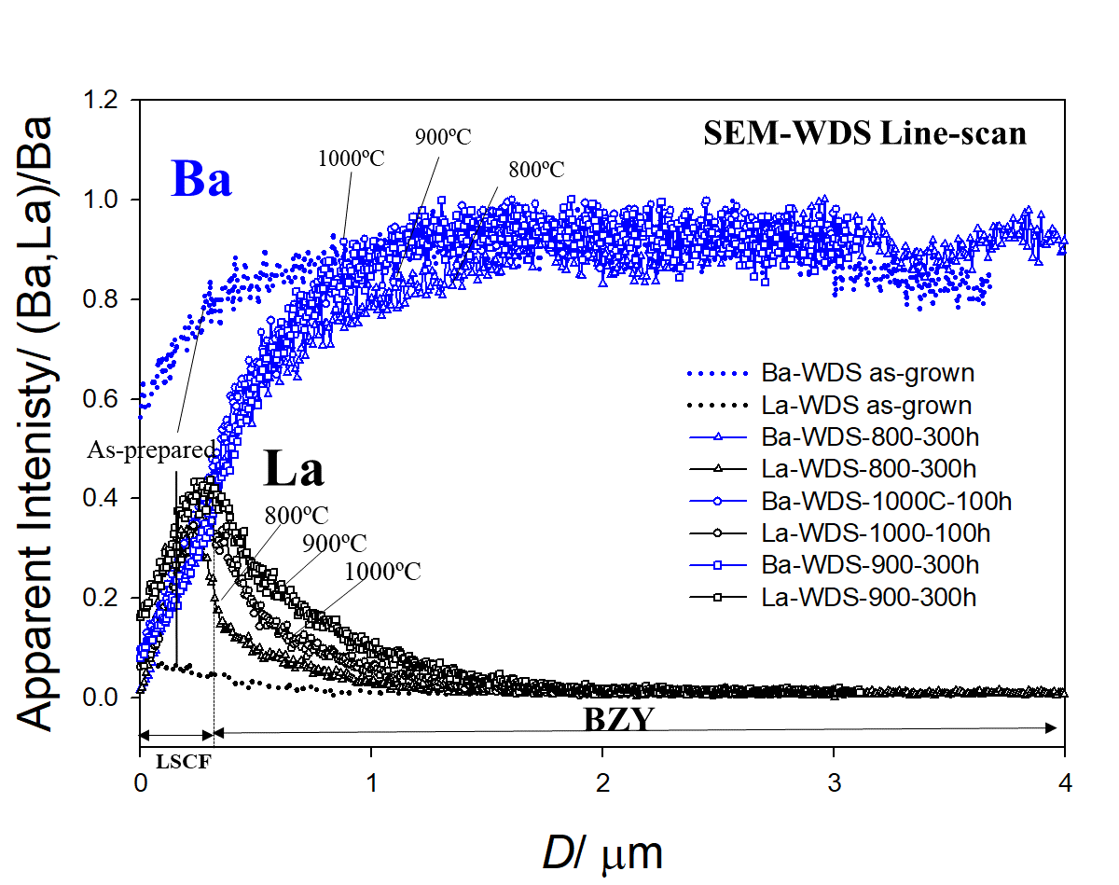

Fig. S4 SEM-WDS line-scans of LSCF films grown on BZY substrates before after annealing. Ba diffused into LSCF during the growth in LSCF, whereas La diffuses more evidently in BZY20 after prolonged annealing at high temperatures.

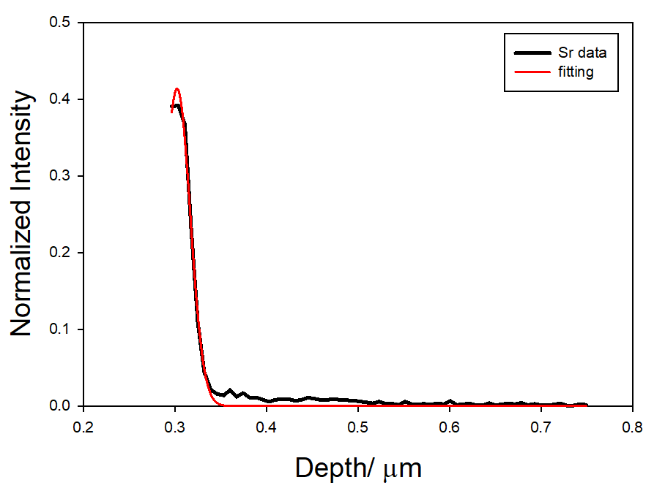

Fig. S5 SIMS depth profile of LSCF/BZY diffusion couple annealed at 1000ºC for 168 h. The apparent bulk diffusivity was determined by fitting the SIMS depth profile with the Crank’s diffusion equation in Ref. [30].

