Article Type (Research Letter-Supplementary Material)

Thermo-Mechanical and Swelling Properties of 3D-printed Poly (Ethylene Glycol) Diacrylate (PEGDA)/ SiO₂ Nanocomposites

John Ryan C. Dizon, Qiyi Chen, Arnaldo D. Valino, Rigoberto C. Advincula*

–––––––––

Dr. J. R. C. Dizon, Q. Chen, Engr. A. D. Valino, Prof. R. C. Advincula
Department of Macromolecular Science and Engineering
Case Western Reserve University
Cleveland, OH 44106, USA
E-mail: rca41@case.edu
Dr. J. R. C. Dizon
Department of Mechanical Engineering, College of Engineering and Architecture
Bataan Peninsula State University
City of Balanga, Bataan, 2100, Philippines

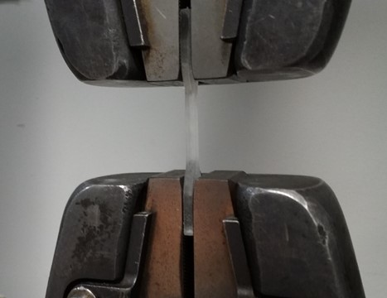
FIG. S1 Set-up for the Tensile Test showing the sample clamped on both ends by the upper and lower gripping part of the testing machine.

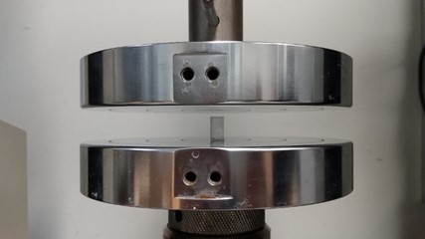
FIG. S2 Set-up for the Compression Test showing the sample clamped on both ends by the upper and lower gripping part of the testing machine.

a)

b)

FIG. S3 FTIR spectra of unfilled PEGDA, PEGDA/SiO₂ nanocomposite and SiO₂ powder; a) whole spectra from 400 cm⁻¹ to 4,000 cm⁻¹; b) enlarged view showing SiOH bending at ~ 960 cm⁻¹.

Table S1 Temperature Values for 10% and 90% Weight Loss

SiO₂ content (%) | Temperature values for 10% Weight Loss (°C) | Temperature values for 90% Weight Loss (°C)
0 | 338 | 438
1 | 338 | 440
3 | 352 | 449
5 | 385 | 458

